Structural Farmer code:

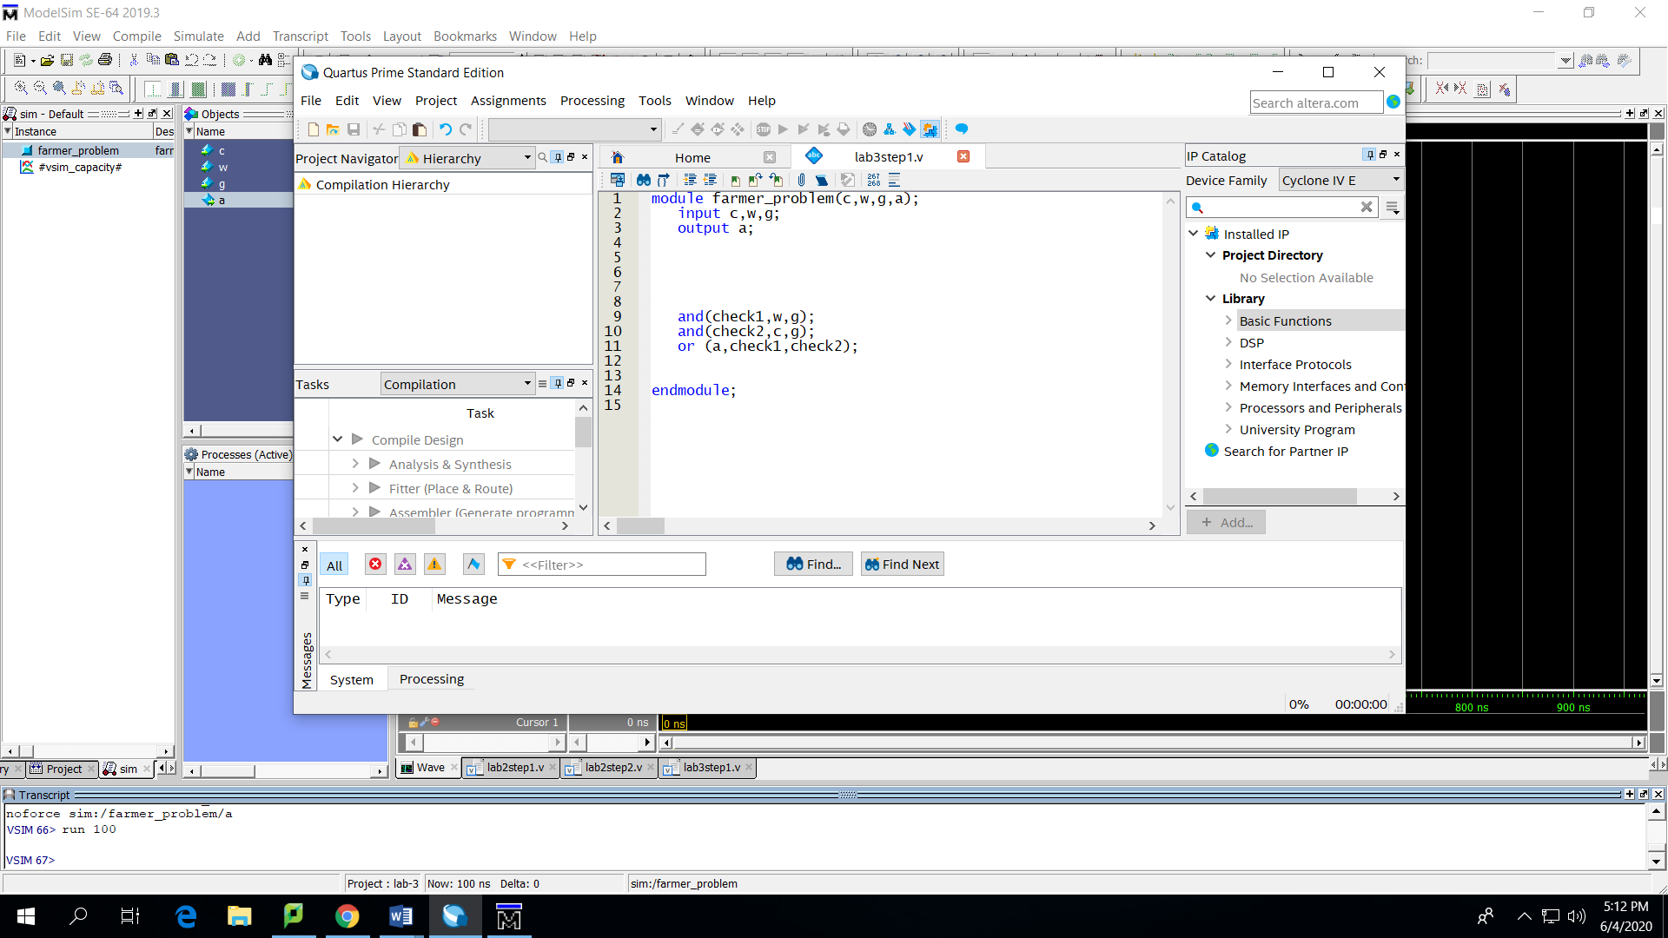

Results:

|  |
| --- |
| 0-0-0 |
| 0-0-1 |
| 0-1-0 |
| 1-0-0 |
| 1-1-0 |
| 1-0-1 |
| 0-1-1 |
| 1-1-1 |

Behavioral farmer code:

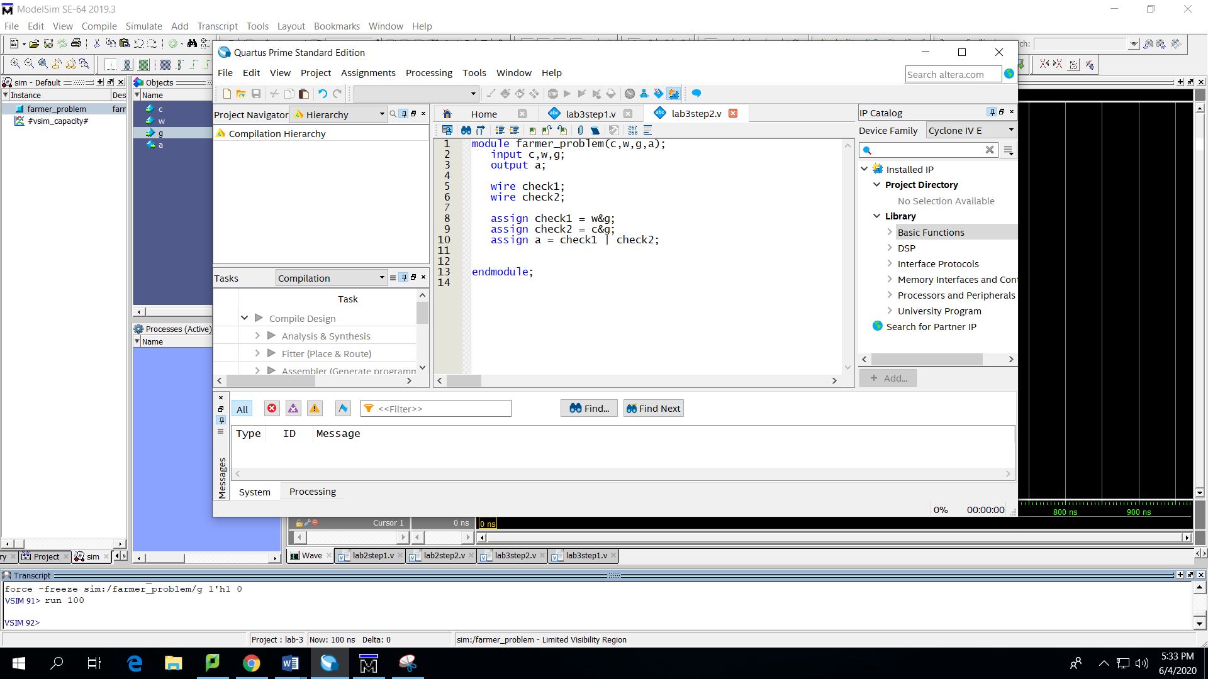

Results:

|  |
| --- |
| 0-0-0 |
| 0-0-1 |
| 0-1-0 |
| 1-0-0 |
| 0-1-1 |
| 1-1-0 |
| 1-0-1 |
| 1-1-1 |

Step3:

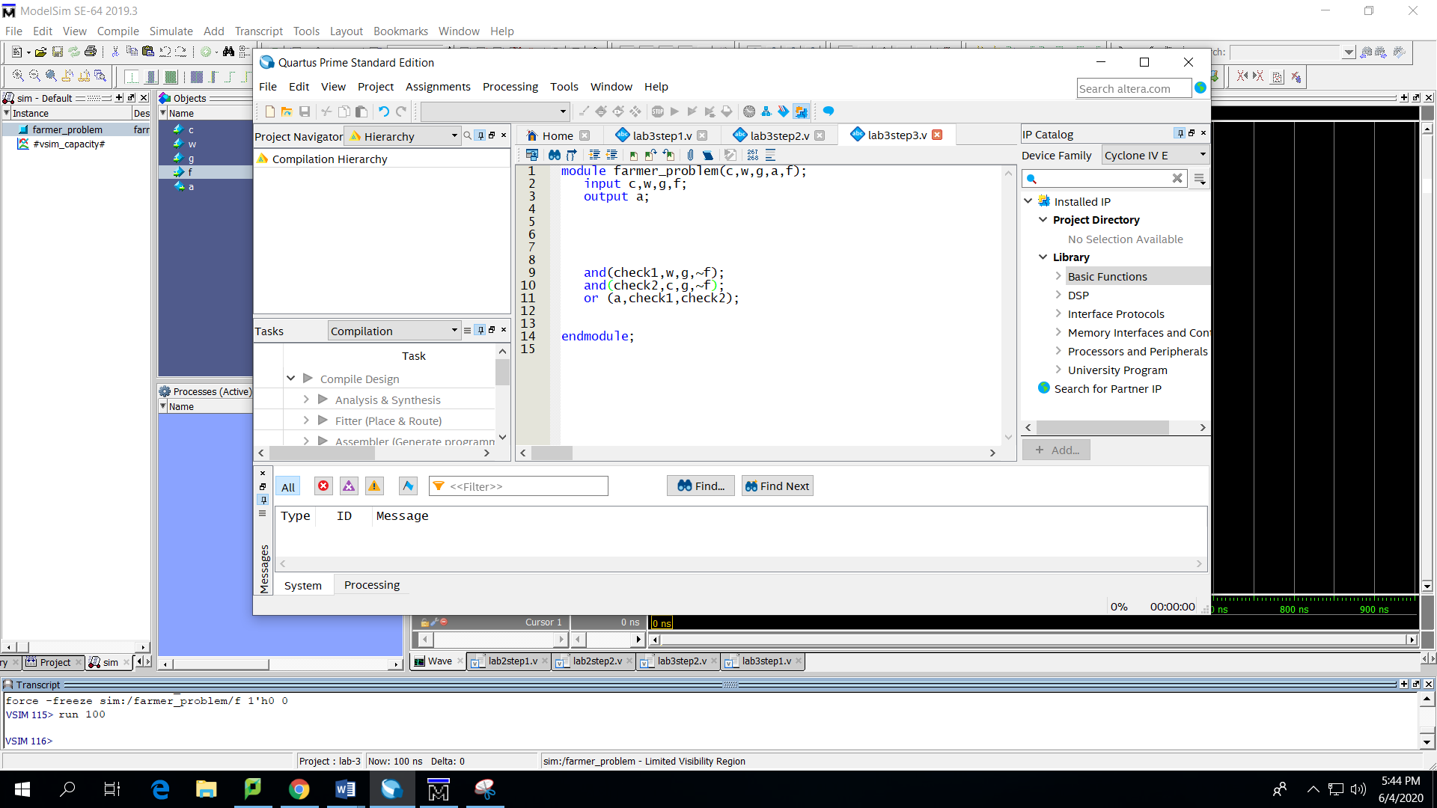

Results

|  |
| --- |
| 0-0-0-0 |
| 0-0-1-0 |
| 0-1-0-0 |
| 1-0-0-0 |
| 0-1-1-0 |
| 1-0-1-0 |
| 1-1-0-0 |
| 1-1-1-0 |
| 0-0-0-1 |
| 0-0-1-1 |
| 0-1-0-1 |
| 1-0-0-1 |
| 0-1-1-1 |
| 1-0-1-1 |
| 1-1-0-1 |
| 1-1-1-1 |