Lab05 verilog code

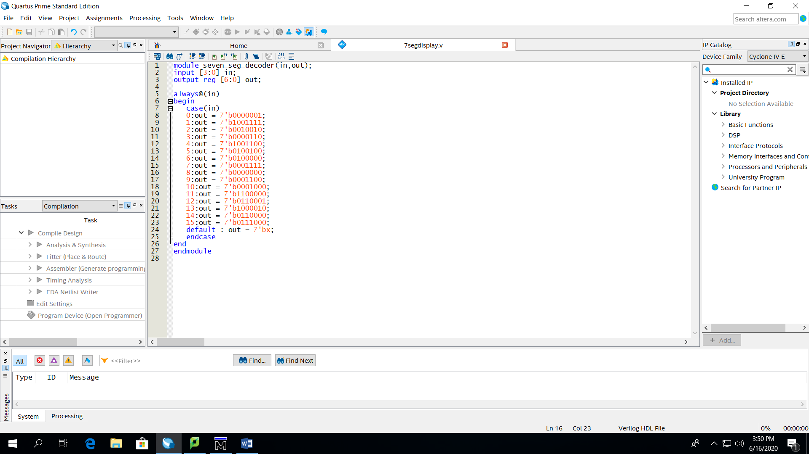

Results

|  |
| --- |
| 0 |
| 1 |
| 2 |
| 3 |
| 4 |
| 5 |
| 6 |
| 7 |
| 8 |
| 9 |
| 10(a) |
| 11(b) |
| 12(c) |
| 13(d) |
| 14(e) |
| 15(f) |

4 7segment display diagram

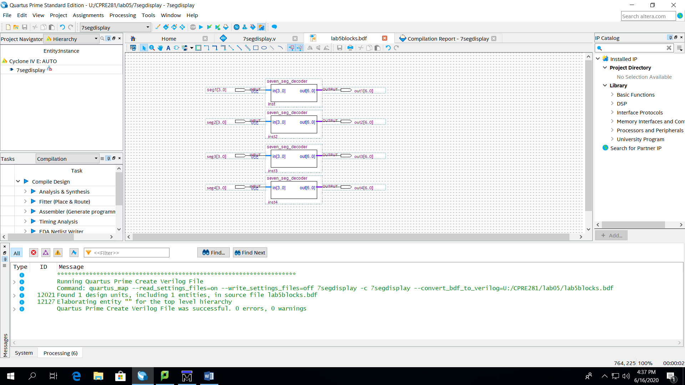

Results:

I chose to do some examples to demonstrate that my code works rather than showing all possible combinations

|  |
| --- |
| 0439 |
| abcd |
| Ab34 |
| Ef78 |
| 912b |
| Ccc1 |
| 808f |
| 1234 |