CprE 381, Computer Organization and

Assembly Level Programming

Lab 1 Report

Student Name: Thriambak Giriprakash

Submit a typeset pdf version of this on Canvas by the due date. Refer to the highlighted language in the lab document for the context of the following questions.

[Part 1.c] Think of three more cases and record them in your lab report.

Case 3: Initialialize MAC operation with no Weight (ildw = 0) ->expect s_w signal to be 0
Case 4: Run MAC operation with no iY value (iY = 0) -> expect o_y to be 30
Case 5: Set up MAC operation using the result of the 1 step MAC operation 85

[Part 1.e] For labels 9, 20, 32, and 33, specify where (VHDL file and line number) these values are located – some will be found in more than one place. Also attempt to explain the functionality of each label as it occurs in the code

9: line 63 (regld.vhd) connects internal storage to external output
20: line 114 (TPU_MV_ELEMENT.vhd)
32: line 117 (TPU_MV_ELEMENT.vhd) -> (Adder.vhd)
33: Entire file TPU_MV_ELEMENT.vhd

[Part 1.g.v] In your lab report, include a screenshot of the waveform. Describe, in plain English, any differences between what you expected and what the simulation showed.

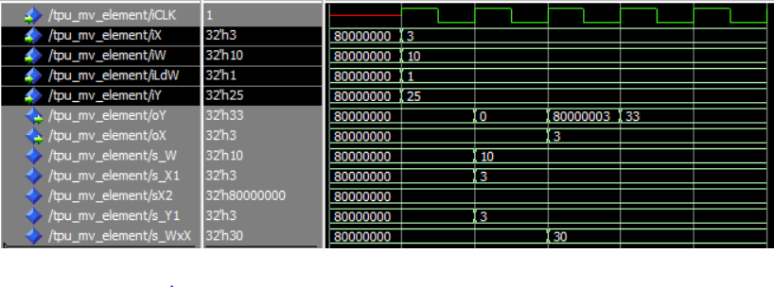
The s_iY value which gets passed from the main input to the delay gets changed to 3 instead of 25

[Part 1.h] In your lab report, include a screenshot of the waveform. Describe, in plain English, how your waveform matches the expected result (e.g., reference the specific cycles and times). In your submission zip file, provide the completed TPU_MV_Element.vhd file in a folder called ‘MAC’.

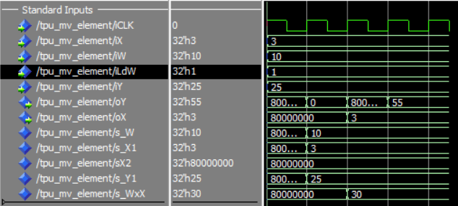
3*10 + 25 = 55 and oX stays at 3 as per the diagram.

[Part 3.a] Draw the truth table, Boolean equation, and Boolean circuit equivalent (using only two-input gates) that implements a 2:1 mux. Include this in your lab report.

Sel | I1 | I2 | Out
0,1 | 0 | 0 | 0,0
0,1 | 0 | 1 | 1,0
1,0 | 1 | 0 | 1,0
1,0 | 1 | 1 | 1,1

(i1*sel)+(i2*!sel) = out

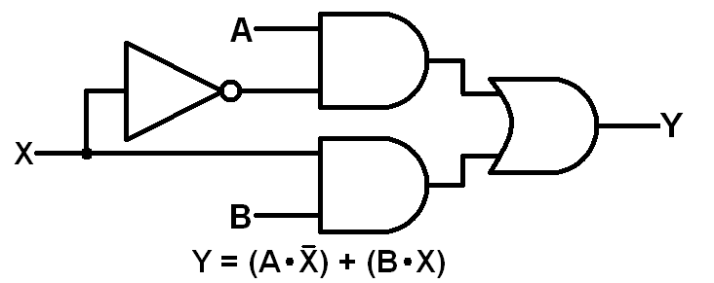

[Part 3.d] In your lab report, include a screenshot of the waveform. Make sure to label the screenshot with which module it is testing. 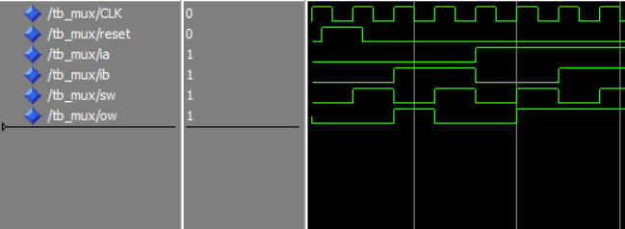

Mux file:
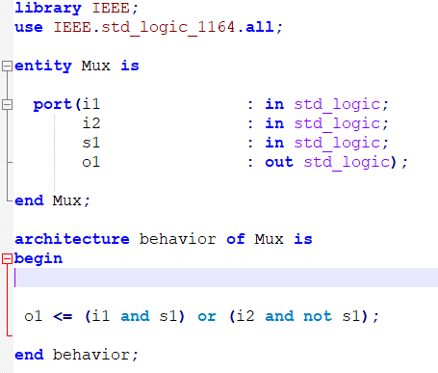

Testbench:
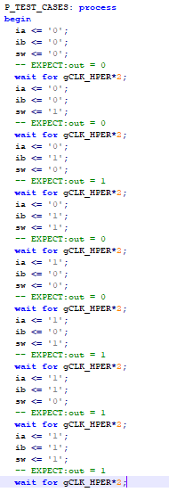

[Part 3.e] Again, in your lab report, include a labeled screenshot of the waveform showing the dataflow mux implementation working.

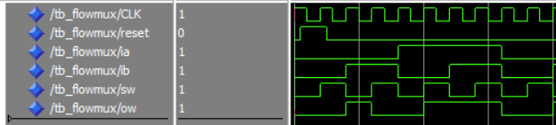

[Part 4] Include a waveform screenshot and corresponding description demonstrating it is working correctly.

Setting 0 for the switch selects the i_d1 and selecting 1 selects i_d0
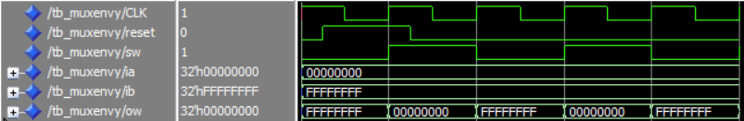
[Part 5.b] Include a waveform screenshot and description in your lab report.

Ones complement uses a nand to inverse any signal coming in so a 0 bit turns to a 1 and a 1 turns to a 0.

[Part 6.a] A full adder takes three single-bit inputs and produces two single-bit outputs – a sum and carry for the addition of the three input bits. Draw the truth table, Boolean equation, and Boolean circuit equivalent (using only two-input gates) that implements a 1-bit full adder. Include this in your report.

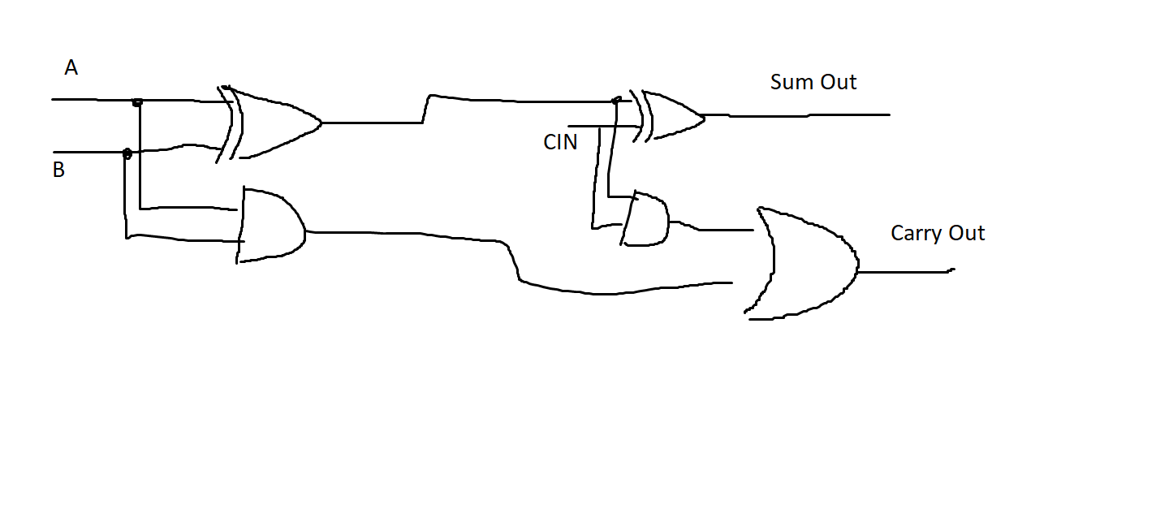

A | B | Cin | S
0 | 0 | 0 | 0
0 | 0 | 1 | 1
0 | 1 | 0 | 1
0 | 1 | 1 | 0
1 | 0 | 0 | 1
1 | 0 | 1 | 0
1 | 1 | 0 | 0
1 | 1 | 1 | 1

Cout = !ABCin + A!BCin + AB!Cin + ABCin
S = !A!BCin + !AB!Cin + A!B!Cin + ABCin

[Part 6.c] Then draw a schematic of the intended design, including inputs and outputs and at least the 0, 1, N-2, and N-1 stages. Include this in your report.

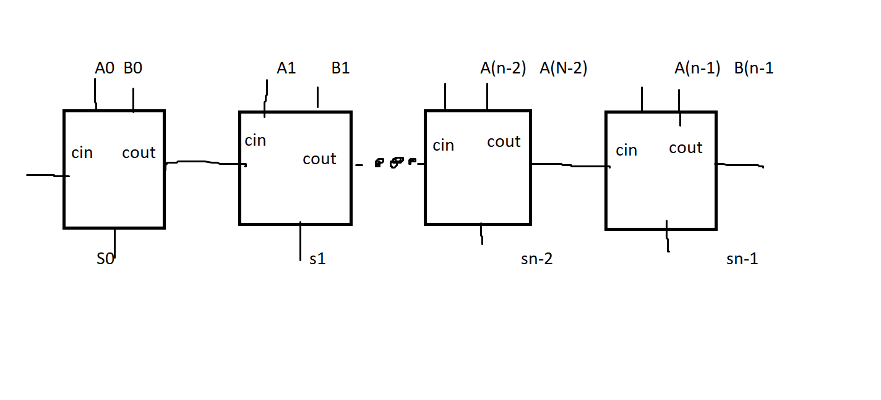

[Part 6.d] Include an annotated waveform screenshot in your write-up.
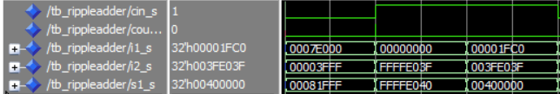

Test 1: 516096 + 16383 =532479 verified with calculator
Test 2: 0 + 4294959167 + 1 (carried in) = 4294959168 verified with calculator
Test 3: 8128 + 4186175 + 1 (carried in) = 4194304 verified with calculator
[Part 7.a] Draw a schematic (don’t use a schematic capture tool) showing how an N-bit adder/subtractor with control can be implemented using only the three main components designed in earlier parts of this lab (i.e., the N-bit inverter, N-bit 2:1 mux, and N-bit adder). How is the ‘nAdd_Sub’ bit used? Include this in your report.

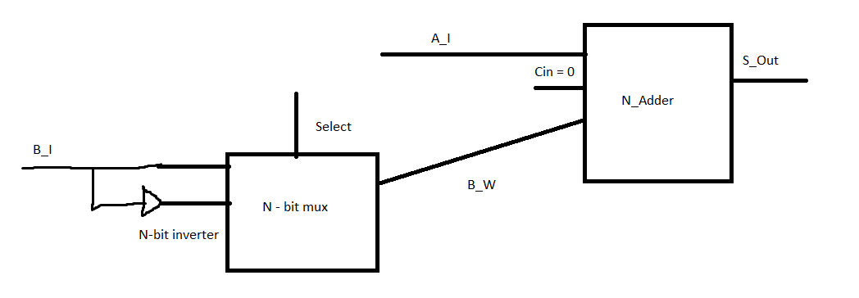
The nAdd_sub bit would be used as the select on the n_bit mux

[Part 7.c] Provide multiple waveform screenshots in your write-up to confirm that this component is working correctly. What test-cases did you include and why?

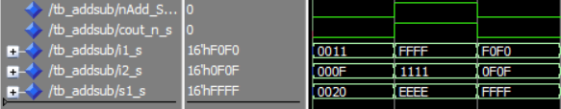

Test one: 0011 + 000F = 0020
Just a random test to see if addition work

Test 2: FFFF-1111
Random test to see if subtraction works

Test 3: F0F0 + 0F0F
Test to see if filling the bits entirely leads to any overflow.

