**TITLE**

**LAB # 2**

**SECTION # 1**

**FULL NAME: Thriambak Giriprakash**

**SUBMISSION DATE: 2/16**

**DATE: 2/15**

# Problem

Some problem.

# Analysis

Some analysis.

# Design

Some design.

# Testing

Some testing.

# Comments

Some comments.

# Screen Shots

<Number the screenshots and paste here. The point of numbering the screenshots is so that you can refer to them during your discussion in the various parts above. Alternatively, you can include the screenshots in-line with the text above as part of your discussion.>

1: 2-1

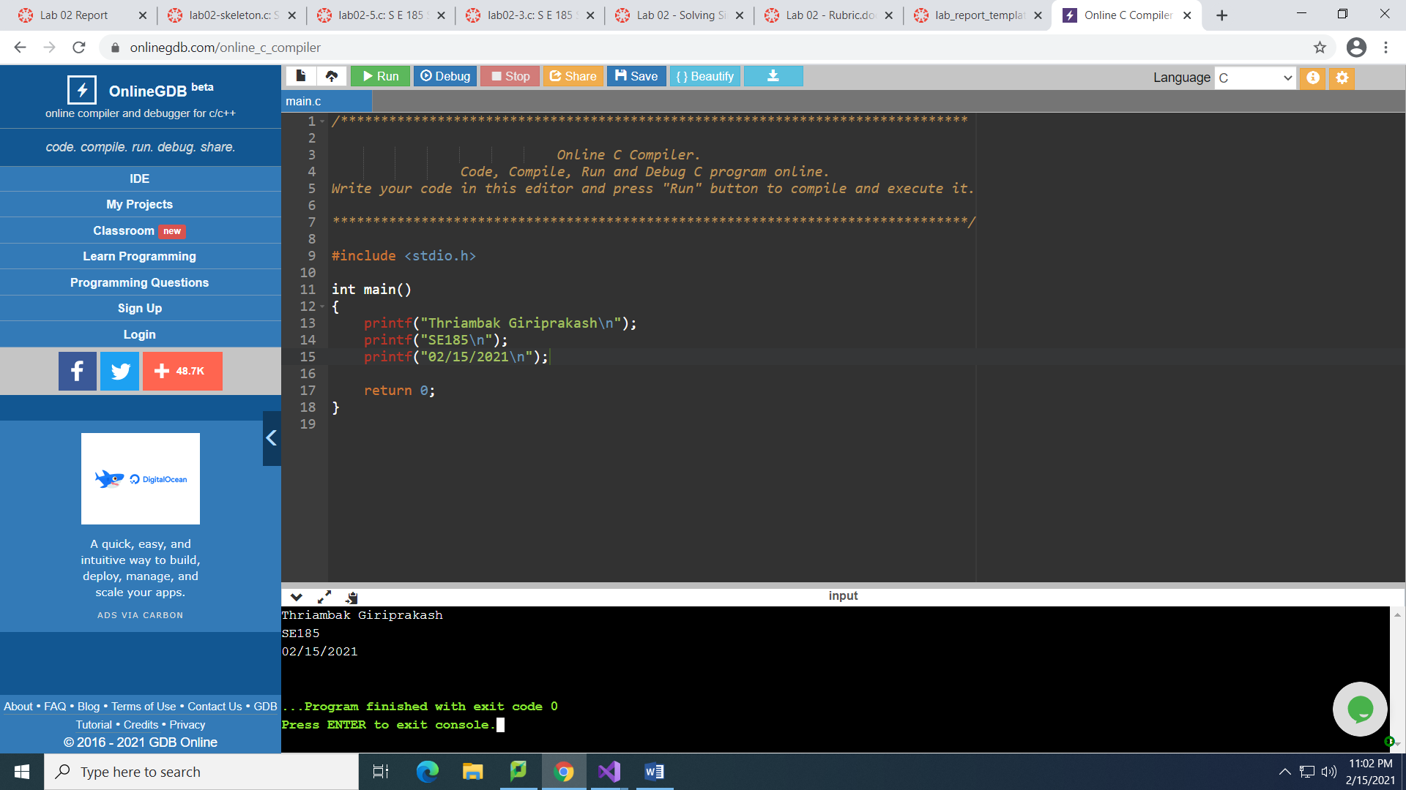

2: 2-2_1

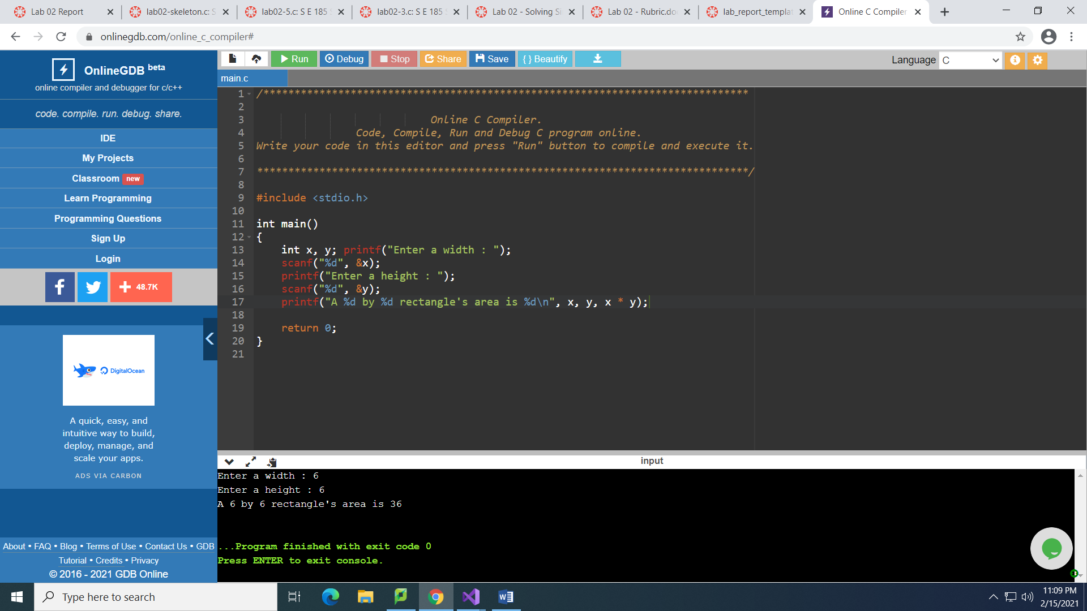

3: 2-2_2

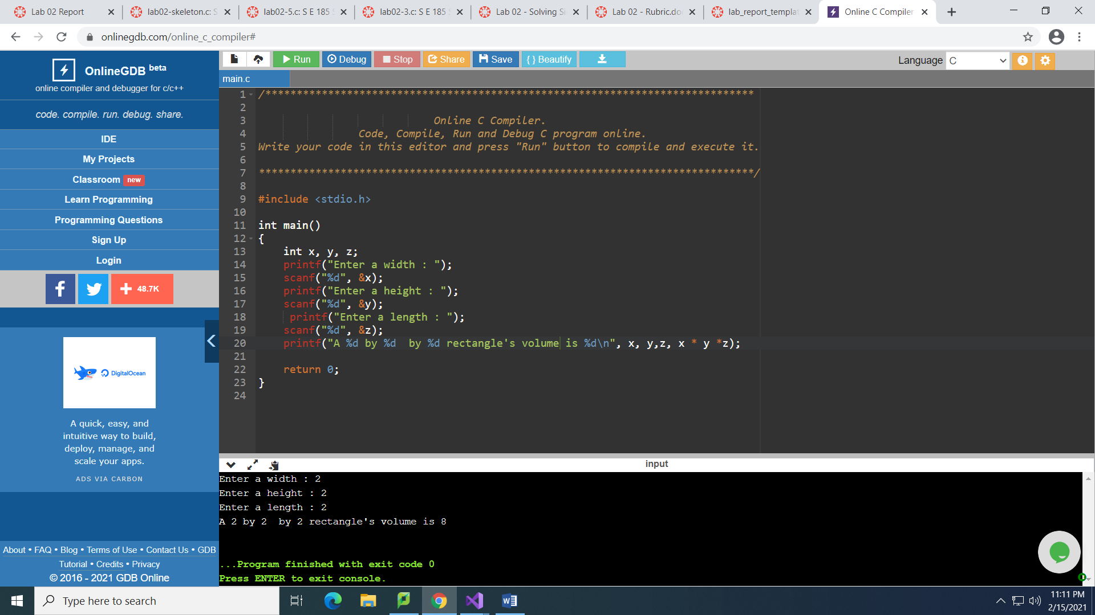

4: 2-3

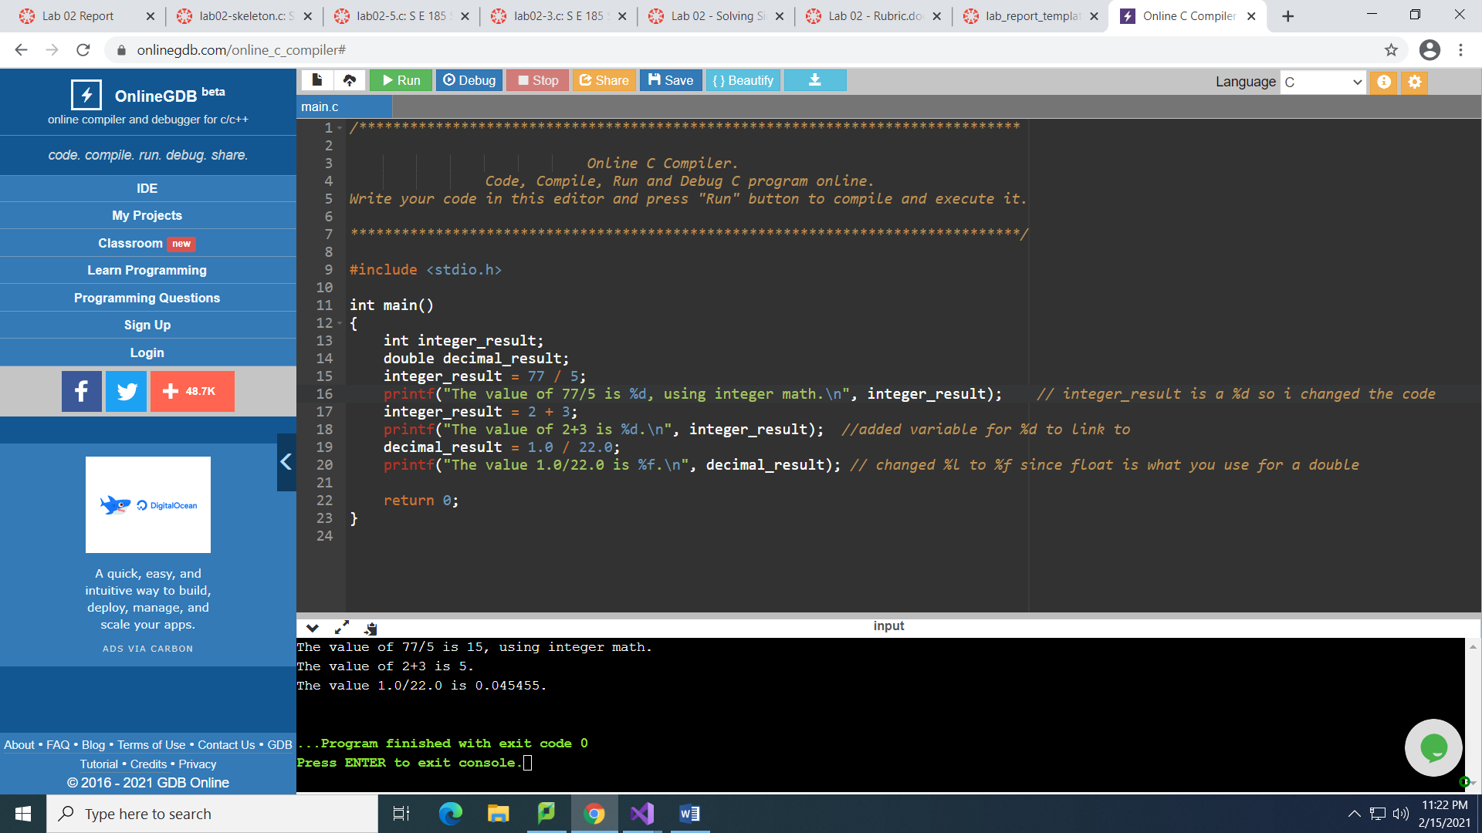

5: 2-4

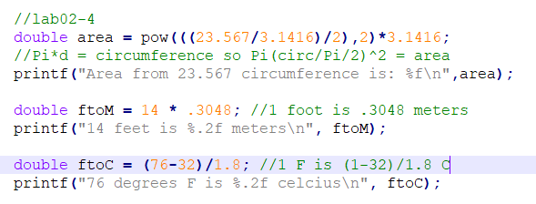

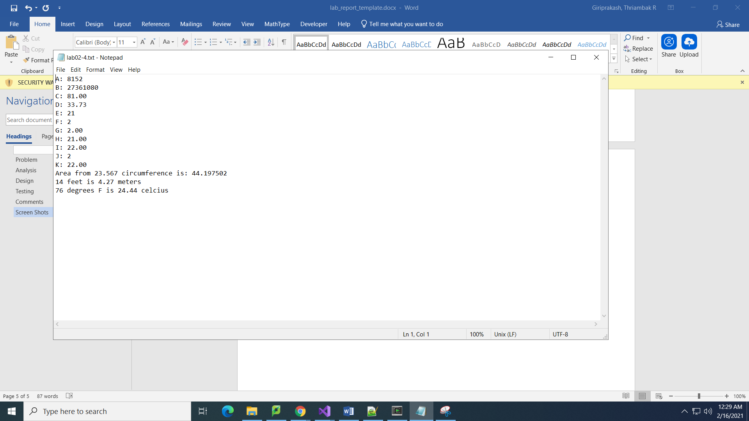

6: 2-5

