AWS VPC Networking and VPC Peering Project
Project Report | AWS Mumbai Region (ap-south-1)

Prepared by | Gubbala Thrikshan Sri Sai
College / Department | Manav Rachna University, Faridabad — B.Tech Computer Science and Engineering
Submission date | 28 October 2026

Logical Network Architecture
VPC1 (128.0.0.0/16) contains a public subnet (128.0.1.0/24) and a private subnet (128.0.2.0/24). VPC2 (28.200.0.0/16) contains a private subnet (28.200.0.0/24). An Active VPC peering connection links the VPCs.
VPC1 — Project-VPC1  128.0.0.0/16 | VPC Peering  Active | VPC2 — Project-VPC2  28.200.0.0/16
Public subnet  128.0.1.0/24  Public EC2: 128.0.1.50  Internet Gateway | pcx-00b5b32521dfdf025 | Private subnet  28.200.0.0/24  Private EC2: 28.200.0.9
Private subnet  128.0.2.0/24  Private EC2: 128.0.2.182 |  | Routes to both VPC CIDRs configured
Note: This is a logical diagram for documentation, not a live AWS topology export.

1. Abstract
This project demonstrates the creation and configuration of two Amazon Virtual Private Clouds (VPCs) in the AWS Mumbai Region. VPC1 contains a public subnet and a private subnet, while VPC2 contains a private subnet. An Internet Gateway provides internet routing for the public subnet, and VPC peering enables private-IP communication between the two VPCs. Three EC2 instances were launched to validate connectivity. The completed tests confirmed communication from the VPC1 public instance to the VPC1 private instance and to the VPC2 private instance.

2. Objectives
- Create two custom VPCs with the specified IPv4 CIDR blocks.
- Create one public subnet and two private subnets as required.
- Configure an Internet Gateway and route tables.
- Establish VPC peering between VPC1 and VPC2.
- Launch one EC2 instance in each subnet.
- Configure security-group rules and validate connectivity using ping.

3. AWS Environment
Cloud provider: Amazon Web Services (AWS)
Region: Asia Pacific (Mumbai), ap-south-1
Operating system: Amazon Linux 2023 (64-bit x86)
Instance type: t3.micro
Connectivity validation: ICMP ping between private IPv4 addresses

4. Network Design
VPC1 — Project-VPC1
CIDR: 128.0.0.0/16
Public subnet: 128.0.1.0/24
Private subnet: 128.0.2.0/24
Internet Gateway: Project-IGW
VPC2 — Project-VPC2
CIDR: 28.200.0.0/16
Private subnet: 28.200.0.0/24
Peering connection: Project-VPC1-to-VPC2-Peering (Active)

5. Resources Created
VPC1 ID: vpc-0fb996def967cdb75
VPC2 ID: vpc-0284e14e0abc0c275
VPC1 public subnet ID: subnet-0a6ba75b881e5bbb2
VPC1 private subnet ID: subnet-038793803333c3e28
VPC2 private subnet ID: subnet-0808a383824f06316
Internet Gateway ID: igw-0c43b9a91e82e56fc
VPC peering ID: pcx-00b5b32521dfdf025

6. EC2 Instances
1. VPC1-Public-EC2 — Instance ID: i-08f430cc7e44ce92c; private IPv4: 128.0.1.50; public IPv4: 52.66.252.170; subnet: VPC1-Public-Subnet.
2. VPC1-Private-EC2 — Instance ID: i-066724416cd8393ef; private IPv4: 128.0.2.182; no public IPv4; subnet: VPC1-Private-Subnet.
3. VPC2-Private-EC2 — Instance ID: i-0ce3435be53f4dd0c; private IPv4: 28.200.0.9; no public IPv4; subnet: VPC2-Private-Subnet.
All three instances were reported as running with status checks passed.

7. Routing Configuration
VPC1 public route table (VPC1-Public-RT):
- 128.0.0.0/16 → local
- 0.0.0.0/0 → Internet Gateway (igw-0c43b9a91e82e56fc)
- 28.200.0.0/16 → VPC peering connection (pcx-00b5b32521dfdf025)
VPC1 private route table (VPC1-Private-RT):
- 128.0.0.0/16 → local
- 28.200.0.0/16 → VPC peering connection (pcx-00b5b32521dfdf025)
VPC2 private route table (VPC2-Private-RT):
- 28.200.0.0/16 → local
- 128.0.0.0/16 → VPC peering connection (pcx-00b5b32521dfdf025)
The peering connection status was confirmed as Active, and the relevant routes were confirmed as Active.

8. Security Configuration
Security groups were configured to permit ICMP traffic between the required VPC CIDR ranges for connectivity testing. The public instance security group also includes SSH access from the administrator’s IP address and the AWS-managed EC2 Instance Connect prefix list used to open the browser-based terminal. The VPC1 and VPC2 private instance security groups include ICMP rules for the VPC CIDR ranges involved in the ping tests.

9. Connectivity Tests and Results
Test 1 — VPC1 public EC2 (128.0.1.50) to VPC1 private EC2 (128.0.2.182): SUCCESS. The ping output showed 4 packets transmitted, 4 received, and 0% packet loss (see Figure 15).
Test 2 — VPC1 public EC2 (128.0.1.50) to VPC2 private EC2 (28.200.0.9): SUCCESS. The ping output showed 4 packets transmitted, 4 received, and 0% packet loss (see Figure 15).
Test 3 — VPC2 private EC2 (28.200.0.9) to VPC1: NOT PERFORMED. The VPC2 instance has no public IPv4 address and Session Manager access was not configured, so a ping could not be initiated from it. The reverse-direction route and ICMP rules are in place; this test is noted as future work.

10. Conclusion
The project successfully demonstrates custom VPC creation, public and private subnet configuration, Internet Gateway routing, VPC peering, route-table configuration, security-group configuration, and ICMP connectivity tests across subnets and VPCs. Both ping tests completed successfully with zero packet loss. The reverse-direction test from the VPC2 private instance was not performed and is noted as future work.

11. Screenshots (Proof of Implementation)
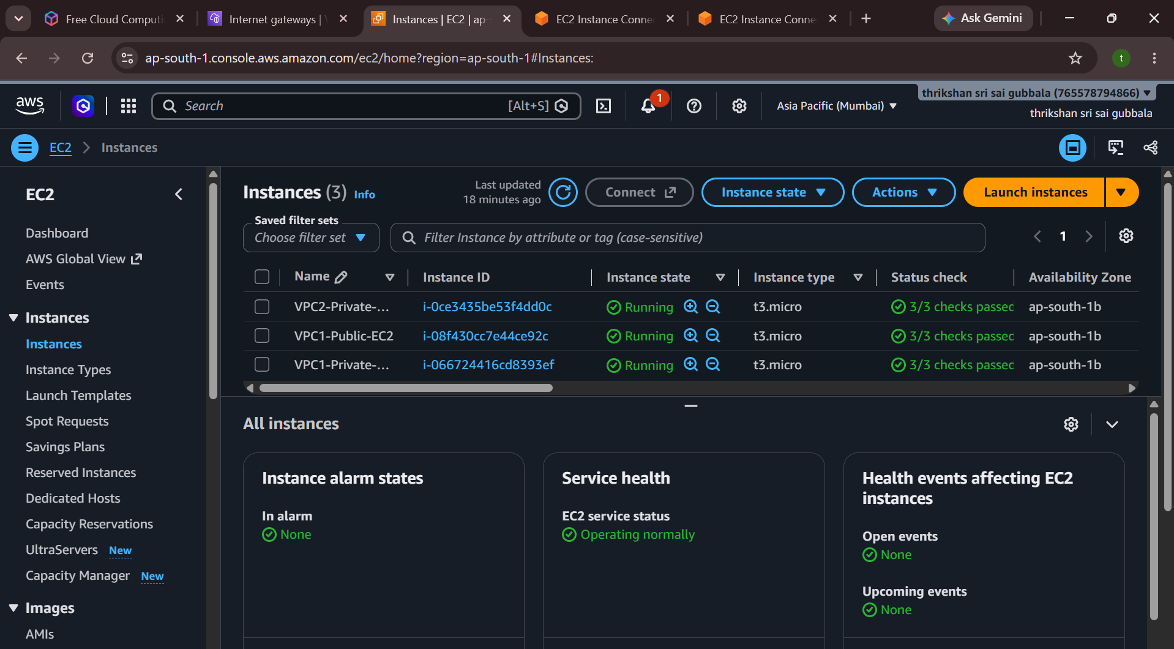
Figure 1: EC2 instances (VPC1-Public-EC2, VPC1-Private-EC2, VPC2-Private-EC2) running with status checks passed
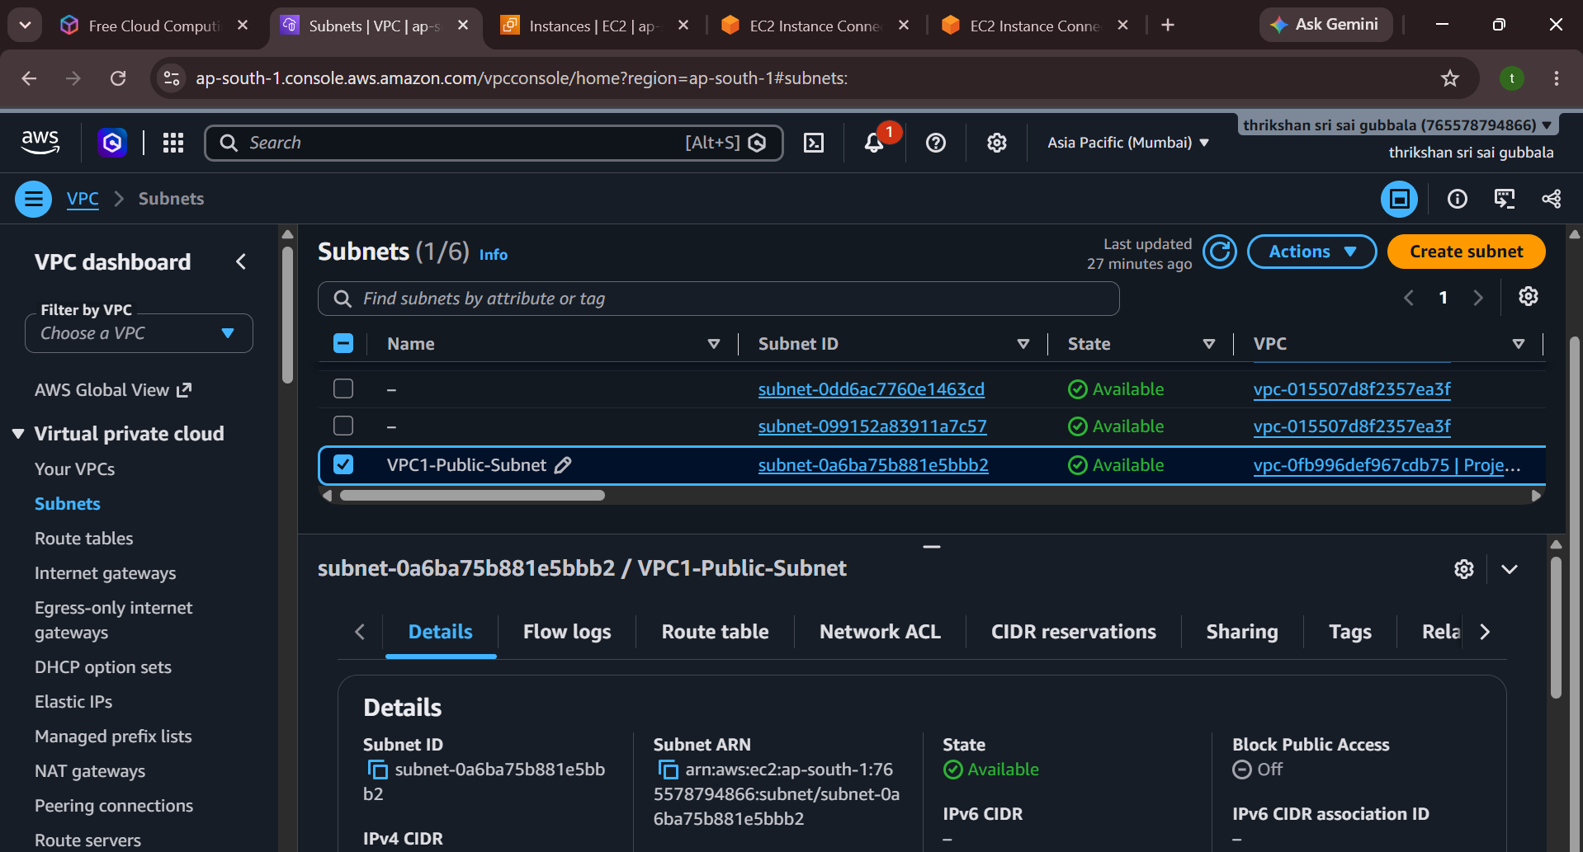
Figure 2: VPC1 public subnet (VPC1-Public-Subnet) details
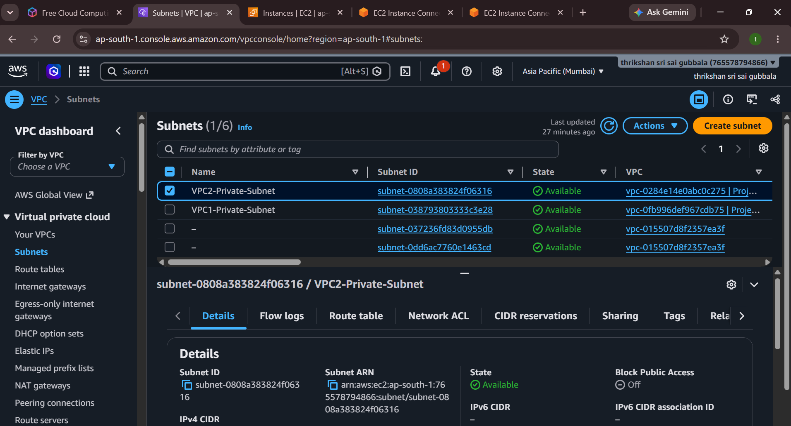
Figure 3: VPC2 private subnet (VPC2-Private-Subnet) details
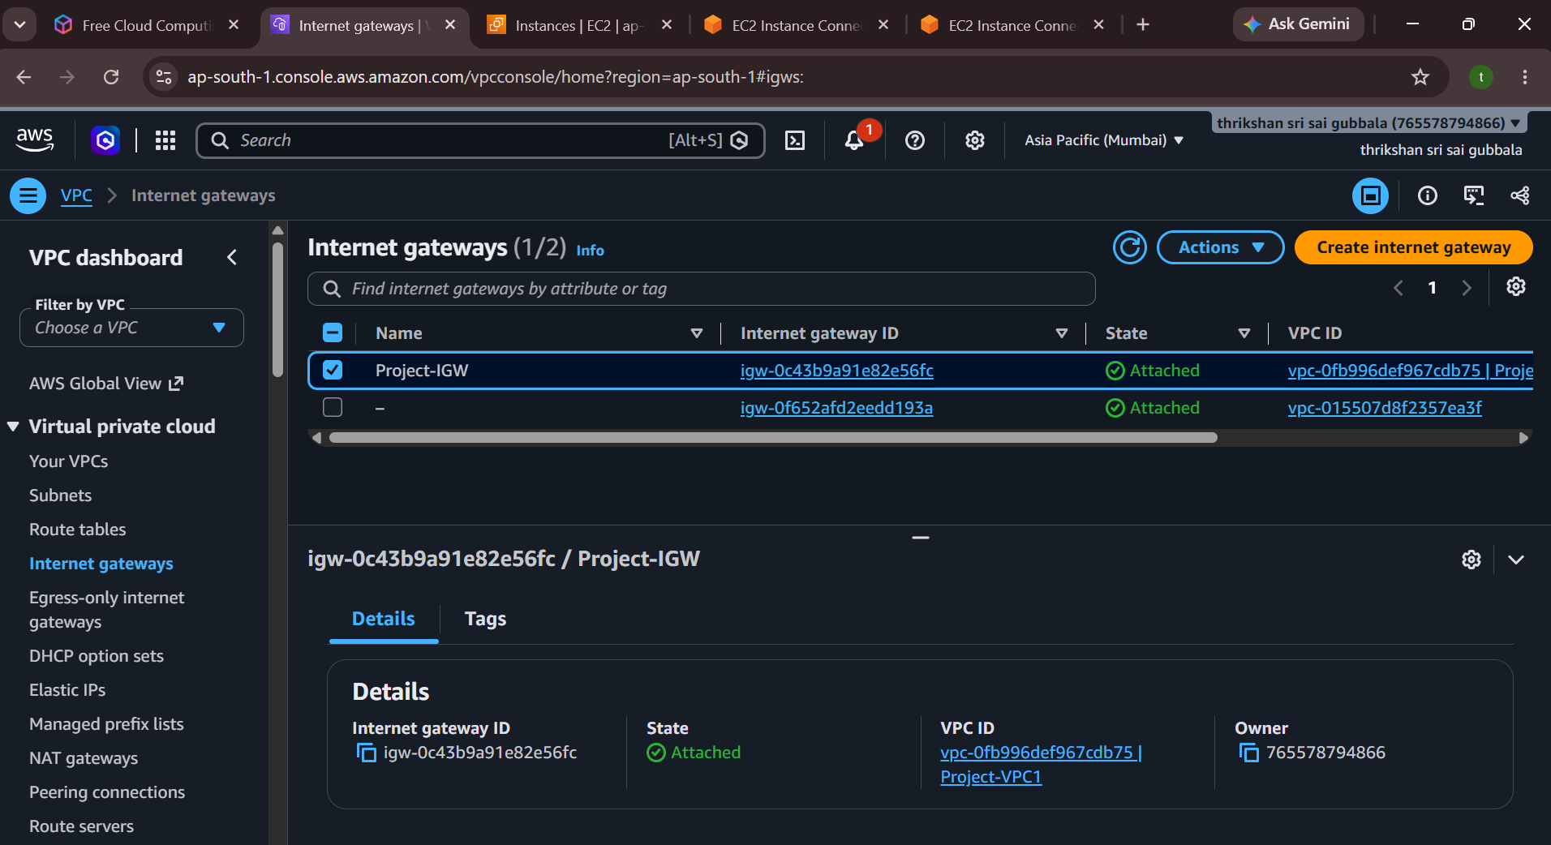
Figure 4: Internet Gateway (Project-IGW) attached to Project-VPC1
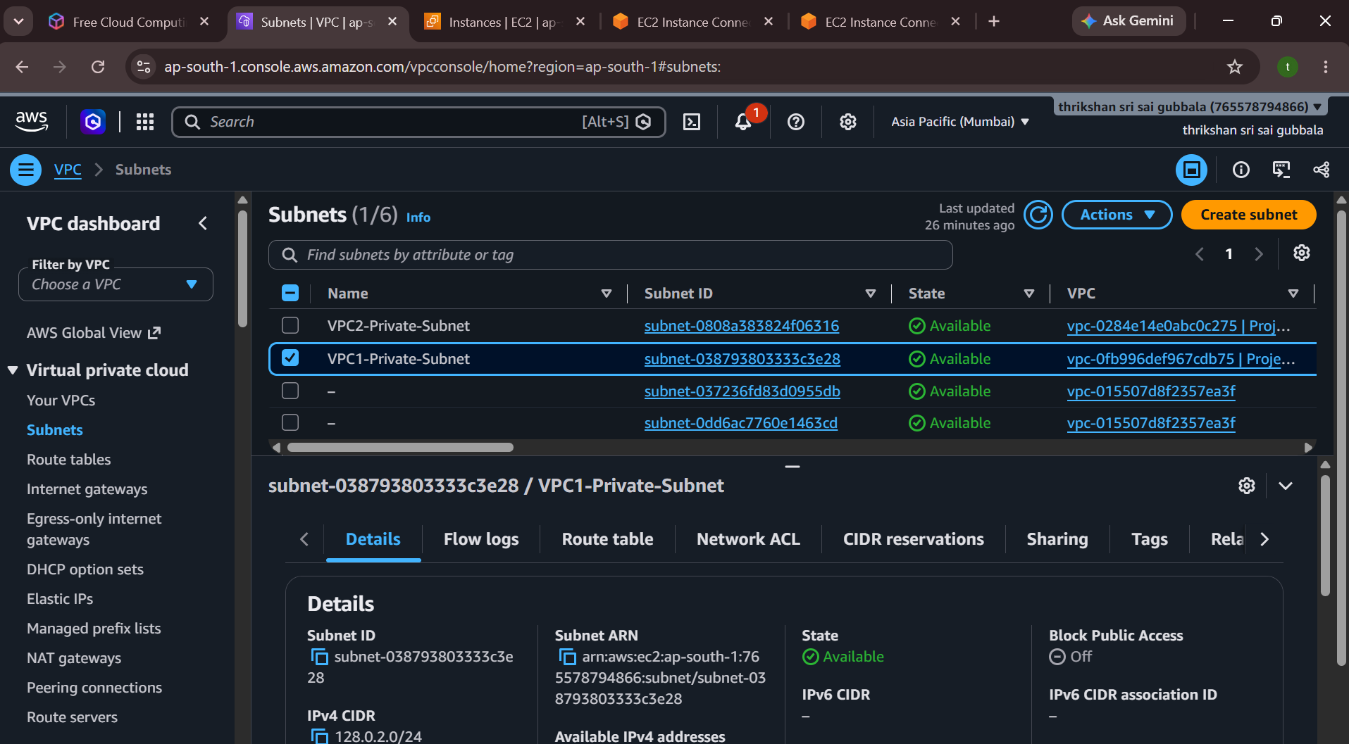
Figure 5: VPC1 private subnet (VPC1-Private-Subnet) details
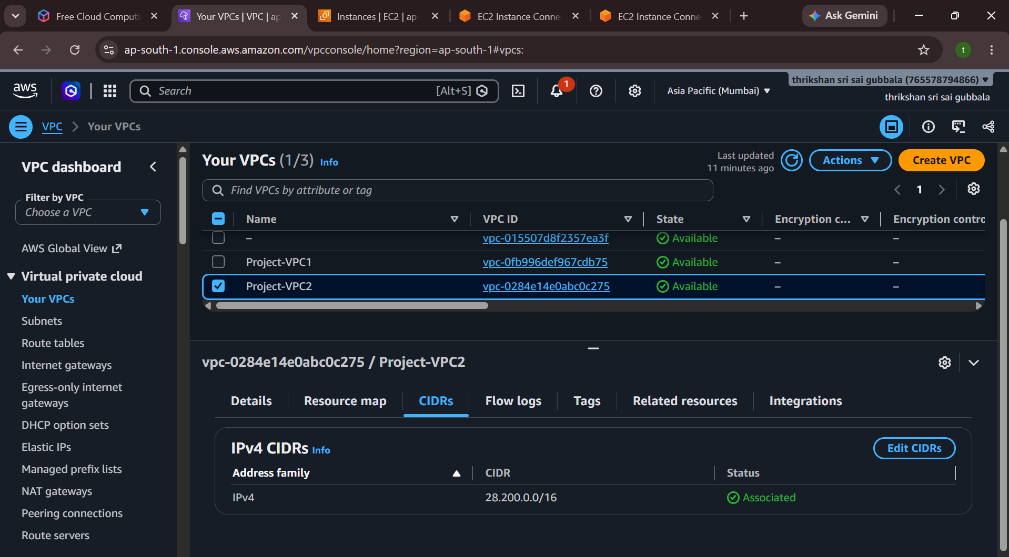
Figure 6: Project-VPC2 IPv4 CIDR block (28.200.0.0/16)
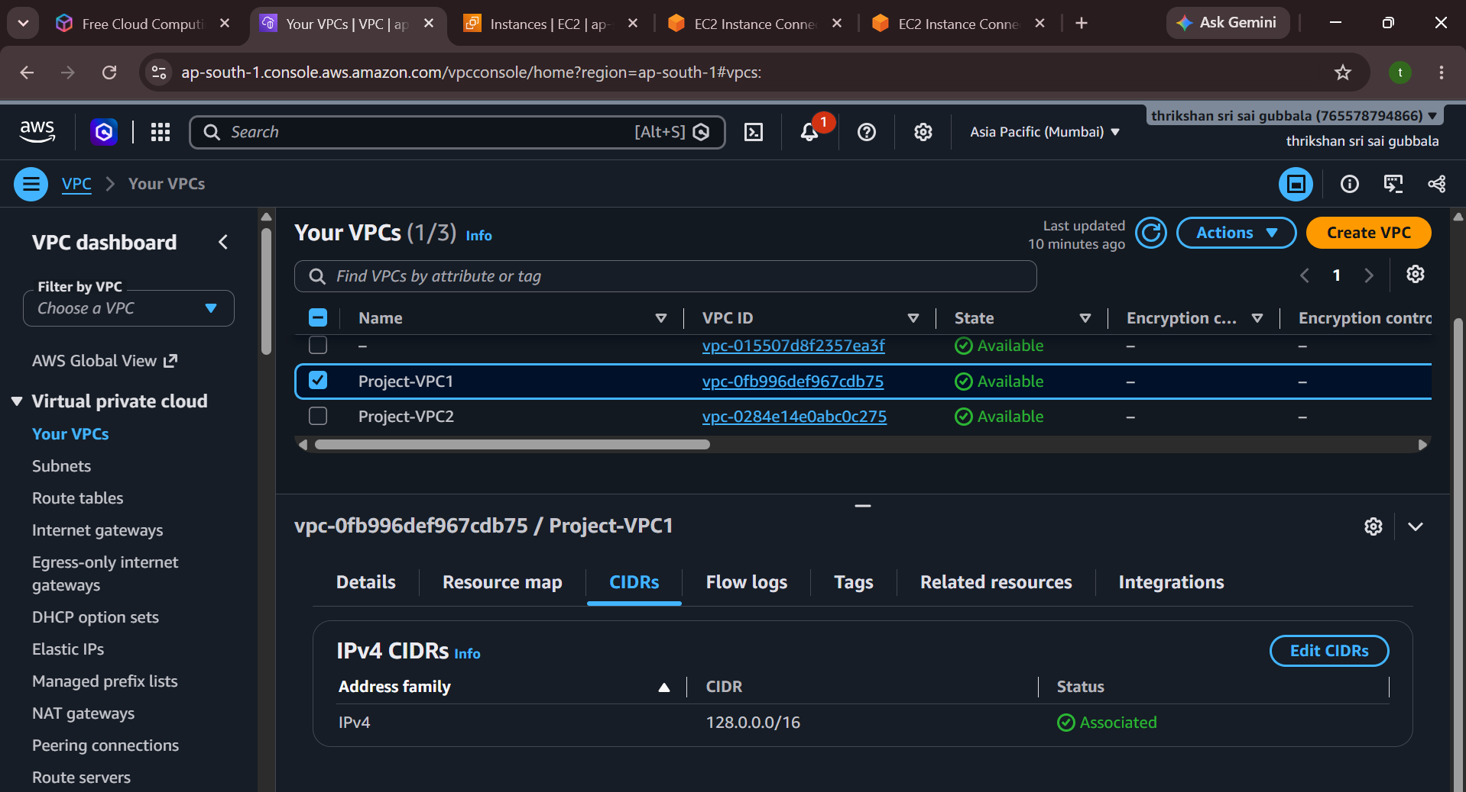
Figure 7: Project-VPC1 IPv4 CIDR block (128.0.0.0/16)
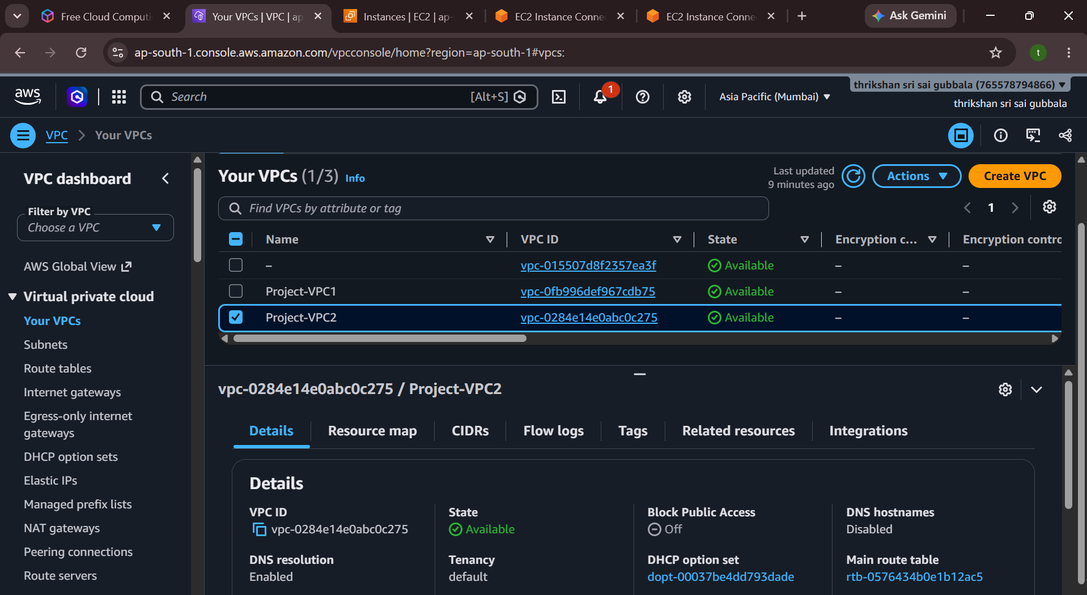
Figure 8: Project-VPC2 details
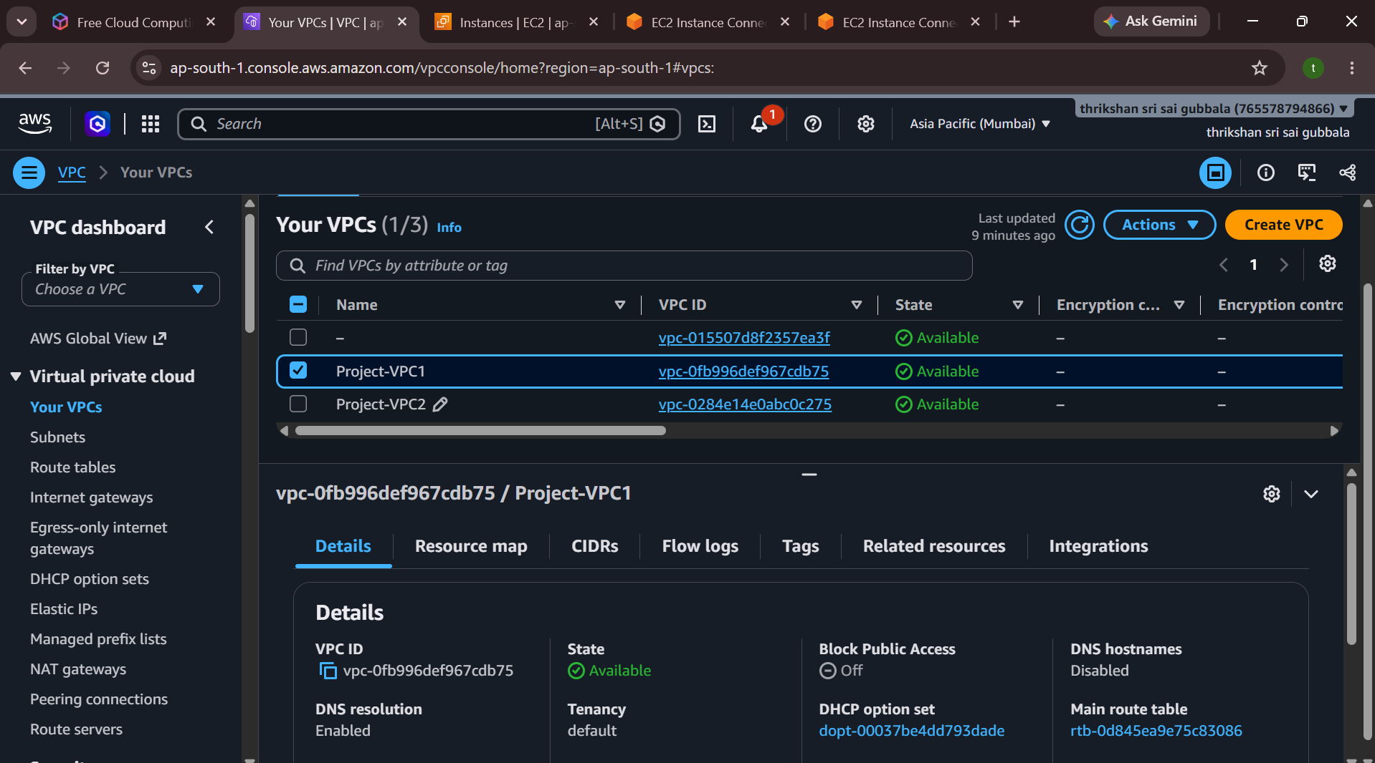
Figure 9: Project-VPC1 details
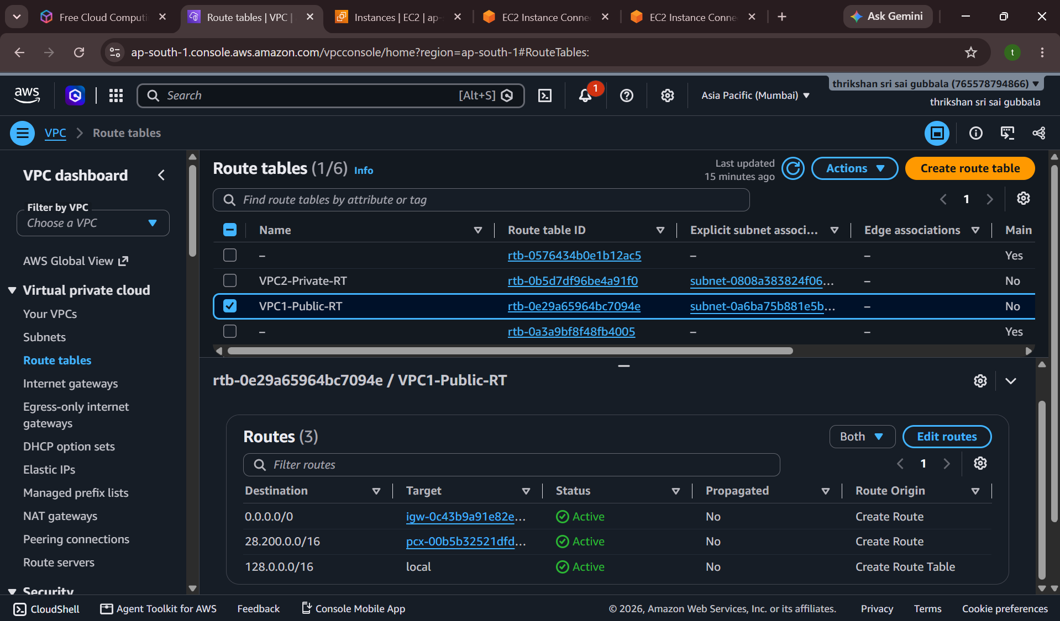
Figure 10: VPC1-Public-RT route table (local, Internet Gateway and peering routes)
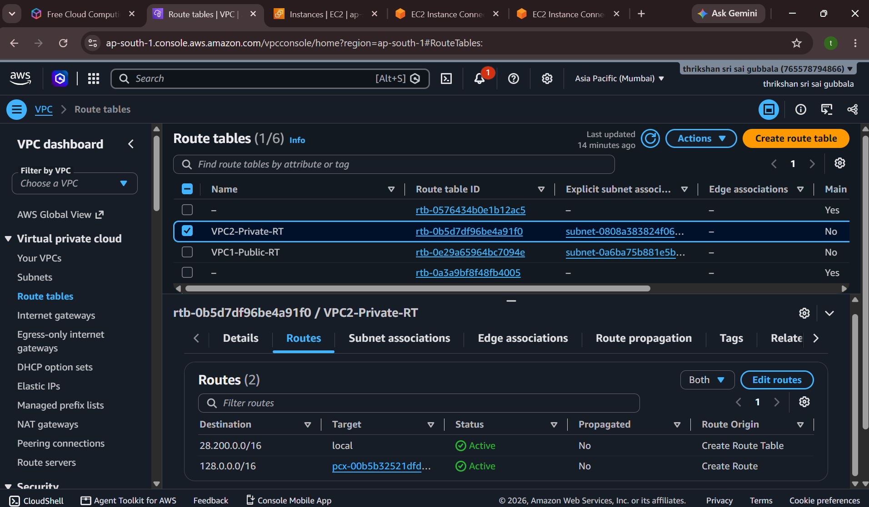
Figure 11: VPC2-Private-RT route table (local and peering routes)
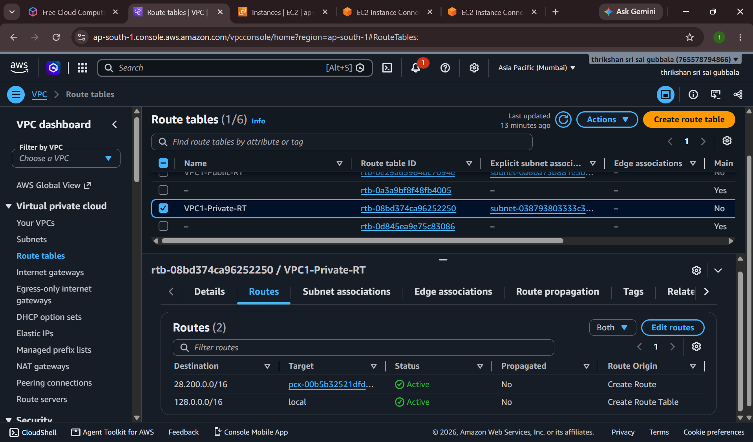
Figure 12: VPC1-Private-RT route table (local and peering routes)
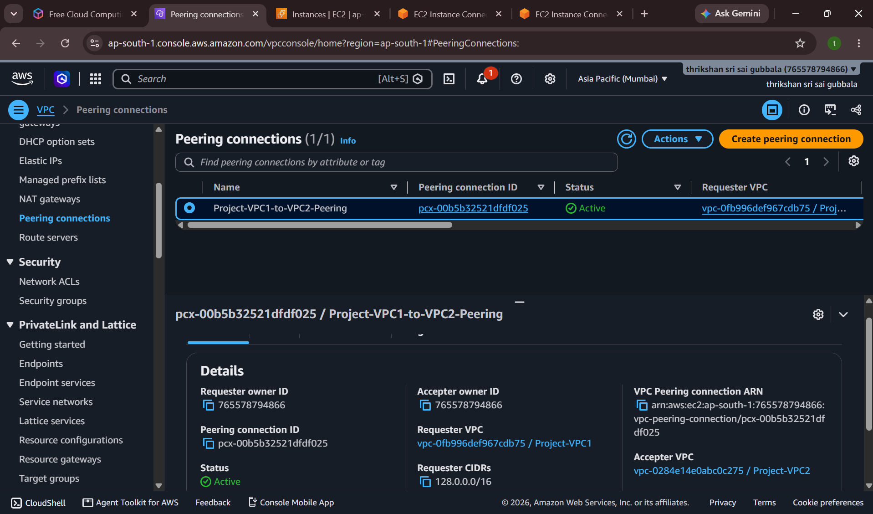
Figure 13: VPC peering connection Project-VPC1-to-VPC2-Peering in Active state
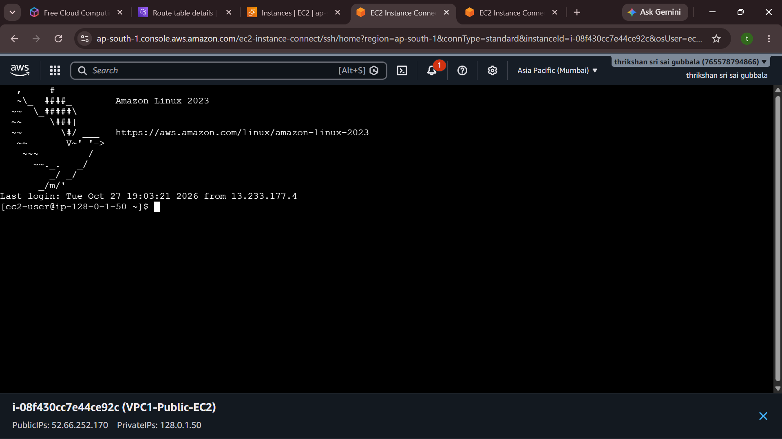
Figure 14: EC2 Instance Connect session on VPC1-Public-EC2
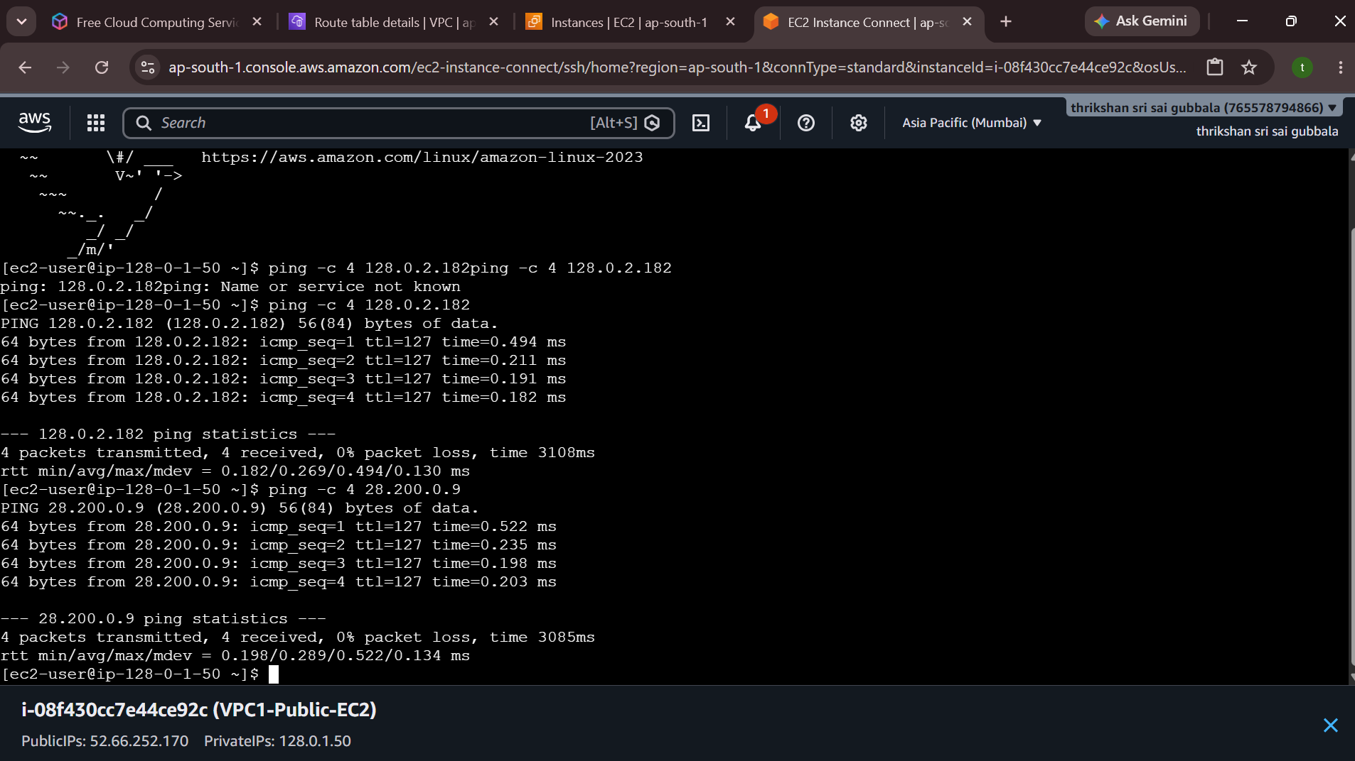
Figure 15: Ping from VPC1 public EC2 to VPC1 private EC2 and VPC2 private EC2
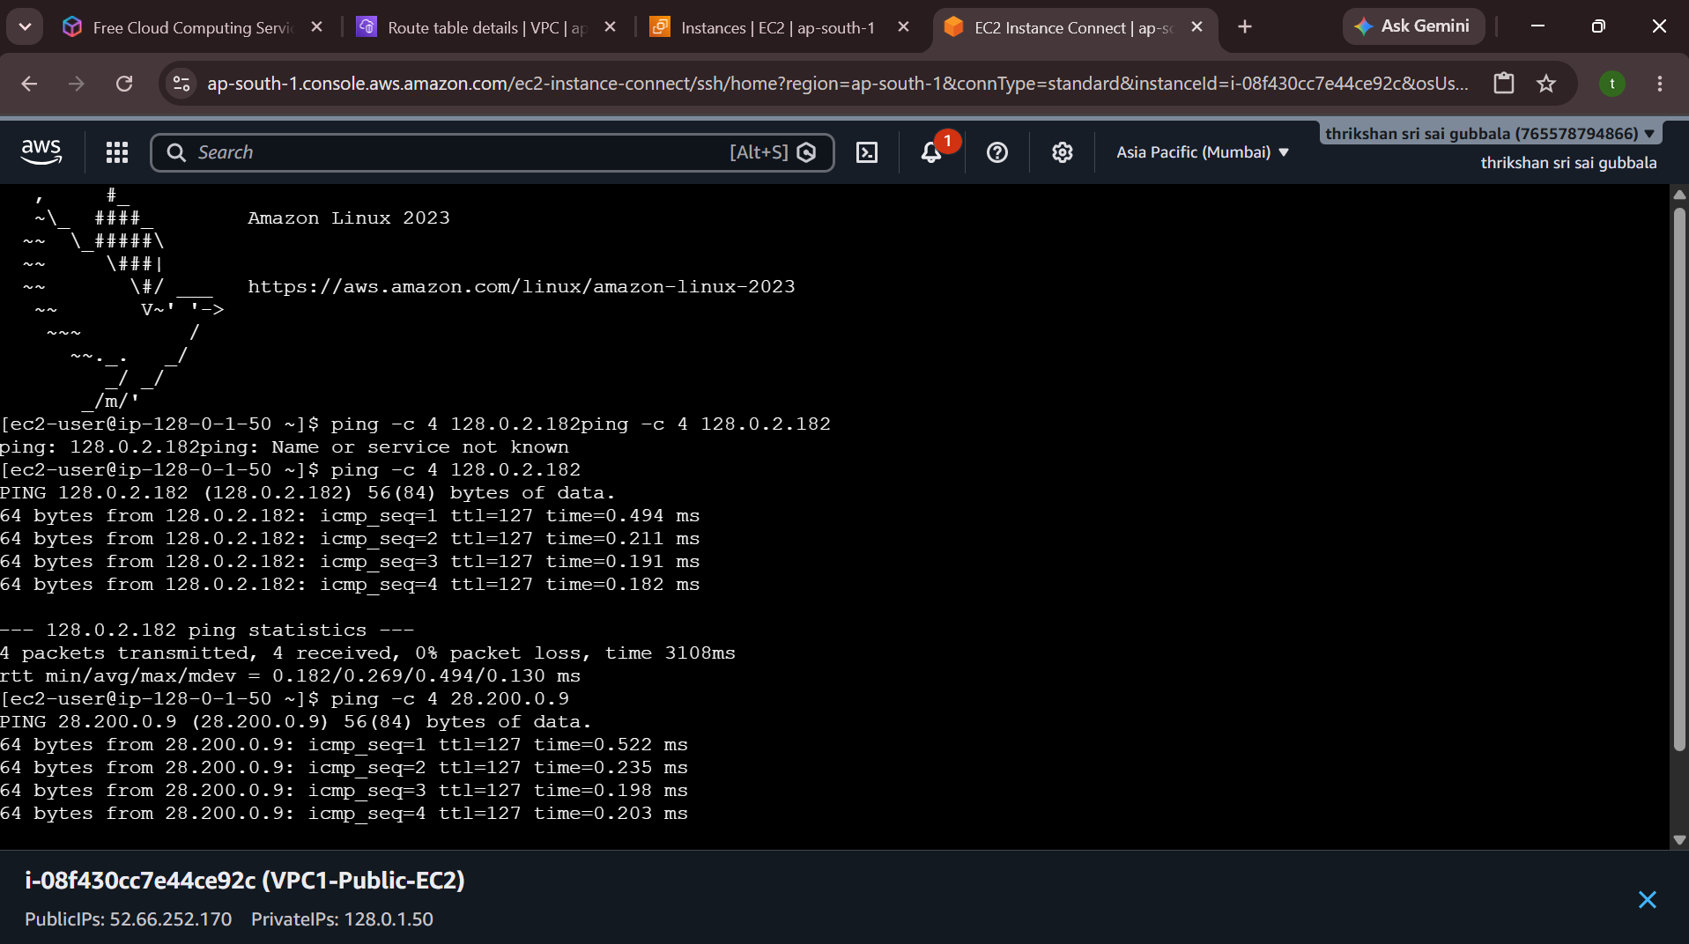
Figure 16: Ping test output (full terminal view)

