Week 3: Logistics Data Exploration and Visualization
Prepared using the simulated Week 2 logistics dataset
Repository: https://github.com/thrisha-reddy880/logistics-data-analytics
Dataset: week2/logistics_data_raw.csv

1. Introduction and objectives
This project explores delivery performance and shipping cost patterns using the Week 2 simulated logistics dataset. The goals are to understand delivery-time distribution, compare shipping modes, inspect the relationship between distance and freight cost, summarize recorded delivery statuses, and document data-quality issues before drawing operational recommendations.

2. Dataset overview
The raw file contains 62 rows and nine fields: Order_ID, Order_Date, Delivery_Days, Shipping_Mode, Distance_km, Freight_Cost, Quantity, Customer_Segment, and Delivery_Status. After removing 2 duplicate Order_ID rows, 60 unique orders remain. This is a small simulated dataset, so patterns should be treated as illustrative and not generalized to all logistics operations.

3. Methodology and data preparation
- Loaded the CSV using pandas and parsed order dates as dates.
- Removed duplicate Order_ID records by retaining the first occurrence.
- Trimmed extra whitespace and standardized capitalization in category labels.
- Converted delivery days, distance, freight cost, and quantity to numeric values.
- Changed non-positive delivery days, distance, and freight cost to missing values because they are invalid physical measurements.
- Used the interquartile-range (IQR) rule to flag unusual delivery times, distances, and freight costs. Outliers remain in the data with flags to preserve traceability.
- Exported cleaned data, descriptive statistics, shipping-mode summaries, status counts, correlation values, missing-value counts, and a JSON summary.
Missing values are not automatically imputed. Imputation could distort a small dataset, and each missing field needs domain-aware review. The status categories are preserved as recorded: Delivered, On Time, Late, and In Transit are not assumed to be interchangeable.

4. Descriptive statistics
Delivery days: valid count = 58, mean = 8.76, median = 7.50, standard deviation = 9.34, minimum = 2.00, maximum = 75.00.
Freight cost: valid count = 59, mean = 3366.82, median = 2680.90, minimum = 620.80, maximum = 35000.00. The unusually high freight-cost observation should be checked against the source rather than accepted uncritically.
Delivery status counts: Delivered: 18; On Time: 18; Late: 16; In Transit: 8.
IQR outlier flags: Delivery_Days: 1; Distance_km: 0; Freight_Cost: 1.

5. Visualizations and interpretation

Figure 1. Delivery-time distribution
A histogram shows the shape and spread of recorded delivery durations. It helps identify clustering, skew, and unusually long deliveries. Invalid non-positive values are missing, while long durations are retained and flagged.
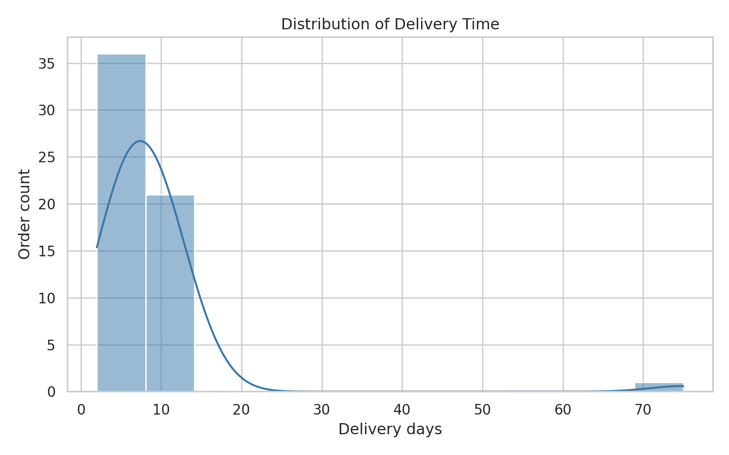

Figure 2. Average freight cost by shipping mode
A bar chart makes mode-level average freight costs easy to compare. Differences may reflect distance, service type, order mix, or unusual costs; they should not be interpreted as the causal effect of shipping mode.
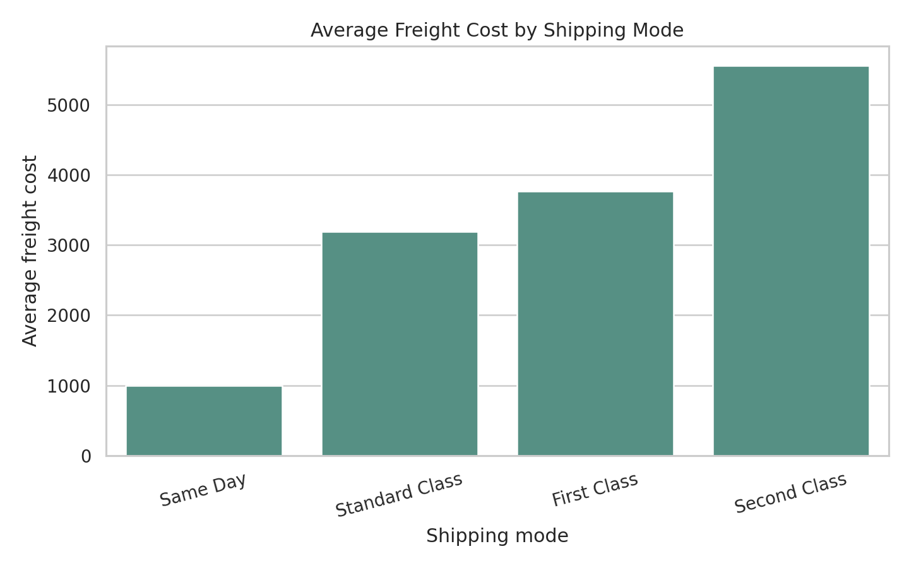

Figure 3. Delivery-time spread by shipping mode
A box plot compares medians and variability across modes and makes potential outliers visible. Mode-level conclusions are tentative because the sample is small and modes may have different route profiles.
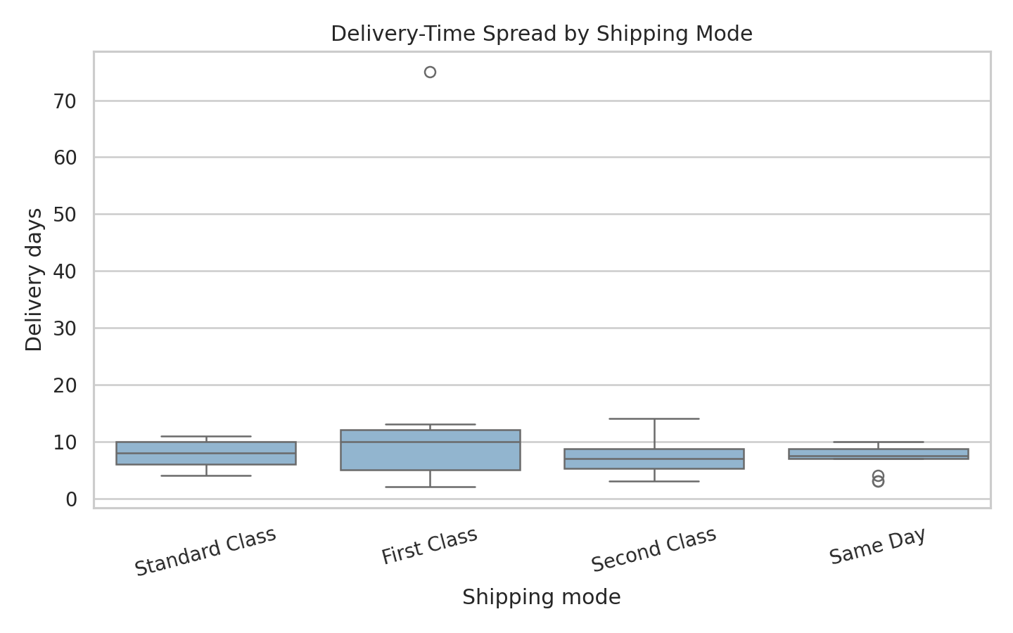

Figure 4. Distance versus freight cost
A scatter plot shows whether longer routes tend to have higher freight costs and reveals unusual points. Freight charges may also depend on service level, quantity, and surcharges, so distance alone may not explain all variation.
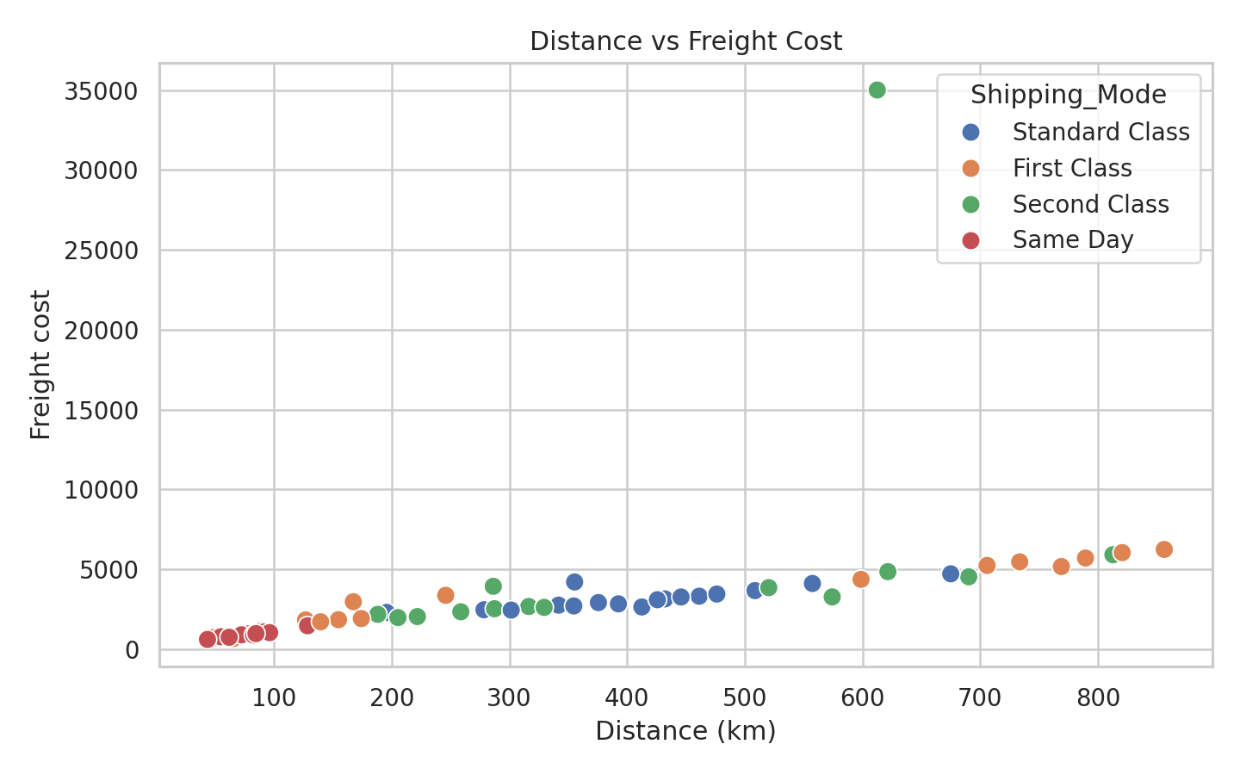

Figure 5. Recorded delivery status counts
A count plot shows the operational mix of the status labels. The categories should be clarified with a formal status definition before calculating an on-time delivery rate.
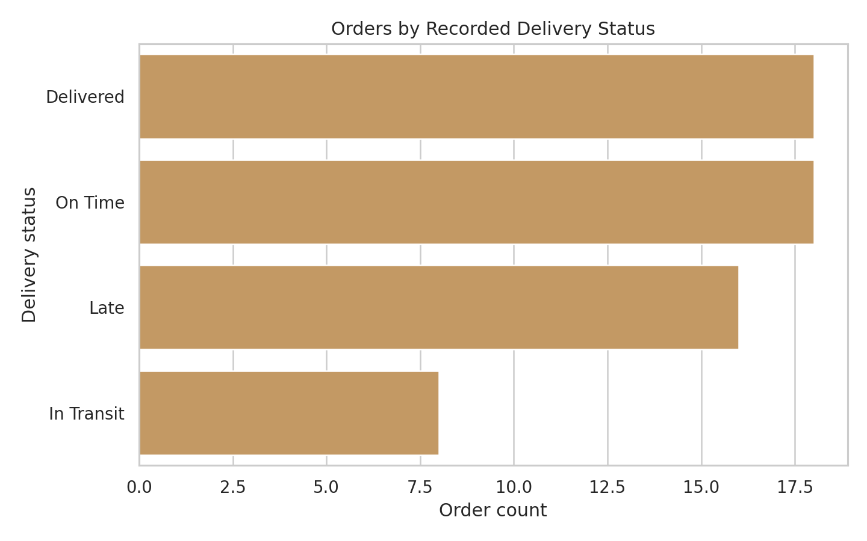

Figure 6. Correlation heatmap
A heatmap summarizes pairwise linear correlations among delivery days, distance, freight cost, and quantity. Correlation indicates association, not causation, and can be sensitive to outliers and missing values.
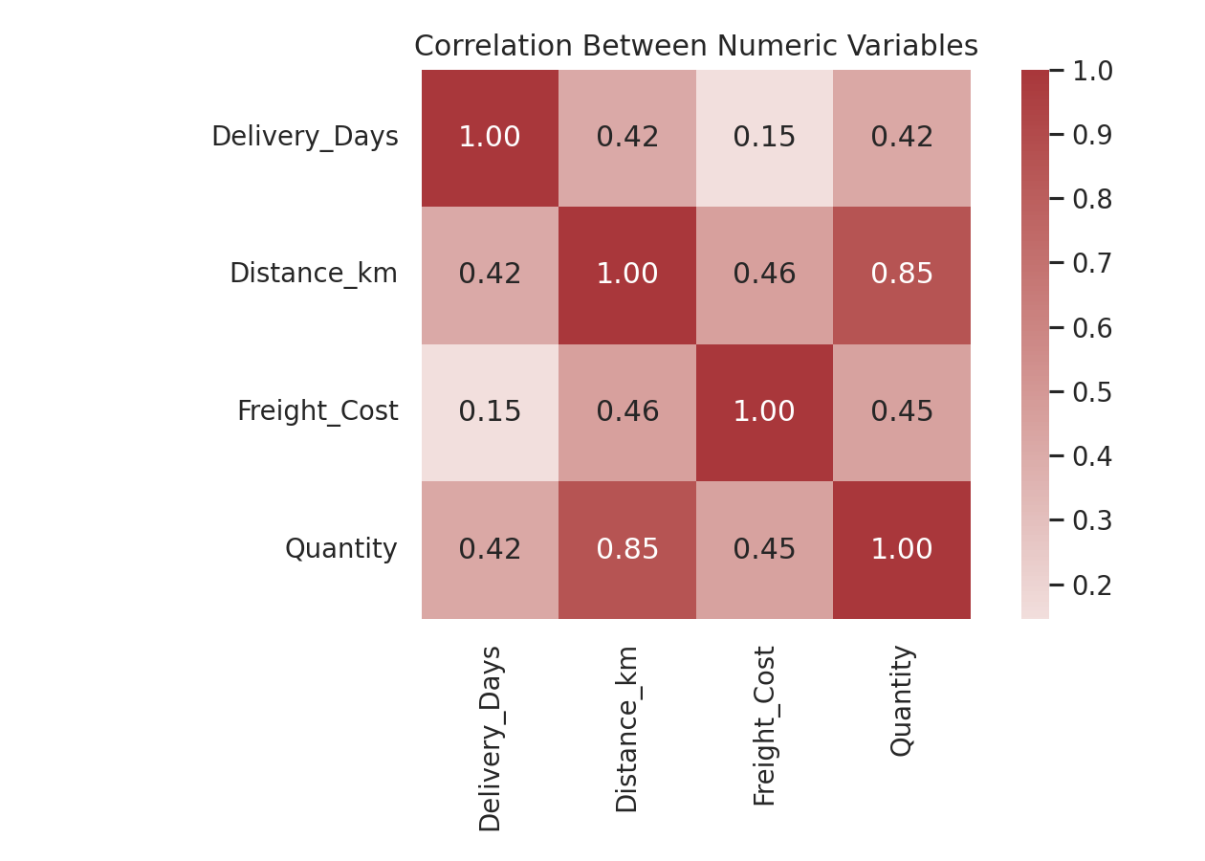

6. Key findings and operational implications
The valid delivery-day mean (8.76) and median (7.50) should be read together: a gap can indicate skew or influence from extreme observations. The maximum duration is especially important to verify against source records because a very long delivery can materially affect the mean.
The freight-cost distribution contains a potentially extreme charge. Review the source invoice or rate card before using it in budgets. Compare mode-level costs alongside distance and quantity so that a mode is not judged unfairly because it serves longer or larger shipments.
Data quality is a primary finding: missing delivery time, distance, and freight cost reduce the amount of evidence available for comparisons. The duplicate records and inconsistent mode labels also show why data validation should precede dashboards or performance reporting.

7. Recommendations
- Introduce validation rules at data entry: delivery days, route distance, and freight charges should be positive, with exceptions routed for review.
- Enforce a unique order identifier or a documented rule for multiple shipment events so duplicate records are not mistaken for separate orders.
- Standardize shipping-mode and status labels with controlled values and a data dictionary.
- Investigate flagged high-cost and long-duration orders against invoices, route records, and carrier notes before removing or correcting them.
- Track promised delivery dates and calculate on-time performance from a clearly defined service-level rule rather than from ambiguous status labels.
- Expand the dataset and include carrier, origin/destination, fuel surcharge, package weight, and promised delivery date to separate cost drivers more reliably.

8. Limitations
The dataset is simulated and contains only 60 distinct orders. Missing values, outliers, and limited operational context constrain inference. This report therefore presents descriptive exploration, not a predictive model or a causal evaluation. Results should be validated on a larger real-world dataset.

9. Reproducibility and code
Run `python -m pip install -r requirements.txt`, then `python src/logistics_analysis.py`. The script regenerates the cleaned CSV, summary tables, JSON summary, and six figures under outputs/.
Core analysis excerpt:
df = raw.drop_duplicates(subset=["Order_ID"], keep="first").copy()
df["Shipping_Mode"] = (
df["Shipping_Mode"].astype("string").str.strip()
.str.replace(r"\s+", " ", regex=True).str.title()
)
df.loc[df["Delivery_Days"] <= 0, "Delivery_Days"] = float("nan")

10. References
Pandas documentation, Working with missing data: https://pandas.pydata.org/docs/user_guide/missing_data.html
Pandas documentation, Visualization: https://pandas.pydata.org/docs/user_guide/visualization.html
Seaborn documentation: https://seaborn.pydata.org/

