EXP NO : 2

AIM:

To simulate a non-deterministic finite automata using c compiler.

ALGORITHM:

1.get the input from the user

2.get 3d matrix to store transition table and initialize the values

4.find the length of the input string and the string

5.refer transition table for each of the entry

6.when we reach out final state out input is accepted otherwise no.

PROGRAM:

#include<string.h>

int main()

{

int i,j,k,l,m,next_state[20],n,mat[10][10][10],flag,p;

int num_states,final_state[5],num_symbols,num_final;

int present_state[20],prev_trans,new_trans;

char ch,input[20];

int symbol[5],inp,inp1;

printf("How many states in the NFA : ");

scanf("%d",&num_states);

printf("How many symbols in the input alphabet : ");

scanf("%d",&num_symbols);

for(i=0;i<num_s

ymbols;i++)

{

printf("Enter the input symbol %d : ",i+1);

scanf("%d",&symbol[i]);

}

printf("How many final states : ");

scanf("%d",&num_final);

for(i=0;i<num_final;i++)

{

printf("Enter the final state %d : ",i+1);

scanf("%d",&final_state[i]);

}

for(i=0;i<10;i++)

{

for(j=0;j<10;j++)

{

for(k=0;k<10;k++)

{

mat[i][j][k]=-1;

}

}

}

for(i=0;i<num_states;i++)

{

for(j=0;j<num_symbols;j++)

{

printf("How many transitions from state %d for the input %d : ",i,symbol[j]);

scanf("%d",&n);

for(k=0;k<n;k++)

{

printf("Enter the transition %d from state %d for the input %d : ",k+1,i,symbol[j]);

scanf("%d",&mat[i][j][k]);

}

}

}

printf("The transitions are stored as shown below\n");

for(i=0;i<10;i++)

{

for(j=0;j<10;j++)

{

for(k=0;k<10;k++)

{

if(mat[i][j][k]!=-1)

printf("mat[%d][%d][%d] = %d\n",i,j,k,mat[i][j][k]);

}

}

}

while(1)

{

printf("Enter the input string : ");

scanf("%s",input);

present_state[0]=0;

prev_trans=1;

l=strlen(input);

for(i=0;i<l;i++)

{

if(input[i]=='0')

inp1=0;

else if(input[i]=='1')

inp1=1;

else

{

printf("Invalid input\n");

exit(0);

}

for(m=0;m<num_symbols;m++)

{

if(inp1==symbol[m])

{

inp=m;

break;

}

}

new_trans=0;

for(j=0;j<prev_trans;j++)

{

k=0;

p=present_state[j];

while(mat[p][inp][k]!=-1)

{

next_state[new_trans++]=mat[p][inp][k];

k++;

}

}

for(j=0;j<new_trans;j++)

{

present_state[j]=next_state[j];

}

prev_trans=new_trans;

}

flag=0;

for(i=0;i<prev_trans;i++)

{

for(j=0;j<num_final;j++)

{

if(present_state[i]==final_state[j])

{

flag=1;

break;

}

}

}

if(flag==1)

printf("Accepted\n");

else

printf("Not accepted\n");

printf("Try with another input\n");

}

}

OUTPUT:

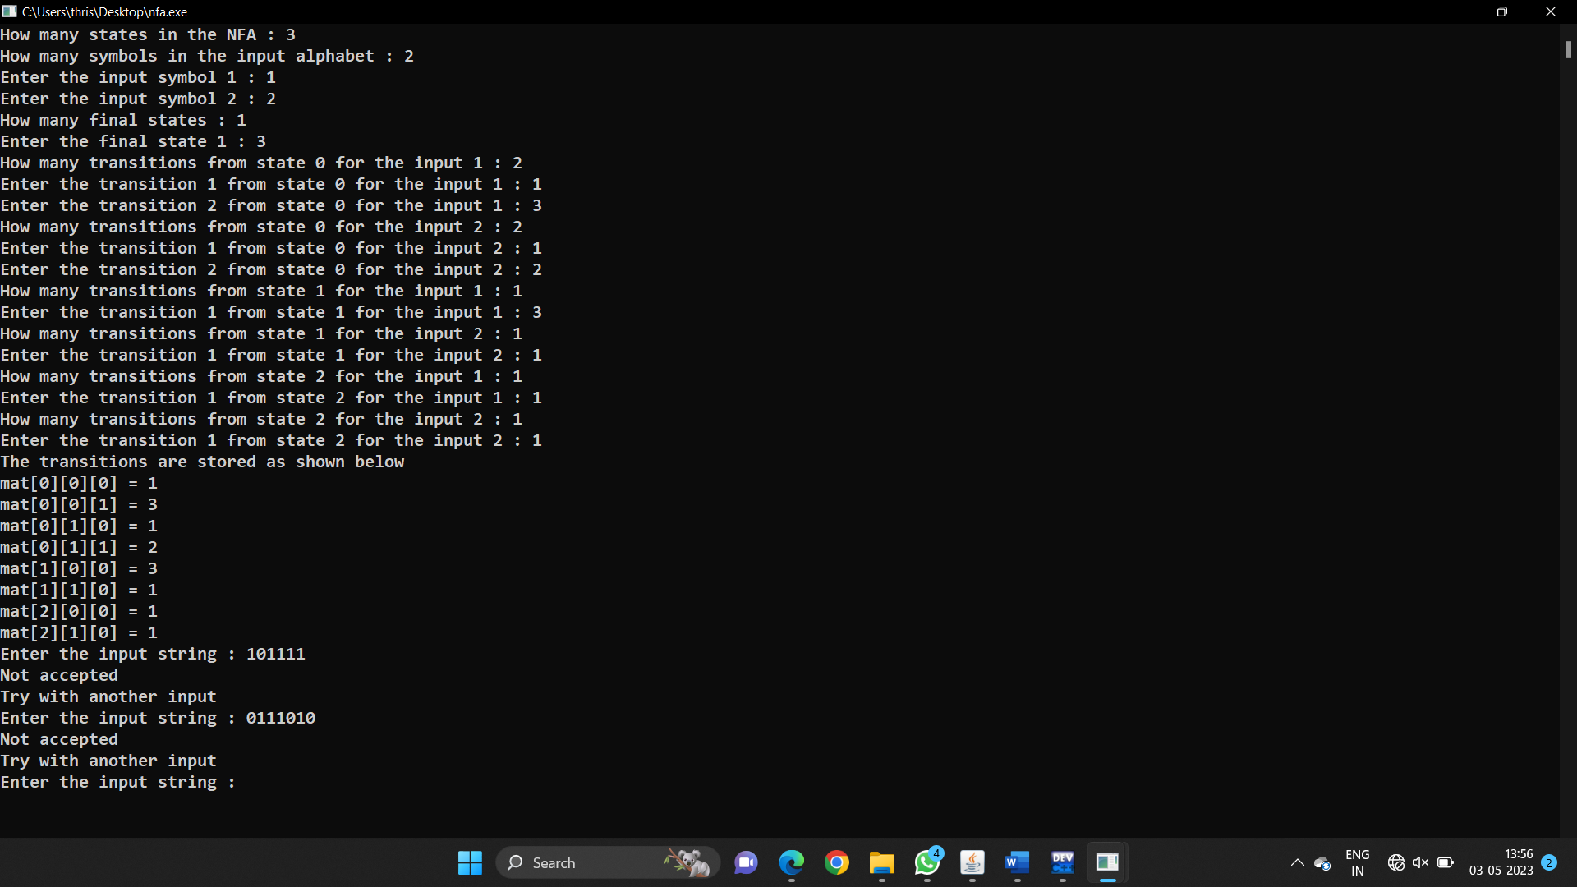

RESULT:

Simulation of non-deterministic finite automata is successful