MAINCRAFTS TECHNOLOGY
VLSI DESIGN INTERNSHIP
Task 3 Completion Report
RTL Design & Verification of Sequential Circuits and Flip-Flops
Verilog HDL Implementation of D Flip-Flop, JK Flip-Flop, 4-bit Register, and 4-bit Counter
Intern Name | Bathula Thrishul
Domain | VLSI Design
Platform Used | EDA Playground (Icarus Verilog 12.0 + EPWave)
Submission Date | August 20, 2026

1. Executive Objective
Building on Task 1 (VLSI fundamentals) and Task 2 (combinational RTL design), Task 3 moves from combinational to sequential logic — the foundation of processors, controllers, and memory systems. This report documents the Verilog RTL implementation, testbench creation, console simulation, and EPWave waveform verification for four sequential building blocks:
- D Flip-Flop — edge-triggered data storage element
- JK Flip-Flop — versatile flip-flop with Set / Reset / Toggle / No-change modes
- 4-bit Register — parallel storage of multi-bit data
- 4-bit Binary Counter — clock-driven up-counter with roll-over
All four designs were written, compiled, and simulated on EDA Playground using Icarus Verilog 12.0, with waveforms captured in EPWave to confirm correct clock-synchronous behavior.

2. Sequential RTL Design Concepts
Concept | Explanation
Sequential Logic | Circuit behavior that depends on current inputs AND previous state (memory).
Flip-Flop | The basic 1-bit storage element, updated only at a clock edge.
Clock Signal | Synchronizes when state updates occur across the circuit.
Register | A group of flip-flops that together store multi-bit data.
Counter | A sequential circuit that increments its stored value every clock cycle.
always @(posedge clk) | The Verilog construct used to describe clock-edge-triggered sequential behavior.

3. Circuit Implementations, Simulation & Results

Part A — D Flip-Flop
1. Truth Table
Clock Edge | D | Q (Next State)
Rising Edge | 0 | 0
Rising Edge | 1 | 1

2. Verilog RTL Design (d_flipflop.v)
module d_flipflop(
input clk,
input D,
output reg Q
);

always @(posedge clk) begin
Q <= D;
end
endmodule
3. Verification Testbench (tb_d_flipflop.v) — EDA Playground Setup
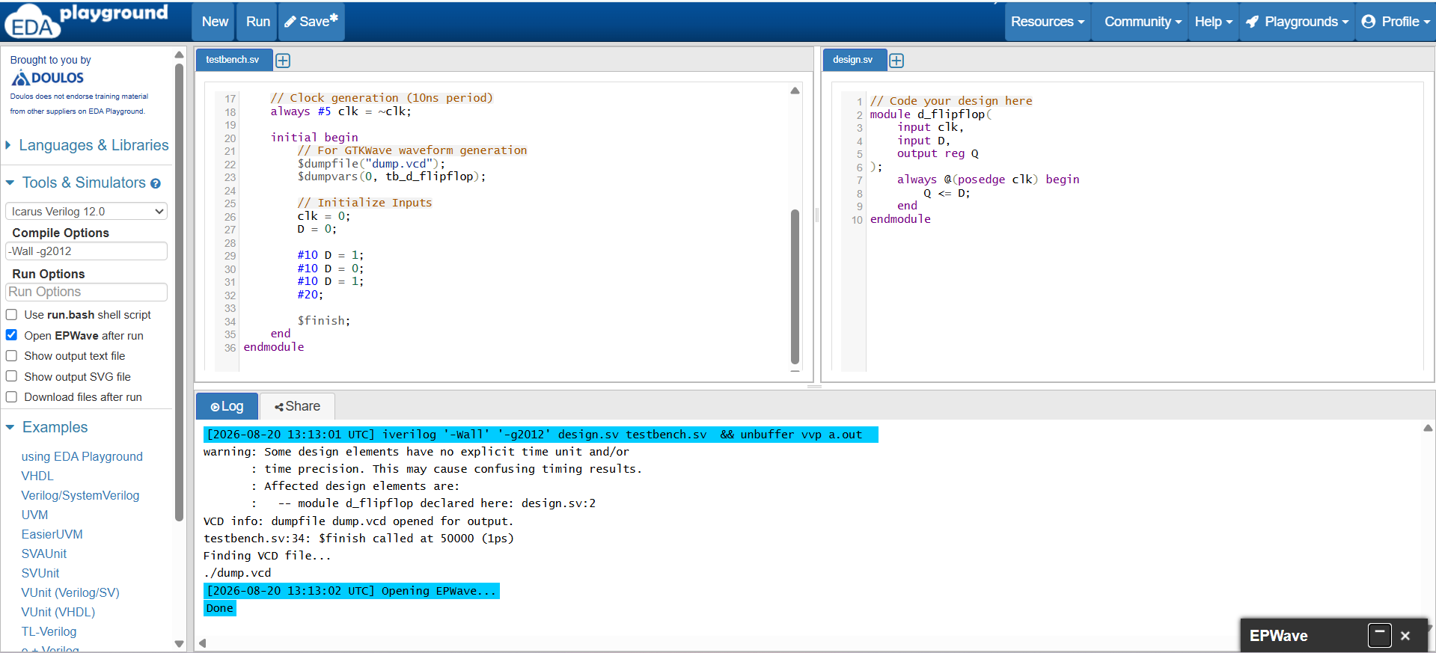
Figure A1 — EDA Playground: d_flipflop.v design and testbench (clock period 10 ns, D toggled every 10 ns)
4. Simulation Log
[2026-08-20 13:13:01 UTC] iverilog -Wall -g2012 design.sv testbench.sv && vvp a.out
VCD info: dumpfile dump.vcd opened for output.
testbench.sv:34: $finish called at 50000 (1ps)
Finding VCD file...
./dump.vcd
Opening EPWave... Done
5. EPWave Waveform
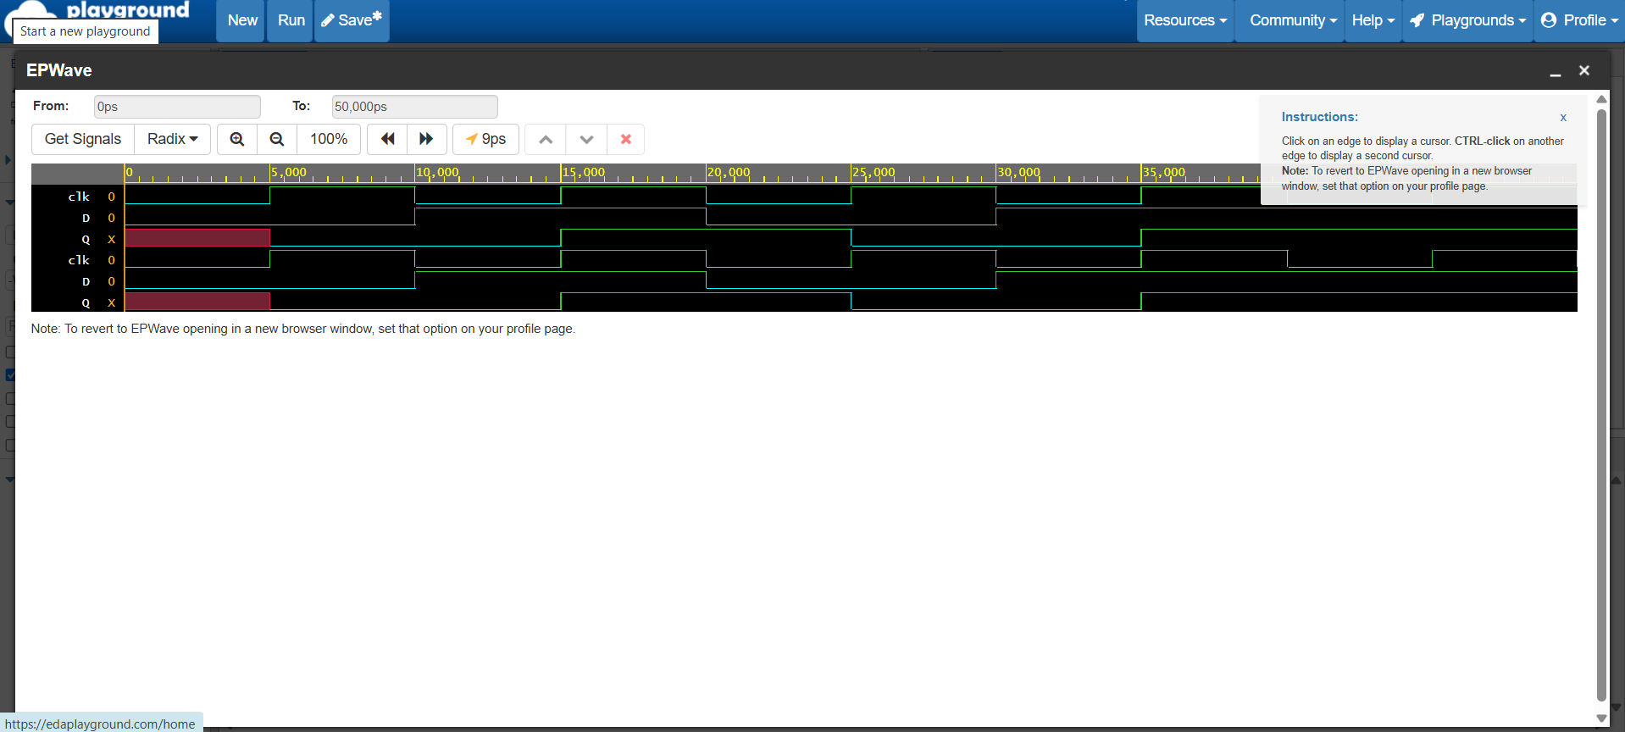
Figure A2 — clk, D and Q signal transitions (0–35,000 ps): Q follows D exactly one clock edge later
Observation: The output Q updates only on the rising edge of clk and holds its value between edges, confirming correct edge-triggered, non-blocking (<=) sequential behavior with no glitches or unintended combinational feed-through.

Part B — JK Flip-Flop
1. Truth Table
J | K | Q (Next State)
0 | 0 | No change
0 | 1 | Reset
1 | 0 | Set
1 | 1 | Toggle

2. Verilog RTL Design (jk_flipflop.v)
module jk_flipflop(
input clk,
input J,
input K,
output reg Q
);
always @(posedge clk) begin
case ({J, K})
2'b00: Q <= Q; // No change
2'b01: Q <= 1'b0; // Reset
2'b10: Q <= 1'b1; // Set
2'b11: Q <= ~Q; // Toggle
endcase
end
endmodule
3. Verification Testbench — EDA Playground Setup
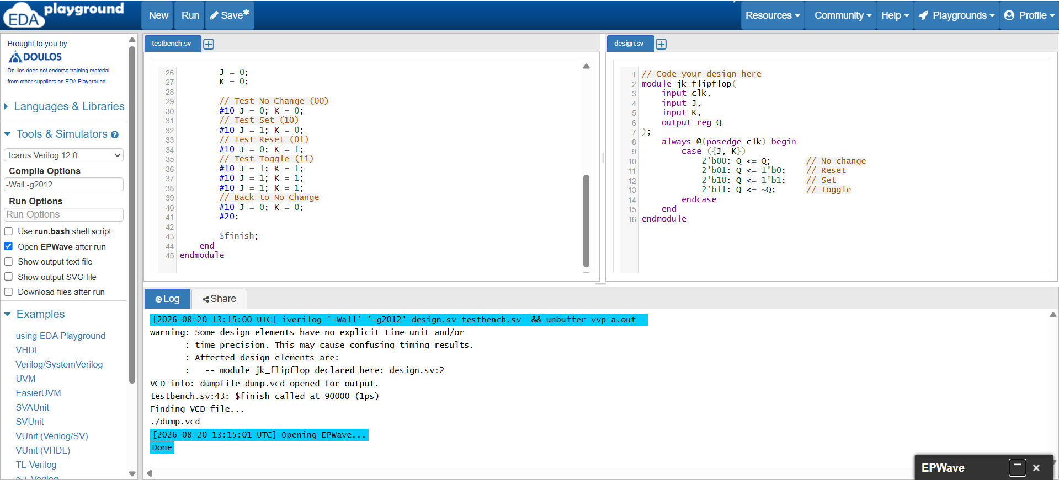
Figure B1 — EDA Playground: jk_flipflop.v design and testbench, exercising all four J/K combinations
4. Simulation Log
[2026-08-20 13:15:00 UTC] iverilog -Wall -g2012 design.sv testbench.sv && vvp a.out
VCD info: dumpfile dump.vcd opened for output.
testbench.sv:43: $finish called at 90000 (1ps)
Finding VCD file...
./dump.vcd
Opening EPWave... Done
5. EPWave Waveform
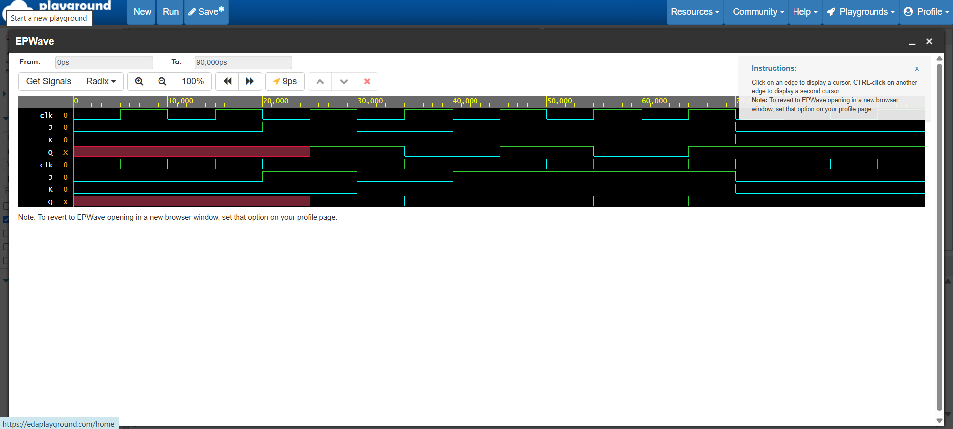
Figure B2 — clk, J, K and Q transitions (0–70,000 ps) across No-change, Reset, Set and Toggle phases
Observation: Q correctly held its previous value for J=K=0, reset to 0 for J=0,K=1, set to 1 for J=1,K=0, and toggled every clock edge for J=K=1 — matching the JK flip-flop truth table exactly.

Part C — 4-bit Register
Registers store multiple bits of data, updated together on the same clock edge.
1. Verilog RTL Design (register4.v)
module register4(
input clk,
input [3:0] D,
output reg [3:0] Q
);
always @(posedge clk) begin
Q <= D;
end
endmodule
2. Verification Testbench — EDA Playground Setup
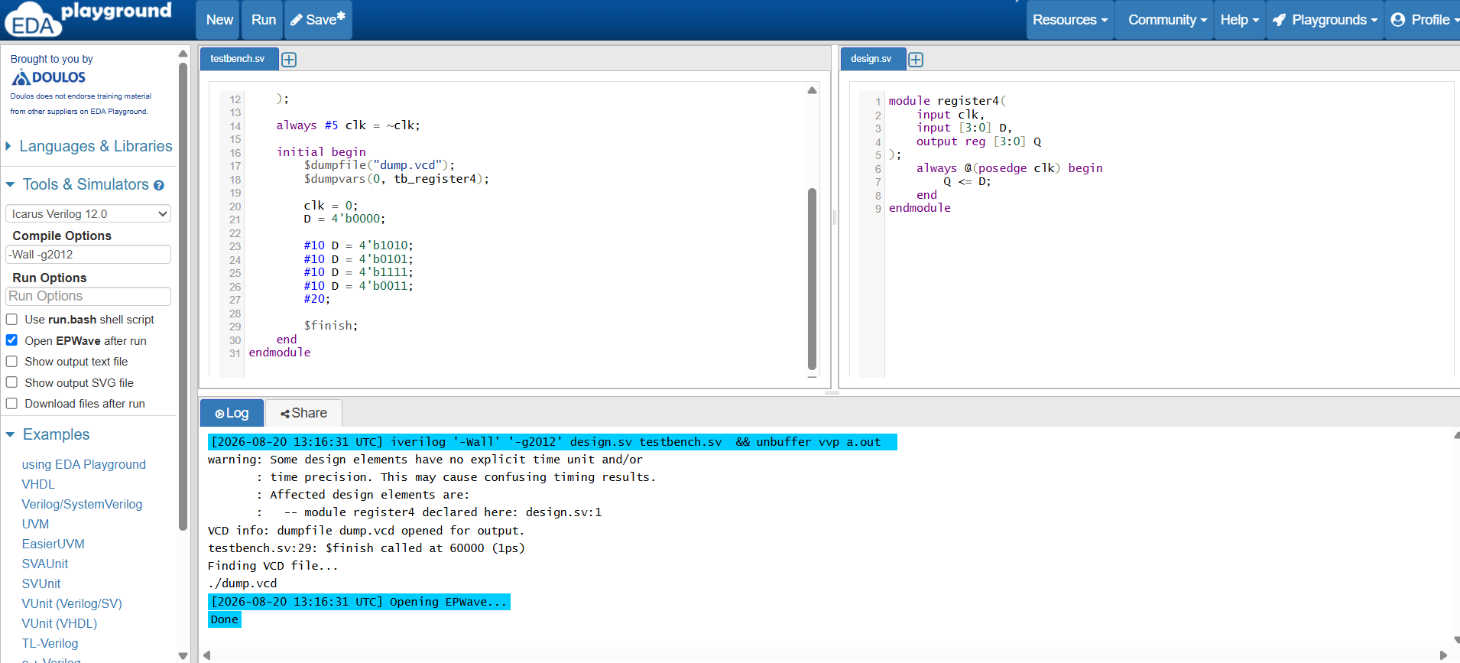
Figure C1 — EDA Playground: register4.v design and testbench (D driven with 4'b1010, 4'b0101, 4'b1111, 4'b0011)
3. Simulation Log
[2026-08-20 13:16:31 UTC] iverilog -Wall -g2012 design.sv testbench.sv && vvp a.out
VCD info: dumpfile dump.vcd opened for output.
testbench.sv:29: $finish called at 60000 (1ps)
Finding VCD file...
./dump.vcd
Opening EPWave... Done
4. EPWave Waveform
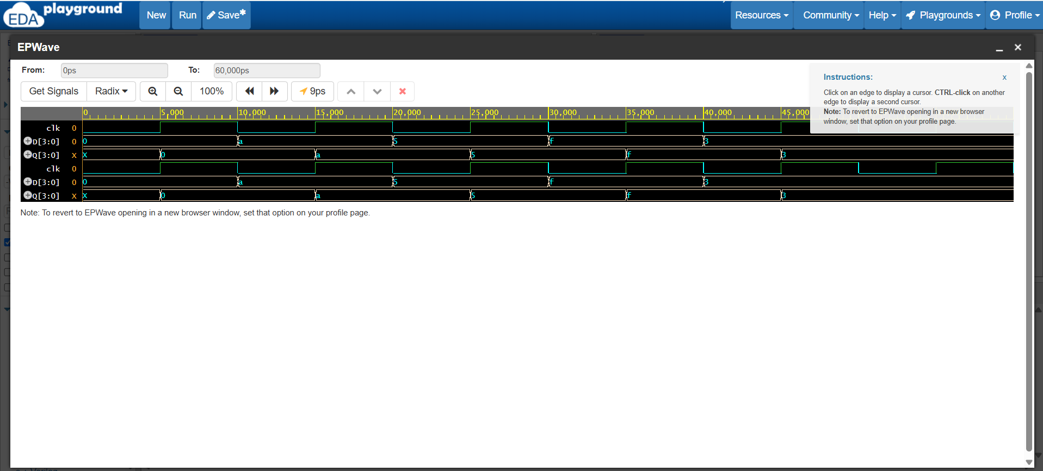
Figure C2 — D[3:0] and Q[3:0] (0–45,000 ps): Q follows D one clock edge later, values 0 → a → 5 → f → 3 (hex)
Observation: All four bits of Q updated simultaneously and only at the rising clock edge, confirming the 4-bit register behaves as four parallel D flip-flops sharing a common clock.

Part D — 4-bit Binary Counter
A counter increments its stored value on every clock cycle and rolls over after reaching its maximum count.
1. Verilog RTL Design (counter4.v)
module counter4(
input clk,
output reg [3:0] count
);
initial count = 4'b0000; // Safe initial state for simulation

always @(posedge clk) begin
count <= count + 1'b1;
end
endmodule
2. Verification Testbench — EDA Playground Setup
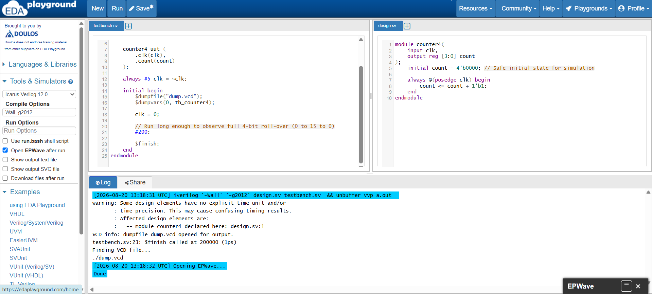
Figure D1 — EDA Playground: counter4.v design and testbench, run for 200 ns to observe a full 0–15–0 roll-over
3. Simulation Log
[2026-08-20 13:18:31 UTC] iverilog -Wall -g2012 design.sv testbench.sv && vvp a.out
VCD info: dumpfile dump.vcd opened for output.
testbench.sv:23: $finish called at 200000 (1ps)
Finding VCD file...
./dump.vcd
Opening EPWave... Done
4. EPWave Waveform
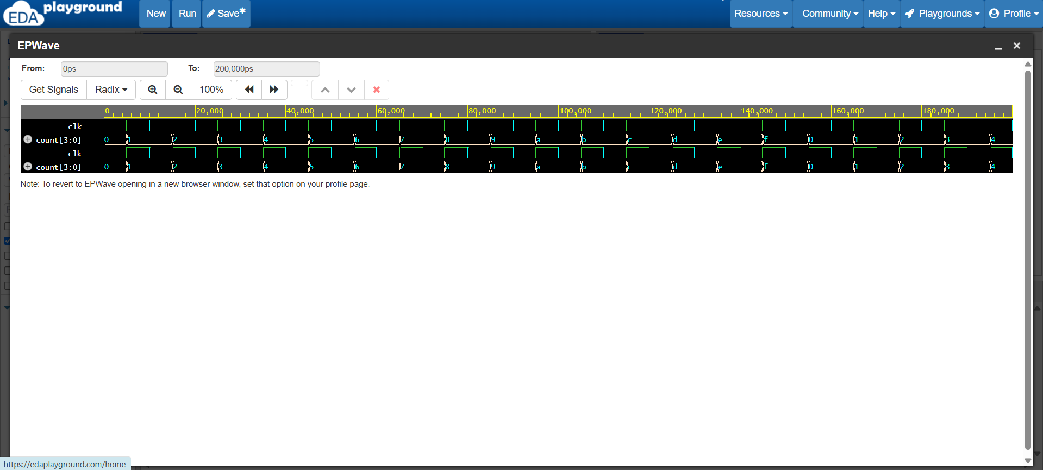
Figure D2 — count[3:0] incrementing every clock cycle (0–190,000 ps), rolling over cleanly from f back to 0
Observation: count increased by exactly 1 on every rising clock edge and wrapped from 4'hF back to 4'h0 without glitches, confirming correct 4-bit modulo-16 counting behavior.

4. Key Takeaways & Conclusion
- Functional Correctness: All four sequential modules used non-blocking assignments (<=) inside always @(posedge clk) blocks, correctly modeling clocked storage with no unintended latches or combinational feedback.
- State Behavior Verified: D flip-flop, JK flip-flop (all 4 modes), register, and counter all matched their respective truth tables / expected count sequences across every EPWave waveform capture.
- Simulation Workflow: Successfully used $dumpfile and $dumpvars in each testbench to generate VCD files for waveform inspection in EPWave, mirroring the industry RTL verification flow.
- Task Completion: RTL modules, testbenches, console logs, and waveform diagrams satisfy all mandatory deliverables for Task 3 of the VLSI Design Internship.

Bathula Thrishul · VLSI Design Intern, Maincrafts Technology · August 2026

