**MONGODB**

Full Querys:

use myproductsdb

db.createCollection("products")

db.products.insertMany([

{ id: "1", product_name: "Intelligent Fresh Chips", product_price: 655, product_material: "Concrete", product_color: "mint green" },

{ id: "2", product_name: "Practical Fresh Sausages", product_price: 911, product_material: "Cotton", product_color: "indigo" },

{ id: "3", product_name: "Refined Steel Car", product_price: 690, product_material: "Rubber", product_color: "gold" },

{ id: "4", product_name: "Gorgeous Plastic Pants", product_price: 492, product_material: "Soft", product_color: "plum" },

{ id: "5", product_name: "Sleek Cotton Chair", product_price: 33, product_material: "Fresh", product_color: "black" },

{ id: "6", product_name: "Awesome Wooden Towels", product_price: 474, product_material: "Plastic", product_color: "orange" },

{ id: "7", product_name: "Practical Soft Shoes", product_price: 500, product_material: "Rubber", product_color: "pink" },

{ id: "8", product_name: "Incredible Steel Hat", product_price: 78, product_material: "Rubber", product_color: "violet" },

{ id: "9", product_name: "Awesome Wooden Ball", product_price: 28, product_material: "Soft", product_color: "azure" },

{ id: "10", product_name: "Generic Wooden Pizza", product_price: 84, product_material: "Frozen", product_color: "indigo" },

{ id: "11", product_name: "Unbranded Wooden Cheese", product_price: 26, product_material: "Soft", product_color: "black" },

{ id: "12", product_name: "Unbranded Plastic Salad", product_price: 89, product_material: "Wooden", product_color: "pink" },

{ id: "13", product_name: "Gorgeous Cotton Keyboard", product_price: 37, product_material: "Concrete", product_color: "sky blue" },

{ id: "14", product_name: "Incredible Steel Shirt", product_price: 54, product_material: "Metal", product_color: "white" },

{ id: "15", product_name: "Ergonomic Cotton Hat", product_price: 43, product_material: "Rubber", product_color: "mint green" },

{ id: "16", product_name: "Small Soft Chair", product_price: 47, product_material: "Cotton", product_color: "teal" },

{ id: "17", product_name: "Incredible Metal Car", product_price: 36, product_material: "Fresh", product_color: "indigo" },

{ id: "18", product_name: "Licensed Plastic Bacon", product_price: 88, product_material: "Steel", product_color: "yellow" },

{ id: "19", product_name: "Intelligent Cotton Chips", product_price: 46, product_material: "Soft", product_color: "azure" },

{ id: "20", product_name: "Handcrafted Wooden Bacon", product_price: 36, product_material: "Concrete", product_color: "lime" },

{ id: "21", product_name: "Unbranded Granite Chicken", product_price: 90, product_material: "Metal", product_color: "gold" },

{ id: "22", product_name: "Ergonomic Soft Hat", product_price: 99, product_material: "Rubber", product_color: "black" },

{ id: "23", product_name: "Intelligent Steel Pizza", product_price: 95, product_material: "Cotton", product_color: "azure" },

{ id: "24", product_name: "Tasty Rubber Cheese", product_price: 47, product_material: "Frozen", product_color: "orchid" },

{ id: "25", product_name: "Licensed Steel Car", product_price: 20, product_material: "Cotton", product_color: "indigo" }

])

db.products.find()

db.products.find({ product_price: { $gte: 400, $lte: 800 } })

db.products.find({ $or: [ { product_price: { $lt: 400 } }, { product_price: { $gt: 600 } } ] })

db.products.find({ product_price: { $gt: 500 } }).limit(4)

db.products.find({}, { product_name: 1, product_material: 1 })

db.products.find({ id: "10" })

db.products.find({}, { product_name: 1, product_material: 1, _id: 0 })

db.products.find({ product_material: "Soft" })

db.products.find({ product_color: "indigo", product_price: 492 })

db.products.deleteMany({ product_price: 28 })

1. Find all the information about each products

Code

db.products.find()

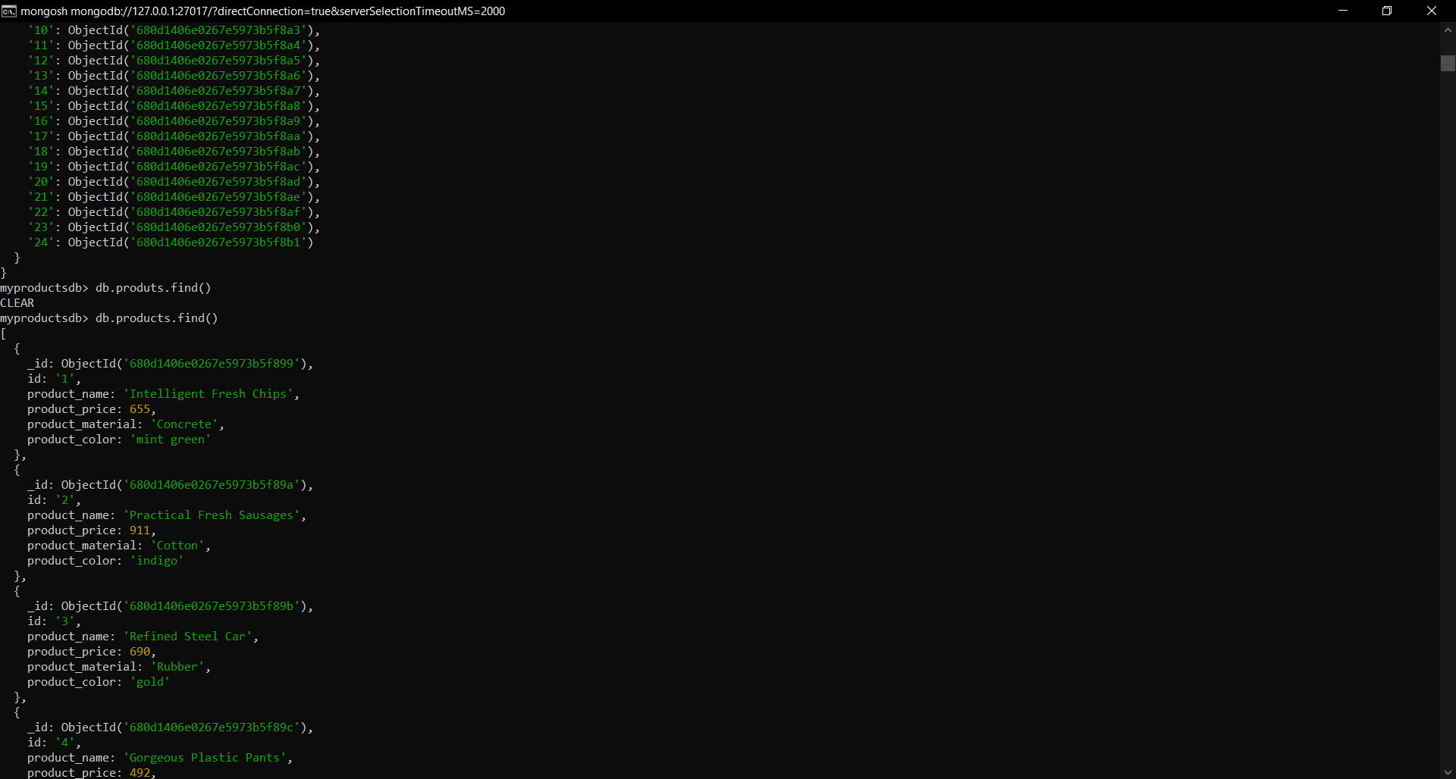

1. Find the product price which are between 400 to 800

Code:

db.products.find({ product_price: { $gte: 400, $lte: 800 } })

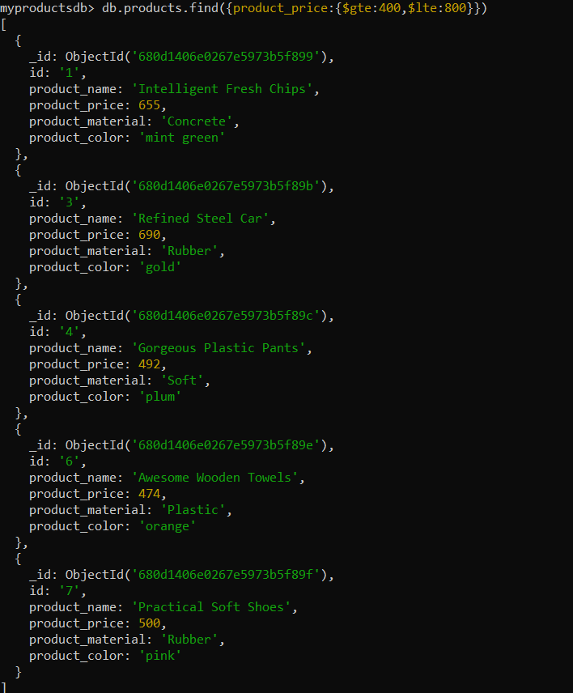

1. Find the product price which are not between 400 to 600

Code: db.products.find({ $or: [ { product_price: { $lt: 400 } }, { product_price: { $gt: 600 } } ] })

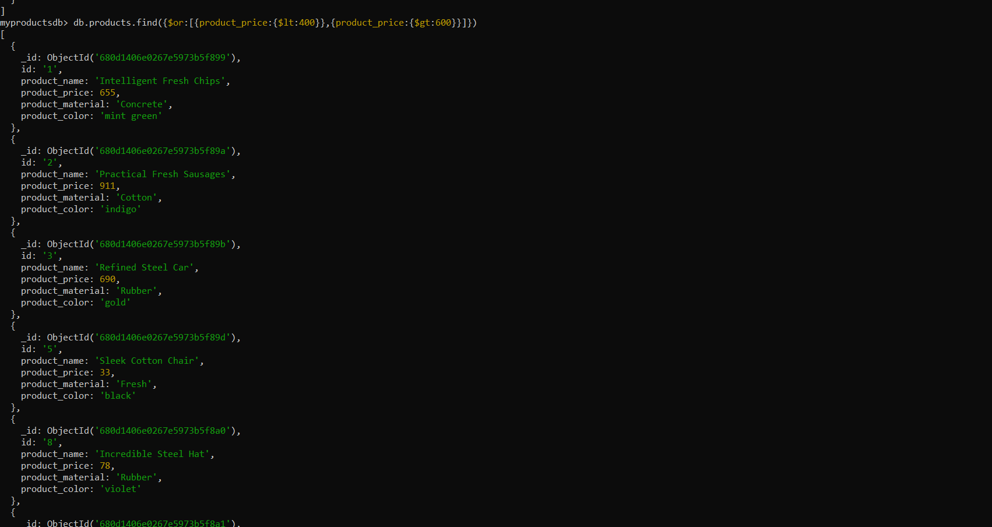

1. List the four product which are greater than 500 in price

Code:

db.products.find({ product_price: { $gt: 500 } }).limit(4)

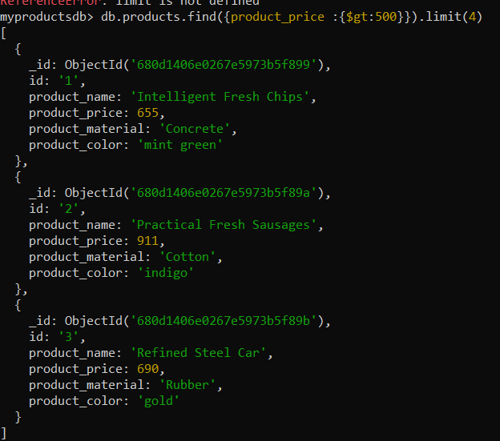

**5. Find the product name and product material of each product:**

Code:

db.products.find({}, { product_name: 1, product_material: 1, _id: 0 })

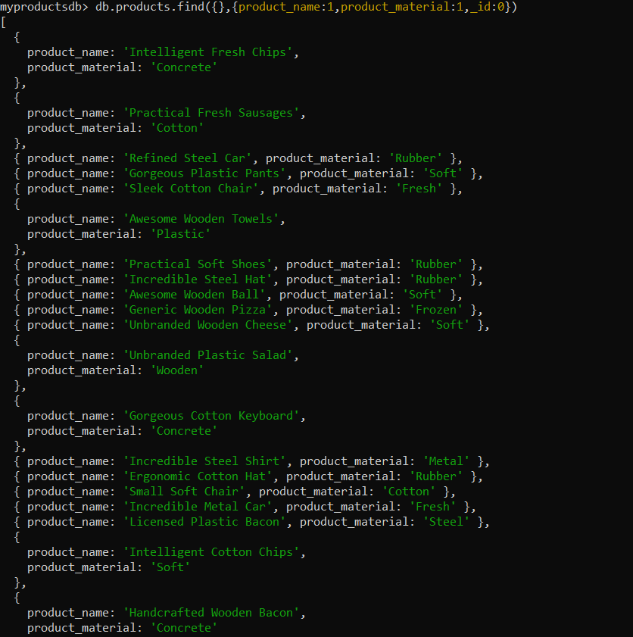

**6. Find the product with a row id of 10:**

Code:

db.products.find({ id: "10" })

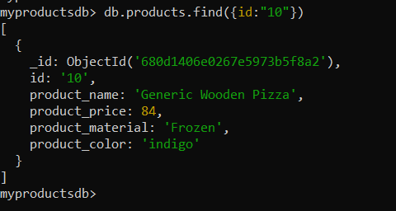

**7. Find only the product name and product material:**

code

db.products.find({}, { product_name: 1, product_material: 1, _id: 0 })

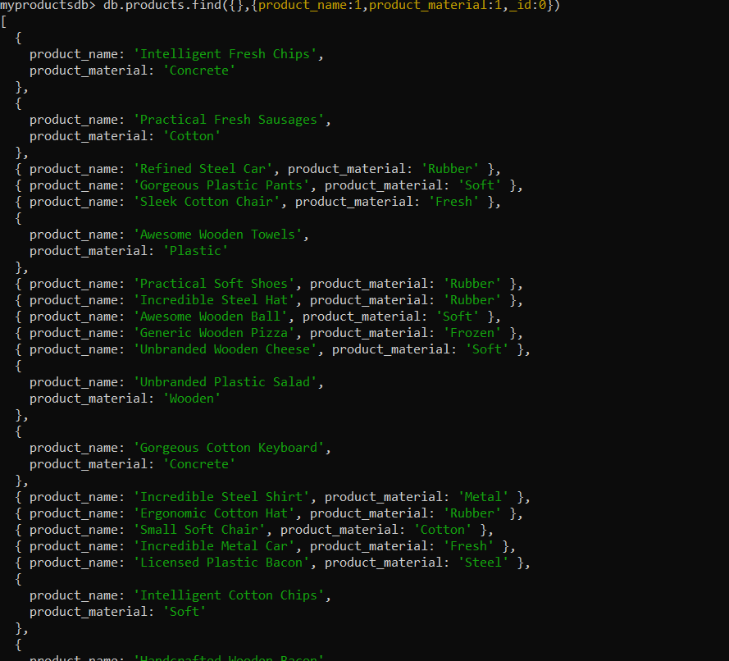

**8. Find all products which contain the value "Soft" in product_material:**

code

db.products.find({ product_material: { $regex: /Soft/i } })

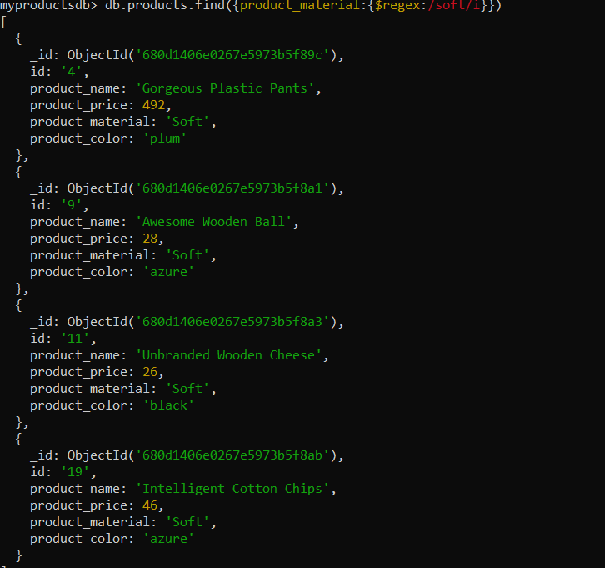

**9. Find products which contain product_color: "indigo" and product_price: 492.00:**

code

db.products.find({ product_color: "indigo", product_price: 492.00 })

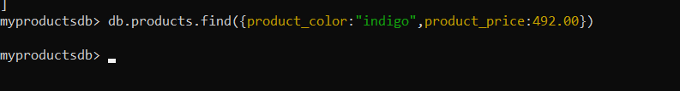

**10. Delete the products which product price value is 28:**

code

db.products.deleteMany({ product_price: 28 })

