SIMATS ENGINEERING
ASSESSMENT TOOL 2

COURSE CODE: ITA0604
COURSE NAME: MACHINE LEARNING

COURSE OUTCOME COVERED
CO1: Learning Problems, Perspectives and Issues, Concept Learning, Version
Spaces &amp; Candidate Elimination, Inductive Bias, Decision Tree Learning,
Representation &amp; Heuristic Search (BL1, BL2)
Assessment Tool Weightage: 20%

QUESTIONS: 5
Total Marks: 25

Annexure A
CONCEPT MAPPING

Code of Conduct:

I THARIKA S (192412031) certify that this submission is my original work
and that I have adhered to the guidelines specified for this assessment.
I understand that any violation of academic integrity rules will result in disciplinary action.
Signature of the student:

Annexure A

Short Answer Test
1. With the necessary sketch, explain all the possible blocks in the machine-learning
system. Give example for showing the concept of the supervised and Un-supervised
learning methods in the machine learning scheme. (5 Marks)
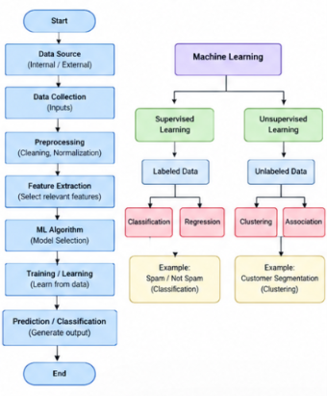

2. Design a machine learning system for disaster management to predict events such
as floods and earthquakes using historical and real-time data. Explain the choice of
model, data preprocessing, and feature selection techniques.
(a) Describe the steps involved in training, validating, and evaluating the model.
(b) Explain how the system can assist in early warning and emergency response.
(5 Marks)
