SIMATS ENGINEERING
SDG ASSIGNMENT – UNIT 1
FRAUD DETECTION USING MACHINE LEARNING
COURSE NAME: MACHINE LEARNING
COURSE CODE: ITA0604
NAME: THARIKA.S
REG NO:192412031
QUESTION : Explain fraud detection using Machine Learning.
1.1 Introduction
Fraud is a major challenge in the financial, banking, e-commerce, insurance, and digital payment sectors. With the rapid growth of online transactions, mobile banking, credit cards, and digital wallets, fraudulent activities have become more frequent and difficult to identify using traditional methods. Fraudulent transactions may involve stolen card details, unauthorized payments, identity theft, account takeover, and suspicious fund transfers.
Traditional fraud detection systems generally depend on predefined rules, transaction limits, and manually specified conditions. Although these methods can identify known fraud patterns, they may fail to detect new and complex fraudulent activities. They may also generate false alarms by classifying genuine transactions as fraudulent.
Machine Learning (ML) provides an effective approach to this problem by enabling computer systems to learn patterns from historical transaction data and use the learned patterns to classify new transactions. Machine Learning models can examine transaction amounts, transaction frequency, time, location, and other relevant features to estimate whether a transaction is legitimate or fraudulent.
This report focuses on designing a fraud detection system using Machine Learning, particularly the Decision Tree algorithm. The system analyzes transaction data, identifies suspicious patterns, and classifies transactions into fraudulent and legitimate categories. Data analysis and visualization using NumPy, Pandas, and Matplotlib can help understand the dataset and evaluate the performance of the proposed approach.

1.2 Aim
To study and design a Machine Learning-based fraud detection system that identifies potentially fraudulent financial transactions using historical transaction data, appropriate preprocessing techniques, and a Decision Tree classification algorithm.
1.3 Objectives
- To understand the problem of financial fraud and its impact on individuals and organizations.
- To identify the relevant Sustainable Development Goals associated with fraud prevention.
- To collect and preprocess an appropriate transaction dataset.
- To identify suitable input features, target variables, and data representations.
- To analyze transaction data using NumPy and Pandas.
- To visualize transaction patterns and class distributions.
- To apply the Decision Tree algorithm to classify transactions.
- To evaluate expected outcomes, advantages, limitations, and real-world applications.
- To recommend practical measures for improving fraud detection and prevention.
1.4 Scope of the Study
The proposed system focuses on detecting credit card or digital payment fraud using transaction-level data. It considers historical transaction records and their associated labels to learn the differences between legitimate and fraudulent transactions.
The study covers dataset preparation, feature analysis, model selection, classification, visualization, and recommendations. It primarily demonstrates a supervised Machine Learning approach and discusses how the model could be integrated into a practical fraud monitoring system.
The proposed model is intended to assist fraud analysts and financial institutions rather than replace human investigation or independently make every high-impact financial decision.

2. PROBLEM STATEMENT AND SDG IDENTIFICATION
2.1 Problem Statement
The increasing volume of digital financial transactions has created opportunities for fraudulent activities. Financial institutions must identify fraudulent transactions quickly while minimizing incorrect alerts on genuine transactions.
Traditional rule-based systems often depend on predefined conditions, such as transactions exceeding a particular amount or multiple payments occurring within a short period. Fraudsters can modify their behavior to bypass these conditions, making rule-based systems less effective against previously unseen patterns.
The main problem is to develop a Machine Learning model that can learn from historical transaction data and distinguish fraudulent transactions from legitimate transactions with acceptable accuracy, precision, recall, and computational efficiency.
The proposed system receives transaction attributes as input and predicts whether each transaction belongs to the legitimate or fraudulent category. Since fraudulent transactions are generally much less frequent than genuine transactions, the model must address class imbalance and avoid relying only on overall accuracy.
2.2 Need for the Proposed System
The proposed system is needed for the following reasons:
- Early detection: Identifies potentially fraudulent transactions before further financial losses occur.
- Automation: Reduces the need to manually examine every transaction.
- Pattern recognition: Learns relationships between transaction characteristics and historical fraud cases.
- Scalability: Can be incorporated into systems that process large numbers of transactions.
- Improved investigation: Helps analysts prioritize suspicious transactions.
- Adaptability: Can be retrained periodically as fraud patterns change.
2.3 Identification of Sustainable Development Goals (SDGs)
The proposed project supports the following United Nations Sustainable Development Goals.

SDG 16: Peace, Justice and Strong Institutions
SDG 16 promotes peaceful and inclusive societies, access to justice, and effective, accountable institutions. Fraud detection supports the goal by helping reduce financial crime, unauthorized transactions, and misuse of financial systems.
Target 16.4 aims to significantly reduce illicit financial flows and combat organized crime. Although transaction-level fraud detection does not address every form of illicit financial activity, it can contribute to stronger financial monitoring and fraud prevention.
SDG 8: Decent Work and Economic Growth
SDG 8 promotes sustained economic growth, productive employment, and decent work. Financial fraud can affect business revenue, consumer confidence, and the stability of digital commerce.
Fraud detection systems help protect businesses and consumers from financial losses and support trust in digital payment systems.
SDG 9: Industry, Innovation and Infrastructure
SDG 9 promotes resilient infrastructure, sustainable industrialization, and innovation. Applying Machine Learning to financial security encourages technological innovation and improves the reliability of digital transaction infrastructure.
2.4 Real-World Relevance
A Machine Learning-based fraud detection system can help banks, payment gateways, e-commerce companies, insurance providers, and digital wallet operators identify suspicious activities. By supporting quicker investigation and better allocation of security resources, the system contributes to safer digital financial services.

BACKGROUND STUDY AND MACHINE LEARNING CHALLENGES
3.1 Background Study
Fraud detection has traditionally relied on manual investigations, predefined business rules, and statistical techniques. Rule-based systems identify transactions that satisfy conditions such as unusually high transaction amounts, repeated failed payments, or transactions from unexpected locations.
These rules are easy to implement and interpret. However, they require continuous manual updates and may not recognize complicated combinations of transaction characteristics.
Machine Learning offers a data-driven alternative. Instead of depending entirely on predefined conditions, an ML model learns patterns from examples of previous fraudulent and legitimate transactions.
Supervised classification is particularly suitable when historical transactions have labels indicating whether fraud occurred. A model can learn from these examples and predict the category of a new transaction.
Decision Trees are useful for an introductory fraud detection project because they produce understandable decision rules. For example, a trained tree may identify a combination of unusual transaction amount, abnormal transaction frequency, and other features as suspicious. The actual conditions must be learned from the dataset rather than assumed in advance.
3.2 Review of Related Work
Several research studies have explored Machine Learning for credit card fraud detection.
- Dal Pozzolo et al. (2015): Studied the challenges of credit card fraud detection, including changing fraud patterns and the difficulty of learning from highly imbalanced transaction data.
- Breiman et al. (1984): Established the Classification and Regression Tree approach, which provides a foundation for decision-tree-based classification.
- Quinlan (1986): Introduced the ID3 decision-tree learning algorithm, which uses information gain to select attributes for splitting training data.
- Breiman (2001): Introduced Random Forests, an ensemble approach that combines multiple decision trees and can improve predictive performance.
These studies demonstrate that data-driven classification can support fraud detection, but model effectiveness depends on data quality, feature selection, class distribution, and evaluation methodology.
3.3 Machine Learning Challenges
1. Class imbalance: Fraudulent transactions form a small proportion of most transaction datasets. A model may achieve high accuracy simply by predicting every transaction as legitimate.
2. Evolving fraud patterns: Fraudsters continuously modify their behavior. A model trained on older data may not recognize new fraud techniques.
3. False positives: Genuine transactions incorrectly classified as fraudulent can inconvenience customers and increase investigation costs.
4. False negatives: Fraudulent transactions incorrectly classified as legitimate may result in financial losses.
5. Data privacy: Financial records may contain sensitive information and must be handled securely.
6. Limited labeled data: Some fraudulent transactions may remain undetected or may not be confirmed immediately, resulting in incomplete labels.
7. Computational requirements: Large-scale financial systems need models that can process transactions with low latency.
8. Explainability: Financial institutions may need understandable reasons for flagging a transaction, particularly when the decision affects a customer.
Therefore, model evaluation must consider more than accuracy. Precision, recall, F1-score, confusion matrices, and the financial consequences of different errors are also important.

IDENTIFICATION OF THE LEARNING PROBLEM AND DATASET
4.1 Identification of the Learning Problem
Fraud detection in this project is formulated as a supervised binary classification problem.
The model learns from historical transactions for which the outcome is already known. Each transaction is assigned one of two classes:
- Class 0: Legitimate transaction.
- Class 1: Fraudulent transaction.
After training, the model receives a new transaction and predicts its class.
4.2 Dataset Selection
The project can use the publicly available Credit Card Fraud Detection dataset on Kaggle.
Dataset link: https://www.kaggle.com/datasets/mlg-ulb/creditcardfraud
The dataset contains anonymized credit card transactions made by European cardholders. It contains 284,807 transactions, of which 492 are labeled fraudulent. The target variable is Class, where 0 represents a legitimate transaction and 1 represents a fraudulent transaction.
The dataset is appropriate because it contains real-world transaction records with a substantial class imbalance, allowing the project to investigate an important challenge in financial fraud detection.
The features V1 to V28 are transformed numerical variables. Time indicates elapsed time from the first transaction in the dataset, and Amount represents the transaction amount. The Class column provides the target label.
4.3 Input Features
The following features can be used for analysis and model building.
Feature | Description
Time | Elapsed time associated with a transaction
V1–V28 | Anonymized numerical transaction features
Amount | Monetary value of the transaction
Class | Target label: 0 or 1
The target variable Class must not be included among the model's input features because it contains the answer the model is expected to predict.
4.4 Data Representation
The dataset can be represented as a numerical feature matrix and a target vector.
- Feature matrix (X): A two-dimensional table where each row represents a transaction and each column represents an input feature.
- Target vector (y): A one-dimensional sequence containing the transaction labels.
- Data type: Numerical tabular data.
- Learning task: Binary classification.
- Output: Predicted class, optionally accompanied by a probability or risk score.
Mathematically, the model learns a mapping:
f(X) → y
Here, X represents the transaction features, f represents the trained classification model, and y represents the predicted class.
4.5 Dataset Suitability
The dataset is suitable for an academic project because it is publicly accessible, contains labeled examples, and allows the application of data preprocessing, exploratory data analysis, decision-tree learning, and performance evaluation.
However, its anonymized features limit direct interpretation. A model trained on this dataset may also require additional testing before it can be used in a real financial institution.

DATA COLLECTION AND PREPROCESSING
5.1 Data Collection
The dataset is downloaded from Kaggle and loaded into a Pandas DataFrame. The original dataset should be retained separately so that preprocessing does not unintentionally alter the source data.
The following steps are used:
- Download the CSV dataset.
- Load the data using Pandas.
- Inspect the number of rows and columns.
- Check the data types and missing values.
- Identify duplicate records.
- Examine the distribution of the target classes.
- Separate input features and target labels.
- Divide the data into training and testing sets.
5.2 Data Preprocessing
Handling missing values: Missing values must be identified using isnull(). Appropriate imputation or removal methods can be applied if missing values exist.
Handling duplicates: Duplicate records should be investigated. They should not be removed automatically without determining whether they represent accidental duplication or legitimate repeated transactions.
Feature scaling: Decision Trees generally do not require feature scaling. However, scaling may be useful if the project later compares the tree with distance-based or gradient-based algorithms.
Class imbalance: The fraudulent class is much smaller than the legitimate class. Class weights or training-only resampling can be considered to improve fraud detection.
Train-test splitting: Data should be divided into training and testing sets. A stratified split can preserve the approximate class proportions in both sets.
Data leakage prevention: Preprocessing operations that learn parameters from data should be fitted using training data only. The test set must remain separate until final evaluation.
For financial applications, a chronological split may be preferable when the objective is to predict future transactions, because it better represents deployment on unseen future data.
5.3 Data Preparation Using Pandas and NumPy
The following code demonstrates basic data inspection and preparation.
import pandas as pd
import numpy as np
df = pd.read_csv("creditcard.csv")
print("Dataset shape:", df.shape)
print(df.head())
print(df.info())
print("Missing values:\n", df.isnull().sum().sum())
print("Duplicate rows:", df.duplicated().sum())
print("Class distribution:")
print(df["Class"].value_counts())
print("Class percentages:")
print(df["Class"].value_counts(normalize=True) * 100)
print("Amount statistics:")
print(df["Amount"].describe())

X = df.drop(columns=["Class"])
y = df["Class"]

print("Feature matrix shape:", X.shape)
print("Target vector shape:", y.shape)
print("Mean amount:", np.mean(df["Amount"]))
print("Median amount:", np.median(df["Amount"]))

OUTPUT :
Dataset shape: (284807, 31)
Missing values:0

Class distribution Class
0 284315
1 492

Class percentages Class
0 99.827...
1 0.172...
Feature matrix shape: (284807, 30)
Target vector shape: (284807,)The code uses Pandas for reading and inspecting the dataset and NumPy for numerical calculations. The class distribution helps determine the severity of the imbalance, while descriptive statistics provide an overview of transaction amounts.
5.4 Importance of Proper Preparation
Proper preprocessing improves the reliability of model training and evaluation. It reduces data-quality issues, helps prevent leakage, and ensures that the evaluation represents the intended use case.
The preprocessing decisions and any removed records should be documented in the final report to maintain reproducibility.

NUMPY/PANDAS ANALYSIS AND DATA VISUALIZATION
6.1 Exploratory Data Analysis
Exploratory Data Analysis (EDA) is performed to understand the distribution, quality, and characteristics of the transaction data before training the model.
Pandas supports filtering, grouping, descriptive statistics, and missing-value analysis. NumPy supports numerical operations such as calculating means, medians, and standard deviations.
The following questions can be investigated:
- How many transactions are legitimate and how many are fraudulent?
- What proportion of transactions belong to the fraudulent class?
- How are transaction amounts distributed?
- Do the amount distributions differ between the two classes?
- Are there missing or duplicate records that require attention?
6.2 Visualization 1: Class Distribution
A bar chart can display the number of legitimate and fraudulent transactions.
import matplotlib.pyplot as pltcounts = df["Class"].value_counts().sort_index()
plt.figure(figsize=(7, 5))
plt.bar(["Legitimate", "Fraudulent"], counts.values)
plt.title("Distribution of Transaction Classes")
plt.xlabel("Transaction Class")
plt.ylabel("Number of Transactions")
plt.show()

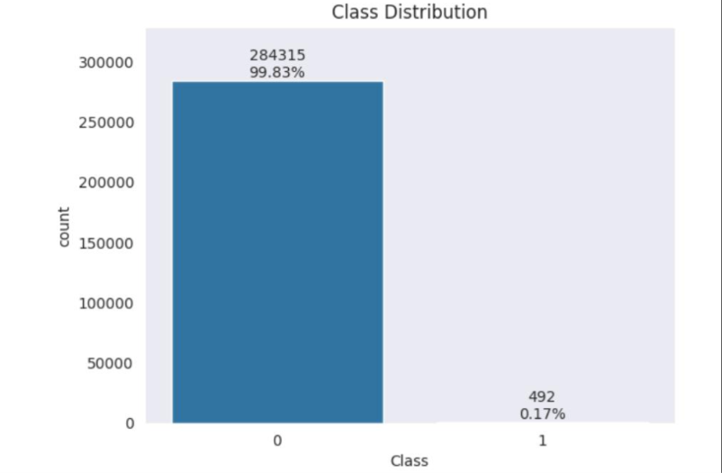
Interpretation: The chart is expected to show a much larger number of legitimate transactions than fraudulent transactions. This imbalance demonstrates why overall accuracy alone is not a sufficient measure of model performance.

6.3 Visualization 2: Transaction Amount Distribution
A histogram can show how transaction amounts are distributed.
plt.figure(figsize=(8, 5))
plt.hist(df["Amount"], bins=50)
plt.title("Distribution of Transaction Amounts")
plt.xlabel("Transaction Amount")
plt.ylabel("Frequency")
plt.show()
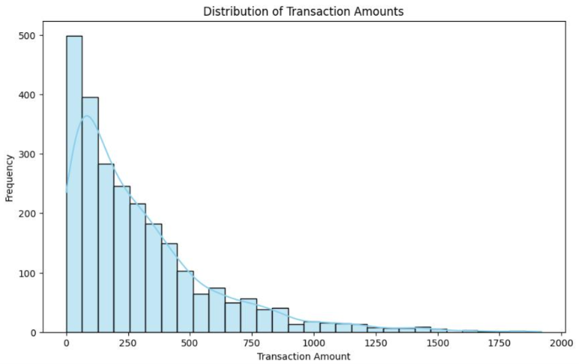
Interpretation: The histogram can reveal whether transaction amounts are concentrated within a narrow range or contain a long tail of larger values. Large transactions are not necessarily fraudulent, so amount alone should not determine the classification.
6.4 Visualization 3: Amount by Transaction Class
A box plot can compare transaction amounts for legitimate and fraudulent records.
plt.figure(figsize=(7, 5))
df.boxplot(column="Amount", by="Class")
plt.title("Transaction Amount by Class")
plt.suptitle("")
plt.xlabel("Class (0 = Legitimate, 1 = Fraud)")
plt.ylabel("Amount")
plt.show()
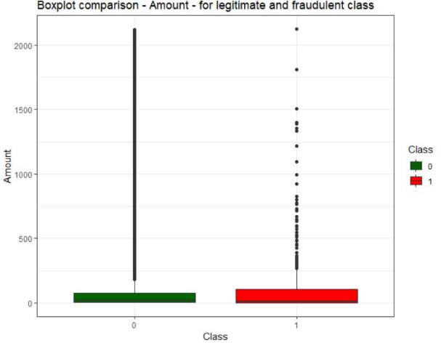
Interpretation: The plot can reveal differences in transaction amount distributions and the presence of outliers. Any observed difference should be verified quantitatively and should not be treated as proof that transaction amount alone can identify fraud.
6.5 Analysis Findings
The class distribution establishes whether imbalance must be addressed. Amount statistics reveal the range and variability of transactions, while visualizations help identify outliers and possible differences between classes.
These findings inform preprocessing, model evaluation, and the selection of suitable performance metrics. Actual numerical findings should be recorded after running the code on the downloaded dataset.

SELECTION AND JUSTIFICATION OF THE MACHINE LEARNING APPROACH
7.1 Selected Algorithm: Decision Tree
A Decision Tree is selected as the primary Machine Learning algorithm because it is suitable for classification tasks and produces interpretable decision rules.
A Decision Tree consists of:
- Root node: The first decision point.
- Internal nodes: Conditions applied to input features.
- Branches: Outcomes of the conditions.
- Leaf nodes: Final predicted classes.
For example, a decision tree may learn that certain combinations of transaction characteristics are associated with higher fraud risk. The specific features and thresholds are determined during training.
7.2 Connection with the ID3 Algorithm
ID3 is a decision-tree learning algorithm that selects attributes using information gain. It is based on the concept of entropy, which measures uncertainty in a set of class labels.
The entropy of a dataset S is:
Entropy(S) = −Σ pᵢ log₂(pᵢ)
Here, pᵢ represents the proportion of examples belonging to class i.
Information gain is calculated as:
Information Gain(S, A) = Entropy(S) − Σ (|Sᵥ| / |S|) Entropy(Sᵥ)
Here, A is the attribute being considered, and Sᵥ represents the subset of data associated with a particular attribute value.
ID3 selects the attribute that produces the highest information gain at each splitting stage.
7.3 Practical Implementation Consideration
Scikit-learn's DecisionTreeClassifier(criterion="entropy") uses entropy-based splitting, but it should not automatically be described as an exact implementation of the original ID3 algorithm. Scikit-learn supports additional features and implementation choices, including numerical splits, stopping controls, and other tree-building options.
For this project, an entropy-based Decision Tree provides a practical implementation of decision-tree learning. If strict implementation of the original ID3 algorithm is required, the algorithm's attribute-selection and recursive splitting procedure must be implemented explicitly.
7.4 Justification for the Selected Approach
The Decision Tree approach is appropriate for the following reasons:
- Interpretability: The learned rules can be inspected and explained.
- Ease of implementation: The model can be built using established Python libraries.
- Limited preprocessing: Numerical features can be used without mandatory standardization.
- Nonlinear relationships: Trees can represent combinations of features and nonlinear decision boundaries.
- Academic relevance: The method directly connects with entropy, information gain, decision-tree learning, and inductive bias in Unit I.
7.5 Inductive Bias
Inductive bias refers to the assumptions a learning algorithm uses to generalize from training examples to unseen examples.
A Decision Tree prefers a sequence of feature-based splits that separate classes. When constraints such as maximum depth or minimum leaf size are applied, the model is encouraged to produce simpler trees.
A shallow tree may be easier to interpret but could miss complex fraud patterns. A very deep tree may memorize training examples and perform poorly on unseen transactions. Appropriate model constraints and validation are therefore necessary.

PROPOSED MODEL, WORKFLOW AND DECISION-MAKING PROCESS
8.1 Proposed System Architecture
The proposed fraud detection system consists of the following stages:
- Transaction data collection.
- Data cleaning and preprocessing.
- Feature and target separation.
- Training and testing data division.
- Decision Tree model training.
- Prediction of unseen transactions.
- Evaluation using classification metrics.
- Flagging suspicious transactions for further review.
8.2 Workflow
Transaction Dataset
↓
Data Inspection and Cleaning
↓
Feature Selection and Preprocessing
↓
Training-Test Split
↓
Entropy-Based Decision Tree Training
↓
Prediction of Transaction Class
↓
Performance Evaluation
↓
Legitimate Transaction / Potential Fraud Alert
8.3 Model Implementation
The following code trains and evaluates a Decision Tree using the Kaggle dataset.
import pandas as pd
from sklearn.model_selection import train_test_split
from sklearn.tree import DecisionTreeClassifier
from sklearn.metrics import (
confusion_matrix, classification_report,
ConfusionMatrixDisplay
)
import matplotlib.pyplot as plt

df = pd.read_csv("creditcard.csv")

X = df.drop(columns=["Class"])
y = df["Class"]

X_train, X_test, y_train, y_test = train_test_split(
X, y, test_size=0.2, random_state=42, stratify=y
)

model = DecisionTreeClassifier(
criterion="entropy",
max_depth=6,
class_weight="balanced",
random_state=42
)

model.fit(X_train, y_train)
y_pred = model.predict(X_test)

print("Classification Report:")
print(classification_report(y_test, y_pred, zero_division=0))

cm = confusion_matrix(y_test, y_pred)

ConfusionMatrixDisplay(
confusion_matrix=cm,
display_labels=["Legitimate", "Fraud"]
).plot()

plt.title("Decision Tree Fraud Detection")
plt.show()
The model uses entropy-based splitting, limits the tree depth, and assigns balanced class weights to address class imbalance during training. These settings are illustrative starting choices and should be tuned using validation data.
OUTPUT:
Classification Report:

precision recall f1-score support

0 ... ... ... 56864
1 ... ... ... 98

accuracy ... 56962
macro avg ... ... ... 56962
weighted avg ... ... ... 56962
8.4 Decision-Making Process
For each transaction, the trained tree evaluates feature-based conditions in sequence. The path followed through the tree leads to a leaf node, which provides the predicted class.
If the model predicts class 0, the transaction is classified as legitimate by the model. If it predicts class 1, the transaction is flagged as potentially fraudulent.
In a real deployment, the prediction may be combined with additional risk checks. Depending on the risk level, a transaction could be allowed, sent for additional authentication, or referred to a fraud analyst. A prediction should not automatically be interpreted as proof of criminal activity.
8.5 Performance Evaluation
The confusion matrix contains four outcomes:
- True Positive (TP): Fraudulent transaction correctly identified as fraud.
- True Negative (TN): Legitimate transaction correctly identified as legitimate.
- False Positive (FP): Legitimate transaction incorrectly flagged as fraud.
- False Negative (FN): Fraudulent transaction incorrectly classified as legitimate.
Important metrics include:
Accuracy = (TP + TN) / (TP + TN + FP + FN)
Precision = TP / (TP + FP)
Recall = TP / (TP + FN)
F1-score = 2 × Precision × Recall / (Precision + Recall)
Accuracy measures overall correctness. Precision measures how many flagged transactions are actually fraudulent, while recall measures how many fraudulent transactions are detected. The F1-score balances precision and recall.
For fraud detection, recall and precision are especially important because missed fraud and excessive false alarms have different financial consequences.

EXPECTED OUTCOMES, ADVANTAGES, LIMITATIONS AND INNOVATION
9.1 Expected Outcomes
The proposed model is expected to:
- Learn decision rules from labeled transaction records.
- Classify unseen transactions as legitimate or potentially fraudulent.
- Reveal the effects of class imbalance on classification performance.
- Produce a confusion matrix and precision, recall, and F1-score values.
- Provide visualizations of transaction distributions and classification errors.
- Demonstrate how an interpretable Machine Learning model can support fraud investigation.
These are expected outcomes, not measured results. Actual performance values must be obtained by running the model on the dataset and recording the output.
9.2 Advantages
Interpretability: Decision Trees provide understandable paths from features to predicted classes.
Simplicity: The model is relatively easy to train and explain compared with many complex learning approaches.
Reduced manual effort: Automated classification can prioritize suspicious transactions for investigation.
Flexible decision rules: The tree can learn combinations of transaction features rather than relying only on manually specified conditions.
Educational value: The implementation demonstrates supervised learning, feature representation, entropy, information gain, and classification evaluation.
9.3 Limitations
Overfitting: A tree that is too deep may memorize training data instead of learning patterns that generalize.
Class imbalance: The model may fail to identify enough fraudulent cases if the minority class is not handled appropriately.
Changing fraud behavior: The model may become less effective when transaction patterns change over time.
Dataset limitations: An anonymized historical dataset may not represent every modern payment environment or fraud scenario.
False alerts: Genuine transactions may be incorrectly flagged, inconveniencing customers and increasing review costs.
Limited model capacity: A single Decision Tree may perform worse than ensemble models such as Random Forest or Gradient Boosting.
Privacy and fairness: Transaction data must be protected, and model errors should be monitored for unfair or disproportionate effects on customers.
9.4 Innovation and Future Scope
The project can be extended beyond a basic Decision Tree model in several ways.
- Compare Decision Tree, Random Forest, and Gradient Boosting using the same train-test methodology.
- Introduce transaction velocity features, such as the number of transactions within a specified time window, where appropriate data are available.
- Use chronological evaluation to study performance on future transactions.
- Apply controlled resampling or class weighting and compare their effects on fraud recall and precision.
- Add probability-based risk scoring and a human-review workflow.
- Monitor model performance over time to detect changes in fraud patterns.
- Develop a dashboard showing transaction counts, flagged cases, evaluation metrics, and trends.
An additional improvement is to choose the operating threshold based on investigation capacity and the cost of missed fraud. This helps balance fraud prevention with the inconvenience caused by false alerts.
9.5 Practical Applications
The proposed approach can support:
- Credit and debit card transaction monitoring.
- Online shopping payment security.
- Digital wallet fraud investigation.
- Suspicious transaction screening in banking.
- Insurance claim anomaly investigation.
- Detection of unusual payment activity in financial services.
The model should be validated in the intended application domain before operational use. Financial systems require security controls, privacy safeguards, monitoring, and procedures for handling disputed decisions.
RECOMMENDATIONS, SDG ALIGNMENT, CONCLUSION AND REFERENCES
10.1 Recommendations for Solving the Problem
The following recommendations are proposed to improve the reliability and real-world usefulness of the fraud detection system.
1. Use representative data: Training data should cover a broad range of legitimate and fraudulent transaction patterns. The data should be checked for missing labels, duplicates, and possible biases.
2. Address class imbalance: Class weighting and carefully applied resampling techniques should be compared. Any resampling must be applied only to training data to prevent leakage.
3. Evaluate using appropriate metrics: Precision, recall, F1-score, and the confusion matrix should be reported along with accuracy. The costs of missed fraud and false alerts should guide model selection.
4. Validate on unseen data: A separate test dataset should be used to estimate how the model performs on transactions it has not encountered during training. Chronological testing should be considered when predicting future activity.
5. Improve feature engineering: Additional features, such as transaction frequency and deviations from a customer's usual spending behavior, may improve detection when they can be computed reliably and lawfully.
6. Maintain data privacy: Sensitive transaction details should be secured, access should be restricted, and only necessary data should be retained.
7. Monitor model performance: Fraud patterns can change over time. Periodic evaluation and retraining may be required to maintain effectiveness.
8. Include human oversight: High-risk or ambiguous cases should be reviewed according to established procedures. Customers should have an appropriate process to challenge incorrect decisions.

10.2 Recommendations Aligned with SDGs
SDG 16 – Peace, Justice and Strong Institutions: Financial institutions should strengthen transaction monitoring, secure customer information, and maintain transparent procedures for investigating suspicious activity. These measures can contribute to efforts against financial crime and illicit financial flows.
SDG 8 – Decent Work and Economic Growth: Businesses should adopt appropriate fraud prevention measures to reduce financial losses and strengthen confidence in digital payments. Safer payment systems can support the growth of legitimate digital commerce.
SDG 9 – Industry, Innovation and Infrastructure: Financial organizations should invest in reliable data infrastructure, responsible Machine Learning systems, and secure digital payment technologies. Research and innovation should be combined with careful validation and ongoing monitoring.
10.3 Conclusion
Fraud detection is an important application of Machine Learning because increasing digital transaction volumes make manual and purely rule-based detection difficult to scale. A supervised classification system can learn from historical transaction data and help identify transactions that require further investigation.
This report presents an entropy-based Decision Tree approach for classifying transactions as legitimate or fraudulent. The methodology includes dataset selection, preprocessing, NumPy and Pandas analysis, visualization, model training, and performance evaluation.
The selected approach is appropriate for an introductory Machine Learning assignment because Decision Trees are relatively easy to understand and connect directly with the concepts of entropy, information gain, inductive bias, and decision-tree learning. Data visualization and confusion-matrix analysis further support the interpretation of model behavior.
However, high accuracy alone does not guarantee effective fraud detection. Class imbalance, changing fraud patterns, false positives, false negatives, privacy concerns, and generalization to unseen transactions must be considered. The model's actual effectiveness should be established through appropriate evaluation rather than assumed in advance.
The project supports SDG 16 by contributing to stronger financial monitoring, SDG 8 by supporting trust in digital commerce, and SDG 9 by encouraging responsible technological innovation. With representative data, careful evaluation, privacy safeguards, and human oversight, Machine Learning can become a valuable component of a broader fraud prevention system.
10.4 References
- United Nations. (n.d.). Goal 8: Decent Work and Economic Growth. https://sdgs.un.org/goals/goal8
- United Nations. (n.d.). Goal 9: Industry, Innovation and Infrastructure. https://sdgs.un.org/goals/goal9
- United Nations. (n.d.). Goal 16: Peace, Justice and Strong Institutions. https://sdgs.un.org/goals/goal16
- Machine Learning Group, Université Libre de Bruxelles. Credit Card Fraud Detection Dataset. Kaggle. https://www.kaggle.com/datasets/mlg-ulb/creditcardfraud
- Quinlan, J. R. (1986). Induction of decision trees. Machine Learning, 1, 81–106. https://doi.org/10.1007/BF00116251
- Breiman, L., Friedman, J. H., Olshen, R. A., & Stone, C. J. (1984). Classification and Regression Trees. Wadsworth International Group.
- Breiman, L. (2001). Random forests. Machine Learning, 45, 5–32. https://doi.org/10.1023/A:1010933404324
- Dal Pozzolo, A., Caelen, O., Johnson, R. A., & Bontempi, G. (2015). Calibrating probability with undersampling for unbalanced classification. In 2015 IEEE Symposium Series on Computational Intelligence. https://doi.org/10.1109/SSCI.2015.33
- Pedregosa, F., et al. (2011). Scikit-learn: Machine learning in Python. Journal of Machine Learning Research, 12, 2825–2830. https://jmlr.org/papers/v12/pedregosa11a.html
- McKinney, W. (2010). Data structures for statistical computing in Python. In Proceedings of the 9th Python in Science Conference, 56–61. https://doi.org/10.25080/Majora-92bf1922-00a

