SIMATS ENGINEERING
SDG – 2 ASSIGNMENT
COURSE NAME : MACHINE LEARNING
COURSE CODE : ITA0604
NAME: THARIKA.S
REG NO: 192412031
36. QUESTION : Hypothesis Space Search Using a Genetic Algorithm for Neural Network-Based Famine Risk Prediction (SDG 2 – Zero Hunger)
1. Introduction
Hypothesis space search is a machine learning process in which a learning algorithm explores a set of possible hypotheses to identify a model that best explains the available data or performs a specified prediction task. In famine risk prediction, each hypothesis represents a possible predictive model that estimates famine risk in vulnerable regions using relevant socioeconomic, agricultural, climatic, and food-security indicators.
A genetic algorithm (GA) can be used to search for suitable neural network weights by applying evolutionary operations such as selection, crossover, and mutation. The objective is to identify a set of weights that produces accurate and reliable famine risk predictions. This application supports Sustainable Development Goal 2 (SDG 2 – Zero Hunger) by potentially helping authorities identify vulnerable regions and prioritize food-security interventions.
2. Problem Statement
Famine risk is influenced by several interacting factors, including food availability, food prices, rainfall variability, crop production, conflict, population displacement, and household purchasing power. Analyzing these factors using conventional methods may be challenging when their relationships are complex and nonlinear.
Therefore, a neural network-based prediction model can be developed to estimate famine risk from relevant historical and current data. A genetic algorithm can be used to search for suitable neural network weights and improve the model's predictive performance. The resulting predictions should support, rather than replace, expert assessment and established food-security monitoring systems.
3. Concept of Hypothesis Space Search
A hypothesis space is the collection of candidate models that a learning algorithm can consider for a particular task.
Let the hypothesis space be represented as:

H = {h₁, h₂, h₃, ..., hₙ}
Each hypothesis, hᵢ, represents a candidate predictive model. In a neural network, a hypothesis is determined by its architecture, weights, biases, activation functions, and other relevant model settings.
For famine risk prediction, a hypothesis maps input indicators to an estimated risk category or probability. For example, the input may include rainfall anomalies, crop yield, food-price changes, and food-insecurity indicators. The output may represent a defined risk category such as low, moderate, or high, provided that these categories are specified consistently in the training data.
Hypothesis space search attempts to identify a candidate model that performs well according to a predefined objective and appropriate validation criteria.
4. Role of the Genetic Algorithm
A genetic algorithm is a population-based optimization method inspired by biological evolution. Instead of updating neural network weights only through gradient-based learning, a GA generates and evaluates candidate weight configurations using evolutionary operations.
The main components are:
4.1 Chromosome Representation
Each chromosome encodes a candidate set of neural network weights and, if required, biases. For example, a chromosome may contain the numerical values of all trainable parameters in a small feedforward neural network.
Different chromosomes represent different candidate hypotheses.
4.2 Initial Population
The algorithm generates an initial population of candidate chromosomes, commonly using random initialization within selected ranges. Each chromosome is decoded into neural network parameters and evaluated on the training data.
4.3 Fitness Evaluation
A fitness function measures the quality of each candidate model. For a classification task, a suitable objective could be validation-informed model selection using training loss, with performance assessed separately on held-out validation data.
For example, if the model predicts famine risk categories, cross-entropy loss can be used as a training objective. Lower loss indicates better agreement between predicted probabilities and the observed class labels on the data used for evaluation.
The fitness function must be defined carefully so that the GA does not reward incorrect predictions or exploit data leakage.

4.4 Selection
Selection favors chromosomes with better fitness for reproduction. Better-performing candidates are more likely to contribute their encoded weights to the next generation, although selection does not guarantee that the best solution will be found.
4.5 Crossover
Crossover combines portions of two parent chromosomes to create offspring. For real-valued neural network weights, this may involve exchanging parameter segments or using arithmetic combinations of parent parameters.
The resulting offspring are evaluated to determine whether they provide improved predictive performance.
4.6 Mutation
Mutation introduces small random changes to selected chromosome values. In a real-valued representation, a weight may be adjusted by adding a random perturbation.
Mutation helps maintain population diversity and explore weight configurations that may not be reached through crossover alone.
4.7 Replacement and Termination
The algorithm forms a new population from selected parents and offspring. Elitism may preserve a small number of high-quality candidates. The process continues until a stopping condition is reached, such as a maximum number of generations or insufficient improvement over several generations.
The best candidate is then selected based on the predefined objective and evaluated using data that were not used to tune the model.
5. Application to Famine Risk Prediction
The proposed system can be organized into the following stages.
Stage 1: Data collection
Collect relevant and appropriately licensed data from reliable sources. Potential indicators include rainfall and temperature anomalies, crop yields, food prices, agricultural production, food-insecurity assessments, conflict-related disruptions, and population displacement. The choice of features depends on data availability, geographic coverage, and the intended prediction target.
Stage 2: Data preprocessing
Handle missing values, inconsistent measurements, outliers, and differences in feature scales. Ensure that the training and evaluation datasets are separated appropriately to prevent information leakage.

Stage 3: Neural network design
Develop a neural network that accepts the selected indicators as inputs and predicts a clearly defined famine-risk outcome. The output could be a probability or a risk category, depending on the available labels and intended use.
Stage 4: Genetic algorithm initialization
Create a population of chromosomes representing candidate neural network weights and biases.
Stage 5: Fitness evaluation and evolution
Evaluate each candidate using a predefined loss or fitness measure. Apply selection, crossover, and mutation to generate successive populations of candidate models.
Stage 6: Model selection and validation
Select a candidate using training and validation procedures, then evaluate its predictive performance on a separate test dataset. Appropriate measures may include precision, recall, F1-score, class-specific error rates, and calibration of predicted probabilities.
Stage 7: Risk reporting
Present the predictions alongside relevant uncertainty estimates, data limitations, and the indicators contributing to the assessment where suitable explanation methods are available. Predictions should be reviewed alongside field assessments and food-security expertise before decisions are made.
6. System architecture

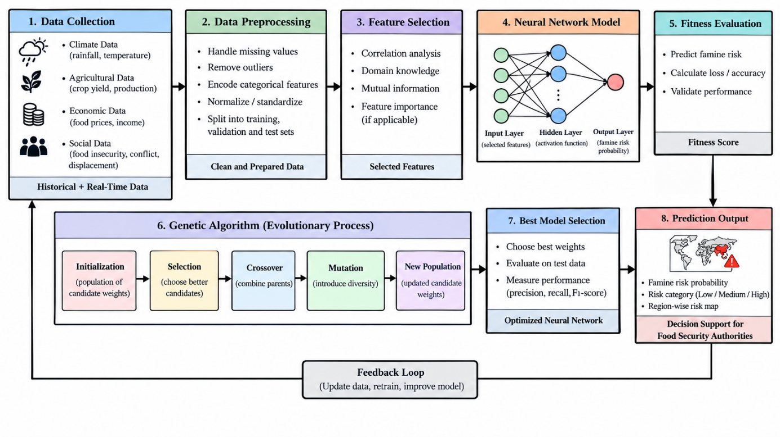

6. Illustrative Example of Hypothesis Space Search
Consider a hypothetical neural network that predicts whether a region is at elevated famine risk. Its inputs include rainfall anomaly, crop yield, and food-price change. The output is a probability of the defined high-risk class.
Suppose the GA begins with three candidate chromosomes:
Candidate | Encoded neural network parameters | Illustrative training loss
H₁ | Weight configuration 1 | 0.62
H₂ | Weight configuration 2 | 0.41
H₃ | Weight configuration 3 | 0.53
These values are illustrative and are not results from a real famine dataset.
If the objective is to minimize training loss, H₂ is the best of these three candidates because it has the lowest loss. The GA may select H₂ more frequently for reproduction, combine its parameters with those of another parent, and introduce mutations to create new candidates.
The new candidates are evaluated again. Across generations, the population may discover weight configurations with lower loss. However, lower training loss alone does not establish that the model predicts famine risk accurately in new regions or future periods. Validation and independent testing are essential to assess generalization.
7. Advantages of the Approach
- Search over complex parameter spaces: A GA can explore candidate neural network weights without requiring the objective to be differentiable.
- Population-based exploration: Multiple candidate configurations are evaluated, which can help explore different parts of the search space.
- Flexible optimization: The method can be adapted to different network architectures and suitable fitness objectives.
- Potential for nonlinear prediction: Neural networks can model complex relationships among climatic, agricultural, and socioeconomic indicators when sufficient representative data are available.
- Decision-support potential: Reliable risk estimates may help food-security agencies prioritize further assessment and preparedness activities.
8. Limitations and Precautions
- Computational cost: Evaluating many neural network candidates over multiple generations can be expensive.
- No guarantee of a global optimum: A genetic algorithm may converge to a suboptimal solution and does not guarantee the best possible neural network weights.
- Data quality and coverage: Missing, outdated, biased, or geographically unrepresentative data can reduce predictive reliability.
- Class imbalance: Severe famine events may be relatively rare in some datasets, so overall accuracy alone may conceal poor detection of high-risk cases.
- Changing conditions: Conflict, market disruption, policy changes, and climate variability can change the relationships learned from historical data.
- Ethical and operational considerations: Predictions should not be treated as definitive evidence of famine. Independent verification, uncertainty reporting, and expert review are necessary before operational decisions.
9. Relationship to SDG 2 – Zero Hunger
Sustainable Development Goal 2 aims to end hunger, achieve food security and improved nutrition, and promote sustainable agriculture. A well-validated famine-risk prediction system may contribute to this goal by identifying areas requiring further assessment, supporting early-warning activities, and informing the prioritization of food assistance and agricultural support.
The system does not itself eliminate hunger or guarantee that a famine will be prevented. Its contribution depends on data quality, predictive reliability, timely interpretation, and effective action by relevant authorities and humanitarian organizations.
10. Conclusion
Hypothesis space search using a genetic algorithm provides a method for exploring candidate neural network weights for famine risk prediction. Each chromosome represents a candidate model, and fitness evaluation, selection, crossover, and mutation guide the search toward configurations that perform well on the defined objective.
When combined with appropriate preprocessing, validation, independent testing, uncertainty assessment, and expert oversight, this approach can serve as a potential decision-support tool for identifying vulnerable regions. Its relevance to SDG 2 lies in supporting evidence-based food-security monitoring and early-warning efforts, rather than replacing established humanitarian assessment and response systems.

