SIMATS ENGINEERING
ASSESSMENT TOOL 2

COURSE CODE: ITA 0604
COURSE NAME: MACHINE LEARNING
NAME: THARIKA. S
REG NO: 192412031

COURSE OUTCOME COVERED
CO2: Neural Network Representation, Perceptron Model, Multilayer Perceptrons,
Backpropagation Algorithm, Deep Neural Networks, Genetic Algorithms, Hypothesis
Space Search, Genetic Programming, Models of Evaluation and Learning (BL1, BL2)
Assessment Tool Weightage: 20%

QUESTIONS: 15
Total Marks:25

Annexure A
SCENARIO-BASED QUESTIONS

Code of Conduct:
I THARIKA. S (192412031)certify that this submission is my original work
and that I have adhered to the guidelines specified for this assessment.
I understand that any violation of academic integrity rules will result in disciplinary action.
Signature of the student:

QUESTION 1 (5 MARKS)
Explain the Functional Blocks of a Machine Learning System with Supervised and Unsupervised Learning Examples.
1. Aim
To explain the functional blocks of a machine learning system and illustrate the differences between supervised and unsupervised learning using suitable examples.
2. Conceptual Understanding
A Machine Learning (ML) system enables computers to learn patterns from data and make predictions or identify meaningful relationships without explicitly programming every rule. The major functional blocks include data collection, preprocessing, feature extraction, model selection, training, and evaluation.
3. Block Diagram
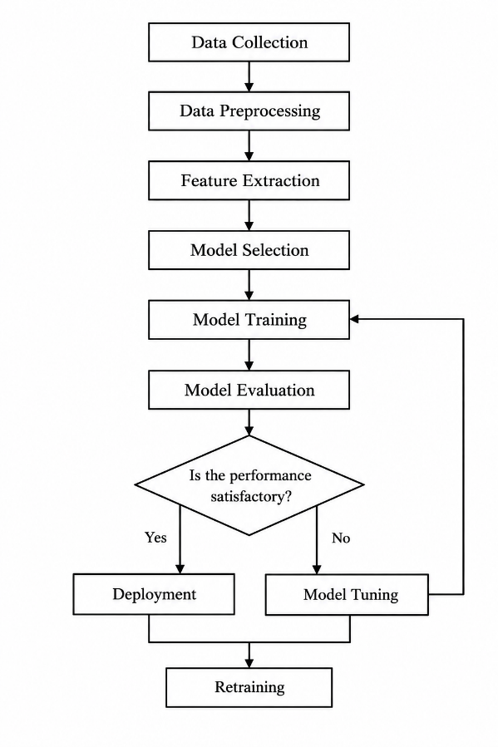
4. Explanation of Functional Blocks
a) Data Collection
Data is gathered from relevant sources such as sensors, databases, surveys, images, and online repositories. The quality and quantity of the collected data influence the performance of the model.
Example: Collecting historical rainfall, river-water levels, and flood records for flood prediction.
b) Data Preprocessing
Raw data is cleaned and transformed into a suitable format. This includes handling missing values, removing duplicate records, treating outliers where appropriate, encoding categorical variables, and normalizing numerical features when necessary.
Example: Filling missing rainfall measurements and converting categorical weather conditions into numerical representations.
c) Feature Extraction
Relevant information is extracted from raw data to represent the problem effectively. This may involve calculating statistical properties, transforming signals, or deriving meaningful variables.
Example: Extracting average rainfall, maximum temperature, and changes in river-water level from weather and sensor records.
d) Model Selection and Training
An appropriate algorithm is selected and trained using the prepared data. The model learns patterns by adjusting its parameters according to the selected learning method.
Example: Training a decision tree or neural network to predict whether a flood will occur.
e) Model Evaluation
The trained model is tested on unseen data to determine how well it generalizes. Suitable evaluation measures include accuracy, precision, recall, F1-score, and mean squared error, depending on the task.
Example: Evaluating a flood-classification model using precision and recall.
5. Supervised and Unsupervised Learning
Supervised Learning
Supervised learning uses labelled data, where each input is associated with a known output. The model learns the relationship between inputs and outputs to predict labels for unseen examples.
Example: A disease-prediction dataset contains patient attributes such as age, glucose level, and blood pressure, along with the known disease status (Yes/No). The model learns from these input-output pairs and predicts the disease status of a new patient.
Unsupervised Learning
Unsupervised learning uses unlabelled data, where the desired output is not provided. The algorithm identifies hidden patterns, similarities, or groups within the data.
Example: A clustering algorithm groups weather records into different patterns based on rainfall, temperature, and humidity without predefined flood or non-flood labels.
6. Comparison
Supervised Learning:
- Data: Labelled
- Objective: Predict known target outputs
- Algorithms: Decision Tree, SVM, Neural Network
- Example: Disease prediction
Unsupervised Learning:
- Data: Unlabelled
- Objective: Discover hidden patterns
- Algorithms: K-Means, Hierarchical Clustering
- Example: Grouping patients by similar characteristics
7. Conclusion
A machine learning system converts raw data into useful predictions or patterns through preprocessing, feature extraction, training, and evaluation. Supervised learning learns from labelled examples, whereas unsupervised learning discovers patterns from unlabelled data. Both approaches are useful depending on the availability of labelled data and the application objective.

QUESTION 2 (5 MARKS)
Design a Machine Learning System for Disaster Management Using Historical and Real-Time Data.
1. Aim
To design a machine learning system that supports disaster prediction and management using historical records and real-time data, thereby improving early warning, risk assessment, and emergency response.
2. Problem Statement
Natural disasters such as floods and earthquakes can cause significant loss of life and property. Traditional monitoring systems may be limited by delayed information or difficulty in analysing multiple data sources simultaneously. A machine learning system can analyse historical patterns and incoming sensor observations to estimate disaster risk and support timely decision-making.
3. Proposed System Architecture
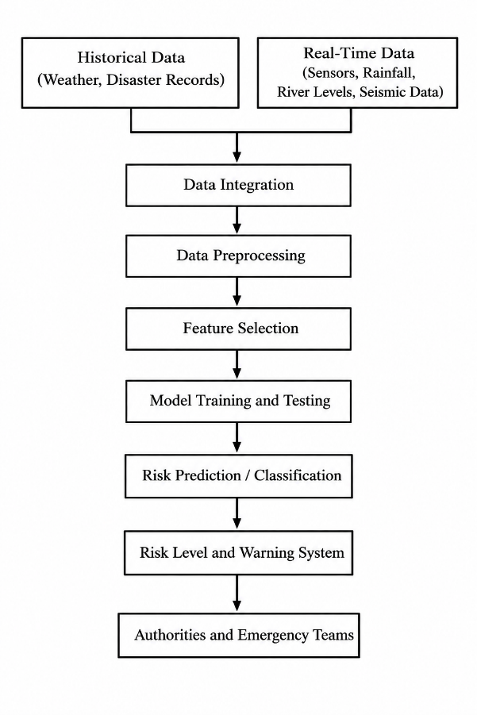
4. Data Sources and Feature Selection
Historical Data Sources
- Previous flood and earthquake records.
- Rainfall, river-water levels, and weather observations.
- Seismic measurements, earthquake magnitude, and location records.
- Geographic information, elevation, and soil characteristics.
- Historical damage assessments and affected population records.
Real-Time Data Sources
- Rain gauges and river-level sensors.
- Weather monitoring stations and satellite observations.
- Seismometers and ground-motion sensors.
- GPS-based location data and other authorized monitoring systems.
Important Features
For flood prediction, useful features include rainfall intensity, cumulative rainfall, river-water level, rate of water-level increase, soil moisture, and elevation.
For earthquake-related applications, useful features include seismic-wave measurements, ground acceleration, historical seismicity, and fault-related geographic information.
Feature selection can be performed using correlation analysis, domain knowledge, mutual information, or feature-importance scores from tree-based models. Selected features should be relevant to the prediction target and available at the time of prediction.
5. Model Selection and Justification
a) Random Forest
Random Forest is suitable for classifying flood risk using structured historical and sensor data. It can model nonlinear relationships and provide feature-importance estimates.
b) Artificial Neural Network (ANN)
An ANN is suitable when sufficient representative training data are available and complex nonlinear relationships need to be learned. Recurrent neural networks may be considered for sequential sensor data.
c) Time-Series Models
Models such as ARIMA may be useful for forecasting variables such as river-water level or rainfall trends when the data satisfy the model's assumptions.
Selected Approach
A Random Forest classifier is a practical baseline for structured flood-risk classification. An ANN can be compared against it using validation results. The final model should be selected based on measured performance rather than assuming that a neural network is always more accurate.
Important Limitation
Earthquakes cannot currently be predicted reliably as exact future events with precise time, location, and magnitude. Machine learning can assist with seismic monitoring, probabilistic hazard assessment, event detection, and rapid estimates after an earthquake. It should not be presented as a guaranteed earthquake prediction system.
6. Data Preprocessing
- Data cleaning: Remove duplicate records and correct invalid measurements.
- Missing-value handling: Impute missing values appropriately or exclude records when necessary.
- Data integration: Combine historical records with time-stamped sensor observations.
- Categorical encoding: Convert categorical variables into numerical form.
- Feature scaling: Standardize or normalize numerical features when required by the selected algorithm.
- Class imbalance handling: Apply class weights or suitable resampling within the training data if disaster events are underrepresented.
- Data splitting: Divide the data into training, validation, and test sets. Use chronological splitting for time-dependent observations to avoid data leakage.
7. Training, Validation, and Evaluation
Training: The model learns the relationship between selected features and known outcomes using historical labelled records.
Validation: Validation data are used to tune model parameters, choose features, adjust classification thresholds, and compare candidate algorithms.
Testing: The final model is evaluated using an independent test set that was not used for training or model selection.
Evaluation Metrics
Precision = TP / (TP + FP)
Recall = TP / (TP + FN)
F1-score = 2 * (Precision * Recall) / (Precision + Recall)
False-Negative Rate = FN / (TP + FN)
For disaster management, recall and false-negative analysis are particularly important because missed warnings can have serious consequences. However, false alarms must also be controlled to maintain public trust.
8. Applications and Benefits
- Early warning: Identifies dangerous conditions and triggers alerts when validated risk thresholds are exceeded.
- Risk assessment: Identifies vulnerable locations using geographic and historical information.
- Resource allocation: Helps authorities prioritize evacuation support, shelters, medical teams, and emergency supplies.
- Emergency response: Integrates updated observations to support operational decisions.
- Continuous improvement: Allows models to be updated as new verified data become available.
The system should complement official disaster-monitoring agencies and verified warning mechanisms rather than replace them.

9. Conclusion
A machine learning-based disaster management system can integrate historical records and real-time observations to estimate risk and support early warning. Appropriate feature selection, leakage-free training, independent testing, and careful evaluation are essential for reliable performance. The system is a decision-support tool, not a guarantee that every disaster can be predicted in advance.

QUESTION 3 (5 MARKS)
Explain How Backpropagation Updates Weights in a Multilayer Perceptron for Binary Classification.
1. Aim
To explain the forward pass, error calculation, backward propagation, and weight-update process in a multilayer perceptron (MLP) used for binary classification.
2. Conceptual Understanding
A multilayer perceptron is a feedforward artificial neural network consisting of an input layer, one or more hidden layers, and an output layer. Each neuron calculates a weighted sum of its inputs, adds a bias, and applies an activation function.
Backpropagation calculates how the loss changes with respect to each weight and bias. Gradient descent then updates these parameters to reduce the loss.
3. Network Architecture
The diagram is illustrative. In a typical fully connected MLP, each neuron in one layer connects to every neuron in the next layer.
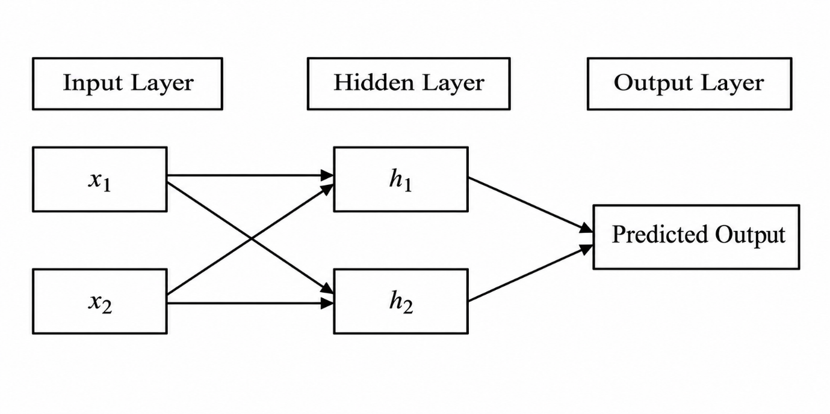
4. Forward Pass
The input features are passed through the network to calculate the predicted output.
Hidden-layer neuron:
z_j = SUM(w_ij * x_i) + b_j
h_j = f(z_j)
Output neuron:
z_o = SUM(v_j * h_j) + b_o
Predicted output:
y_hat = sigmoid(z_o)
sigmoid(z_o) = 1 / (1 + exp(-z_o))
Here:
- x_i = Input feature
- w_ij = Input-to-hidden weight
- b_j = Hidden-layer bias
- v_j = Hidden-to-output weight
- b_o = Output-layer bias
- y_hat = Predicted probability of the positive class
The sigmoid function produces an output between 0 and 1. A threshold, commonly 0.5, can be used to classify the output as Yes or No.
5. Error Calculation
For binary classification, binary cross-entropy is a commonly used loss function.
Loss = -[y * ln(y_hat) + (1 - y) * ln(1 - y_hat)]
Here:
- y = Actual output
- y_hat = Predicted probability
- ln = Natural logarithm
A large loss indicates that the prediction is inconsistent with the actual label. Training attempts to minimize the loss across the training examples.

6. Backward Propagation and Weight Updates
Backpropagation applies the chain rule of differentiation to calculate the gradient of the loss with respect to each weight.
For a sigmoid output with binary cross-entropy loss:
Output error term:
delta_o = y_hat - y
Hidden-layer error term:
delta_j = f'(z_j) * v_j * delta_o
Output-layer weight gradient:
dL/dv_j = delta_o * h_j
Hidden-layer weight gradient:
dL/dw_ij = delta_j * x_i
Weights are updated using gradient descent.
Output-layer weight update:
v_j_new = v_j_old - eta * delta_o * h_j
Hidden-layer weight update:
w_ij_new = w_ij_old - eta * delta_j * x_i
Here, eta represents the learning rate. Biases are updated similarly using their respective gradients.
7. Simple Numerical Illustration
Consider a single sigmoid output neuron with one input.
Given:
Input x = 1
Initial weight w = 0.5
Bias b = 0
Actual output y = 1
Learning rate eta = 0.1
Step 1: Forward Pass
z = w * x + b
z = 0.5 * 1 + 0 = 0.5
Predicted output:
y_hat = 1 / (1 + exp(-0.5))
y_hat = 0.6225 approximately
Step 2: Calculate the Error Term
delta = y_hat - y
delta = 0.6225 - 1
delta = -0.3775
Step 3: Calculate the Weight Gradient
dL/dw = delta * x
dL/dw = -0.3775 * 1
dL/dw = -0.3775
Step 4: Update the Weight
New weight = Old weight - Learning rate * Weight gradient
New weight = 0.5 - 0.1 * (-0.3775)
New weight = 0.5 + 0.03775
New weight = 0.53775 approximately
Step 5: Update the Bias
New bias = Old bias - Learning rate * Error term
New bias = 0 - 0.1 * (-0.3775)
New bias = 0.03775 approximately
The weight increases because the target is 1 while the initial predicted probability is only about 0.6225. This update increases the predicted probability for the given positive input.
Note: This numerical example uses a single sigmoid neuron to demonstrate the weight-update principle. In an MLP, the same procedure is applied to the output layer and then propagated backward through the hidden layers.
8. Influence of Learning Rate and Activation Functions
Learning Rate
A small learning rate generally produces smaller, more gradual updates and may slow training. An excessively large learning rate can cause unstable updates or prevent convergence. A suitable learning rate balances training speed and stability.
Activation Functions
- Sigmoid: Useful for producing binary-classification probabilities at the output layer, but may suffer from vanishing gradients in hidden layers.
- ReLU: Commonly used in hidden layers because it is computationally simple and can reduce the vanishing-gradient problem for positive activations.
- Tanh: Produces values between -1 and 1 and can be useful in some hidden-layer configurations.
The choice of activation function affects gradient flow, convergence, and the network's ability to learn nonlinear patterns.
9. Conclusion
Backpropagation trains an MLP by calculating prediction error, propagating gradients backward through the network, and updating weights and biases using gradient descent. A suitable learning rate, appropriate activation functions, and sufficient representative training data help improve convergence and classification performance.

QUESTION 4 (5 MARKS)
Explain the Evolution of Candidate Solutions Using a Genetic Algorithm to Maximize Fitness.
1. Aim
To explain how a Genetic Algorithm optimizes candidate solutions using selection, crossover, and mutation, and to identify the best solution based on the given fitness values.
2. Conceptual Understanding
A Genetic Algorithm (GA) is a population-based optimization technique inspired by natural selection and biological evolution. It searches for an optimal or near-optimal solution by repeatedly evaluating candidate solutions and generating new candidates.
The main operations are:
- Selection: Chooses promising individuals based on their fitness.
- Crossover: Combines information from selected parent solutions to generate offspring.
- Mutation: Randomly modifies selected genes to introduce diversity and explore new solutions.
- Fitness evaluation: Measures the quality of each candidate solution.
3. Given Dataset
Example 1: Speed = High, Accuracy = Low, Fitness = 40, Suitable = No
Example 2: Speed = Medium, Accuracy = Medium, Fitness = 60, Suitable = Yes
Example 3: Speed = High, Accuracy = Medium, Fitness = 75, Suitable = Yes
Example 4: Speed = Low, Accuracy = High, Fitness = 65, Suitable = Yes
Example 5: Speed = Medium, Accuracy = High, Fitness = 80, Suitable = Yes
The objective is to maximize the fitness value while identifying a suitable combination of speed and accuracy.
4. Chromosome Representation
Each candidate solution can be represented as a chromosome containing two genes.
Chromosome = [Speed, Accuracy]
Examples:
Example 1 = [High, Low]
Example 2 = [Medium, Medium]
Example 3 = [High, Medium]
Example 4 = [Low, High]
Example 5 = [Medium, High]
The given fitness values are used to evaluate the initial candidates. A separate mathematical fitness function has not been provided, so the given scores are treated as the authoritative fitness values for the initial population.
5. Step-by-Step Genetic Algorithm
Step 1: Initial Population
The five candidate solutions form the initial population. Their fitness values range from 40 to 80.
The highest initial fitness is 80, achieved by Example 5, with Medium speed and High accuracy.
Step 2: Selection
Selection gives preference to candidates with higher fitness values. Tournament selection or fitness-proportionate selection can be used.
For example, Example 5 with fitness 80 and Example 3 with fitness 75 are strong candidates for selection as parents. Example 1 with fitness 40 is less likely to be selected.
Selection does not guarantee that the highest-fitness individual will always be chosen; the exact outcome depends on the selection method.
Step 3: Crossover
Crossover combines genes from two selected parents to create offspring.
Suppose the selected parents are:
Parent 1 = [High, Medium]
Parent 2 = [Medium, High]
A possible offspring is:
Offspring = [High, High]
This offspring combines the speed gene of Parent 1 with the accuracy gene of Parent 2.
The fitness and suitability of this offspring cannot be calculated from the supplied dataset alone because a fitness score for the new combination has not been specified. Its fitness must be evaluated using a defined objective function or additional evaluation data.
Step 4: Mutation
Mutation randomly changes one gene in an offspring with a small probability.
Before mutation = [High, High]
After mutation = [Medium, High]
Mutation introduces diversity and allows the algorithm to explore alternative combinations. It may improve or reduce fitness, so the mutated candidate must be evaluated again.
Step 5: Fitness Evaluation and Replacement
The newly generated offspring are evaluated using the fitness function. Depending on the replacement strategy, the best candidates are retained for the next generation.
An elitist strategy preserves the best solution found so far, preventing it from being lost during crossover or mutation.
6. Evolution Across Generations
Initial population:
Example 1: [High, Low] - Fitness 40
Example 2: [Medium, Medium] - Fitness 60
Example 3: [High, Medium] - Fitness 75
Example 4: [Low, High] - Fitness 65
Example 5: [Medium, High] - Fitness 80
Next generation:
Candidate = [High, High]
Fitness = Not provided
This is an illustrative crossover offspring. Its fitness must be calculated separately.
Candidate = [Medium, High]
Fitness = 80, based on the supplied dataset for this combination.
This is an illustrative candidate matching Example 5. The table does not establish that fitness increases in every generation. In a real GA, improvement depends on the fitness function, selection strategy, crossover, mutation, and replacement method.
7. Final Optimized Solution
Among the five candidates in the supplied dataset, the highest-fitness suitable solution is:
Speed = Medium
Accuracy = High
Fitness Value = 80
Suitable Solution = Yes
Therefore, Example 5 is the best solution among the given candidates.
It cannot be claimed to be the global optimum of every possible speed-accuracy combination without a complete fitness function and evaluation of the search space.
8. Conclusion
A Genetic Algorithm improves candidate solutions through selection, crossover, mutation, and repeated fitness evaluation. Based on the given dataset, Example 5, with Medium speed and High accuracy, achieves the maximum recorded fitness of 80. Further generations may explore other combinations, but their fitness must be evaluated before claiming additional improvement.

QUESTION 5 (5 MARKS)
Explain Neural Network Classification Using Backpropagation and Evaluate the Model Using a Confusion Matrix.
1. Aim
To explain how a neural network classifies patients based on medical attributes, calculate the confusion matrix values from actual and predicted outputs, and evaluate the model using standard classification metrics.
2. Problem Statement
A neural network is used to predict whether a patient has a disease based on age, blood pressure, glucose level, and lifestyle risk. The model's performance is evaluated by comparing its predicted outputs with the actual disease labels.
3. Given Dataset
Example 1:
Age = 45
Blood Pressure = High
Glucose Level = High
Lifestyle Risk = High
Actual Output = Yes
Predicted Output = Yes
Example 2:
Age = 50
Blood Pressure = Normal
Glucose Level = High
Lifestyle Risk = Medium
Actual Output = Yes
Predicted Output = No
Example 3:
Age = 30
Blood Pressure = Normal
Glucose Level = Normal
Lifestyle Risk = Low
Actual Output = No
Predicted Output = No
Example 4:
Age = 60
Blood Pressure = High
Glucose Level = High
Lifestyle Risk = High
Actual Output = Yes
Predicted Output = Yes
Example 5:
Age = 40
Blood Pressure = Normal
Glucose Level = Normal
Lifestyle Risk = Medium
Actual Output = No
Predicted Output = Yes
Here, Yes represents the positive class (disease present), and No represents the negative class (disease absent).
4. Neural Network Architecture and Training
A feedforward neural network can be designed with four input features, one or more hidden layers, and one output neuron.
Input Layer:
- Age
- Blood Pressure
- Glucose Level
- Lifestyle Risk

Hidden Layer:
- Weighted sums
- Activation functions
Output Layer:
- Disease probability
- Yes / No prediction
Forward Propagation
The input features are passed through the network. Each neuron calculates a weighted sum and applies an activation function to produce the output.
Weighted sum:
z = SUM(w_i * x_i) + b
Predicted probability:
y_hat = 1 / (1 + exp(-z))
Here, w_i denotes a weight, x_i denotes an input feature, b is the bias, and y_hat is the predicted probability of the disease.
If the predicted probability is at least 0.5, the output may be classified as Yes; otherwise, it is classified as No.
Error Calculation
The predicted output is compared with the actual label using a suitable loss function, such as binary cross-entropy.
Loss = -[y * ln(y_hat) + (1 - y) * ln(1 - y_hat)]

Backpropagation
The loss gradients are propagated backward through the network to calculate how the weights and biases should change.
Weight update:
New weight = Old weight - Learning rate * Weight gradient
These steps are repeated over the training data until the model learns useful patterns. The supplied predicted outputs are treated as given; the original training parameters are not provided, so the predictions cannot be independently reproduced from the table alone.
5. Confusion Matrix Calculation
A confusion matrix compares actual labels with predicted labels.
True Positive (TP): Actual Yes, predicted Yes.
True Negative (TN): Actual No, predicted No.
False Positive (FP): Actual No, predicted Yes.
False Negative (FN): Actual Yes, predicted No.
Step-by-Step Calculation
Example 1: Actual = Yes, Predicted = Yes.
Result: TP = 1.
Example 2: Actual = Yes, Predicted = No.
Result: FN = 1.
Example 3: Actual = No, Predicted = No.
Result: TN = 1.
Example 4: Actual = Yes, Predicted = Yes.
Result: TP = 1.
Example 5: Actual = No, Predicted = Yes.
Result: FP = 1.
Therefore:
TP = 2
TN = 1
FP = 1
FN = 1
6. Confusion Matrix
Actual Yes, Predicted Yes = 2 (TP)
Actual Yes, Predicted No = 1 (FN)
Actual No, Predicted Yes = 1 (FP)
Actual No, Predicted No = 1 (TN)
Total observations = TP + TN + FP + FN
Total observations = 2 + 1 + 1 + 1 = 5
7. Performance Evaluation Metrics
a) Accuracy
Accuracy measures the proportion of all predictions that are correct.
Formula:
Accuracy = (TP + TN) / (TP + TN + FP + FN) * 100
Substitution:
Accuracy = (2 + 1) / (2 + 1 + 1 + 1) * 100
Accuracy = 3 / 5 * 100
Accuracy = 60%
b) Precision
Precision measures the proportion of predicted positive cases that are actually positive.
Formula:
Precision = TP / (TP + FP) * 100
Substitution:
Precision = 2 / (2 + 1) * 100
Precision = 2 / 3 * 100
Precision = 66.67%
c) Recall (Sensitivity)
Recall measures the proportion of actual positive cases correctly identified.
Formula:
Recall = TP / (TP + FN) * 100
Substitution:
Recall = 2 / (2 + 1) * 100
Recall = 2 / 3 * 100
Recall = 66.67%
d) Specificity
Specificity measures the proportion of actual negative cases correctly identified.
Formula:
Specificity = TN / (TN + FP) * 100
Substitution:
Specificity = 1 / (1 + 1) * 100
Specificity = 1 / 2 * 100
Specificity = 50%
e) F1-Score
The F1-score is the harmonic mean of precision and recall.
Formula:
F1-score = 2 * (Precision * Recall) / (Precision + Recall)
Using the exact fractions:
F1-score = 2 * ((2/3) * (2/3)) / ((2/3) + (2/3))
F1-score = 4/9 / (4/3)
F1-score = 1/3 * 2
F1-score = 2/3
F1-score = 66.67%
f) Error Rate
Error rate measures the proportion of incorrect predictions.
Formula:
Error Rate = (FP + FN) / Total Observations * 100
Substitution:
Error Rate = (1 + 1) / 5 * 100
Error Rate = 2 / 5 * 100
Error Rate = 40%
8. Summary of Calculated Results
True Positives (TP) = 2
True Negatives (TN) = 1
False Positives (FP) = 1
False Negatives (FN) = 1
Accuracy = 60%
Precision = 66.67%
Recall / Sensitivity = 66.67%
Specificity = 50%
F1-Score = 66.67%
Error Rate = 40%
9. Interpretation of Results
The model achieves 60% accuracy, correctly classifying three out of five patients. Its precision and recall are both 66.67%, meaning that two out of three predicted positive cases are correct and two out of three actual positive cases are detected.
However, the model has one false negative and one false positive. The false negative represents a patient with the disease who is incorrectly classified as disease-free. In medical applications, this error may have serious consequences.
The specificity of 50% indicates that only half of the actual negative cases are correctly identified. Therefore, the model requires further improvement and independent validation before it can be considered suitable for clinical decision support.
The five observations are too few to establish reliable real-world performance.
10. Role of Preprocessing and Feature Selection
Data Preprocessing
- Handle missing or inconsistent patient records.
- Encode categorical features such as blood pressure and lifestyle risk into numerical values.
- Normalize or standardize numerical features where appropriate.
- Check for outliers and data-entry errors.
- Split the data into training, validation, and test sets to avoid overfitting and data leakage.

Feature Selection
- Identify relevant features using domain knowledge and statistical analysis.
- Remove redundant or irrelevant variables where justified.
- Use methods such as mutual information, correlation analysis, or model-based feature importance.
- Perform feature selection using training data only to prevent information leakage.
These steps can improve model efficiency and generalization, but they do not guarantee higher accuracy. Their effectiveness must be verified through appropriate validation.
11. Conclusion
The neural network classification results produce TP = 2, TN = 1, FP = 1, and FN = 1. The calculated accuracy is 60%, precision is 66.67%, recall is 66.67%, specificity is 50%, and F1-score is 66.67%.
These results indicate limited performance on the supplied examples, with errors that require attention. Appropriate preprocessing, feature selection, larger representative datasets, and independent validation are necessary to improve reliability.

