Group: SE-2111, SE-2112

Students: Orynbasar Aizhan, Beknazarova Aidana.

Link to the presentation: [here](https://www.canva.com/design/DAFl0TRk1PA/yXvAUCEOehP7QWk_2NDMCQ/edit?utm_content=DAFl0TRk1PA&utm_campaign=designshare&utm_medium=link2&utm_source=sharebutton)

Link to the GitHub: <https://github.com/through-this-dunya/finalProject>

**Project Proposal:**

* The relevance of the topic.

The topic of selling smart watches is highly relevant in the modern world, as wearable electronics devices are becoming more and more popular and in demand among a wide audience. Here are a few reasons why this topic is relevant:

1. Expanding functionality: Smart watches not only show the time, but also perform many other tasks. They allow you to track physical activity, monitor your heart rate, receive notifications of incoming calls and messages, and use many useful applications. More and more people are looking for devices that combine many functions in one compact device, and smartwatches are ideally suited to this requirement.

2. Health and fitness: At present, fitness and a healthy lifestyle are gaining more and more popularity. Smartwatches provide the ability to track physical activity, monitor heart rate and exercise levels, and offer personalized recommendations and tips to achieve a healthy lifestyle. This is especially true in the context of increased interest in health and fitness in the wake of the COVID-19 pandemic.

3. Technological progress: Smart watches are an example of advanced technology and innovation. They combine the functions of a computer, phone and fitness tracker, allowing users to be always connected and control their lives right from the wrist. Regular updates and new features make these devices even more attractive to a wide audience, which encourages many to purchase smartwatches.

4. Style and fashion: Smart watches have also become a fashion accessory. Many manufacturers offer a wide range of styles, colors and materials to suit individual customer preferences. Thanks to this, smart watches have become not only a functional device, but also an element of style and fashion, allowing you to express your individuality and emphasize your image.

All these factors make the topic of selling smart watches relevant and attractive for business. It offers an opportunity to meet the growing demand for the latest technology and devices, helps people improve their health and lifestyle, and provides a stylish and fashionable accessory for everyday use.

* Analysis of competitors

|  |  |  |  |
| --- | --- | --- | --- |
| # | Name | Description | Link |
| 1 | Mobilephones | Mobilephones is a chain of electronics stores offering a wide selection of smartwatches of various brands and models.  **pros:**  Easy to use and understandable;  **cons:**  Old site design;  No registration and authorization; | https://mobilephones.kz/ |
| 2 | Tehcom | Tehcom is an electronics retail chain that offers a variety of smart watches from various brands.  **pros:**  Easy to use and understandable;  Minimalist website design;  **cons:**  No registration and authorization; | https://tehcom.kz/g8065198-smart-chasy |
| 3 | Mechta | Mechta is a large multi-brand chain of electronics stores, present in different cities of Kazakhstan.  **pros:**  Good search filtering  Easy and fast payment | <https://www.mechta.kz/section/smart-chasy/> |
| 4 | Shop.kz | Shop.kz is an online store specializing in the sale of mobile devices and accessories.  **pros:**  Good search engine  **cons:**  No registration and authorization;  A lot of filters and they don't work well | <https://shop.kz/smart-chasy/filter/almaty-is-v_nalichii-or-ojidaem-or-dostavim/apply/> |

* Project auditory

The audience of a project aimed at selling smart watches can be quite wide and varied. Here are some characteristics of the target audience:

|  |  |
| --- | --- |
| Gender | Smart watches are of interest to both men and women. Depending on the brand and model, smartwatches can be designed with different styles and preferences in mind to cater to the interests of both genders. |
| Age | The target audience may include people of different age groups. Smart watches can be attractive to young people who lead an active lifestyle and are interested in new technologies. At the same time, they may also be of interest to more mature people who value functionality, convenience, and health tracking capabilities. |
| Technical Knowledge | The target audience may vary in terms of technical knowledge. Some potential buyers may be seasoned technology enthusiasts, while others may be newcomers who are just getting started with wearable electronics. |
| Interests and needs | The target audience may include people who are interested in fitness and a healthy lifestyle, those who need constant communication and task management, as well as those who value the style and fashionable look of an accessory. |

* Project features

Before the implementation of the project, we conducted a mini-analysis and found out that there are many stores for selling smart watches, but many stores do not have a website. They only sell through social media. And where there are sites, there is no usual understandable service. In short, sites selling smart watches will not be superfluous, and as you know, in our time, all businesses need advertising, social networks and selling sites. Therefore, our project is needed for beginners or people with existing medium-sized businesses. Therefore, the peculiarity of our project is an understandable and simple function.

**Project Description**

Descriptions for object modeling in software development

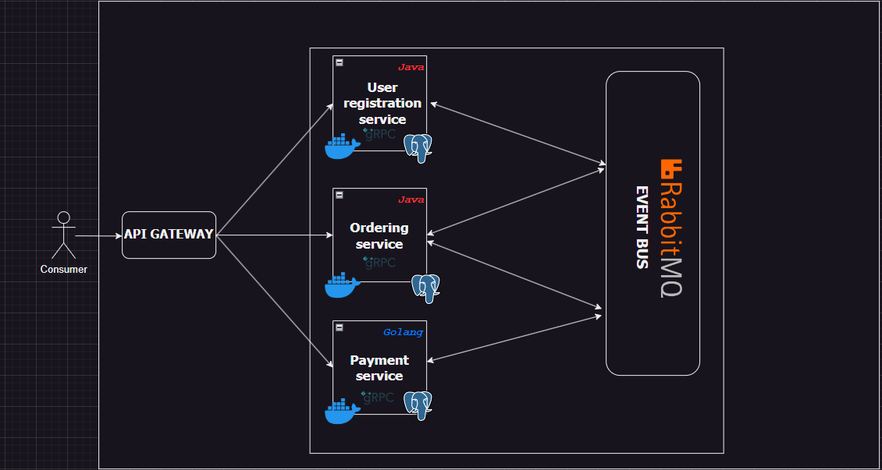

Our project is written in Golang and we use PostgreSQL for the database. The site has the functions of registering with a token and logging in.

**Who did what?**

*Aizhan – backend developer.*

Aizhan was the AI2 project manager and backend developer. Made the main functions of the website and tested the functions. During development, she did many experiments about the database. The project was developed in the Golang programming language in the Visual Studio environment. She was responsible for microservices like Product SVC (gRPC) and Authentication SVC (gRPC).Using leadership skills, she led the team, tracked progress, and motivated them to work effectively.

*Aidana – backend developer*

Aidana worked as a backend developer in our project, who planned and managed the development schedule. The backend was developed in the Golang programming language in the Visual Studio environment. She was responsible for microservice like Order SVC (gRPC) and API Gateway (HTTP).Also helped in fixing bugs during the project.