Department of CSE (Artificial Intelligence & Machine Learning)

Academic Year: 2024-25 Name of Student: Raj Nikam
Semester: V Student ID: 22106027
Class / Branch: T.E./ CSE(AI&ML) Roll No: 61
Subject: WCN Lab
Name of Instructor: Prof. Poonam Tiware

Experiment No. 6
Aim: Create webpage using react and express js
Program:
For creating the express backend:
- mkdir backend
- npm init -y
- npm install express cors nodemon concurrently
- Modify the scripts section of package.json as mentioned below
- Run the development server using: npm run dev
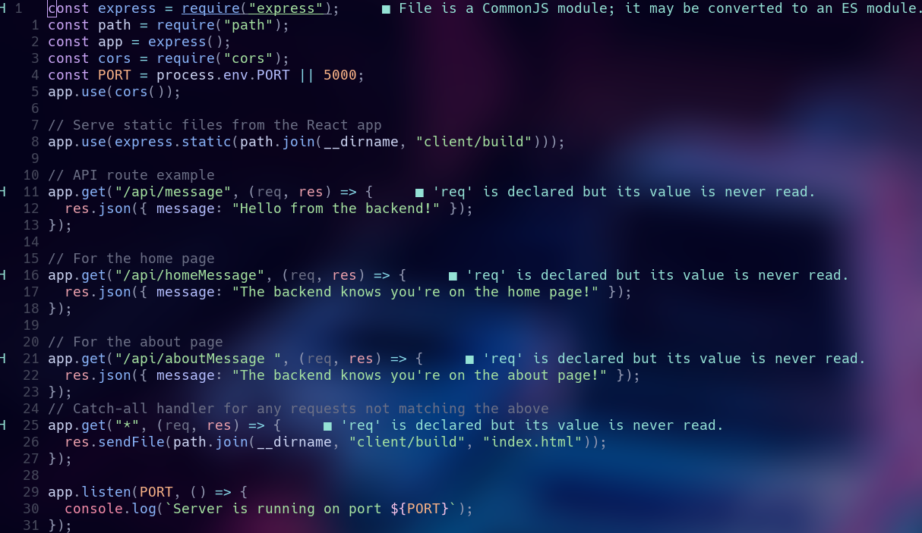
Server.js:

package.json
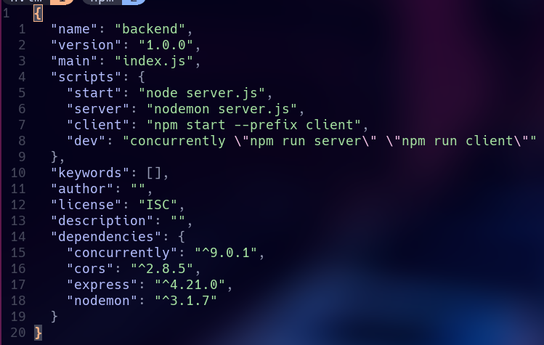
Create the frontend:
1. npx create-react-app frontend
2. npm install react-router-dom
3. Create 2 files in src: Home.js and About.js
4. Create the build using: npm run build

App.js
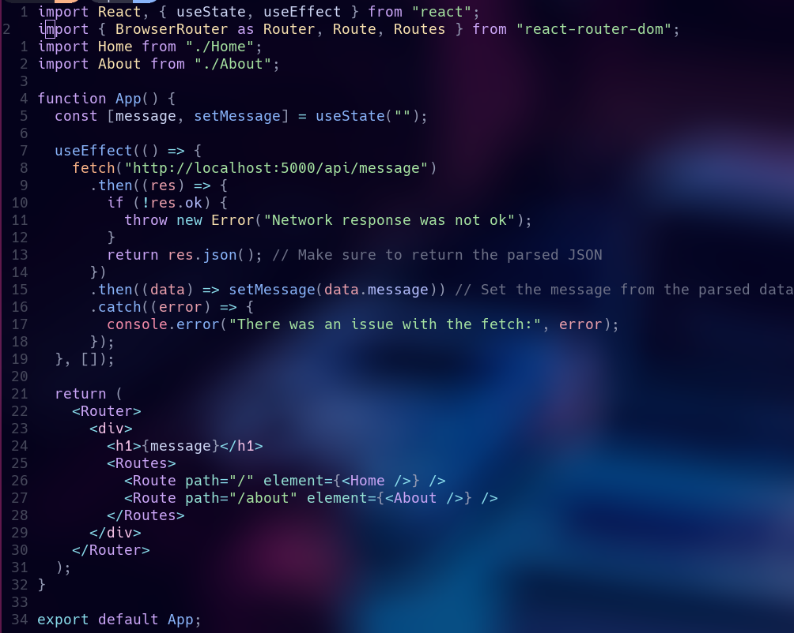

About.js
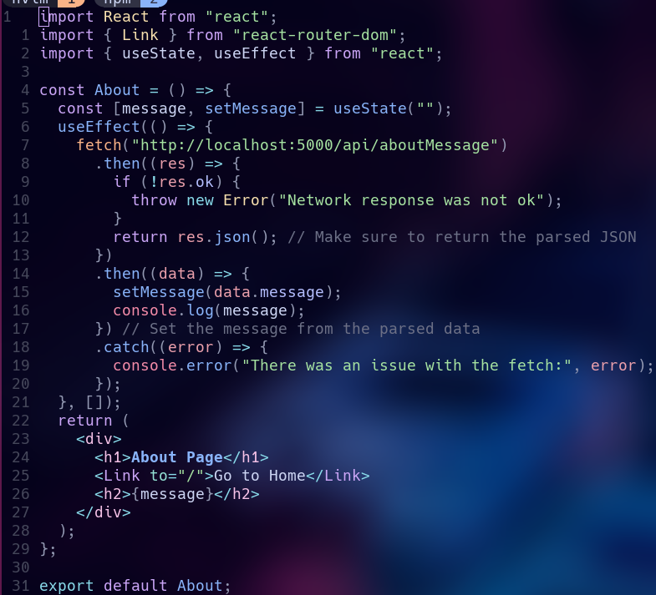

Home.js
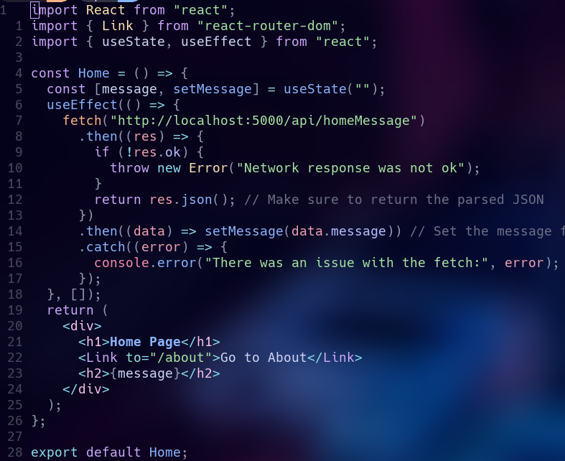

Output:
