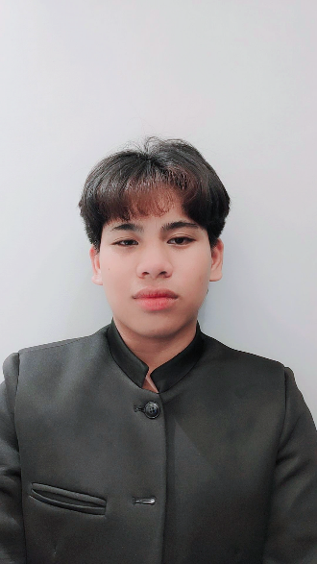**KEN LESTHER MEJIA GUENALDO**

Brgy. Utod Nasugbu, Batangas

0956-962-7217

[kenguernaldo@gmail.com](mailto:kenguernaldo@gmail.com)

# Objective

For this matter, I would like to continue and use my valuable knowledge and skills from different work environment to obtain a position with a company that extends opportunities for growth and advancement and become an asset of your company.

# EDUCATIONal background

Nasugbu Christian Faith Academy

*Junior High*

San Roque St. Brgy. 4 Nasugbu, Batangas

Present

Bagbag National High School

*Junior High*

Greenfield, Rosario Cavite

2017 - 2021

Bagbag Elementary School

Novaliches, Quezon City

2013 - 2017

# Skills

* Adaptability
* Quick learner
* Flexibility
* Communication
* Computer Literate (MSWord, Powerpoint, Excel)

# Personal information

Age : 16

Date of Birth : October 3, 2006

Sex : Male

Place of Birth : Nasugbu, Batangas

Citizenship : Filipino

Religion : Roman Catholic

Civil Status : Single

# Reference

Leo Angelo Reloj Magat

Brgy. Calayo Nasugbu Batangas

Mario Obrador

Brgy. Utod Nasugbu, Batangas

*Brgy. Captain*

Ireneo B. Guernaldo

Brgy. Utod Nasugbu, Batangas

*Brgy. Councilor*

*I hereby certify the above information is true and correct with the best of my knowledge.*

Ken Lesther Mejia Guernaldo

Applicant