1 2 3 4 5 6 7 8

预留5V输入接口，连接器间距2.54mm
SWD调试编程接口
J1
1
2
3
4
5

SDI

GND PB15/MOSI

3V3 J4

GND
10
11
BOOT0 | BOOT1 | 启动方式
0 | 无关 | 用户闪存
1 | 0 | ISP下载模式
1 | 1 | 内部RAM

U5
MiniSD
DAT3 CMD
Vss Vcc CLK
Css2 DAT0 DAT1 DAT2
1 SDIO_D2 PC10

5V

C5
A 106
3
C3 104
U1
AMS1117-3.3V
VCCOUT
2
C2
1
GND

106
3V3

C4 104
1 K A 2
GD GD

D3 5V1

STM32工作模式已经默认接地：BOOT0通过R7接地

GND
GD GD
C1

3V3

104
BOOT0
3V3 GND
R1
10K PA13_SWDIO
PA14_SWCLK

R4 10K

SPI_1X5
SCL

CS SDO
D/C BLK
PB13/SCK
PB12/CS PB14/MISO

PB1/RS
PB0/BLK

SIP8-2.54mm
1
2
3
4
5
6
7
8
2 SDIO_D3 PC11
3 SDIO_CMD PD2 3V3 4
5 SDIO_SCK PC12
6
7 SDIO_D0 PC8
8 SDIO_D1 PC9
9 SD_NC

C19 104

A

GND
STM32工作模式选择

GND
TFT液晶屏接口
GND

供电稳压供电
DevEBox 大越创新

GND
12
13

DevEBox大越电子mcudev.taobao.com 大越电子出品
可以接本店：0.96寸、1.3寸OLED液晶屏 1.3寸、2.0寸TFT 高清液晶屏
1.44寸、1.8寸TFT液晶屏 2.4寸、2.8寸TFT液晶屏

SD/TF卡接口(小卡座，自弹)

大越电子出品: shop389957290.taobao.com
大越电子出品: shop389957290.taobao.com

还有其他规格，欢迎到店咨询
店铺：mcudev.taobao.com

3V3

R5 510R
1

D1 LED
2 1

STM32H750VB /H743VI核心板
内 核 ：Cortex-M7 (H750VB) FLASH：128K
(H743VI) FLASH：2048K (2M)

QUADSPI_BK1_IO2 PE2

U2

STM32H750VB /H743VI
- PE2/SPI4_SCK
VDD 100

3V3

GND

3V3

GND
PB11 PB10

PC4

J6

1

1
2
3
4
5
6
7
8
9
10
11
12
13
14
15
16
17
18
19
20
21
22
23
24
2
3
4
5
DCMI_SDA 6
DCMI_SCL 7
8
DCMI_RESET 9

可以接本店摄像头模块：
OV2640-200 万像素
OV5640-500 万像素(自动对焦)

RAM：1024K
2

C8 10P
PE3 DCMI_D4 PE4 DCMI_D6 PE5 DCMI_D7 PE6
- PE3
- PE4/SPI4_NSS/DCMI_D4
- PE5/SPI4_MISO/DCMI_D6
- PE6/SPI4_MOSI/DCMI_D7
VSS 99
PE1/UART8_TX/DCMI_D3 98
PE0/UART8_RX/DCMI_D2 97
PB9/I2C1_SDA/UART4_TX/FDCAN1_TX 96

PE1 DCMI_D3 PE0 DCMI_D2 PB9
GND
PA5 PA7 PA4 PB7
DCMI_CH1 10
DCMI_PWDN 11
DCMI_HREF 12
DCMI_VSYNC 13
此处为FPC插座（翻盖式）

GND
VBAT 6
Y1
VBAT
PB8/I2C1_SCL/UART4_RX/FDCAN1_RX 95
PB8 R7
PC6
DCMI_D0 14
店铺可以选购FPC转接延长线

供电指示灯
B
GND
GND

C9

C10 20P

C11 20P

10P

Y2 25M

32.768K

GND

C6 104

GND 3V3

RST

GND

VREF+
PC13 7
PC14 8
PC15 9
10
11
12
13
14
PC0 15
PC1 16
PC2 17
PC3 18
19
20
PC13/RTC_TAMP_1/ RTC_TS PC14-OSC32_IN
PC15-OSC32_OUT VSS
VDD
PH0-OSC_IN PH1-OSC_OUT NRST
PC0 PC1
PC2_C/ADC3_INP0 PC3_C/ADC3_INP1 VSSA
VREF+
BOOT0 94
PB7/I2C4_SDA 93
PB6/I2C4_SCL 92
PB5/SPI1_MOSI 91
PB4/SPI1_MISO 90
PB3/SPI1_SCK 89
PD7 88
PD6/USART2_RX 87
PD5/USART2_TX 86
PD4 85
PD3 84
PD2/SDMMC1_CMD 83
PD1/UART4_TX/FDCAN1_TX 82
PD0/UART4_RX/FDCAN1_RX 81

PB7 PB6 PB5 PB4 PB3 PD7 PD6 PD5 PD4 PD3 PD2 PD1 PD0
BOOT0
DCMI_VSYNC 10K QSPI_BK1_NCS
SPI1_MOSI SPI1_MISO SPI1_SCK

DCMI_D5 SDIO_CMD
GND

GND
PC7 PE0 PE1 PE4 PD3 PE5 PE6 PA6 PA8
DCMI_D1 DCMI_D2 DCMI_D3 DCMI_D4 DCMI_D5 DCMI_D6 DCMI_D7 DCMI_PCLK DCMI_XCLK
15
16
17
18
19
20
21
22
23
24

FPC-24P
25
26

店铺1：mcudev.taobao.com B
店铺2: shop389957290.taobao.com
GD GD

3V3
GND
Key RST GND
C17
VDDA

PA0
PA1 PA2 PA3
- VDDA
- PA0/TIM2_CH1/TIM5_CH1/UART4_TX
PC12/SDMMC1_CK 80
PC11/SDMMC1_D3 79
PC12 SDIO_SCK
PC11 SDIO_D3
PC10 SDIO_D2 PA15
PA14_SWCLK

GND

mcudev.taobao.com
C22
1 2
3 4
5 6
7 8
9 10
11 12
13 14
15 16
17 18
19 20
21 22
23 24
25 26
27 28
29 30
31 32
33 34
35 36
37 38
39 40
41 42
43 44

PA1
R14 2 D2
1
3V3
R34

0R
R11
0R
104
23
24
25

26
PA1/TIM2_CH2/TIM5_CH2/UART4_RX PA2/TIM2_CH3/TIM5_CH3/USART2_TX PA3/TIM2_CH4/TIM5_CH4/USART2_RX
PC10/SDMMC1_D2
PA15 PA14 /SWCLK
78
77
76

75
DCMI接口-摄像头插座
510R
2 1 LED
GND
C23 104
GND
3V3 DCMI_HREF PA4
27
28
VSS VDD
VDD VSS
74
73
3V3 GND
DCMI_CH1
PA5
29
PA4/SPI6_NSS/DCMI_HSYNC
VCAP
72 2.2uF
PA13_SWDIO
DCMI_PCLK PA6 DCMI_PWDN PA7 DCMI_RESET PC4
PC5
30
31
32
33
PA5/SPI6_SCK PA6/SPI6_MISO/DCMI_PIXCLK PA7/SPI6_MOSI
PC4
PA13 /SWDIO PA12/OTG_FS_DP PA11/OTG_FS_DM PA10/USART1_RX
71
70
69
68
PA12/USB_DP PA11/USB_DM
PA10/RXD1
PA9/TXD1
5V
J2
5V
LED指示灯
PB0/BLK
PB1/RS
PB0 PB1
34
35
PC5 PB0/TIM3_CH3
PA9/USART1_TX PA8/MCO1
67
66
PA8 PC9
DCMI_XCLK SDIO_D1
3V3
3V3
PE7/UART7_RX PE8/UART7_TX
PC7/TIM3_CH2/USART6_RX/DCMI_D1 PC6/TIM3_CH1/USART6_TX/DCMI_D0

QUADSPI_CLK PB2
PD9
PD11 PD13
PD10 PD12
- PB1/TIM3_CH4
PC9/SDMMC1_D1 65
PC8
SDIO_D0

PE7
- PB2
PC8/SDMMC1_D0 64 PC7 DCMI_D1
GND
PD8
GND

PE9/TIM1_CH1/UART7_RTS PE10/TIM1_CH2N/UART7_CTS PE11/TIM1_CH2/SPI4_NSS PE12/TIM1_CH3N/SPI4_SCK PE13/TIM1_CH3/SPI4_MISO PE14/TIM1_CH4/SPI4_MOSI PE15/FMC_D12/LCD_R7
PD15/TIM4_CH4 PD14/TIM4_CH3 PD13/I2C4_SDA PD12/I2C4_SCL
PD11 PD10 PD9/USART3_RX
PD14
PD13 QUADSPI_BK1_IO3 PD12 QUADSPI_BK1_IO1 PD11 QUADSPI_BK1_IO0 PD10
PD9 PD8
PD15 PC7 PC9
PA9/TXD1 PA11/USB_DM PA15
PC11
PE8 PE9
38
39
63
62
PC6 PD15
DCMI_D0

GND
C

GND

K1

Key K2

Key

按键

PE3

PC5

STM32H750VB /H743VI核心板（M版）
DevEBox大越电子 嵌入式开发网精品店
mcudev.taobao.com 大越电子出品

GND 3V3

DCMI_SCL
DCMI_SDA
C21

PB11 47
48
PE10 40
PE11 41
PE12 42
PE13 43
PE14 44
PE15 45
PB10 46
2.2uF 49
50

PB10/TIM2_CH3/I2C2_SCL/USART3_TX PB11/TIM2_CH4/I2C2_SDA/USART3_RX VCAP
VSS VDD

STM32H7xx

C12
C16
C15
C14
C13

104 104 104
104
104

PD8/USART3_TX PB15/SPI2_MOSI
PB14/SPI2_MISO 53
61
60
59
58
57
56
55
54
PB13/SPI2_SCK/FDCAN2_TX 52
PB12/SPI2_NSS/FDCAN2_RX 51

3V3 C18
106

PB15 PB14 PB13 PB12

PB15/MOSI PB14/MISO PB13/SCK PB12/CS

3V3

PD0 PD2 PD4 PD6 PB3 PB5 PB7 PB9 PE1

Header 22X2

J3
1 2
3 4
5 6
7 8
9 10
11 12
13 14
15 16
17 18
19 20
21 22
23 24
25 26
27 28
29 30
31 32
33 34
35 36
37 38
39 40
41 42
43 44

PC12 PD1 PD3 PD5 PD7 PB4 PB6 PB8 PE0

C
PD14 PC6 PC8 PA8
PA10/RXD1 PA12/USB_DP PC10

3V3

大越电子出品: shop389957290.taobao.com

接口支持QSPI接口模式

GND

5V
嵌入式开发网
标准MicroUSB接口
L1
GND
VDDA

PB15 PB13 PB11 PE15 PE13 PE11 PE9 PE7 PB1

VREF+ PB14 PB12 PB10 PE14 PE12 PE10 PE8 PB2 PB0
GND

C20 3V3
即常见安卓手机供电接口
J5
VCC 1
500mA
PC5
PA7 PA5 PA3
PC4
PA6 PA4 PA2

PB6 PD12

U3
QSPI_BK1_NCS 1
CS
QUADSPI_BK1_IO1 2
DO (IO1) HOLD(IO3) WP(IO2) CLK
GND DI (IO0)
GND

104
8
VCC
7 QUADSPI_BK1_IO3 PD13
D- D+ ID GND
- R2 0R
- R3 0R
4
5

PA11/USB_DM
PA12/USB_DP

VBAT

Q1 3V3
1
1
3

2 1
3
PA1 PC3 PC1 PC13 PE5
PA0 PC2 PC0 PE6 PE4

PE2
NC NC NC NC
QUADSPI_BK1_IO2 3
6 QUADSPI_CLK
PB2
Micro_USB
2 PE3
PE2

4

D GND W25QXX
5 QUADSPI_BK1_IO0 PD11

GND
GND
C7 104

GND
2
BAT54C
9
8
7
6

BAT
B1
GND

Header 22X2

扩展I/O接口
D

外部存储FLASH

USB 供电接口
(STM32 USB Slave)

实时时钟备用电池接口B1（预留）

Title

STM32H750VB /H743VI核心板（M版）

Size
Number DevEBox大越电子
嵌R入evisi式on 开发网

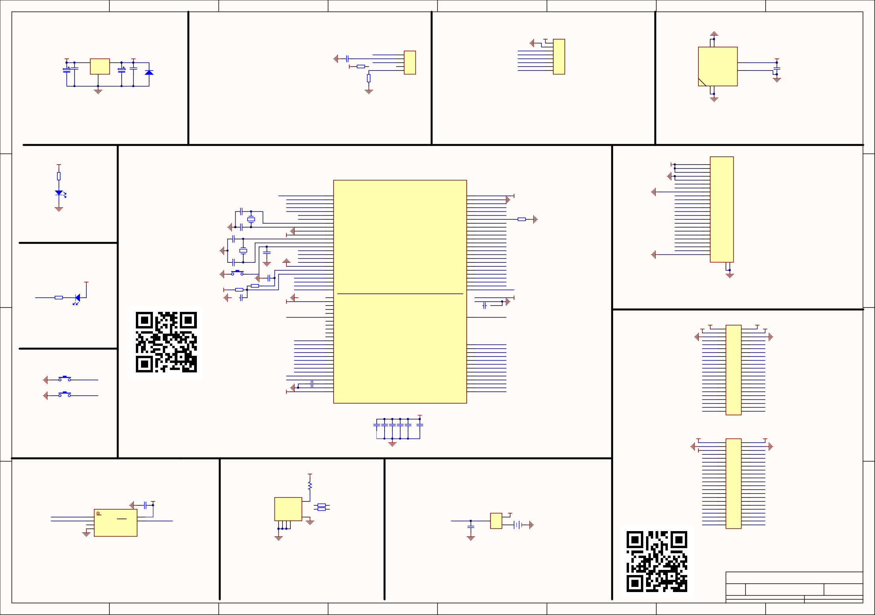

1 2 3 4 5 6
A2
Date: File:

7
mcudev.taobao.com 大越电子出品
2019-11-23 Sheet of
Z:\VMDOC\..\STM32_H7XX_M.SchDoc Drawn By:

8

DevEBox 大越创新
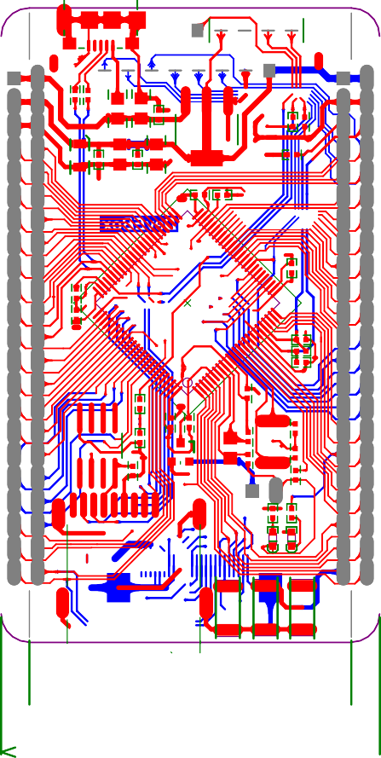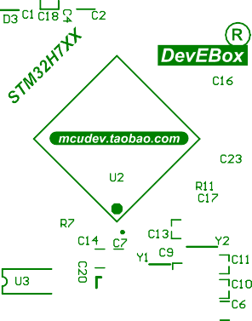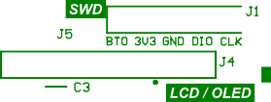

mcudev.taobao.com

嵌入式开发网

Bill of Materials <Parameter Title not found>

Source Data From: STM32_H7XX_M.PrjPcb Project: STM32_H7XX_M.PrjPcb
Variant: None
DevE

Creation Date: 2019-11-23 下午 01:44:44

Print Date: 43792 43792.57279
Box 大越创新

C1, C3, C4, C6, C7, C12, C13, C14, C15, C16, C17, C19, C20, C23

2.2umF
SIP5-2.54mm SPI_1X5

cCuap
Header 5H

deC21, vC22
J1

.taobCapacaitor
Header, 5-Pin, Right Angle

o.com 2

IDE2X22 HDR1X8
Footprint | Comment | LibRef | Designator | Description | Quantity
SIP2-2.54mm | BAT | BATTERY | B1 |  | 1
RC0402 | 104 | Cap, CAP, CAP, CAP,  Cap, Cap, Cap, Cap, Cap, Cap, Cap, Cap Semi,  CAP, Cap |  | Capacitor, Capacitor, Capacitor, Capacitor, Capacitor, Capacitor, Capacitor, Capacitor, Capacitor, Capacitor, Capacitor, Capacitor (Semiconductor SIM Model), [NoValue], Capacitor | 14
RC0805 | 106 | ELECTRO2, ELECTRO2,  Cap | C2, C5, C18 | [NoValue], [NoValue], Capacitor | 3
RC0402 | 10P | CAP | C8, C9 |  | 2
RC0402 | 20P | CAP | C10, C11 | Capacitor | 2
RC0603
LED-0603 | LED | LED | D1, D2 |  | 2
SOD_323 | 5V1 | Diode | D3 | Default Diode | 1

Header 22X2 SIP8-2.54mm
Header 22X2 Header 8
J2, J3 J4
J5
micro_USB | Micro_USB | MiniUSB |  | 1
FPC24-  05MM | FPC-24P | FPC-24P | J6 | 1
SW-SPST | Key | SW-PB | K1, K2, RST | 3
RC0805 | 500mA | RES | L1 | 1
SOT-23- | BAT54C | BAT54C | Q1 1
BAT54C
RC0402 | 10K | Res2 | R1, R4, R7 | Resistor | 3
RC0402 | 0R | Res2 | R2, R3, R11, R34 | Resistor | 4
RC0402 | 510R | Res2 | R5, R14 | Resistor | 2
SOT-223 | AMS1117-3.3V | 11 | U1 |  | 1
 | STM32H7xx | STM32H750V | U2 |  | 1
SOP8L | W25QXX
 | MiniSD | MiniSD | U5 |  | 1
JZ3215-32K | 32.768K | CRYSTAL | Y1 | 晶振 | 1
JZ5032-8M 25M CRYSTAL Y2 Crystal |  |  |  |  | 1

Header, 22-Pin, Dual row 2
Header, 8-Pin 1
1

Approved
53

W25嵌QXX U3
Notes
入

式开发网 1

