Sample R markdown document

LakshmiPrasanna. Thsaliki

04/12/2020

In this document I will show how to execute basic statistical analysis on IRIS dataset. The main aim of this document is to get a free flow of using R markdown to create analysis

I have read quite few articles about the convenience of using R markdown for Document creation. Although, I am still learning a lot about the markdown shorcuts and snippets that becomes handy in creating interesting document, I will showcase few formatting ways of using the R markdown

This document is my analysis on the data set: IRIS Dataset. The following are the aspects I have explored

• Data Summary

• plotting

• Visualizing Distribution Of Data

PREPROCESSING Step 1 Loading the data and necessary libraries:

rm(list=ls())  
data(iris())

## Warning in data(iris()): data set 'iris()' not found

dim(iris)

## [1] 150 5

This data has 150 rows and 5 columns.

summary(iris)

## Sepal.Length Sepal.Width Petal.Length Petal.Width   
## Min. :4.300 Min. :2.000 Min. :1.000 Min. :0.100   
## 1st Qu.:5.100 1st Qu.:2.800 1st Qu.:1.600 1st Qu.:0.300   
## Median :5.800 Median :3.000 Median :4.350 Median :1.300   
## Mean :5.843 Mean :3.057 Mean :3.758 Mean :1.199   
## 3rd Qu.:6.400 3rd Qu.:3.300 3rd Qu.:5.100 3rd Qu.:1.800   
## Max. :7.900 Max. :4.400 Max. :6.900 Max. :2.500   
## Species   
## setosa :50   
## versicolor:50   
## virginica :50   
##   
##   
##

**There are 50 Setosa, 50 Versicolor and 50 Virginica specis in this dataset**

plot(iris$Petal.Length, iris$Petal.Width)

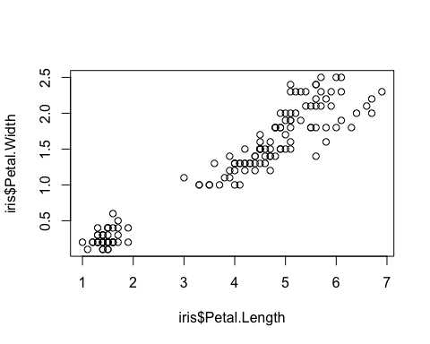 *Plot of Length and width of IRIS petals*

hist(iris$Petal.Length)

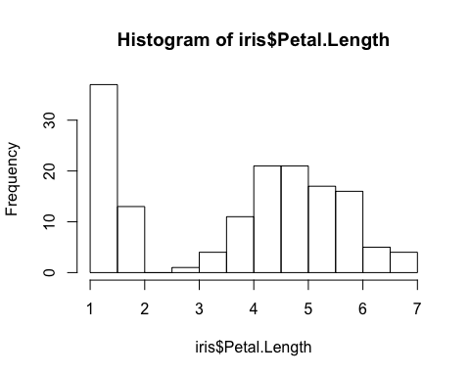

**The Histogram shows the distribution that the petal length is 1 for most of the values**

This is my small presentation of the R markdown.

Thank you for going through