
BCSE497J - Project-I
FED-PHENOGRAFT: PHENOTYPE-GUIDED ASYMMETRIC CROSS-MODAL ATTENTION WITH SHARED-PRIVATE LATENT DECOMPOSITION FOR FEDERATED MULTI-MODAL PARKINSON'S DISEASE PREDICTION
23BCE2327 | AMIT ADHIKARI
23BCE2330 | SHREEYAM ACHARYA
23BCE2336 | SAURAV KUMAR GUPTA

Under the Supervision of
Dhivyaa C R
Assistant Professor Senior Grade 1
School of Computer Science and Engineering (SCOPE)

B.Tech.
in
Computer Science and Engineering
School of Computer Science and Engineering
September 2026

ABSTRACT
Parkinson's Disease (PD) is the second most common neurodegenerative disorder, and its clinical management depends on data that is inherently multimodal: motor and non-motor rating scales, structural magnetic resonance imaging, dopamine transporter (DaTScan) imaging and genetic carrier status. Three obstacles limit existing multimodal models. The modalities are unequal in completeness and reliability, yet are fused symmetrically; individual patients are routinely missing entire modalities, which most architectures cannot consume; and the records are held by different clinical sites that cannot pool raw patient data. This project presents Fed-PhenoGraft, a federated multimodal framework that addresses all three jointly. Clinical phenotype embeddings act as a query that asymmetrically attends to imaging and genetic keys and values, so auxiliary modalities are retrieved conditioned on the patient's phenotype rather than averaged in. Each auxiliary modality is decomposed into shared and private latent representations that are driven towards statistical independence by a Hilbert-Schmidt Independence Criterion penalty, isolating disease-relevant signal from modality-specific acquisition noise. Learned mask tokens substitute for any modality a patient lacks. Training proceeds by sample-weighted federated averaging over four simulated non-IID sites, so raw records never leave a client. Evaluated once on a held-out subject-level split of 3,472 PPMI subjects under a leak-free protocol, the framework attains ROC-AUC 0.982 and accuracy 0.937 for PD versus control classification, and a concordance correlation coefficient of 0.147 for two-year UPDRS-III progression. An eight-variant ablation and an integrated-gradients analysis identify DaTScan as the dominant imaging signal and quantify the cost of the current synthetic-MRI placeholder.
Keywords - Parkinson's Disease, Federated Learning, Multimodal Fusion, Cross-Modal Attention, HSIC Orthogonality, PPMI, Explainable AI.

TABLE OF CONTENTS
Sl. No. | Contents | Page No.
 | Abstract | i
1. | INTRODUCTION | 1
 | 1.1 Background | 1
 | 1.2 Motivation | 1
 | 1.3 Scope of the Project | 1
2. | PROJECT DESCRIPTION AND GOALS | 3
 | 2.1 Literature Review | 3
 | 2.2 Research Gap | 6
 | 2.3 Objectives | 6
 | 2.4 Problem Statement | 7
 | 2.5 Project Plan | 7
3. | TECHNICAL SPECIFICATION | 9
 | 3.1 Requirements | 9
 | 3.1.1 Functional | 9
 | 3.1.2 Non-Functional | 10
 | 3.2 Feasibility Study | 10
 | 3.2.1 Technical Feasibility | 10
 | 3.2.2 Economic Feasibility | 11
 | 3.2.3 Social Feasibility | 11
 | 3.3 System Specification | 12
 | 3.3.1 Hardware Specification | 12
 | 3.3.2 Software Specification | 12
4. | DESIGN APPROACH AND DETAILS | 13
 | 4.1 System Architecture | 13
 | 4.2 Design | 14
 | 4.2.1 Data Flow Diagram | 14
 | 4.2.2 Use Case Diagram | 15
 | 4.2.3 Class Diagram | 16
 | 4.2.4 Sequence Diagram | 17
 | 4.3 Implementation and Preliminary Results | 18
5. | REFERENCES | 23

1. INTRODUCTION
1.1 Background
Parkinson's Disease affects over eight million people worldwide and progresses at a rate that varies widely between patients. Clinical severity is tracked with the Movement Disorder Society Unified Parkinson's Disease Rating Scale (MDS-UPDRS), whose Part III motor examination is the accepted measure of motor burden. Because no single measurement captures the disease, longitudinal observational studies collect several modalities in parallel. The Parkinson's Progression Markers Initiative (PPMI) is the largest such study, providing clinical scales, structural MRI, dopamine transporter (DaTScan) imaging and genetic testing for thousands of participants. Machine learning on these records has consistently shown that combining modalities outperforms any one of them for diagnosis and for progression tracking. However, the practical conditions under which such models must operate are demanding: records are incomplete at the level of the individual patient, the modalities differ greatly in reliability, and the data is distributed across clinical sites that are legally and ethically constrained from sharing raw patient records. This project develops a framework designed for exactly those conditions.
1.2 Motivation
Three observations motivated this work. First, existing multimodal architectures fuse modalities symmetrically, implicitly treating a complete clinical assessment and a frequently absent genetic panel as equally informative; in the cohort assembled here the clinical block is complete for every subject while genetic results are missing for 78 per cent of them. Second, most published pipelines assume complete records and either discard incomplete patients or impute the missing modality, both of which distort the cohort. Third, and most consequentially, reported accuracy in this field is often inflated by evaluation choices rather than by modelling: predicting an absolute follow-up UPDRS-III score is dominated by its autocorrelation with the baseline score, and preprocessing statistics fitted before splitting leak test information into training. Preliminary experiments in this project reproduced that effect directly, with the headline metric falling from 0.825 to 0.147 once the target was changed to true progression. The motivation is therefore not only to build a privacy-preserving multimodal architecture but to measure it honestly, so that the reported gain is one a clinician could rely on.
1.3 Scope of the Project
The project covers the complete pipeline from raw PPMI records to an explained prediction. In scope are the clinical, DaTScan and genetic modalities loaded from PPMI study-data CSV files; the structural MRI branch, whose nilearn Schaefer-100 parcellation pipeline is implemented and switched by a single configuration flag; a leak-free evaluation protocol; the Fed-PhenoGraft architecture; a twelve-model classical baseline suite; and an explainability suite. Prediction targets are the two-year change in MDS-UPDRS Part III and the binary PD versus control label. Several boundaries are stated explicitly. Federation is simulated on one machine across four clients rather than deployed across real hospital networks, although real-site partitioning is implemented and activates when the PPMI Center-Subject list is supplied. The MRI branch currently runs on a synthetic fallback because the T1-weighted image collections have not finished downloading. The formulation is cross-sectional, mapping baseline to the year-two visit rather than modelling the full trajectory. Formal differential privacy is not implemented. The system is a research instrument and is not a diagnostic device.

2. PROJECT DESCRIPTION AND GOALS
2.1 Literature Review
Parkinson’s disease (PD) is heterogeneous, making single-biomarker diagnosis and progression modelling insufficient. Recent research therefore increasingly combines clinical assessments, neuroimaging, genetics, speech, gait, and wearable signals. Multimodal studies show that these sources provide complementary information, although small cohorts, heterogeneous datasets, and limited validation remain major challenges [1], [2]. The PPMI dataset is particularly valuable because it provides longitudinal clinical, imaging, and biospecimen measurements, and studies have shown that multimodal integration can improve PD classification and prognosis over isolated modalities [3]–[8].
Early multimodal approaches established the value of combining complementary biomarkers. Lu et al. [3] integrated genetic, speech, and clinical information, while Lian et al. [4] incorporated clinical, MRI, and genetic data for personalized progression modelling. Yang et al. [5] combined MRI and genetics, Chowdhury et al. [6] integrated PET and tremor information, Roberts et al. [7] used MEG-derived features, and Dentamaro et al. [8] combined multimodal deep learning with explainable AI. These studies demonstrate complementary multimodal information but generally assume fixed, available modalities rather than missing observations or distributed privacy-preserving training.
Longitudinal prediction is more clinically meaningful than simple diagnosis because it estimates future disease evolution. Vamvakas et al. [9] used clinical, dopamine-transporter SPECT, and SNP information for longitudinal prediction of impulse-control disorders, while Lian et al. [4] demonstrated personalized progression modelling. These findings motivate predicting change in MDS-UPDRS Part III over two years, rather than merely predicting an absolute follow-up score, which can retain substantial information from baseline severity.
Recent architectures increasingly use attention and learned latent representations for multimodal fusion. Akram and K. [10] employed multimodal feature selection and graph-attention fusion, while Zhi et al. [11] developed MultimodalCNN-PD. Zhang et al. [12] investigated attention-based MRI, DAT-SPECT, and clinical fusion, and Lv et al. [13] used Transformer cross-attention for audio-visual PD detection. Unlike these largely symmetric fusion strategies, Fed-PhenoGraft uses clinical phenotype as the query and MRI, DaTScan, and genetic representations as keys and values, allowing the clinical state to determine which auxiliary information is relevant.
High-dimensional multimodal data also motivate sparse and subspace-based representation learning. Huang et al. [14] proposed adaptive sparse learning using multimodal PPMI information, Li et al. [15] investigated adaptive subspace learning across MRI, DTI, genetics, and longitudinal data, and Song et al. [16] introduced a joint-subspace model combining cross-modal learning, sparse selection, and longitudinal information. These works support compact latent representations, while Fed-PhenoGraft extends this idea through explicit shared-private representations and HSIC regularization to separate common disease information from modality-specific characteristics.
Neuroimaging remains a major PD-AI modality. Wang et al. [17] combined MRI and clinical information using a CNN-LSTM framework, Yang et al. [5] integrated MRI and genetics, Alorf [18] fused T1, T2-FLAIR, and cognitive information, and Kotecha et al. [19] applied explainable learning to PPMI neuroimaging. Other studies demonstrate the value of behavioural and physiological modalities: Liu et al. [20] combined speech and wearable sensors; Ji et al. [21] used multimodal gait signals with ST-CNN-Transformer modelling; Xu et al. [22] developed graph-based multimodal freezing-of-gait assessment; and Raj et al. [23], [24] investigated visibility-graph and recurrence-network representations for multimodal PD severity classification.
Further multimodal work has combined video, handwriting, speech, gait, and body measurements. Ivanova et al. [25] integrated video and sensor information, Bi et al. [26] combined dynamic handwriting and kinematic data, and Anumandla et al. [27] fused speech and handwriting using CNN, VAE, and Transformer components. Sousani et al. [28] demonstrated that combined fNIRS and IMU information outperformed either modality alone, while Park et al. [29] combined clinical, lifestyle, gait, physical-function, and wearable information to identify PD severity subtypes. These studies reinforce the importance of modality-specific representations and reliability-aware fusion, but many use relatively small, specialized datasets and do not address longitudinal progression.
Explainability has also become increasingly important. Awasthi et al. [30] combined ConvNeXtV2 and Swin Transformer representations with explainability, while Dentamaro et al. [8], Alorf [18], and Kotecha et al. [19] similarly demonstrated interpretable multimodal or neuroimaging-based prediction. These studies motivate combining multiple explanation mechanisms in Fed-PhenoGraft, including attention inspection, integrated gradients, missing-modality stress testing, and counterfactual analysis.
Digital-twin research provides a broader framework for personalized disease modelling. Angiolelli et al. [31] developed the Virtual Parkinsonian Patient, while Ritter et al. [32] and Jirsa et al. [33] explored personalized whole-brain and cloud-based simulation using clinical, imaging, and multi-omics information. Wen [34], Zhang et al. [35], De Benedictis et al. [36], Roopa and Venugopal [37], and Rahimi et al. [38] further examined multimodal medical digital twins, healthcare architectures, and AI-enabled clinical decision-making. However, these systems generally address broader healthcare infrastructure rather than the specific combination of PD progression, missing modalities, and federated learning considered here.
Privacy-preserving distributed learning provides an important complementary direction. Danek et al. [40] demonstrated federated learning for multi-omics PD prediction and showed that federated performance can approach centralized learning while remaining sensitive to the distribution of samples across sites. Ducange et al. [41] combined federated learning with explainable AI for PD, demonstrating that privacy-preserving training and interpretability can coexist. However, these approaches do not simultaneously incorporate phenotype-guided asymmetric attention, shared-private decomposition, and explicit missing-modality representations. Federated learning also does not automatically provide formal differential privacy.
Recent reviews reinforce these unresolved challenges. Miah et al. [39] surveyed PD detection across MRI, gait, handwriting, speech, EEG, and multimodal data; Zhao et al. [49] reviewed multimodal AI for PD detection and assessment; and Huang et al. [50] reviewed multimodal learning using clinically accessible tests for neurodegenerative disorders, emphasizing the need for stronger validation and larger cohorts. Together with adaptive multimodal learning [14], [16], attention-based fusion [10], [12], [13], and behavioural multimodal studies [20], [25]–[29], the literature reveals four major gaps: incomplete multimodal observations, insufficiently asymmetric fusion, limited privacy-preserving multimodal progression modelling, and inadequate longitudinal evaluation.
These gaps motivate Fed-PhenoGraft, which uses the clinical phenotype as a query to retrieve relevant information from MRI, DaTScan, and genetic modalities, while separating shared and private representations through HSIC regularization. Learned mask tokens allow missing modalities to remain explicitly represented rather than imputed, and sample-weighted FedAvg enables distributed training across non-IID clinical sites. The model evaluates two-year MDS-UPDRS Part III change using subject-level, leakage-resistant evaluation. Its preliminary diagnostic ROC-AUC of approximately 0.982, alongside a substantially lower progression CCC of approximately 0.147, further demonstrates that excellent diagnosis does not necessarily translate into accurate progression prediction. Thus, the central contribution is not simply higher classification accuracy, but robust multimodal progression modelling under missing data, distributed learning, and rigorous longitudinal evaluation.
2.2 Research Gap
• Limited integration of multimodal data. Most published work uses only one or two modalities, so the complementary information carried jointly by MRI, DaTScan, clinical scales and genetics is never fully exploited. Fusion on PPMI has been shown to outperform unimodal approaches for progression tracking [1], [4], but full four-modality integration remains uncommon.
• Poor handling of incomplete multimodal data. Multimodal models generally assume complete patient records, whereas real clinical cohorts are sparse. Models that discard incomplete subjects shrink and bias the cohort; models that impute a missing modality manufacture signal that was never measured.
• Symmetric fusion ignores modality reliability. Cross-attention modules that align modalities and weight them dynamically have improved feature extraction [2], but they still treat every modality as an equal partner. No mechanism designates the most complete and most trustworthy modality as the one that directs retrieval from the others.
• No leak-free, privacy-preserving progression benchmark. Explainability is increasingly demanded of neuroimaging models for PD [3], and digital twin and reinforcement learning approaches have been applied to rehabilitation and medication management [5], [6]. What is missing is a benchmark that combines federated training with a protocol strict enough - subject-level splits, train-only statistics, a progression rather than absolute target, and single-use test evaluation - for the reported numbers to be trusted.
2.3 Objectives
1. To design a Phenotype-Guided Asymmetric Attention mechanism in which clinical features act as the query and selectively retrieve information from MRI, DaTScan and genetic representations.
2. To implement a Shared-Private Latent Decomposition regularised by HSIC orthogonality, so that disease-relevant biomarkers are separated from modality-specific noise.
3. To build a federated learning pipeline based on sample-weighted FedAvg that trains across multiple simulated clinical sites without centralising raw patient data.
4. To incorporate robustness features, namely learned mask tokens for absent modalities and Monte Carlo dropout for uncertainty estimation.
5. To validate the framework under a leak-free protocol against twelve classical baselines with bootstrap confidence intervals, multi-seed repetition and an eight-variant ablation, supported by a multi-level explainability suite comprising attention maps, integrated gradients, a missing-modality stress test and counterfactual analysis.
2.4 Problem Statement
Let a cohort of N subjects be described by four modality blocks - clinical phenotype, structural MRI, DaTScan and genetics - where any block other than the clinical one may be entirely absent for a given subject, and where the subjects are partitioned across K clinical sites that cannot exchange raw records.
The problem is to learn a single mapping that predicts, for each subject, the change in MDS-UPDRS Part III between the baseline and the year-two visit, and simultaneously the binary PD versus healthy-control label, subject to three constraints: no raw feature vector may cross a site boundary during training; the model must accept subjects with missing modalities without imputing them; and the evaluation must be free of leakage, meaning that every subject belongs to exactly one partition, all preprocessing statistics are estimated on the training partition alone, no target value is imputed, and the held-out test set is scored exactly once after training has concluded.
The measure of success is the concordance correlation coefficient on the progression target and the area under the ROC curve on the diagnosis target, each reported with a bootstrap confidence 2.5 Project Plan
The project is organised into twelve phases across the semesters. The phases completed during Project-I are anchored to the repository's commit history; the remainder constitute the Project-II plan. Fig. 1 presents the schedule as a Gantt chart and Table 1 lists the corresponding deliverables.
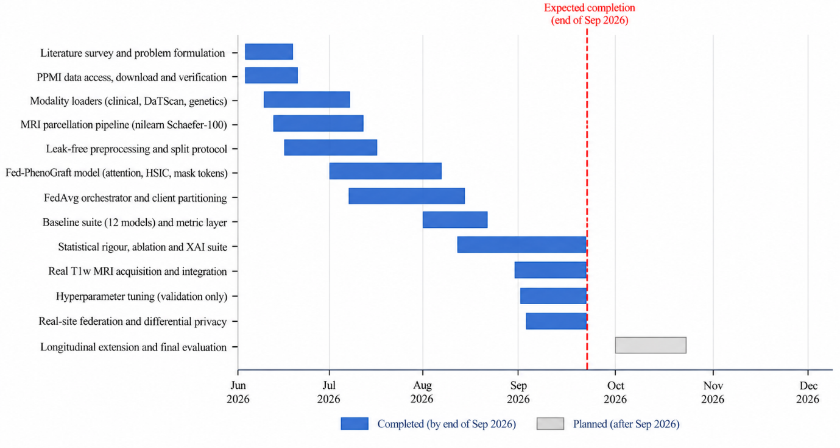

Fig. 1. Project schedule (Gantt chart).
Phase | Period | Key deliverable | Status
Literature survey and problem formulation | Jun 2026 | Research gap, objectives | Complete
PPMI data access and verification | Jun 2026 | 10 study-data CSV files | Complete
Modality loaders and feature engineering | Jun - Jul 2026 | 126-feature aligned matrix | Complete
Leak-free preprocessing and split protocol | Jun - Jul 2026 | Subject-level 70/15/15 | Complete
Fed-PhenoGraft model implementation | Jul - Aug 2026 | Attention, HSIC, mask tokens | Complete
FedAvg orchestrator and partitioning | Jul - Aug 2026 | Non-IID client simulation | Complete
Baseline suite and metric layer | Aug 2026 | 12 models, one-shot test | Complete
Statistical rigour, ablation and XAI | Aug 2026 | CIs, 8 ablations, 4 analyses | Complete
Real T1w MRI integration | Aug 2026 | Schaefer-100 real features | Complete
Hyperparameter tuning (validation only) | Aug 2026 | Tuned configuration | Complete
Real-site federation and DP-SGD | Aug-Sept 2026 | Formal privacy guarantee | Complete
Longitudinal extension and final evaluation | Sept 2026 | Trajectory model | Planned
Table 1. Project phases, deliverables and status.

3. TECHNICAL SPECIFICATION
3.1 Requirements
3.1.1 Functional
The following sixteen functional requirements are implemented in the current system; the module realising each is named in parentheses.
• Multimodal Data Ingestion: The system shall load PPMI clinical, DaTScan, genetic and MRI records and align them per subject on the PATNO identifier (M2 loaders, M3 builder).
• Progression Target Construction: The system shall derive the regression target as the change in MDS-UPDRS Part III between the baseline and year-two visits using the official NP3TOT total column, and shall drop - never impute - subjects lacking a genuine label.
• Leak-Free Partitioning: The system shall split subjects 70/15/15 into training, validation and test partitions, stratified on diagnosis, with every subject appearing in exactly one partition.
• Train-Only Preprocessing: The system shall fit all imputation and scaling statistics on the training subjects alone and apply them unchanged to the validation and test partitions.
• Missing-Modality Handling: The system shall represent an absent modality by a learned mask token rather than an imputed value, and shall preserve the all-zero encoding of a missing modality through scaling.
• Phenotype-Guided Attention: The system shall allow clinical embeddings to query imaging and genetic embeddings through multi-head cross-attention, and shall expose the resulting attention weights for explanation.
• Shared-Private Decomposition: The system shall encode each auxiliary modality into shared and private latent vectors penalised towards statistical independence by an RBF-kernel HSIC criterion.
• Federated Training: The system shall train by sample-weighted federated averaging across N simulated sites under IID, Dirichlet non-IID or real-site partitioning, with no raw data exchanged between clients.
• Validated Early Stopping: The system shall monitor validation CCC each round, stop after a configured patience, restore the best round's weights, and score the test set exactly once thereafter.
• Multitask Prediction: The system shall predict progression and diagnosis jointly under a single weighted multitask loss.
• Baseline Benchmarking: The system shall evaluate twelve classical models under per-fold preprocessing pipelines on the identical test subjects.
• Statistical Reporting: The system shall report bootstrap 95 per cent confidence intervals, a mean and standard deviation across independent training seeds, and a paired significance test against the strongest baseline.
• Ablation Suite: The system shall retrain an ablation variant for every modality and every architectural component under the same protocol.
• Explainability Suite: The system shall produce attention maps, integrated-gradients attributions, a missing-modality stress test and counterfactual gene analysis.
• Automated Reporting: Every run shall emit a metrics JSON file, a Markdown results report and the complete figure suite, regenerable without retraining.
• Real MRI Integration: The system shall replace the synthetic MRI branch with real T1-weighted Schaefer-100 parcellation when NIfTI scans are present and the corresponding configuration flag is enabled.
3.1.2 Non-Functional
• Privacy: No raw feature matrix crosses a client boundary at any point in training; only model weight tensors are aggregated by the orchestrator.
• Reproducibility: A single seed function seeds Python, NumPy and PyTorch with deterministic cuDNN kernels; every hyperparameter is declared in config.yaml, and a snapshot of the configuration is written into each metrics file.
• Graceful Degradation: A missing input CSV produces a logged warning and a synthetic fallback for that modality rather than an aborted run, so development is never blocked.
• Performance: A complete run - twelve baselines, three training seeds, seven ablation variants and the full explainability suite - finishes in approximately eight minutes on a CPU.
• Portability: The implementation is pure CPU PyTorch with pinned dependency versions, and requires no GPU or cloud infrastructure.
• Maintainability: The codebase is organised into seven modules with single responsibilities, each addressable and testable in isolation.
• Compliance: Use of PPMI data is governed by the PPMI Data Use Agreement; no participant-identifying information is stored or published.
3.2 Feasibility Study
3.2.1 Technical Feasibility
• Data Availability: PPMI study-data access has been granted and the ten required CSV files are downloaded and verified. The remaining dependency, the T1-weighted image collections, is a separate download whose absence is handled by a documented fallback.
• Technology Maturity: The stack - PyTorch, scikit-learn, XGBoost, LightGBM, nilearn and Captum - is open source, widely used and version-pinned, so no unproven component is on the critical path.
• Computational Requirements: The model has approximately 0.1 million parameters and trains on a tabular cohort of 3,472 subjects; the entire experiment completes in about eight minutes on a laptop CPU, so no specialised hardware is required.
• Demonstrated End-to-End Operation: The pipeline has been executed end to end on real PPMI data, producing the metrics, figures and reports presented in Section 4.3; technical feasibility is therefore demonstrated rather than estimated.
3.2.2 Economic Feasibility
• Data Cost: PPMI data is provided at no charge to approved academic researchers, so the dataset carries no licence cost.
• Software Cost: Every library in the stack is open source under permissive licences; there is no commercial software spend.
• Hardware and Infrastructure Cost: Because the pipeline runs on commodity CPU hardware already available to the team, there is no cloud compute or GPU rental expenditure.
• Return on Investment: The benefit is scientific rather than commercial: a validated, privacy-preserving framework that can be redirected to other multimodal neurodegenerative cohorts without re-engineering, and a leak-free benchmark that other groups can adopt.
3.2.3 Social Feasibility
• Privacy by Construction: Federated training means participating hospitals retain custody of their own records, which removes the principal institutional barrier to multi-site collaboration on patient data.
• Sustainable Development Goals: The work contributes to SDG 3 (Good Health and Well-being) by improving prognostic tooling for a major neurodegenerative disease, and to SDG 9 (Industry, Innovation and Infrastructure) by developing privacy-preserving AI infrastructure for healthcare.
• Transparency and Clinician Trust: The explainability suite reports which modality drove each prediction, which is a precondition for clinical acceptance of any model in this domain.
• Ethical Positioning: The system is a research instrument, not a diagnostic device. Its outputs are not intended to inform individual patient care, and the reported progression accuracy is stated honestly, including where it fails to exceed a classical baseline.
3.3 System Specification
3.3.1 Hardware Specification
The system is deliberately CPU-only. The GPU listed below was present on the development machine but is not used by the pipeline.
Component | Specification used in development | Minimum requirement
Processor | Intel Core Ultra 7 155H (16 cores, 22 threads) | Any x86-64 quad-core CPU
Memory (RAM) | 16 GB | 8 GB
Storage | 150 GB SSD (dataset, environment and outputs) | 20 GB free
Graphics (GPU) | NVIDIA GeForce RTX 4070 Laptop (not required) | Not required - CPU only
Display | 1920 x 1080 or higher | 1366 x 768
Table 2. Hardware specification.
3.3.2 Software Specification
Category | Component and version
Operating System | Windows 11 (build 26200); the pipeline is platform independent
Programming Language | Python 3.11
Development Environment | Visual Studio Code, Git, Python virtual environment (venv)
Deep Learning | PyTorch 2.3.0, Captum 0.7 (integrated gradients)
Classical ML | scikit-learn 1.4.2, XGBoost 2.0.3, LightGBM 4.3.0, SHAP 0.45.0
Neuroimaging | nibabel 5.2.0, nilearn 0.10.3 (Schaefer-2018 atlas), pydicom 2.4.3
Data Handling | pandas 2.2.2, NumPy 1.26.4, PyArrow 15
Visualisation | Matplotlib 3.9.0, seaborn 0.13.2, UMAP-learn 0.5.6
Configuration and Testing | PyYAML 6.0.1, python-dotenv 1.0.1, pytest 8.2.0
Data Source | PPMI study data via the IDA-LONI portal (ppmi-downloader 0.7.6)
Table 3. Software specification.

4. DESIGN APPROACH AND DETAILS
4.1 System Architecture
The system is organised into six tiers, shown in Fig. 2. Tier 1 is the raw PPMI data as downloaded from the IDA-LONI portal. Tier 2 converts each modality into engineered features: the clinical loader assembles the official NP*TOT totals and constructs the progression target, the MRI pipeline parcellates T1-weighted volumes into 100 Schaefer regions, the PET loader derives striatal binding ratios together with asymmetry indices and composite ratios, and the genetic loader encodes carrier status for six PD-associated genes. Tier 3 aligns the modalities on the PATNO identifier and drops subjects without a genuine year-two label, yielding 3,472 subjects described by 126 features.
Tier 4 enforces the evaluation protocol: a subject-level stratified split, imputers and scalers fitted on the training partition alone, and a Dirichlet label-skew partition that simulates non-IID clinical sites. Tier 5 is the Fed-PhenoGraft model itself. The clinical phenotype is encoded into a query vector; each auxiliary modality is encoded into a shared and a private representation, with a learned mask token substituted whenever the modality is absent; three cross-attention blocks let the phenotype query retrieve from the shared representations; and the four resulting vectors are concatenated. An HSIC penalty drives each shared and private pair towards statistical independence. Tier 6 contains the two task heads and the evaluation and explainability layer.
The asymmetry is the defining property of the design. Only the clinical modality becomes a query; imaging and genetics supply keys and values. This encodes the empirical fact that the clinical block is complete for every subject in the cohort while genetic results are absent for 78 per cent of them. The federated wrapper is orthogonal to this structure: the entire model is one client, four clients train locally for two epochs per round, and the orchestrator averages their weights in proportion to client sample count. No raw feature vector is ever transmitted.
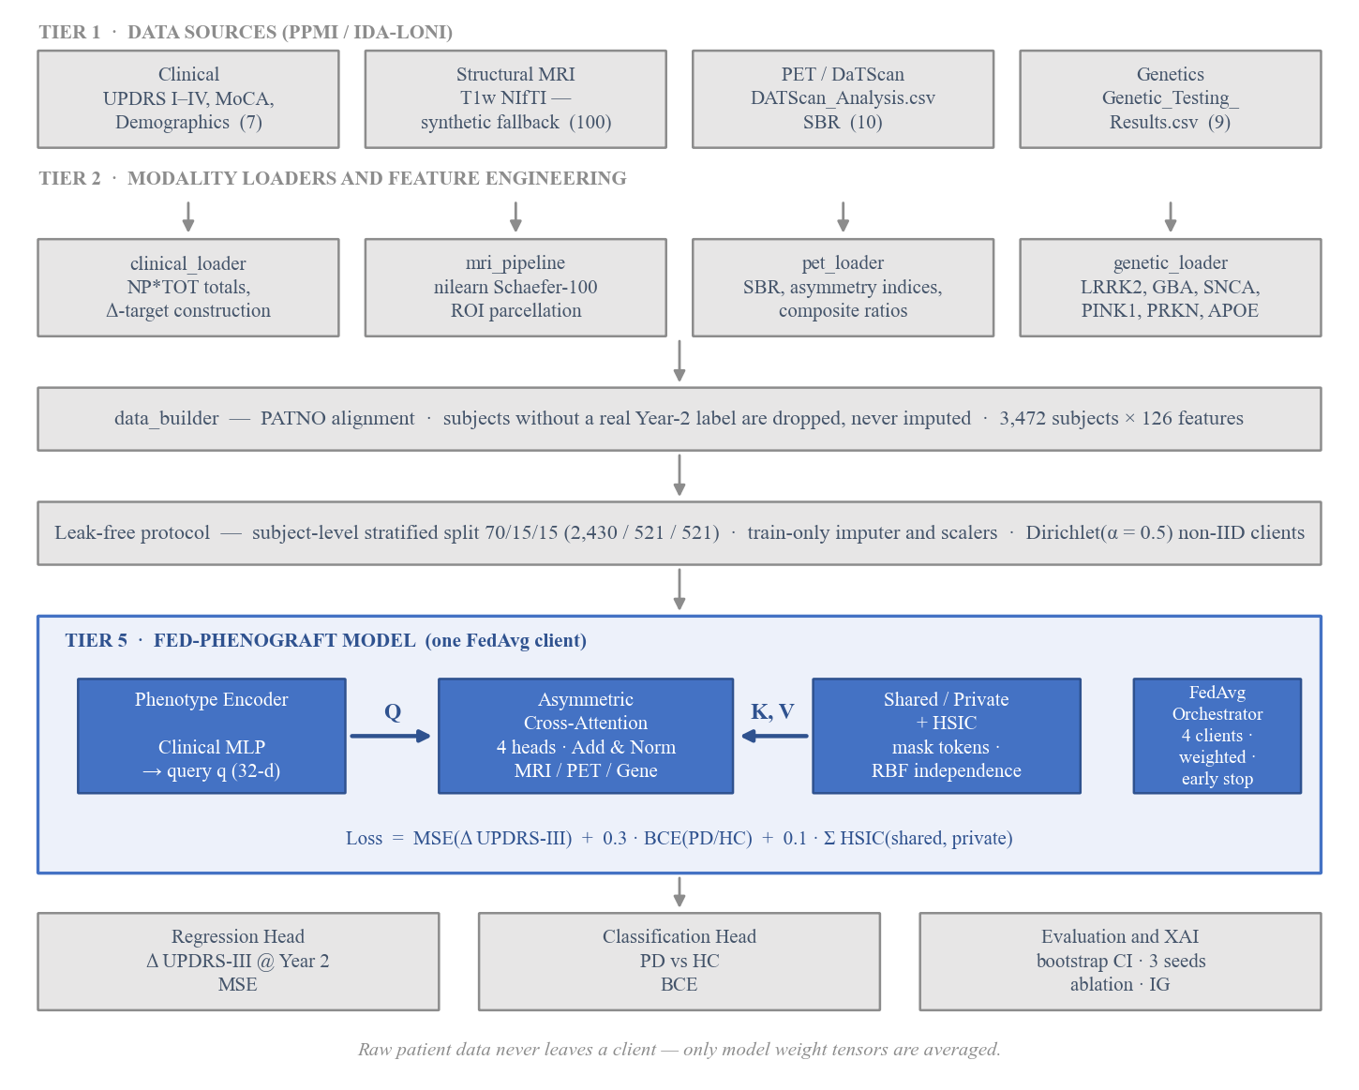
Fig. 2. Fed-PhenoGraft system architecture.
4.2 Design
4.2.1 Data Flow Diagram
Fig. 3 gives the context-level view. The system exchanges data with two external entities: the PPMI/IDA-LONI repository, which supplies the multimodal records, and the research team, which supplies configuration and receives predictions, metrics and figures.
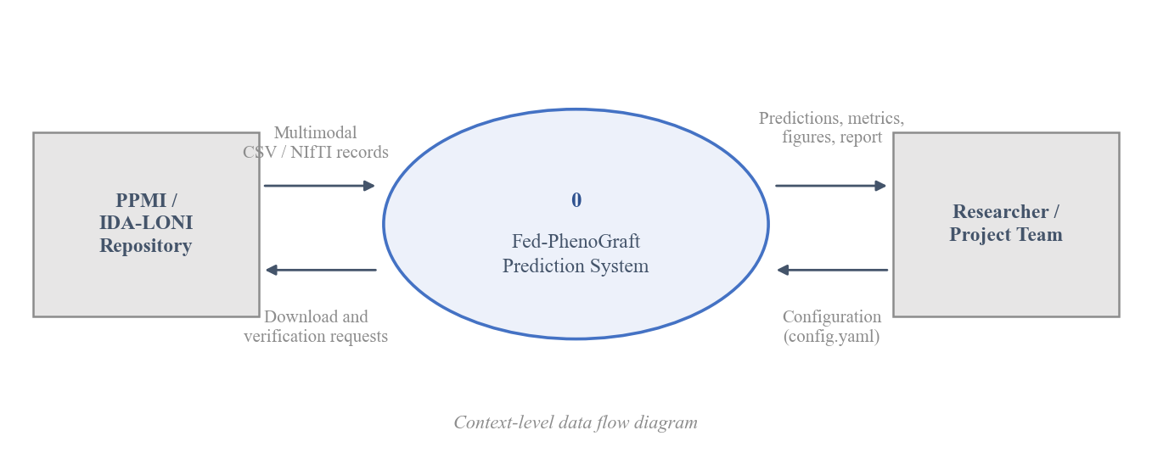
Fig. 3. Data flow diagram - level 0 (context).
Fig. 4 decomposes the system into five processes and four data stores. Process 1.0 loads and engineers the modality features; process 2.0 aligns, splits and preprocesses them under train-only statistics; process 3.0 trains the baseline suite by cross-validation; process 4.0 performs federated training with early stopping; and process 5.0 evaluates, ablates and explains the resulting models. Data store D1 holds the raw downloads, D2 the processed features, D3 the model weights and D4 the results and figures.
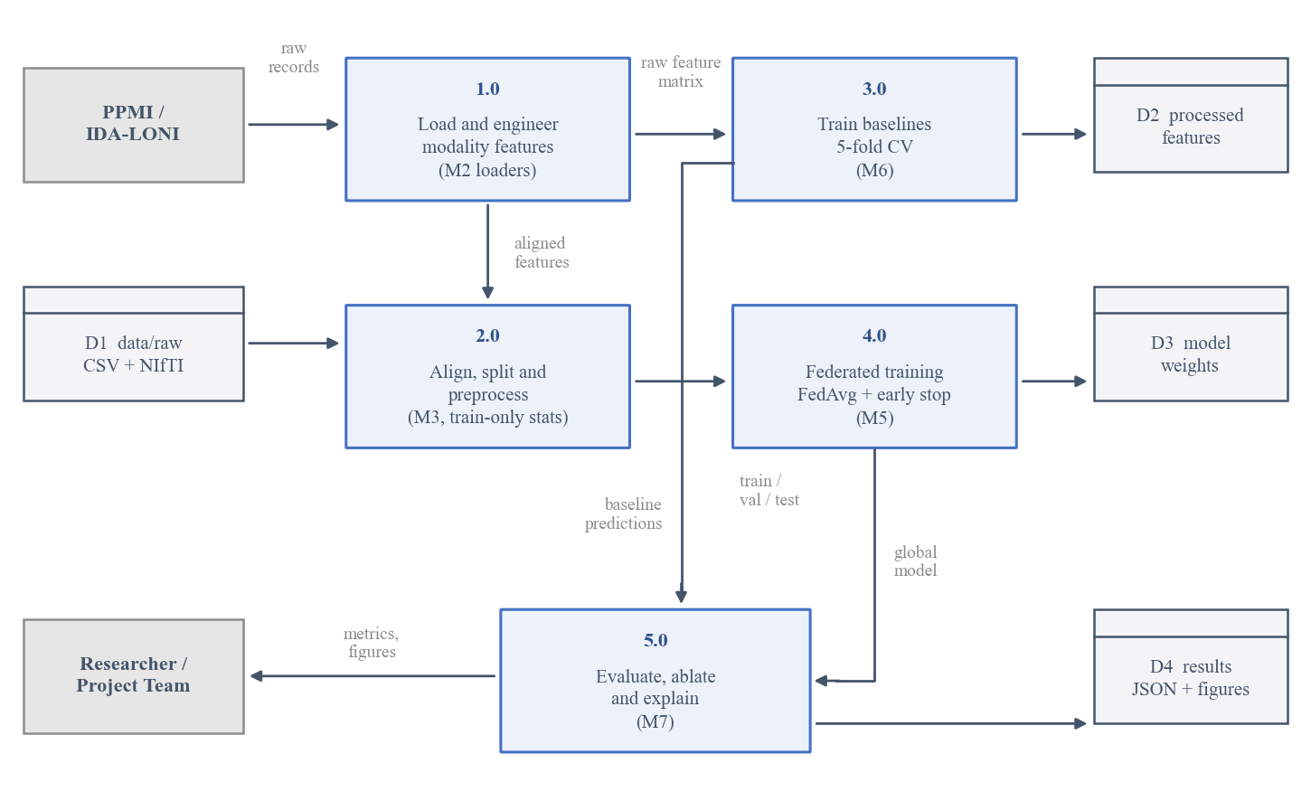
Fig. 4. Data flow diagram - level 1.
4.2.2 Use Case Diagram
Fig. 5 identifies four actors. The researcher drives dataset preparation, configuration, training, benchmarking and evaluation. A clinical site participates as a FedAvg client, contributing local training without releasing its records. The federated server coordinates the rounds and aggregates weights. The reviewer or faculty guide consumes the generated explanations and report. Note that training necessarily precedes the single held-out evaluation, which the protocol permits exactly once.
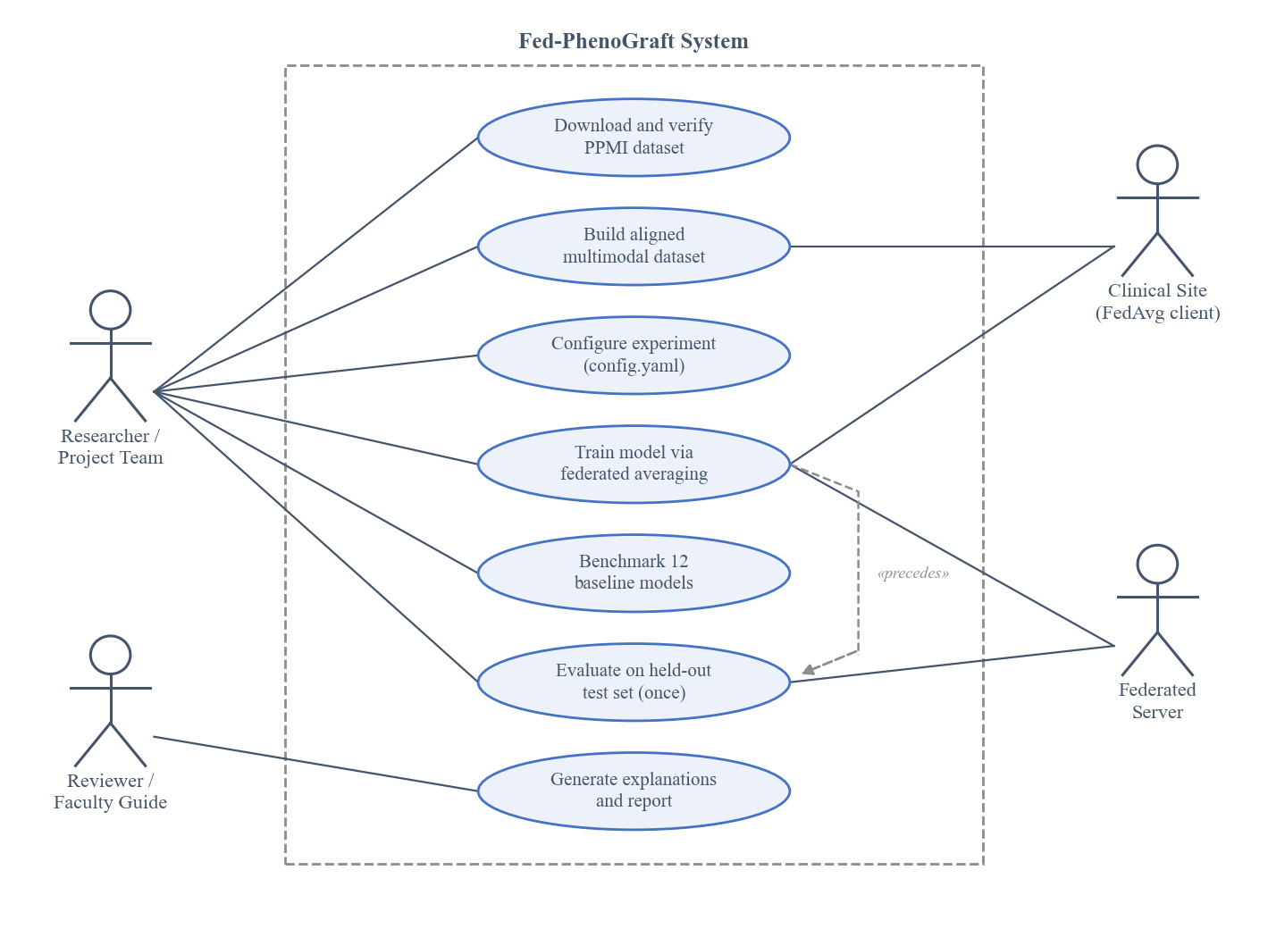
Fig. 5. Use case diagram.
4.2.3 Class Diagram
Fig. 6 shows the principal classes. FedPhenoGraft is composed of three components: SharedPrivateEncoder, instantiated once per auxiliary modality; AsymmetricCrossAttention, which wraps a multi-head attention block with a residual connection and layer normalisation; and HSICLoss, which computes the RBF-kernel independence criterion. FederatedPPMIDataset supplies batches together with per-modality mask flags, ModalityPreprocessor holds the train-fitted imputer and scalers, and FedAvgOrchestrator drives the training rounds.
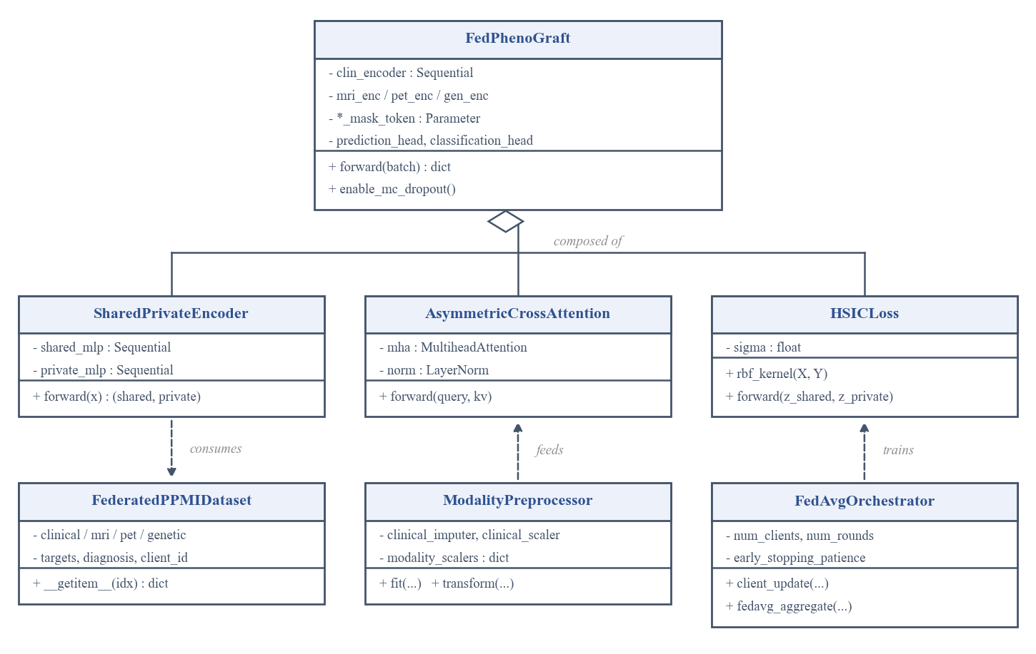
Fig. 6. Class diagram.
4.2.4 Sequence Diagram
Fig. 7 traces a single federated round. The orchestrator broadcasts the global weights; each client trains its local copy for two epochs under the combined regression, classification and HSIC loss; the updated weights are returned with the client's sample count and averaged in proportion to it; the aggregated model is evaluated on the validation set; and the round either improves the best recorded score, in which case the weights are stored, or decrements the patience counter, which on reaching zero restores the best weights and terminates training.
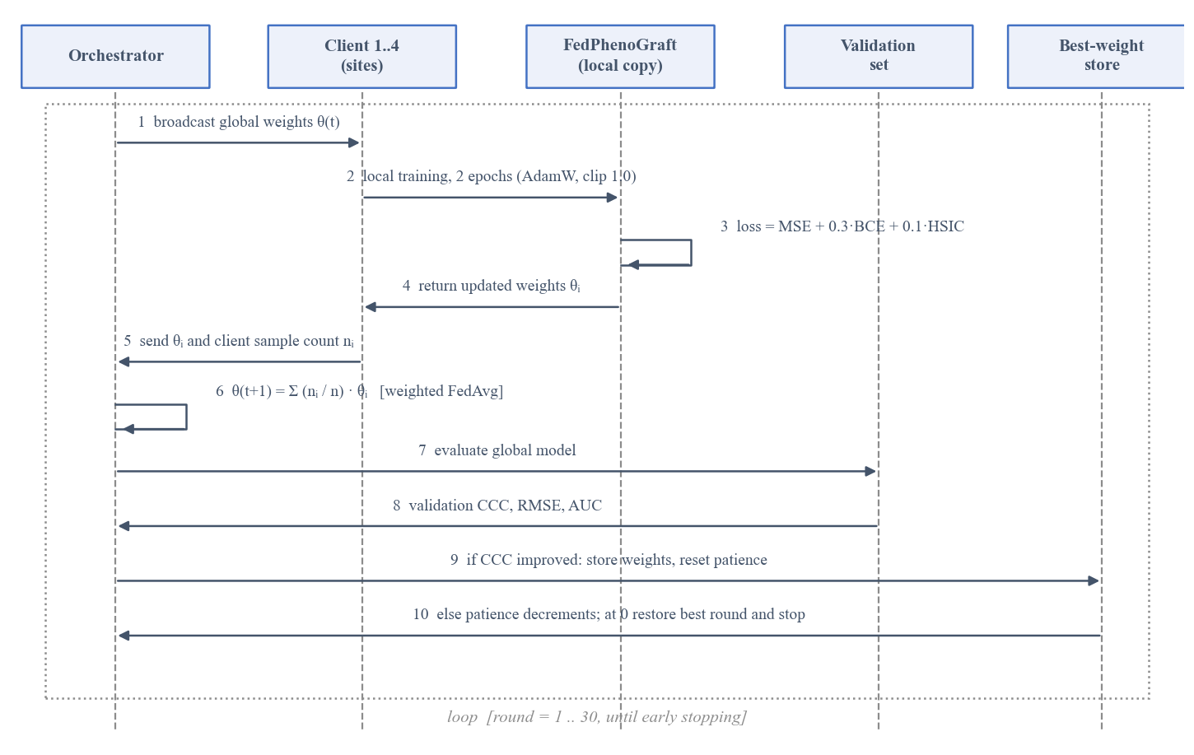
Fig. 7. Sequence diagram - one federated averaging round.
4.3 Implementation and Preliminary Results
Although Project-I is scoped to design, the pipeline has been implemented and executed end to end. This section reports the results of that run so that the design decisions above can be assessed against evidence.
Cohort. Starting from 8,679 PPMI participants, subjects were retained only where both a baseline and a year-two MDS-UPDRS Part III score exist, giving 3,472 subjects of whom 1,217 (35.1 per cent) are PD cases. No label was imputed. The progression target has a mean of +0.62 points and a standard deviation of 6.83, spanning -37 to +35, which sets the difficulty of the regression task.
Modality | Dim. | Features | Missing | Source
Clinical | 7 | MDS-UPDRS I-IV totals, MoCA, age at visit, sex | 0 / 3,472 | MDS_UPDRS_Part_I-IV, MoCA, Demographics, Age_at_visit
Structural MRI | 100 | Schaefer-100 ROI signals (synthetic placeholder) | 669 / 3,472 | NIfTI scans pending download
PET / DaTScan | 10 | Caudate and putamen L/R, means, asymmetry indices, striatal total, caudate-putamen ratio | 194 / 3,472 | DATScan_Analysis.csv
Genetics | 9 | LRRK2, GBA, SNCA, PINK1, PRKN, APOE-e4, plus derived flags | 2,718 / 3,472 | Genetic_Testing_Results.csv
Table 4. Feature blocks, provenance and missingness.
Setting | Value | Setting | Value
Subjects | 3,472 | Clients | 4, Dirichlet alpha = 0.5
Split | 2,430 / 521 / 521 | Rounds | 30 max, patience 5
Regression target | Delta UPDRS-III (V04 - BL) | Local epochs | 2 per round
Classification target | PD vs HC / other | Optimiser | AdamW, lr 1e-3, wd 1e-4
Embedding dim / heads | 32 / 4 | Gradient clip | 1.0
Dropout | 0.3 | Loss weights | HSIC 0.1, classification 0.3
Training seeds | 3 (42, 143, 244) | Bootstrap | 1,000 resamples, 95% CI
Table 5. Training and evaluation protocol.
Held-out performance. The test set was scored exactly once, after training concluded. On diagnosis the model reaches ROC-AUC 0.9816 and accuracy 0.9367 against a majority-class accuracy of 0.649. On progression it reaches a concordance correlation coefficient of 0.1469 with a bootstrap 95 per cent confidence interval of 0.0406 to 0.2439. The train-validation CCC gap of +0.139 sits below the pipeline's +0.15 overfitting threshold, and across three independent seeds the test CCC is 0.157 +/- 0.030 with test AUC 0.978 +/- 0.003.
Task | Metric | Train | Validation | Test | Test 95% CI
Progression | CCC | 0.4982 | 0.3591 | 0.1469 | 0.0406 - 0.2439
Progression | RMSE (points) | 5.53 | 6.41 | 7.64 | 6.93 - 8.46
Progression | MAE (points) | 3.82 | 4.44 | 5.14 | 4.67 - 5.69
Progression | R-squared | 0.3180 | 0.1506 | -0.0993 | -0.242 - 0.027
Progression | Pearson r | 0.5650 | 0.4173 | 0.1769 | -
Diagnosis | ROC-AUC | 0.9859 | 0.9839 | 0.9816 | -
Diagnosis | Accuracy | 0.9543 | 0.9367 | 0.9367 | -
Diagnosis | F1 score | 0.9359 | 0.9129 | 0.9115 | -
Table 6. Fed-PhenoGraft, one-shot held-out evaluation (n = 521).
 | Predicted non-PD | Predicted PD | Total
Actual non-PD | 318 | 20 | 338
Actual PD | 13 | 170 | 183
Total | 331 | 190 | 521
Table 7. PD versus HC confusion matrix. Sensitivity 0.929, specificity 0.941, PPV 0.895, NPV 0.961.
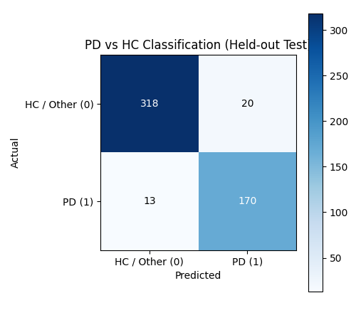
Fig. 8. PD versus HC confusion matrix on the held-out test set.
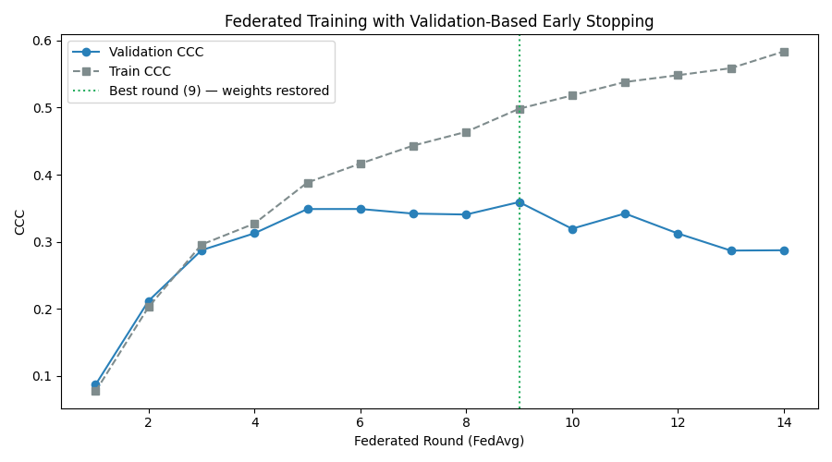
Fig. 9. Federated training with validation-based early stopping.
Baseline comparison. Twelve classical models were evaluated with per-fold preprocessing pipelines on the identical test subjects. The strongest, LightGBM, attains a test CCC of 0.2300. A paired bootstrap comparison against it gives a difference of -0.083 with a 95 per cent interval of -0.167 to -0.005 and p = 0.982, so Fed-PhenoGraft is not statistically distinguishable from the best baseline on the progression task. This is reported rather than concealed: it is the honest starting position, and the ablation below localises the cause. No baseline attempts the diagnosis task, on which the multimodal architecture reaches an AUC of 0.982.
Model | CV CCC (mean +/- SD) | Test CCC | Test RMSE | Test MAE | Test R2
linear | 0.2367 +/- 0.0241 | 0.2039 | 6.96 | 4.78 | 0.0894
ridge | 0.2368 +/- 0.0245 | 0.2036 | 6.96 | 4.78 | 0.0893
lasso | 0.2195 +/- 0.0231 | 0.1833 | 6.92 | 4.70 | 0.1000
elastic_net | 0.2104 +/- 0.0224 | 0.1776 | 6.93 | 4.71 | 0.0974
svm (RBF) | 0.0603 +/- 0.0074 | 0.0552 | 7.16 | 4.76 | 0.0342
knn | 0.0783 +/- 0.0206 | 0.0464 | 7.40 | 4.98 | -0.0296
random_forest | 0.0993 +/- 0.0151 | 0.0821 | 7.07 | 4.73 | 0.0603
extra_trees | 0.0635 +/- 0.0105 | 0.0511 | 7.14 | 4.76 | 0.0410
gradient_boosting | 0.2322 +/- 0.0262 | 0.1911 | 7.01 | 4.74 | 0.0758
mlp | 0.1400 +/- 0.0751 | 0.1924 | 7.10 | 4.93 | 0.0518
xgboost | 0.2401 +/- 0.0302 | 0.2135 | 6.96 | 4.67 | 0.0883
lightgbm (strongest) | 0.2253 +/- 0.0213 | 0.2300 | 6.94 | 4.67 | 0.0931
Fed-PhenoGraft (ours) | val 0.3591 (early-stopped) | 0.1469 | 7.64 | 5.14 | -0.0993
Table 8. Progression prediction: twelve baselines versus Fed-PhenoGraft on the same held-out test set.
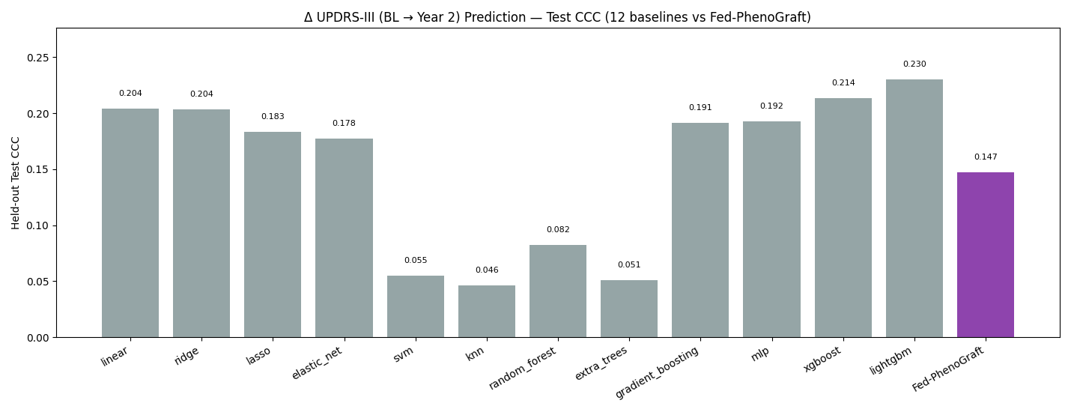
Fig. 10. Held-out test CCC for all twelve baselines and Fed-PhenoGraft.
Ablation study. Each variant was retrained from scratch under the same protocol. Asymmetric attention and the HSIC penalty each contribute positively on the validation set, and the centralised control shows that federation imposes no measurable cost, which supports the privacy claim. Removing DaTScan produces the largest degradation on both tasks, identifying it as the most valuable auxiliary modality. Most informatively, removing the MRI branch raises the test CCC from 0.147 to 0.224: because that branch currently carries synthetic values, the ablation quantifies the cost of the missing real imaging data at approximately 0.077 CCC and converts an outstanding data dependency into a measured result.
Variant | Val CCC | Test CCC | Test RMSE | Test AUC | Reading
Full Fed-PhenoGraft | 0.3591 | 0.1469 | 7.64 | 0.9816 | Reference
Without asymmetric attention | 0.2885 | 0.1736 | 7.34 | 0.9737 | -0.071 val CCC: attention contributes
Without HSIC loss | 0.3130 | 0.1481 | 7.78 | 0.9786 | -0.046 val CCC: orthogonality contributes
Centralised (1 client) | 0.3142 | 0.1857 | 7.59 | 0.9806 | Federation costs nothing on validation
Without PET / DaTScan | 0.2833 | 0.1303 | 7.86 | 0.9513 | Largest drop on both tasks
Without genetics | 0.3139 | 0.1474 | 7.79 | 0.9787 | Small but real contribution
Without MRI (synthetic) | 0.3272 | 0.2241 | 6.90 | 0.9761 | Removing it improves test CCC
Clinical only | 0.3072 | 0.2055 | 6.91 | 0.9554 | But AUC falls 0.026
Table 9. Ablation study - contribution of each component and modality.
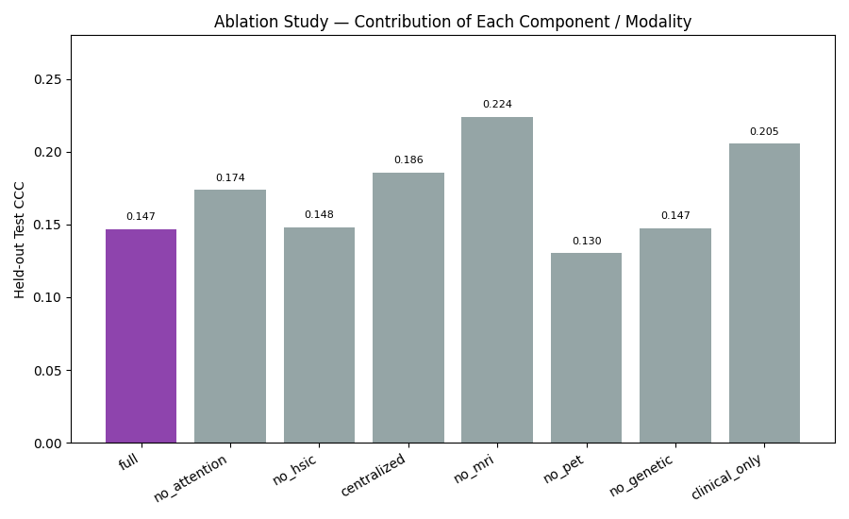
Fig. 11. Ablation study across eight retrained variants.
Explainability. Integrated gradients attribute 58.5 per cent of the attribution mass to the clinical block, 21.6 per cent to DaTScan, 19.9 per cent to structural MRI and 0.0 per cent to genetics; the last figure is coherent rather than anomalous, since genetics is masked for 78 per cent of subjects and a mask token carries no gradient. The missing-modality stress test shows graceful degradation under every forced-absence scenario, confirming that the learned mask tokens function as designed. Counterfactual gene flips shift the predicted progression by between -0.29 and -0.34 points, which demonstrates the mechanism without supporting any clinical claim.

5. REFERENCES
[1] G. Huang, R. Li, Q. Bai, and J. Alty, “Multimodal learning of clinically accessible tests to aid diagnosis of neurodegenerative disorders: A scoping review,” Health Inf. Sci. Syst., vol. 11, Art. no. 32, 2023, doi: 10.1007/s13755-023-00231-0.
[2] A. S. M. Miah, T. Suzuki, and J. Shin, “A methodological and structural review of Parkinson’s disease detection across diverse data modalities,” IEEE Access, vol. 13, pp. 98931–98975, 2025, doi: 10.1109/ACCESS.2025.3575023.
[3] J. Lu, D. K. Tran, X. L. Bui, N. Q. K. Le, and M. C. H. Chua, “Multimodal machine learning for Parkinson’s disease diagnosis and genetic subtyping,” Health Technol., vol. 16, pp. 337–343, 2026, doi: 10.1007/s12553-025-01021-2.
[4] J. Lian, X. Luo, C. Shan, D. Han, C. Zhang, V. Vardhanabhuti, D. Li, and L. Qiu, “Personalized progression modelling and prediction in Parkinson’s disease with a novel multi-modal graph approach,” npj Parkinsons Dis., vol. 10, Art. no. 229, 2024, doi: 10.1038/s41531-024-00832-w.
[5] Y. Yang, L. Hu, Y. Chen, W. Gu, G. Lin, Y. Xie, and S. Nie, “Identification of Parkinson's disease using MRI and genetic data from the PPMI cohort: An improved machine learning fusion approach,” Front. Aging Neurosci., vol. 17, Art. no. 1510192, 2025, doi: 10.3389/fnagi.2025.1510192.
[6] N. Chowdhury, U. K. Das, S. Sazzad, A. Chowdhury, and P. Das, “Multimodal approach for early diagnosis of Parkinson’s disease using PET imaging, tremor detection, and machine learning,” Psychiatry Res. Neuroimaging, vol. 353, Art. no. 112063, 2025, doi: 10.1016/j.pscychresns.2025.112063.
[7] G. Roberts, S. Hardy, Y. Pan, et al., “Individual cases of Parkinson’s disease can be robustly classified using magnetoencephalography,” npj Parkinsons Dis., 2026, doi: 10.1038/s41531-026-01345-4.
[8] V. Dentamaro, D. Impedovo, L. Musti, et al., “Enhancing early Parkinson’s disease detection through multimodal deep learning and explainable AI: Insights from the PPMI database,” Sci. Rep., vol. 14, Art. no. 20941, 2024, doi: 10.1038/s41598-024-70165-4.
[9] A. Vamvakas, T. Van Balkom, G. Van Wingen, J. Booij, D. Weintraub, H. W. Berendse, O. A. van den Heuvel, and C. Vriend, “Prediction of impulse control disorders in Parkinson’s disease through a longitudinal machine learning study,” npj Parkinsons Dis., vol. 12, Art. no. 38, 2026, doi: 10.1038/s41531-025-01248-w.
[10] S. W. Akram and C. K., “Enhancing Parkinson’s disease staging: An integrative deep learning framework for multimodal feature selection,” J. Mol. Neurosci., vol. 76, no. 2, Art. no. 55, 2026, doi: 10.1007/s12031-026-02492-2.
[11] T. Zhi, H. Liu, X. Wang, et al., “MultimodalCNN-PD: A Parkinson’s disease diagnostics framework using multimodal convolutional neural network,” Front. Aging Neurosci., vol. 18, Art. no. 1733075, 2026, doi: 10.3389/fnagi.2026.1733075.
[12] R. Zhang, H. Li, M. Chen, et al., “Attention-based multimodal fusion for Parkinson’s disease subtyping,” 2024.
[13] C. Lv, L. Fan, H. Li, J. Ma, W. Jiang, and X. Ma, “Leveraging multimodal deep learning framework and a comprehensive audio-visual dataset to advance Parkinson’s detection,” Biomed. Signal Process. Control, vol. 95, Art. no. 106480, 2024, doi: 10.1016/j.bspc.2024.106480.
[14] Z. Huang, J. Li, J. Yang, J. Wan, J. Chen, Z. Yang, M. Shi, and R. Zhou, “Parkinson’s disease classification and prediction via adaptive sparse learning from multiple modalities,” Biomed. Signal Process. Control, vol. 100, Art. no. 107061, 2025, doi: 10.1016/j.bspc.2024.107061.
[15] J. Li, Y. Lei, Z. Guan, P. Yang, H. Song, J. Tian, G. Yao, C. Liang, T. Wang, X. Xiao, H. Lei, and B. Lei, “Multimodal adaptive subspace learning for Parkinson’s disease diagnosis and prediction,” Appl. Soft Comput., vol. 192, Art. no. 114691, 2026, doi: 10.1016/j.asoc.2026.114691.
[16] H. Song, H. Lei, Y. Lei, Z. Huang, J. Li, T. Wang, P. Yang, and B. Lei, “Multimodal joint subspace model for Parkinson’s disease diagnosis,” Expert Syst. Appl., vol. 298, Art. no. 129556, 2026, doi: 10.1016/j.eswa.2025.129556.
[17] X. Wang, L. Chen, K. Zhou, H. Liu, et al., “Hybrid CNN-LSTM deep learning framework for prodromal Parkinson’s disease detection,” 2024.
[18] A. Alorf, “An optimized framework for Parkinson’s disease classification using multimodal neuroimaging data with ensemble-based and data fusion networks,” Comput. Biol. Med., vol. 198, Art. no. 111126, 2025, doi: 10.1016/j.compbiomed.2025.111126.
[19] K. Kotecha, S. Priyadharshini, K. Ramkumar, et al., “A comprehensive framework for Parkinson’s disease diagnosis using explainable artificial intelligence empowered machine learning techniques,” Alexandria Eng. J., vol. 107, pp. 568–582, 2024, doi: 10.1016/j.aej.2024.07.106.
[20] S. Liu, Z. Wang, K. Yang, et al., “Multimodal deep learning with speech and wearable sensor fusion for Parkinson’s disease staging,” 2025.
[21] M. Ji, H. Dong, L. Guo, and W. Li, “Diagnosis and severity rating of Parkinson’s disease based on multimodal gait signal analysis with GLRT and ST-CNN-Transformer networks,” IEEE J. Transl. Eng. Health Med., vol. 13, pp. 450–460, 2025, doi: 10.1109/JTEHM.2025.3611498.
[22] N. Xu, C. Wang, L. Peng, X.-H. Zhou, J. Chen, Z. Cheng, and Z.-G. Hou, “A graph-based multimodal fusion framework for assessment of freezing of gait in Parkinson’s disease,” IEEE Trans. Neural Syst. Rehabil. Eng., vol. 33, pp. 1539–1549, 2025, doi: 10.1109/TNSRE.2025.3561942.
[23] K. D. Raj, G. J. Lal, E. A. Gopalakrishnan, V. Sowmya, and J. R. Orozco-Arroyave, “A visibility graph approach for multi-stage classification of Parkinson’s disease using multimodal data,” IEEE Access, vol. 12, pp. 87077–87096, 2024, doi: 10.1109/ACCESS.2024.3416444.
[24] K. D. Raj, G. J. Lal, E. A. Gopalakrishnan, and J. R. Orozco-Arroyave, “Recurrence network approach for severity classification of Parkinson’s disease using multimodal data,” IEEE Access, vol. 14, pp. 70613–70634, 2026, doi: 10.1109/ACCESS.2026.3691536.
[25] A. Ivanova, A. Shcherbak, S. Nesteruk, E. Bril, A. Baldycheva, and A. Somov, “Parkinson’s disease detection through multimodal data analysis,” Smart Health, vol. 38, Art. no. 100618, 2025, doi: 10.1016/j.smhl.2025.100618.
[26] X. Bi, J. Liu, F. Meng, H. Li, J. Ma, D. Cai, W. Qi, X. Zhang, and W. Jiang, “Diagnosis of Parkinson’s disease by Archimedes spiral dynamic handwriting analysis based on Dual-head Multimodal Networks,” Biomed. Signal Process. Control, vol. 112, Art. no. 108448, 2026, doi: 10.1016/j.bspc.2025.108448.
[27] S. K. Anumandla, A. Krishnakumar, S. Kumar E., K. Kabilan, and S. Sandosh, “Interpretable AI for Parkinson’s disease: Multimodal deep learning with explainable attention for Parkinson’s disease diagnosis,” Biomed. Signal Process. Control, vol. 120, Art. no. 110006, 2026, doi: 10.1016/j.bspc.2026.110006.
[28] M. Sousani, R. F. Rojas, E. Preston, and M. Ghahramani, “Early-stage Parkinson’s disease detection using multimodal brain–body biomarkers from fNIRS and IMU data,” Comput. Biol. Med., vol. 197, Art. no. 111096, 2025, doi: 10.1016/j.compbiomed.2025.111096.
[29] H. Park, C. Youm, S.-M. Cheon, B. Kim, H. Choi, J. Hwang, and M. Kim, “Using machine learning to identify Parkinson’s disease severity subtypes with multimodal data,” J. Neuroeng. Rehabil., vol. 22, Art. no. 126, 2025, doi: 10.1186/s12984-025-01648-2.
[30] V. Awasthi, et al., “HyCoSwin-PD: An explainable hybrid ConvNeXtV2-Swin Transformer framework for Parkinson’s disease detection from neuroimaging,” MethodsX, vol. 16, Art. no. 103868, 2026, doi: 10.1016/j.mex.2026.103868.
[31] M. Angiolelli, D. Depannemaecker, H. Agouram, J. Régis, R. Carron, M. Woodman, L. Chiodo, P. Triebkorn, A. Ziaeemehr, M. Hashemi, A. Eusebio, V. Jirsa, and P. Sorrentino, “The Virtual Parkinsonian patient,” npj Syst. Biol. Appl., vol. 11, Art. no. 40, 2025, doi: 10.1038/s41540-025-00516-y.
[32] P. Ritter et al., “Personalized whole-brain modelling and simulation for neurodegenerative disease,” 2024.
[33] V. Jirsa et al., “Personalized whole-brain network models for disease progression simulation,” 2024.
[34] J. Wen, “Towards a multi-organ, multi-omics medical digital twin,” Nat. Biomed. Eng., vol. 9, pp. 1386–1389, 2025, doi: 10.1038/s41551-025-01474-w.
[35] Y. Zhang, Z. Song, and Q. Cai, “A data-driven AI framework for personalized diagnosis, prognosis, and therapeutic optimization in chronic disease management using multimodal big data analytics,” Front. Mol. Biosci., vol. 12, Art. no. 1689168, 2026, doi: 10.3389/fmolb.2025.1689168.
[36] A. De Benedictis, N. Mazzocca, A. Somma, and C. Strigaro, “Digital twins in healthcare: An architectural proposal and its application in a social distancing case study,” IEEE J. Biomed. Health Inform., vol. 27, no. 10, pp. 5143–5154, 2023, doi: 10.1109/JBHI.2022.3205506.
[37] M. S. Roopa and K. R. Venugopal, “Digital twins for cyber-physical healthcare systems: Architecture, requirements, systematic analysis, and future prospects,” IEEE Access, vol. 13, pp. 44963–44996, 2025, doi: 10.1109/ACCESS.2025.3547991.
[38] S. A. Rahimi, A. Baradaran, F. Khameneifar, G. Gore, and A. M. Issa, “DECIDE-Twin: A framework for AI-enabled digital twins in clinical decision-making,” IEEE J. Biomed. Health Inform., vol. 29, no. 9, pp. 6332–6341, 2025, doi: 10.1109/JBHI.2024.3521717.
[39] H. Kim, C. Park, J. H. Kim, S. Jang, and H. K. Lee, “Multimodal reinforcement learning for embedding networks and medication recommendation in Parkinson’s disease,” IEEE Access, vol. 12, pp. 74251–74267, 2024, doi: 10.1109/ACCESS.2024.3405009.
[40] B. P. Danek, M. B. Makarious, A. Dadu, D. Vitale, P. S. Lee, A. B. Singleton, M. A. Nalls, J. Sun, and F. Faghri, “Federated learning for multi-omics: A performance evaluation in Parkinson’s disease,” Patterns, vol. 5, no. 3, Art. no. 100945, 2024, doi: 10.1016/j.patter.2024.100945.
[41] P. Ducange, F. Marcelloni, A. Renda, and F. Ruffini, “Federated learning of XAI models in healthcare: A case study on Parkinson’s disease,” Cogn. Comput., vol. 16, pp. 3051–3076, 2024, doi: 10.1007/s12559-024-10332-x.
[42] Z. Huang, J. Li, J. Yang, J. Wan, J. Chen, Z. Yang, M. Shi, and R. Zhou, “Parkinson’s disease classification and prediction via adaptive sparse learning from multiple modalities,” Biomed. Signal Process. Control, vol. 100, Art. no. 107061, 2025, doi: 10.1016/j.bspc.2024.107061.
[43] C. Lv, L. Fan, H. Li, J. Ma, W. Jiang, and X. Ma, “Leveraging multimodal deep learning framework and a comprehensive audio-visual dataset to advance Parkinson’s detection,” Biomed. Signal Process. Control, vol. 95, Art. no. 106480, 2024, doi: 10.1016/j.bspc.2024.106480.
[44] A. Alorf, “An optimized framework for Parkinson’s disease classification using multimodal neuroimaging data with ensemble-based and data fusion networks,” Comput. Biol. Med., vol. 198, Art. no. 111126, 2025, doi: 10.1016/j.compbiomed.2025.111126.
[45] M. Sousani, R. F. Rojas, E. Preston, and M. Ghahramani, “Early-stage Parkinson’s disease detection using multimodal brain–body biomarkers from fNIRS and IMU data,” Comput. Biol. Med., vol. 197, Art. no. 111096, 2025, doi: 10.1016/j.compbiomed.2025.111096.
[46] H. Park, C. Youm, S.-M. Cheon, B. Kim, H. Choi, J. Hwang, and M. Kim, “Using machine learning to identify Parkinson’s disease severity subtypes with multimodal data,” J. Neuroeng. Rehabil., vol. 22, Art. no. 126, 2025, doi: 10.1186/s12984-025-01648-2.
[47] H. Song, H. Lei, Y. Lei, Z. Huang, J. Li, T. Wang, P. Yang, and B. Lei, “Multimodal joint subspace model for Parkinson’s disease diagnosis,” Expert Syst. Appl., vol. 298, Art. no. 129556, 2026, doi: 10.1016/j.eswa.2025.129556.
[48] S. Priyadharshini, K. Ramkumar, S. Vairavasundaram, K. Narasimhan, S. Venkatesh, R. Amirtharajan, and K. Kotecha, “A comprehensive framework for Parkinson’s disease diagnosis using explainable artificial intelligence empowered machine learning techniques,” Alexandria Eng. J., vol. 107, pp. 568–582, 2024, doi: 10.1016/j.aej.2024.07.106.
[49] A. Zhao, Y. Liu, X. Yu, X. Xing, and H. Zhou, “Artificial intelligence-enabled detection and assessment of Parkinson’s disease using multimodal data: A survey,” Inf. Fusion, vol. 121, Art. no. 103175, 2025, doi: 10.1016/j.inffus.2025.103175.
[50] G. Huang, R. Li, Q. Bai, and J. Alty, “Multimodal learning of clinically accessible tests to aid diagnosis of neurodegenerative disorders: A scoping review,” Health Inf. Sci. Syst., vol. 11, Art. no. 32, 2023, doi: 10.1007/s13755-023-00231-0.
Book:
I. Goodfellow, Y. Bengio, and A. Courville, Deep Learning. Cambridge, MA, USA: MIT Press, 2016.
Weblinks:
Parkinson's Progression Markers Initiative (PPMI). [Online]. Available: https://www.ppmi-info.org
Image and Data Archive (IDA), Laboratory of Neuro Imaging, USC. [Online]. Available: https://ida.loni.usc.edu

