Cloud Removal Project Methodology and Experimental Results
  - Progress through 6 November 2026
Prepared for discussion with the project TA and supervising professor. The project reconstructs Sentinel 2 optical imagery from multiple optical dates and Sentinel 1 radar observations, and evaluates whether the learned model transfers to a new geographic region.

Main findings
The project has moved from a small, same tile prototype to held out geographic evaluation and then to region adaptation. A new full archive EDA now covers every indexed location in the two extracted regions, asiaWest and asiaEast. The prototype produced high validation scores, but geographic tests exposed a much smaller advantage over the published UnCRtainTS architecture.
On the original asiaWest held out tile, three seeds gave CATFormer with its experimental refiner a mean PSNR of 33.12 dB and RGB SSIM of 0.9325, compared with 32.69 dB and 0.9204 for the locally retrained UnCRtainTS baseline. The structural improvement was consistent across these seeds; the PSNR difference was small relative to variation. The refiner added little on average.
The new asiaEast experiment retained the earlier CATFormer seed 0 weights as its starting point. On 574 held out test locations, the unchanged model scored 30.90 dB. Ordinary fine tuning increased this to 32.50 dB. Masked self supervised adaptation followed by fine tuning reached 33.47 dB and reduced spectral angle error to 4.36 degrees. These are single seed results, and the self supervised branch used additional training compute.
There is a retention trade off. On the consistently reprocessed asiaWest test set, ordinary fine tuning improved PSNR to 33.20 dB, whereas the self supervised branch scored 32.22 dB, below the original 32.50 dB. We therefore have a promising target region adaptation result, but not yet a universally better model.

What this report establishes
The following pages document the data, actual model code, sampling rules, objectives, experiments, quantitative scores and six example predictions. They distinguish completed measurements from explanations that still need testing. No claim of a globally best architecture or a verified new state of the art is supported by the current experiments.
Reading guide: full archive EDA is on page 3, methodology is on pages 3 to 7, October evaluation on pages 8 and 9, transfer experiments on pages 10 to 14, case studies on pages 17 to 22, and reproducibility and references on pages 23 and 24. Next experiments are proposed on page 16. Evidence identifiers E1 to E8 and references R1 to R6 support the discussion.

Project development and changes in direction
Period | Work completed | Why it mattered
22 to 23 October | Downloaded asiaWest and ran a single tile prototype | Established a working SAR and optical reconstruction pipeline
23 October | Replaced brightness cloud scores with s2cloudless | Bright ground was previously mistaken for cloud
23 October | Separated whole tiles and retrained a published baseline | Reduced spatial leakage and created a stronger comparison
23 October | Repeated both main models over three seeds | Exposed variation hidden by a single favourable run
23 October TA meeting | Raised self supervision, embeddings and cross generalisation | Shifted the question from architecture scores to geographic transfer
1 to 2 November | Downloaded asiaEast and ran transfer experiments | Tested old weights before adaptation, then compared two adaptation approaches
6 November | Reran EDA over every indexed location in both extracted regions | Replaced the original small-sample cloud summary with full-region coverage and quality summaries

Lessons from the prototype
The first brightness heuristic gave a cloud score to clear bright soil. Replacing it improved target selection and the cloud information supplied to the network. The early v0 result is therefore not an architecture controlled comparison with later runs. The v1 and v2 single tile scores were useful for debugging, but validation patches belonged to the same scene as the training patches.
The full region runs also uncovered blank all zero acquisitions. They were being selected as the clearest targets because a blank image can receive a very low cloud score. The affected runs were stopped and restarted after filtering the targets. This is why an image that can be read successfully is not necessarily a valid learning target.

Questions from the TA and our response
Self supervised learning asks whether observed training data can supply a reconstruction signal before ordinary fine tuning. Embeddings ask what the encoder represents and whether features change across geography. Cross generalisation asks how a model trained on asiaWest behaves on untouched asiaEast data, and whether adaptation improves that behaviour without erasing useful source knowledge.
The current experiment addresses all three with one fixed evaluation design: measure the unchanged source checkpoint first, adapt only on permitted training locations, keep geographically held out target locations for evaluation, and extract encoder features from the saved models. The same architecture is used throughout this transfer comparison.

Dataset and the observations used
The data source is SEN12MS CR TS, introduced for multimodal and multitemporal cloud removal [R1]. In this project a location is an ROI, tile and patch identifier with a time series of paired optical and radar patches. Sentinel 2 contributes 13 optical bands; Sentinel 1 contributes VV and VH radar channels. The working patches are 256 by 256 pixels.
The two extracted regions occupy 191.69 decimal GB in compressed archives: 85.83 GB for asiaWest and 105.85 GB for asiaEast. SHA 512 checks passed. These sizes describe the archives, not the extracted footprint. The other dataset regions are not included in this analysis.

Full archive exploratory data analysis
Region | Complete / indexed | S2 / S1 frames | Clear <5% | Overcast >90% | Mean cloud
asiaWest | 1,920 / 1,920 | 57,600 / 57,600 | 61.4% | 25.7% | 30.7%
asiaEast | 2,277 / 2,277 | 68,310 / 68,310 | 43.5% | 36.9% | 44.5%

On 6 November, the rerun covered all 4,197 indexed locations in the two extracted regions. All 4,197 locations have 30 paired dates, giving 125,910 frames per sensor, spanning 2018-01-01 to 2018-12-28. There were 0 optical read failures and 0 non-finite radar values. The mean all-band-zero pixel fraction was 0.96% in asiaWest and 0.00% in asiaEast. One asiaEast location had no frame below 5% detected cloud. The other dataset regions were not extracted and are outside this analysis.
Cloud coverage is estimated from cached s2cloudless probabilities, with a pixel counted as cloudy above 0.4. The figure summarizes every optical frame. The detector is an estimate rather than a hand-labelled mask; the saved results also report a 0.5 threshold sensitivity check. Band means use spatially sampled pixels and should be read as descriptive summaries.
Spatially sampled Sentinel 2 mean digital numbers for B2/B3/B4/B8 were 2471, 2435, 2708, 3160 in asiaWest and 3093, 2894, 3071, 3691 in asiaEast. Mean Sentinel 1 VV/VH backscatter was -11.34/-20.62 dB in asiaWest and -11.06/-18.72 dB in asiaEast.
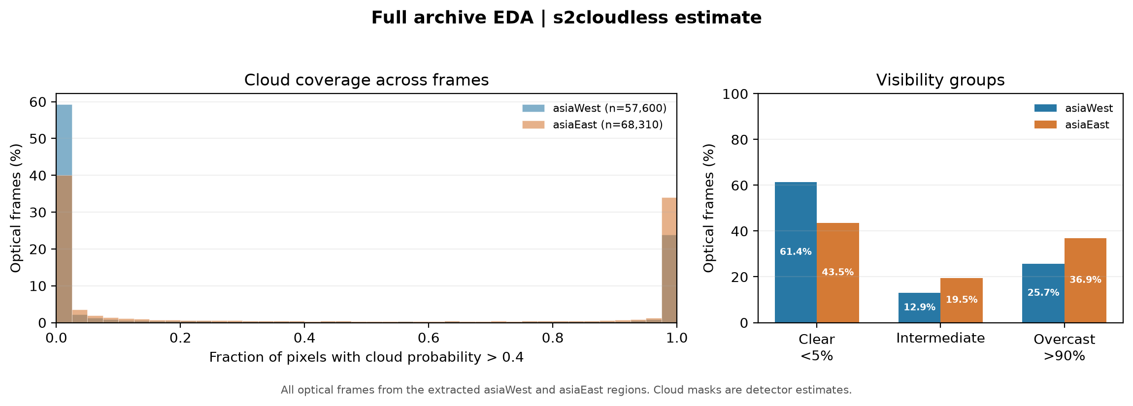
Figure 1 Cloud coverage distribution across all extracted asiaWest and asiaEast optical frames

Preprocessing and quality control

Optical and radar scaling
Optical digital numbers are clipped to the interval 0 to 10,000 and divided by 10,000. Model outputs and metric references are therefore on a 0 to 1 scale. Radar VV is clipped to minus 25 to 0 dB and VH to minus 32.5 to 0 dB, then each channel is linearly mapped to 0 to 1. The transfer audit rejects nonfinite radar and optical inputs.
Cloud probabilities come from s2cloudless, using all 13 bands, with average_over equal to 4 and dilation_size equal to 2 [R3]. Maps are cached as unsigned 8 bit arrays and decoded by dividing by 255. They are detector estimates; they are not hand labelled clouds and may confuse haze, bright surfaces or shadows.

Rules used in the new transfer experiment
A candidate location must have at least four paired observation dates. The reference must have no all zero optical pixels and at most 5 percent of pixels with detector probability above 0.4. Among complete candidates, the reference date with the smallest such cloud fraction is chosen. One asiaEast location was excluded because no reference met this low cloud condition.
The three inputs are selected from the other paired dates, ordered by actual absolute day difference from the reference. Each must have the expected band dimensions, finite values, and fewer than 50 percent missing optical pixels. Missing optical pixels are marked as fully cloudy. No input can be the selected reference acquisition. The relative optical dates are passed to the network in months, using day difference divided by 30.
Past and future observations are both allowed. This is retrospective reconstruction, not a causal forecasting system. A later clear frame may supply information about a cloudy earlier target date, so operational use would need a separate causal evaluation.

Why the October and November scores differ
The October loader selected dates and valid references using a different policy. The November audit changes the candidate reference, rejects heavily missing inputs and uses actual day gaps. It also eliminates the old fallback that could accept an invalid target when no complete date existed. Consequently, the November source model must be re evaluated with the new manifest. Directly attributing differences between the October and November tables to model training would be incorrect.
The selected low cloud image is a reference, not certified cloud free ground truth. Seasonal change, land cover change, atmosphere and residual contamination remain possible sources of disagreement.

CATFormer architecture as implemented
CATFormer is the working project name for a roughly 5.54 million parameter model. It uses convolutional spatial blocks and learned temporal attention in a U Net shaped encoder and decoder. It is not a full spatial Transformer at every scale. The component descriptions here follow model.py [E2].
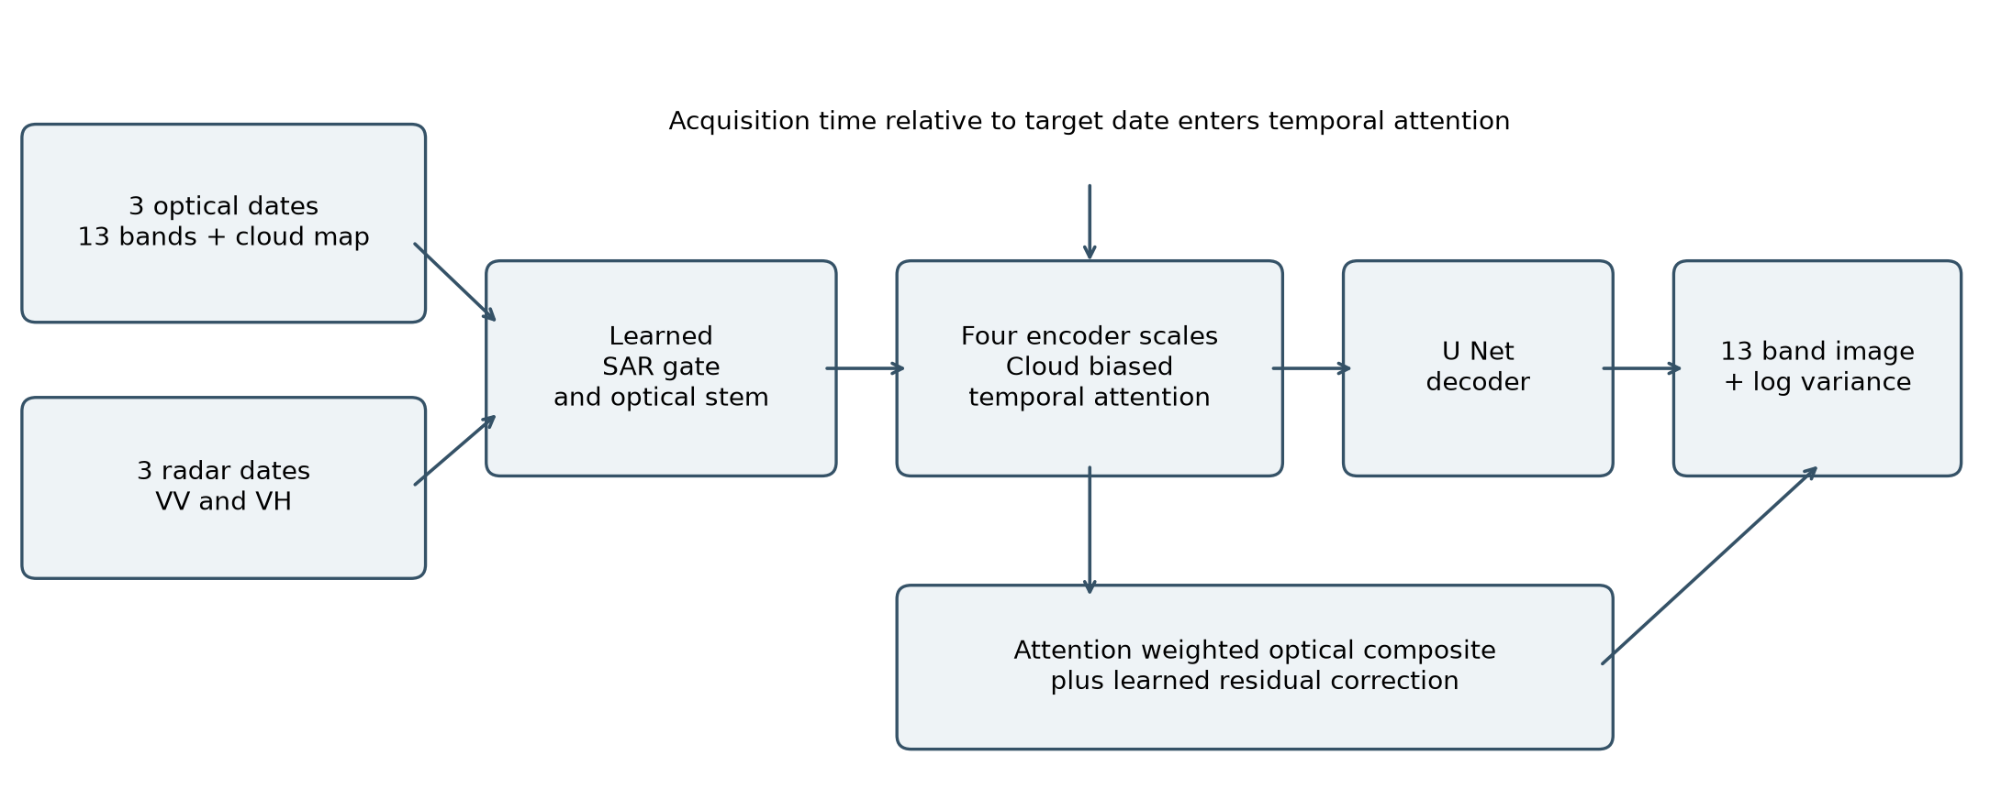
Figure 2 Data flow through CATFormer Stage 1

Radar and optical feature fusion
For each date, the optical stem receives 13 optical bands plus the cloud probability map. A parallel radar branch encodes VV and VH. A sigmoid gate observes the optical features, radar features and cloud map and adds gated radar features to the optical stream. This is a learned gate: the implementation does not force radar contribution to be zero on clear pixels.

Temporal fusion at multiple scales
Four encoder widths are 48, 96, 192 and 384 channels, with two depthwise convolutional residual blocks per scale. At each scale, four attention heads assign weights across the three dates independently at each spatial position. Acquisition time enters through a sinusoidal embedding. A learned nonnegative cloud penalty lowers attention scores where the cloud probability is high.
date weights = softmax over dates of [score - softplus(beta) × cloud probability]

Image reconstruction and uncertainty
The decoder combines fused features across scales. Full resolution temporal attention produces a weighted optical composite. The output head predicts a 13 band correction added to that composite, with the final image clipped to 0 to 1. A second set of 13 output channels predicts log variance, clipped to minus 10 to 5. These variance outputs have not been calibrated against held out error; they should not be described as proven confidence estimates.

Training objective and metric definitions
The supervised objective combines absolute reflectance error, uncertainty fitting, RGB structural similarity and spectral angle. All methods in the October architecture comparison used the project training script; UnCRtainTS did not use its original published training procedure unchanged.
L = L1 weighted + 0.1 × Gaussian NLL + 0.2 × RGB SSIM loss + 0.1 × SAM loss
The per pixel L1 weight is 1 plus the minimum cloud probability over input dates. A pixel hidden in every date receives more weight. Weights are normalised by their mean so that changes in cloud coverage do not simply rescale the entire loss.
NLL = mean of 0.5 × [log variance + squared error × exp(-log variance)]
In the implemented NLL, the mean prediction is detached. This blocks the direct residual gradient to the mean, while the variance output and shared features can still update. L1, SSIM and SAM directly train the mean. Gaussian log density losses can be negative on continuous normalised data; the negative total training losses in November are not by themselves evidence of an optimisation failure.
Metric | Computation in this project | Direction
PSNR | Compute mean squared error across 13 bands per patch, convert to dB, then average patches | Higher
RGB SSIM | Structural similarity on bands 4, 3 and 2 with data range 1, averaged over patches | Higher
MAE | Mean absolute error on normalised values across all 13 bands | Lower
SAM | Per pixel spectral angle across 13 bands in degrees, averaged over pixels and patches | Lower

All metrics use the numerical model outputs and references before the display stretch. PSNR is a mean of individual patch PSNR values, not a single value derived from pooled error across the dataset. SSIM is computed only on RGB, so it cannot establish preservation of all 13 spectral channels.
The SAM denominator contains a small stabilising constant. Spectral angle is unstable when a spectral vector has very low magnitude, including dark water or near zero bands. A later analysis should report valid signal masks and sensitivity to this stabiliser. The old water explanation is a hypothesis, not a measured land versus water result.
For reproducibility, the saved code also fixes the training SSIM approximation: it uses 7 pixel local averages on RGB. Evaluation uses scikit image structural_similarity. These are related but not identical SSIM calculations.

Published baseline and the experimental refiner

UnCRtainTS comparison
UnCRtainTS is a published attention based cloud removal model with uncertainty prediction [R2]. The project uses the authors repository and a wrapper with about 0.57 million parameters. Radar channels precede optical channels; inputs are multiplied by 10 internally, predicted means divided by 10 and variances by 100. Dates are supplied in days [E2].
The October comparison retrained this architecture using the project samples, augmentations and composite loss. The wrapper configures published architectural options, but the outer script supplies the optimisation objective. Therefore the measured result is a locally retrained architectural baseline, not a reproduction of the original paper benchmark or its original multivariate likelihood training.
It also has a substantial size advantage: CATFormer Stage 1 has about ten times as many parameters. A small quality gain must be considered alongside memory, computation and inference cost. No end to end latency comparison has been completed.

Stage 2 residual bridge
An optional 3.26 million parameter refiner was tested in October. It receives the Stage 1 image, log variance, the minimum cloud probability and mean radar input. Stage 1 is frozen. During training the refiner observes a noisy interpolation between the Stage 1 output and the reference, and predicts their residual difference.
x(s) = (1 - s) × Stage 1 image + s × reference + 0.02 × sqrt[s(1 - s)] × noise
Training target = reference - Stage 1 image; four Euler updates are used at inference
The code calls this a flow matching refiner. A more cautious description is an experimental residual bridge inspired by flow methods. The interpolation adds noise while the regression target is the endpoint difference; this project has not established formal flow consistency, stochastic calibration or equivalence to a published diffusion sampler.
Across three seeds its average PSNR improvement over Stage 1 was only about 0.015 dB. Best refiner checkpoints were chosen early in two seeds, and an unrefined fallback was not included as an explicit Stage 2 validation candidate in the old script. The later region adaptation experiments consequently use Stage 1 only. They do not include a transferred or retrained refiner.

Relationship to the literature
EMRDM and SADER were reviewed as examples of direct conditional restoration and efficient multitemporal diffusion [R4, R5]. Neither has been trained under this project protocol. Their published numbers cannot be used to claim that this system exceeds them.

Evaluation design for the asiaWest experiments

The early same tile experiment
Initial training used 216 patches and validation used 54 patches from the same tile, ROIs1868 tile 127. Patch identifiers were sorted and the final 20 percent held out. The shared tile meant that terrain, dates and large cloud events were common across both partitions. This provided a debugging test, not evidence of geographic transfer.
Prototype | PSNR on same tile validation | Status
v0 brightness cloud heuristic | 34.61 dB | Different cloud selection so not controlled against later runs
v1 s2cloudless | 40.27 dB | Same tile validation only
v2 Stage 1 | 40.62 dB | Same tile validation only
v2 with refiner | 41.07 dB | Same tile validation only

Whole tile separation
Once asiaWest was fully extracted, it contained 1,920 patch locations, with 30 optical and 30 radar dates per location, or 57,600 images per sensor. The region contained seven tiles. A fixed split was selected independently of the model seed.
Partition | Tiles | Locations
Training | 1868/127; 1970/83; 2017/115; 2017/130; 2017/69 | 1,395
Validation | ROIs1970 tile 57 | 255
Test | ROIs1970 tile 112 | 270

All tile labels include their ROI prefix; the shortened numeric ROI labels in the training row refer to ROIs1868, ROIs1970 and ROIs2017. Validation chose the checkpoint with the highest patch mean PSNR. The test tile was scored only after that selection, with no gradient updates from its locations.
The validation tile was unusually easy: the least cloudy input scored about 44.3 dB. This is a weak selection signal for a harder cloud removal test tile, particularly for the refiner. The partition still improves on same tile validation, but one test tile cannot represent the diversity of the region.
Both architectures used 40 epochs, batch size 8, AdamW with weight decay 0.05, and a OneCycle learning rate schedule. CATFormer used peak learning rate 0.0003 and UnCRtainTS 0.001. Supervised augmentation used shared right angle rotations and horizontal flips. The optional refiner trained for 20 epochs and used four inference updates.
For the repeated comparison, seeds 0, 1 and 2 changed model initialisation and data ordering. The geographic split remained fixed. Results below report sample standard deviation across seeds; this is not a confidence interval over geographic regions.

Results from the asiaWest seed comparison
Model | PSNR | RGB SSIM | MAE | SAM degrees
Least cloudy input | 30.80 | 0.8402 | 0.03304 | 7.90
UnCRtainTS | 32.69 ± 0.27 | 0.9204 ± 0.0043 | 0.02093 ± 0.00107 | 9.75 ± 0.47
CATFormer Stage 1 | 33.10 ± 0.67 | 0.9329 ± 0.0028 | 0.01999 ± 0.00100 | 9.66 ± 0.35
CATFormer with refiner | 33.12 ± 0.60 | 0.9325 ± 0.0033 | 0.01949 ± 0.00043 | 9.39 ± 0.33

Table 1 October protocol on ROIs1970 tile 112, 270 test locations. Learned model values are mean ± sample standard deviation over three seeds. Baselines are deterministic for the fixed samples. [E3]

What is supported
The structural result is the clearest signal. Every CATFormer Stage 1 seed scored above every UnCRtainTS seed on RGB SSIM. CATFormer Stage 1 mean SSIM was about 0.9329 compared with 0.9204 for UnCRtainTS. This is a consistent observation in the tested tile, but it does not establish the same gain in new regions.
CATFormer with refiner improved mean PSNR by 0.42 dB over UnCRtainTS and reduced mean MAE by about 6.7 percent. The PSNR seed standard deviation of about 0.60 dB is larger than that mean gap. Three seeds and one test tile are insufficient for a strong claim of general superiority or a formal statement about statistical significance.

What did not hold up
The refiner was not a consistent PSNR improvement. Per seed changes relative to Stage 1 were +0.238, -0.010 and -0.183 dB. The mean improvement was therefore negligible, and its effect depends on checkpoint selection and the seed.
All learned models had worse SAM than the least cloudy baseline on this test tile. Even the refiner averaged 9.39 degrees versus 7.90 degrees for copying a selected input. A high structural score can coexist with spectral distortion. This was a reason to investigate geographic adaptation rather than treating a single PSNR score as the endpoint.
The mean input baseline scored only 23.29 dB. It remains a useful sanity check: averaging cloudy inputs can preserve clouds and blur changing land surfaces. The stronger least cloudy baseline is the comparison that matters more in this dataset.

Design of the asiaEast transfer experiment
The starting point was the original asiaWest CATFormer Stage 1 seed 0 checkpoint. It was chosen in advance rather than selected by the asiaEast test score. Its SHA 256 fingerprint was recorded, checked again after the experiments, and remained unchanged [E4]. Both adaptation branches independently load this same file.

Fixed geographic separation
Region | Training | Validation | Test
asiaWest | 1,395 locations on five original tiles | 255 locations on tile 1970/57 | 270 locations on tile 1970/112
asiaEast | 569 locations in ROIs1970 | 1,133 locations in ROIs1868 | 574 locations in ROIs2017

AsiaEast was separated by whole ROI, using fixed random seed 1234. The held out test ROI contains tiles 117 and 25, with 285 and 289 locations respectively. ROI labels are reused across the regional archives, so region plus ROI plus tile identify the geography. The audit also checked patch footprints in a common coordinate system and found no spatial intersection across the new partitions or between regional samples.
There are only three target ROI groups, so the split is naturally uneven. The training set is smaller than validation, and each partition may represent different land and cloud conditions. This is stronger separation than mixing adjacent patches, but it is a small number of geographic groups, not hundreds of independent regions.

Ordinary continued training
The supervised adaptation set contains all 569 target training locations plus a fixed sample of 190 original asiaWest training locations: 759 locations in total and about 25 percent source replay. Source validation and test locations are excluded from replay. The new run uses batch size 4, AdamW with learning rate 0.00003 and weight decay 0.05, and cosine learning rate decay over 20 epochs.
The earlier files contain weights rather than full optimiser state. Continuing from them means preserving learned weights and creating a fresh optimiser at a smaller learning rate. It is not an exact continuation of the earlier optimisation trajectory. New runs save their own model, optimiser, scheduler and random state checkpoints in separate directories.
The unchanged model is evaluated first. Ordinary fine tuning and the self supervised branch then use identical supervised manifests, source replay samples and nominal fine tuning schedules. Validation selects their checkpoints. The test scores do not choose the training epoch.

Self supervised learning procedure
The self supervised stage uses information already present in the observed training inputs. It does not require the separate selected reference to define its reconstruction target. It is a masked reconstruction task applied before supervised fine tuning, with all data still restricted to training locations.

How a masked training example is made
For each sample, the code selects the input date with the largest proportion of pixels whose cloud probability is below 0.1. It copies that observed optical image as the reconstruction target and marks its low cloud, nonmissing pixels as eligible. A random coarse grid hides approximately half of the 32 by 32 pixel blocks. The same spatial blocks are hidden in every optical date, preventing direct copying from another optical date at those positions.
Hidden optical values are replaced by zero and their cloud probability is set to one. Radar remains available, as do the visible optical blocks. The relative timestamps are recentered so that the chosen observed date, rather than the original supervised reference, is time zero. This keeps the input timing consistent with the self supervised target.
Masked L1 = sum of [eligible mask × absolute error] / [13 × sum of eligible mask]
Only masked pixels that were originally clear and nonmissing contribute to the objective. Batches with no eligible pixels are skipped. The supervised low cloud reference is not used in this loss. The implementation trains the model through its image output, so the stage is not a separately frozen encoder pretraining procedure. Because only image L1 is used, uncertainty calibration is not directly trained in this stage.

Checkpoint selection and ordinary fine tuning
Eight self supervised epochs were run using the same 569 target and 190 replay locations. A fixed masking seed on observed validation inputs selects the self supervised checkpoint using masked MAE. The best saved checkpoint was at zero based epoch 4, the fifth completed epoch. Training then runs 20 supervised epochs with the same objective used in ordinary fine tuning.
The ordinary fine tuned checkpoint was selected at supervised epoch 17; the self supervised branch selected supervised epoch 10. These are one based counts translated from zero based saved logs. A saved pre update candidate is also allowed, so adaptation need not overwrite a model that already has the best validation score.

What this comparison can establish
The experiment compares two practical adaptation procedures. It does not isolate the causal value of the masked objective from extra computation: the self supervised branch has eight additional training epochs. A 28 epoch supervised adaptation control and repeated seeds are needed before claiming that self supervision itself is responsible for the gain.

Held out target results and source retention
Method | PSNR dB | RGB SSIM | MAE | SAM degrees
Least cloudy input | 29.50 | 0.8748 | 0.05524 | 4.95
Original weights | 30.90 | 0.9434 | 0.02630 | 5.71
Ordinary fine tuning | 32.50 | 0.9532 | 0.02081 | 4.91
SSL then fine tuning | 33.47 | 0.9519 | 0.01937 | 4.36

Table 2 November protocol on the held out asiaEast test ROI, 574 locations in two tiles. One model seed per procedure. [E5]
Ordinary fine tuning improves target PSNR by 1.61 dB over the unchanged source model, reduces MAE by about 20.9 percent and lowers SAM by 0.80 degrees. The self supervised branch improves PSNR by 2.58 dB over the unchanged model and by 0.97 dB over ordinary fine tuning. Its MAE is about 6.9 percent lower than ordinary fine tuning and its SAM is lower by about 0.55 degrees.
There is no single winner on every target metric. Ordinary fine tuning has slightly higher RGB SSIM, 0.9532 versus 0.9519. The self supervised branch has the strongest target PSNR, MAE and spectral angle. Both adapted models improve on the least cloudy baseline across these four metrics in this test ROI.
Method | PSNR dB | RGB SSIM | MAE | SAM degrees
Original weights | 32.50 | 0.9369 | 0.02093 | 10.45
Ordinary fine tuning | 33.20 | 0.9343 | 0.01870 | 8.48
SSL then fine tuning | 32.22 | 0.9269 | 0.02171 | 9.28

Table 3 AsiaWest retention on the same 270 original test locations under the November sampling policy. [E5]
Ordinary fine tuning improves source PSNR by 0.71 dB and source SAM by 1.98 degrees, while slightly reducing RGB SSIM. In contrast, the self supervised branch loses 0.27 dB of source PSNR and 0.0100 SSIM relative to the unchanged model, although its source SAM still improves. This is evidence of a retention trade off across metrics, not complete catastrophic forgetting.
The absolute source and target scores cannot, by themselves, quantify a pure geographic penalty. Their scenes, references, cloud visibility and baselines differ. The more controlled evidence is the within target comparison before and after adaptation on exactly the same manifest.

How the results should be interpreted
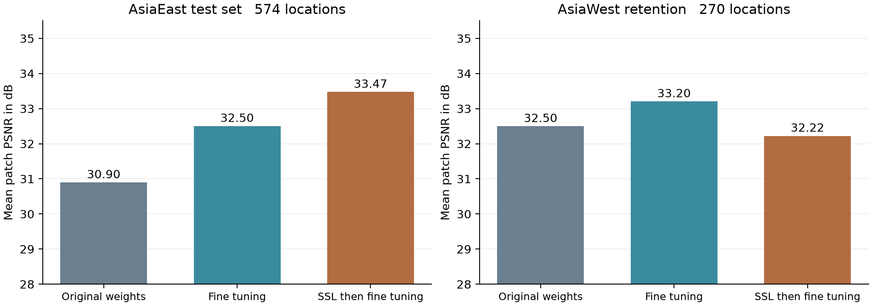
Figure 3 Target improvement and source retention in the same November evaluation protocol

Generalisation before adaptation
The unchanged asiaWest model already beats the asiaEast least cloudy baseline in PSNR and RGB SSIM. It transfers useful information before seeing target region training examples. However, its spectral angle is worse than that simple baseline. Transfer is therefore partial and depends on the metric; the model does not simply fail on the new region.

Adaptation and forgetting
The self supervised procedure gains target accuracy while ordinary fine tuning gives a better balance between the two tested regions. Source replay uses only 190 of the 1,395 available source training locations, so it cannot guarantee source retention. A larger replay sample, a distillation penalty against the original model or selective encoder freezing are plausible next controls, not completed improvements.

How much confidence is justified
The target difference of 0.97 dB is an observed difference in one run, not an established expected gain over training randomness. Test patches within the two tiles are spatially correlated. Bootstrapping individual patches alone would overstate the number of independent examples. Repeating seeds and testing additional held out ROIs would give stronger evidence than making a p value from hundreds of neighbouring patches.
The experiment has also been reviewed repeatedly on its test data. Any later architectural or hyperparameter choice guided by these scores should use new untouched geographic test areas for a final claim. The current asiaEast ROI is now an exploratory benchmark for this project, rather than an indefinitely reusable blind test.

Training behaviour and encoder embeddings
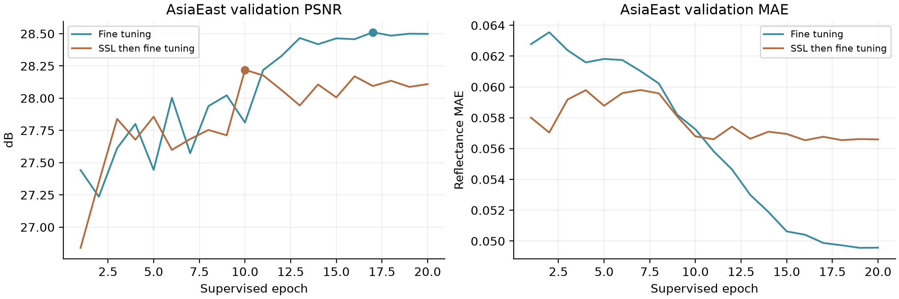
Figure 4 Target validation curves and selected supervised checkpoints
The validation plots show why the selected checkpoint is not necessarily the last epoch. The ordinary and self supervised branches settle at different validation levels. The validation ROI is also geographically different from the test ROI, so lower validation error in one branch does not guarantee it will dominate every test metric.
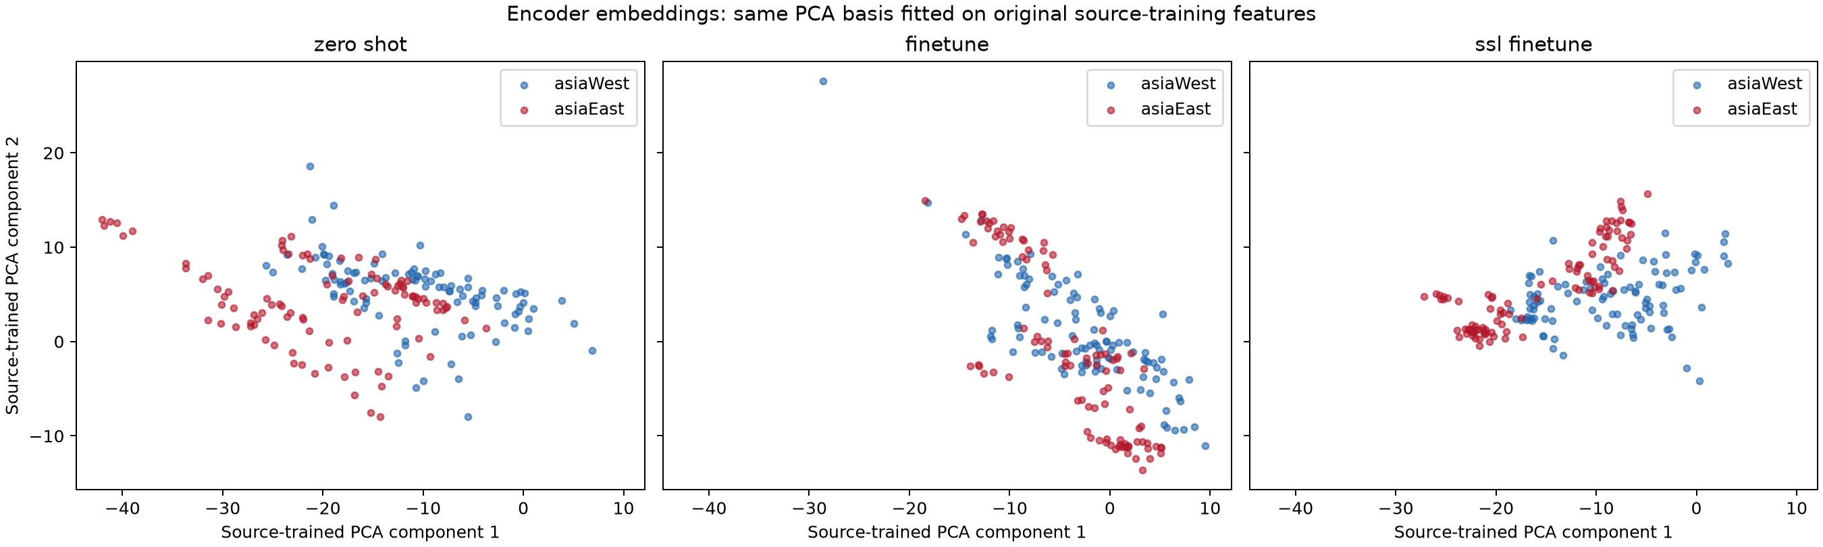
Figure 5 Encoder embeddings projected onto a shared basis fitted to original source training features
For each model, the final convolutional encoder output has 384 channels. Features are averaged over spatial dimensions and then over the three dates, before any fused decoder representation is used. Up to the first 100 sorted locations per region and split were exported, giving at most 600 vectors per model. This is a deterministic subset, not a representative random sample of all terrain.
PCA is fitted only to original model features from asiaWest training locations, then reused for all three models. The plot shows test features from both regions in this fixed basis. Clusters move and overlap differently after adaptation, but visual overlap is not proof of domain invariance or reconstruction quality. First 100 test locations can favour a particular tile, and encoder scales or orientations may change during training. Quantitative reconstruction remains the primary evidence.

Reading the predicted image examples
The six case study pages that follow show actual model inference on held out asiaEast locations. The locations were selected at approximately the 5th, 20th, 40th, 60th, 80th and 95th percentiles of the self supervised model test PSNR distribution. This deliberately spans weak through strong cases. It is not a random sample and is not evidence that the displayed method wins on every location.
Each case uses the same eight panels. The top row shows three optical inputs and the least cloudy input baseline. The bottom row shows the unchanged asiaWest model, ordinary fine tuning, self supervised adaptation plus fine tuning, and the selected low cloud reference. Radar was used during inference but is omitted from these panels to keep the comparisons readable.
All displayed images use Sentinel 2 bands 4, 3 and 2 for RGB and the identical display rule: clip 3.5 times normalised reflectance to the interval 0 to 1. No per image contrast adjustment is applied. Bright clouds can therefore saturate to white. Displayed colour is for qualitative inspection; the printed PSNR scores use all 13 numerical bands before the stretch.

Checks performed on these images
The SSL model PSNR for every displayed case was checked against the saved per location test result, within 0.02 dB. Prediction files were loaded from the same saved checkpoints as the table. The source model panel uses the original seed 0 Stage 1 weights; it does not silently include the October refiner. The other two panels use their validation selected adaptation checkpoints.

What to look for
A useful output should remove visible cloud, preserve roads and terrain structure, and match the reference spectral balance. An apparently sharp texture can be wrong. If all optical inputs are heavily obscured, the network can infer plausible structure from radar or priors without recovering the exact appearance of the target. This risk is visible in the second case.
A clear input does not guarantee a high reference score. The first case has a clear input but substantial colour and vegetation difference from the reference date. Because images are acquired at different times, some error can reflect seasonal surface change or acquisition conditions. We have not independently labelled those causes, so the case discussion treats them as explanations to investigate.
Cloud percentages are detector estimates at probability threshold 0.4. The percentile labels refer to the selected score rank, not a probability or an uncertainty level. The case scores should be read with the full test table rather than substituted for it.

Limitations and proposed next experiments

Claims that remain unproven
The project has not established a globally best architecture, a new published benchmark result, calibrated uncertainty or a unique contribution beyond existing cloud aware fusion methods. It has not isolated the separate effect of cloud bias, radar gating, date encoding and spectral loss. An ablation study is still needed. The current transfer experiment does not include an adapted UnCRtainTS control, so it cannot show that CATFormer is the best adaptation architecture.
The original three seed comparison covers only one held out asiaWest tile. The new experiment adds two target test tiles from one ROI, but only one seed. Reference images can retain clouds. Some inputs are already clear, future observations are available and quality filtering removes particularly incomplete sequences. These scope conditions must be stated with any performance claim.

Next steps in order
1. Repeat the three transfer procedures with at least two additional seeds, preserving the geographic manifest and initial source seed policy. Report per seed results and paired differences, without choosing a favourable seed for the final table.
2. Add an equal compute supervised control. Compare 28 supervised epochs with 8 masked epochs plus 20 supervised epochs. Keep the learning rate policy, data exposures and checkpoint selection rules explicit. A reconstruction gain from this control would separate objective choice from extra optimisation.
3. Improve retention controls. Test larger source replay, frozen early layers or source teacher distillation using source training data only. Choose the trade off on held out source and target validation data, before a final external test.
4. Evaluate by cloud visibility and terrain. Report clear available, partially hidden and fully hidden cases separately; use independently verified water and land masks before attributing SAM failures to water. Examine per band error and low signal sensitivity in SAM.
5. Run component ablations and an adapted published baseline under the same transfer protocol. Revisit the refiner only after Stage 1 and checkpoint selection are stable. If a formal flow claim is required, align its interpolation and velocity objective with a justified formulation.
6. Reserve a further untouched geographic region or ROI for final evaluation. Keep the already reviewed test locations for exploratory development and qualitative diagnosis. Report the number of independent scenes alongside patch counts.

Test case 1 ROIs2017 tile 117 patch 227
Selection percentile 5 of the SSL model test PSNR distribution. A difficult colour and reference date mismatch.
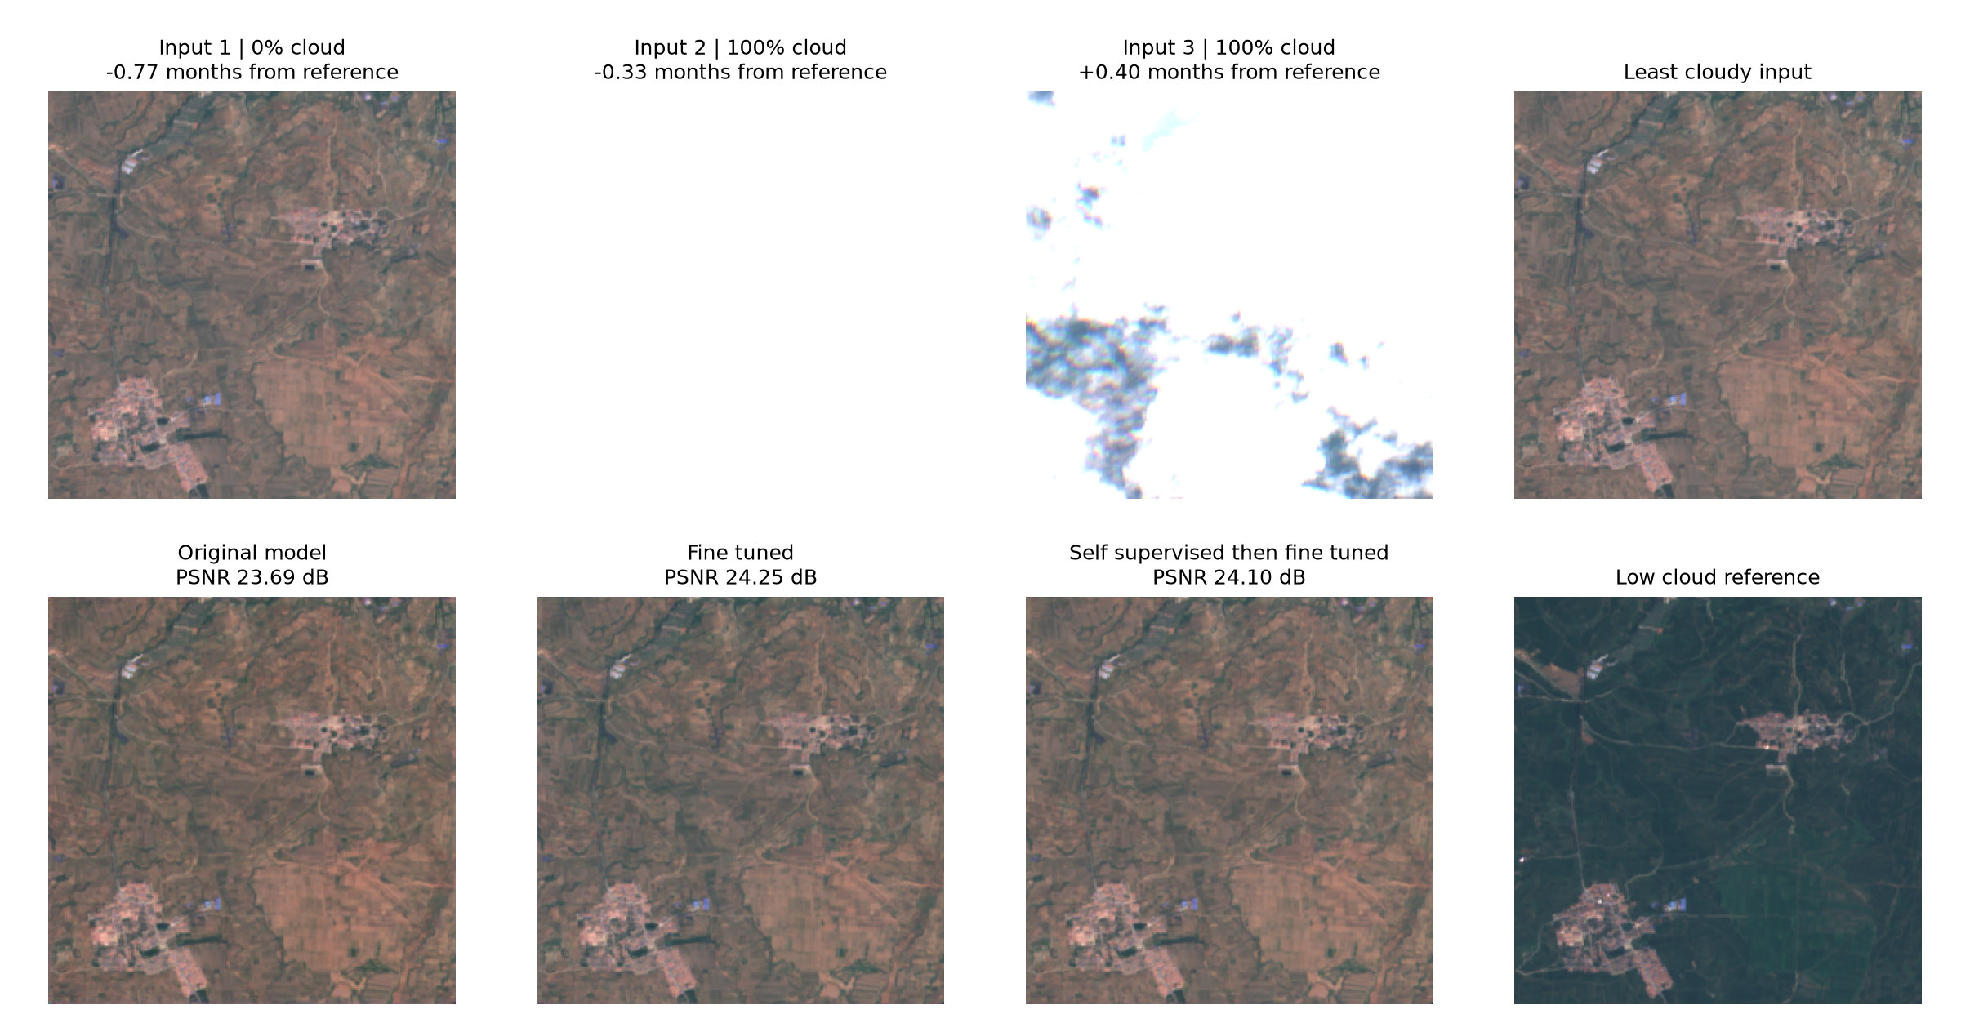
Figure 6 Held out asiaEast inputs and predictions with the same RGB display stretch
The first input is almost clear, but the reference is darker and greener. Ordinary fine tuning reaches 24.25 dB, slightly above the SSL branch at 24.10 dB and the original model at 23.69 dB. All predictions retain much of the input appearance. Seasonal change, atmospheric differences or other date effects are plausible causes, but have not been independently verified. This case shows that a cloud free looking input can still be a difficult temporal reconstruction target.

Test case 2 ROIs2017 tile 117 patch 0
Selection percentile 20 of the SSL model test PSNR distribution. Cloud removal improves but texture remains uncertain.
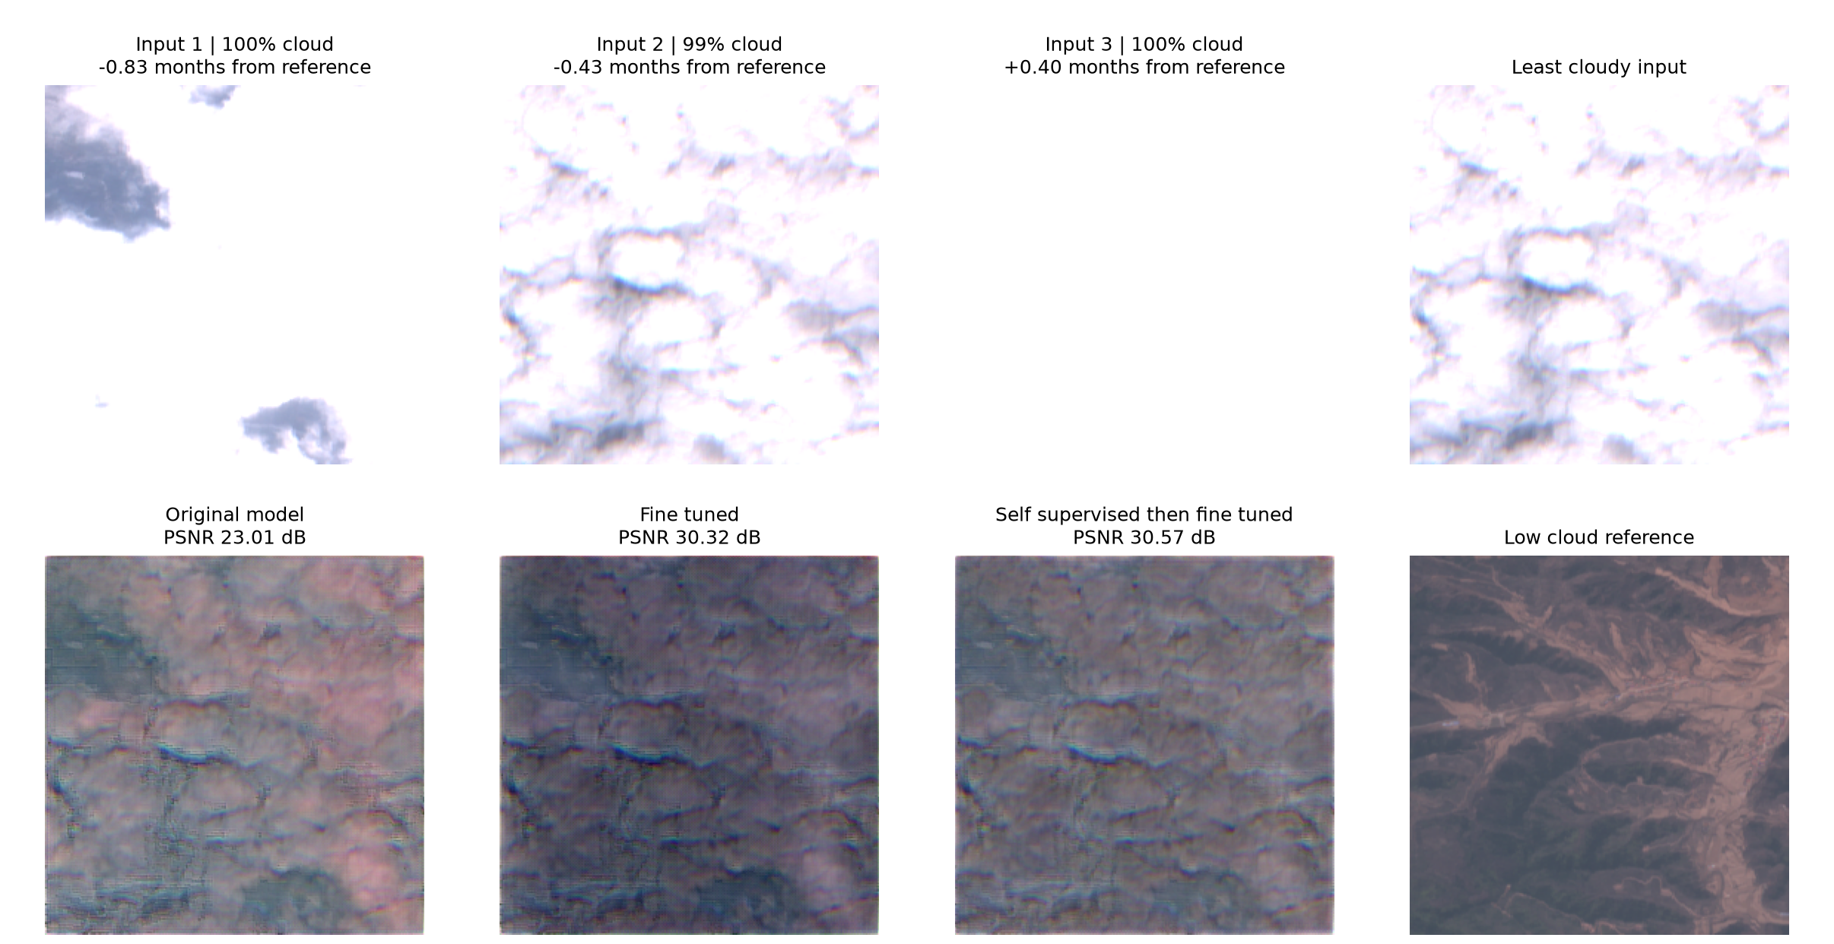
Figure 7 Held out asiaEast inputs and predictions with the same RGB display stretch
All three inputs have approximately 99 to 100 percent detected cloud. The original model reaches 23.01 dB, ordinary fine tuning 30.32 dB and the SSL branch 30.57 dB. Adaptation removes much of the cloud brightness, but predicted textures and colours still differ from the reference. These outputs are inferred reconstructions, not direct observations of the hidden surface; a high PSNR here does not certify every reconstructed feature.

Test case 3 ROIs2017 tile 25 patch 136
Selection percentile 40 of the SSL model test PSNR distribution. The self supervised branch improves the spectral match.
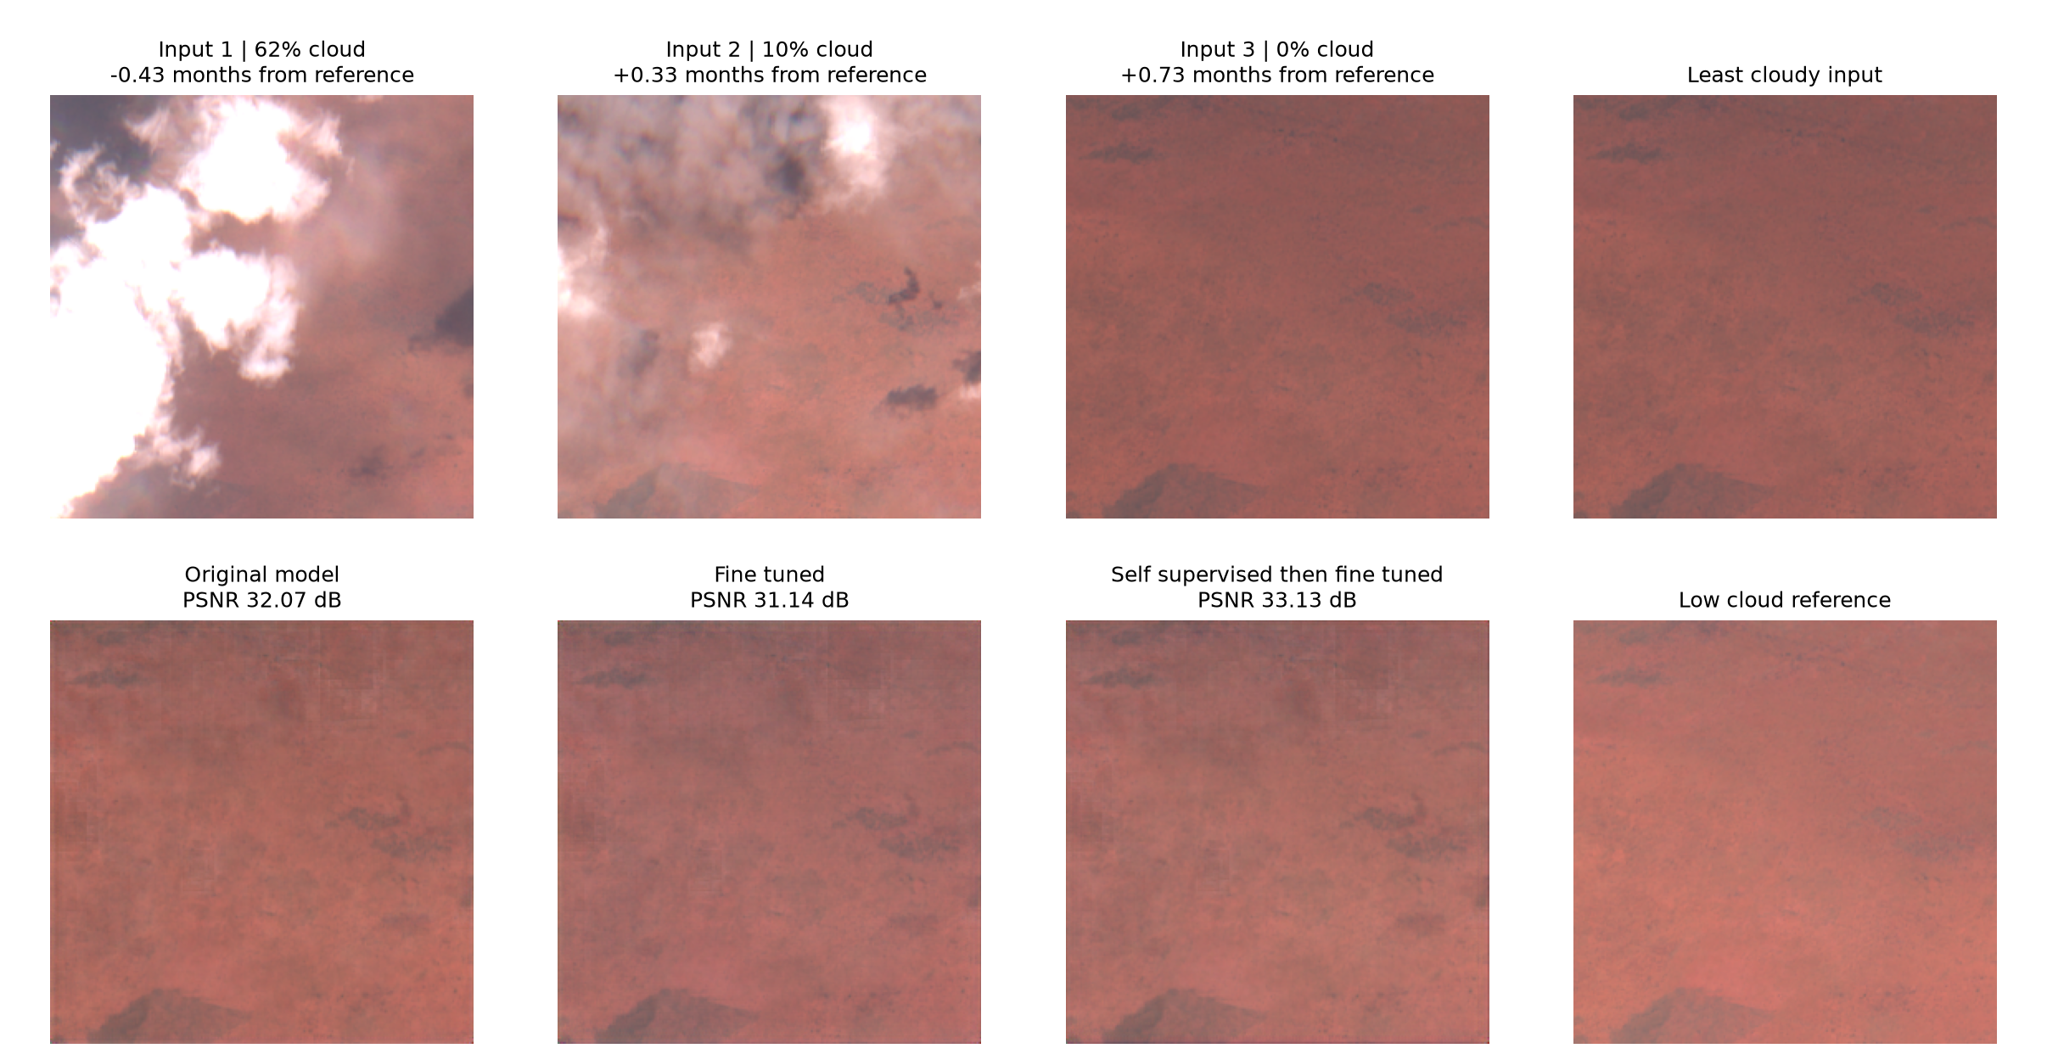
Figure 8 Held out asiaEast inputs and predictions with the same RGB display stretch
A later clear observation is available. The original model reaches 32.07 dB and ordinary fine tuning drops to 31.14 dB. The SSL branch reaches 33.13 dB and has the lowest SAM of these predictions at 2.26 degrees. The score improves, but this is mostly a subtle reflectance comparison over relatively smooth terrain rather than evidence of recovering fine details under complete cloud.

Test case 4 ROIs2017 tile 117 patch 81
Selection percentile 60 of the SSL model test PSNR distribution. Ordinary fine tuning wins this location.
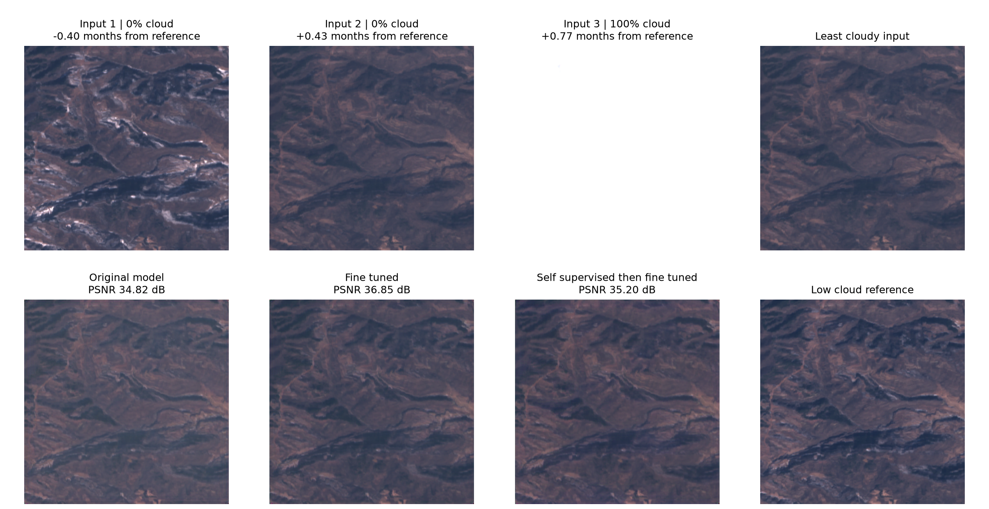
Figure 9 Held out asiaEast inputs and predictions with the same RGB display stretch
Two input dates are nearly clear. Ordinary fine tuning gives 36.85 dB, compared with 35.20 dB for the SSL branch and 34.82 dB for the original model. The terrain structures are visible in all three predictions. This example is included because the method with the strongest aggregate target PSNR does not win every patch.

Test case 5 ROIs2017 tile 25 patch 80
Selection percentile 80 of the SSL model test PSNR distribution. A clear input and haze affect different models differently.
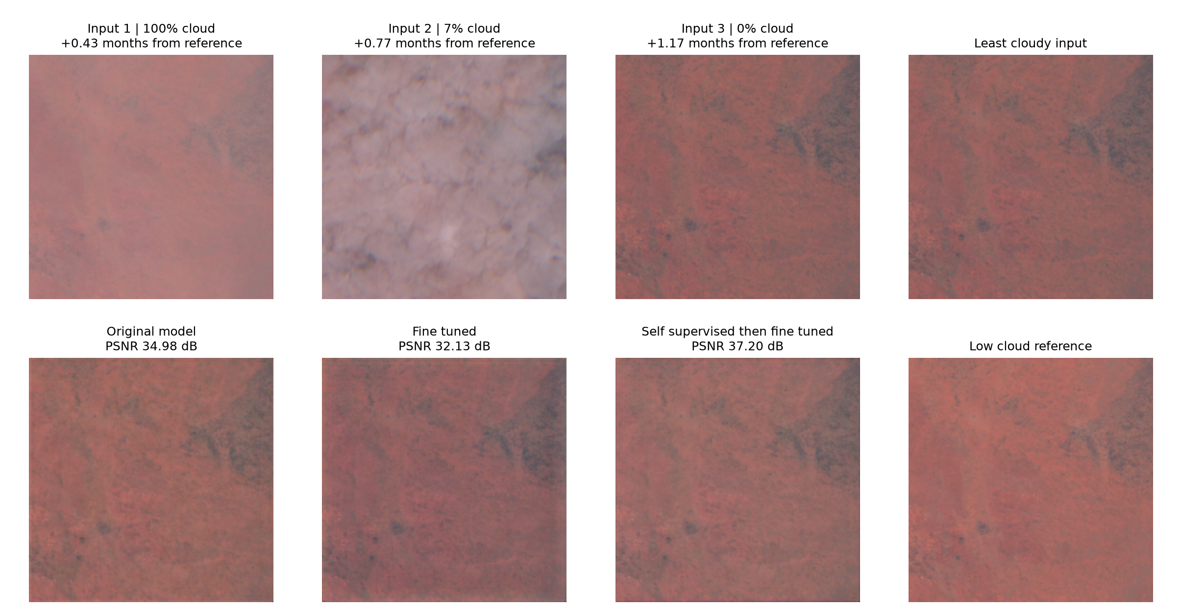
Figure 10 Held out asiaEast inputs and predictions with the same RGB display stretch
The three inputs range from detector flagged cloud to relatively clear observations. The original model gives 34.98 dB, ordinary fine tuning 32.13 dB and the SSL branch 37.20 dB. Its target score is higher here, but detector cloud fractions are imperfect and must be checked against the images. The least cloudy baseline is already strong on this example, so the gain should be judged against that baseline too.

Test case 6 ROIs2017 tile 25 patch 86
Selection percentile 95 of the SSL model test PSNR distribution. A high scoring example with modest remaining differences.
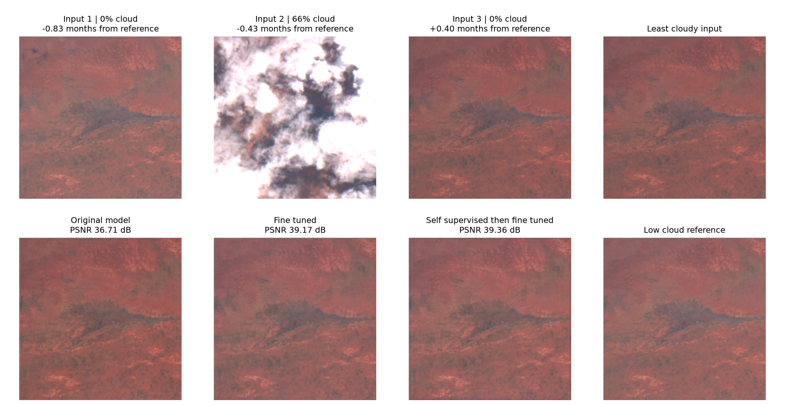
Figure 11 Held out asiaEast inputs and predictions with the same RGB display stretch
The inputs include clear frames surrounding a partially cloudy observation. The original model gives 36.71 dB, ordinary fine tuning 39.17 dB and the SSL branch 39.36 dB. Both adapted predictions closely resemble the low cloud reference. The SSL PSNR lead is small, and ordinary fine tuning has better SAM and RGB SSIM in this particular patch. This is a reminder that PSNR alone does not define spectral or structural fidelity.

Reproducibility and saved experiment files
The transfer pipeline completed on 2 November 2026. The full archive EDA completed on 6 November. Checksums and data preparation succeeded before evaluation. GPU jobs ran sequentially on an allocated 24 GB GPU slice. The recorded elapsed times include data loading, metrics and feature export, so they should not be interpreted as pure neural network training time.
Stage | Job | Elapsed
Preparation and audit | 10040 | 1 h 34 min 08 s
Unchanged model evaluation | 10041 | 1 min 51 s
Ordinary fine tuning | 10042 | 52 min 48 s
SSL and fine tuning | 10043 | 1 h 11 min 49 s
Summary and embedding plot | 10044 | 5 s

The GPU stages total about 2.11 allocated GPU hours. No further training was launched to create this report. The original source checkpoint remains unchanged. Later figure generation used CPU inference for the six displayed cases.
The full EDA was a CPU job (Slurm job 11190). Its per-region summaries, location-level CSVs and frame-level cloud CSVs are saved under eda/full on the HPC. Summary JSON and the figure are included with the report evidence.

Important files on the HPC
Project root: /scratch/tadi.reddy.ug24/cloudrm. Download archives are in raw and extracted observations in data. The strict manifest and quality audit are expansion/prepared/manifest.json and audit.json. The original source weights are runs/full_catformer_v2_s0/best.pt.
Transfer outputs are under runs/transfer_asiaeast_s0. The zero_shot, finetune and ssl_finetune subdirectories contain results, configuration and embeddings. Adapted best.pt files are separate from the source checkpoint. Training history records validation selection and last_training.pt stores state for a deliberate restart. The summary is comparison.json and the embedding figure is embedding_comparison.png.
Source checkpoint SHA 256: 2291b02183702b219caa1663d3fb4ac3d849bc225e2e9a54ed4c86be5f81ad6c. Shared transfer manifest SHA 256: c67acdb5888c8113e40d5b0bafb58a551ae710d16d1478cc72bee3df302d5446.

Code and the accompanying local evidence
The code folder on this Mac is Desktop/cloud_removal_code. The new transfer runner is expansion/cross_region.py. This report folder includes an evidence snapshot and copies of the relevant scripts. The public project repository is https://github.com/thseR5/catformer-cloud-removal. It contains earlier code; the new expansion work should be versioned and reviewed before treating a remote commit as an exact reproduction of this report.
UnCRtainTS upstream checkout used by the project: 5e1f1b58e993645e765b64e10b6e9c7ff828b36f. The evidence snapshot preserves the source result JSON values rather than copying only rounded chat tables.

Evidence and references

Experiment evidence
[E1] Early EDA and prototype results. eda/summary.json and runs/catformer_v0, catformer_v1_s2cl and catformer_v2/results.json.
[E8] Full archive EDA, 6 November 2026. eda/full/full_summary.json, region-level location and cloud-frame CSVs, and the full EDA runner expansion/full_eda.py.
[E2] Actual architecture and local baseline wrapper. model.py, data.py, train.py and baselines.py. Copies retained in this report folder under source/code.
[E3] October three seed tests. runs/full_uncrtaints_s0 through s2/results.json and runs/full_catformer_v2_s0 through s2/results.json.
[E4] Transfer protocol and audit. expansion/cross_region.py, expansion/prepared/audit.json, experiment plan, job records and checkpoint fingerprint.
[E5] Transfer numerical results and selections. runs/transfer_asiaeast_s0/*/results.json, config.json, history.json, ssl_history.json and training_locations.json.
[E6] Embeddings. Saved embeddings.npz and embedding_labels.json files, together with expansion/summarize_transfer.py.
[E7] Qualitative test cases. figures/asiaeast_test_cases/cases.json, input_metadata.json, exported PNGs and expansion/show_test_cases.py.

Primary literature and data sources
[R1] Ebel P, Xu Y, Schmitt M and Zhu X X. SEN12MS CR TS A Remote Sensing Data Set for Multi modal Multi temporal Cloud Removal. IEEE TGRS, 2022. https://arxiv.org/abs/2201.09613. Dataset landing page: https://mediatum.ub.tum.de/1639953.
[R2] Ebel P, Sainte Fare Garnot V, Schmitt M, Wegner J D and Zhu X X. UnCRtainTS Uncertainty Quantification for Cloud Removal in Optical Satellite Time Series. 2023. https://arxiv.org/abs/2304.05464. Official implementation: https://github.com/PatrickTUM/UnCRtainTS.
[R3] Sentinel Hub. Sentinel 2 cloud detector s2cloudless. Official implementation and usage documentation. https://github.com/sentinel-hub/sentinel2-cloud-detector.
[R4] Liu Y and colleagues. Effective Cloud Removal for Remote Sensing Images by an Improved Mean Reverting Denoising Model with Elucidated Design Space. 2025. https://arxiv.org/abs/2503.23717. Reviewed as related work; not benchmarked in this project.
[R5] Zhang Y and colleagues. SADER Structure Aware Diffusion Framework with Deterministic Resampling for Multi Temporal Remote Sensing Cloud Removal. 2026. https://arxiv.org/abs/2602.00536. Reviewed as related work; not benchmarked in this project.
[R6] Project code repository. CATFormer cloud removal. https://github.com/thseR5/catformer-cloud-removal. Local expansion scripts and saved run evidence accompany this report.
Report date 6 November 2026. The architecture and results discussion refers to the saved experiments identified above. Training data, model weights and full resolution satellite archives remain on the HPC.

