SWP 3

3a)
Basic Idea

The aim of this analysis is to estimate price elasticities in a multinominal framework. Each observation of the data set refers to a purchase of 'Cola' beverages in Boston (from 2010 to 2011). Consumers face a choice between 4 different 'Cola' types: Coke Classic, Pepsi, Coke Diet and Pepsi Diet. The following questions emerge immediately: how does a price change of one of the products affect consumer's choice and utility? Does a price change of one product affect the demand for other products? In order to answer these question, we run a multinominal.

Implementation

Naturally, to estimate a multinominal model, a reference (or baseline) measure is needed. In this analysis this is done by comparing the utility of each product to the 'outside product', that is to the remaining consumer basket. Unfortunately these characteristics are not observed, and need therefore to be imputed. We use the total revenue of cola in a certain week as the baseline and compute shares across all products relative to that. The outside-product share is then every sale inside the cola market that cannot be attributed to Coke Classic Diet Coke, Pepsi or Diet Pepsi. Then, elasticities are computed in order to estimate the effect of a price change of each product on its own demand and on the demand of the competing cola beverages.

To implement this, some new variables were created: we computed the market shares for cola and carbonated beverages, as well as their counterpart, the market share of the 'outside product'. Then, own elasticities and cross-elasticities are computed.

The following equations explain the setting mathematically:
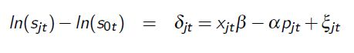
where s refers to the market share and its index to each product (j=0 =: outside product). The regressor matrix x controls for several covariates as marketing actions, seasonal effects and public holidays, and -most importantly- for price variations (separately denoted as p in the equation above). The error term captures unobservable variations.
The estimation results of the regression equation, especially the price coefficient alpha is then used to estimate corss-elasticities:
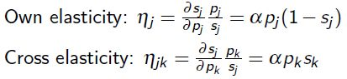

Estimation Results

Table 1 and 2 report estimation results of cross elasticities for bottles and cans, respectively.

bottles | Coke | Diet Coke | Diet Pepsi | Pepsi
Coke | -2.32
Diet Coke | -0.12 | -2.31
Diet Pepsi | -0.06 | -0.06 | -2.37
Pepsi | -0.11 | -0.12 | -0.12 | -2.37
Table 1: Estimation Results of Cross Elasticities for bottles.

cans | Coke | Diet Coke | Diet Pepsi | Pepsi
Coke | -1.67
Diet Coke | -0.14 | -1.65
Diet Pepsi | -0.07 | -0.08 | -1.44
Pepsi | -0.13 | -0.14 | 0.08 | -1.45
Table 2: Estimation Results of Cross Elasticities for cans.

The interpretation of the elasticities are straight forward: a percentage increase in price of product j reduces the demand by the coefficient indicated on the diagonal of the table, e.g. a price increase of one percent of Coke Classic bottles reduces its demand by 2.32%. Similarly, the cross-elasticities indicate the percentage effect on demand of product i given a price increase of product j by one percent. For example, a price increase in Coke Classic bottles reduces the demand for Diet Coke by -0.12%. Surprisingly, the sign of the cross-elasticities is negative, contradictory to economic theory and our expectations. This strange effect may be disregarded as it is close to zero, nevertheless it may be explained by some unobserved consumer behavior (e.g. a consumer 'allegiance'-bias to their favored products).

Furthermore, a strange pattern is observable: demand for Coke cans reacts more sensitive to price changes than Pepsi cans (-1.67% vs. -1.45%); reversely, the demand for Coke bottles is more robust to price changes than Pepsi bottles (-2.32% vs. -2.37%). There is no obvious explanation for this inverse reaction to price changes (at least not in the data). Nevertheless, it would be interesting to analyze this problem in more detail as it is contradictory to economic theory (where more expensive products tend to have higher elasticities than cheaper products and where cross-elasticities shift proportionally).

3b)

Basic Idea

More interesting than using the full data set that contains all differentiated products, it may be more informative to focus the analysis on grouped products that appear to have similar characteristics (or may be considered as substitutes). Therefore, we now run a nested logit model, where we group the Cola beverages by brand (Coke, Pepsi) and by type (diet, classic). Then we regress the market shares on the covariates matrix (as in 3a) and add a variable that controls for the within group shares, s_{j/g.}
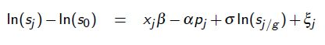
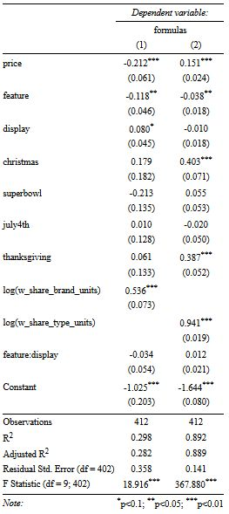
Estimation Results

The regression output table on the right presents the estimated coefficients for (1) cans and (2) bottles. The majority of the coefficients is in line with our expectations, except the coefficient for price in the second (=bottle) model, which is positive. As already seen in SWP 2, are the public holidays (except for bottles at thanksgiving and christmas) not significant. Unfortunately are the coefficients of determination R² varying: the can model's R² is 0.28, which indicates a bad fit; the R² of the bottle model is 0.88, which may be due to multicollinearity.

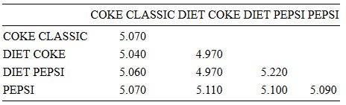
Table 3: own and cross elasticities for the nests “brand”

3c)
→ market share did not deserve further exploration, as they do not differ largely between products.

→ elasticities in 3b (compared to nest) should be greater than in 3a (compared to outside product). I
→ own elasticities are expected to be higher. This is consistent with the idea that products
in a nest face a more competitive choice context
→ cross-elasticities are as well expected to be higher for products within the same nest in contrast to products of other nests.

→ we expected higher elasticities for more expensive products. Bottles have the same price (~1.26-1.28), cans differ a little bit: coke cans cost 3.69, pepsi cans 3.53. Therefore we expect that the price elasticities for cans to be higher.

