Object Oriented Analysis and Design – Part2 (Design)

Q. 1 Which statement is true about elements within the subsystem and public
visibility?
A. Only the subset of elements that define the subsystems API should have public visibility.
B. Only the subsystem proxy class should have public visibility.
C. No elements inside the subsystem should have public visibility.
D. Only the elements that reference external classes should have public visibility.

Q. 2 What are the two types of dependency that can be used from a subsystem?
(Choose two.)
A. <<uses>> dependency to a subsystem interface
B. an <<import>> dependency to a package containing used classes
C. a <<manifest>> relationship to a node in the Deployment model
D. a <<realize>> relationship to one or more collaboration occurrences

Q. 3 Which task is performed during use-case realization refinement?
A. identify participating classes
B. allocate responsibilities among classes
C. model messages between classes
D. model associated class relationships

Q. 4 Which statement is true about design subsystems?
A. They partially encapsulate behavior.
B. They represent an independent capability with clear interfaces.
C. They model a single implementation variant.
D. They can only contain design classes.

Q. 5 Given the following configuration: Package A, which contains class aClass is in
the presentation layer. Package B, which contains a class bClass and an interface bInterface is in the business layer. Package C, which contains cClass is in the data layer. Which is a poor practice?
A. aClass calls a method in bClass.
B. aClass has an attribute of type cClass.
C. aClass realizes bInterface.
D. bClass realizes bInterface.

Q. 6 Which process document describes design mechanisms, any mappings between
design mechanisms, and the details regarding their use?
A. Software Architecture Document
B. Design Guidelines
C. Vision Document
D. Software Development Plan

Q. 7 In the state of a state machine, a behavior can be defined _____.
A. before reaching a state
B. upon reaching a state
C. upon leaving a state
D. inside a state

Q. 8 What is a gate?
A. a parameter that represents a message that crosses the boundary of an interaction or interaction fragment
B. a defined protocol for accessing the internals of a subsystem
C. a decision point in a state machine that has more than two alternatives
D. a set of checkpoints each subsystem design must satisfy before it can be assigned for implementation

Q. 9 When identifying design elements, a simple analysis class will map to
a(n)_____.
A. active class
B. interface
C. design class
D. subsystem

Q. 10 In which OOAD activity is the distribution mechanism identified?
A. Identify Design Elements
B. Identify Design Mechanisms
C. Class Design
D. Architectural Analysis

Q. 11 Click on the exhibit button In the diagram, what is E?
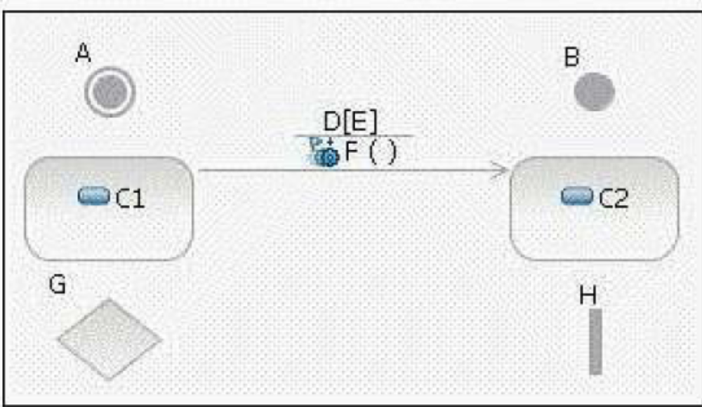
A. fork
B. initial state
C. decision
D. transition
E. final state
F. event
G. state
H. guard condition

Q. 12 Identify Design Elements is part of which workflow detail?
A. Define a Candidate Architecture
B. Design Components
C. Perform Architectural
D. Refine the Architecture

Q. 13 Click on the exhibit button In the diagram, what is H?
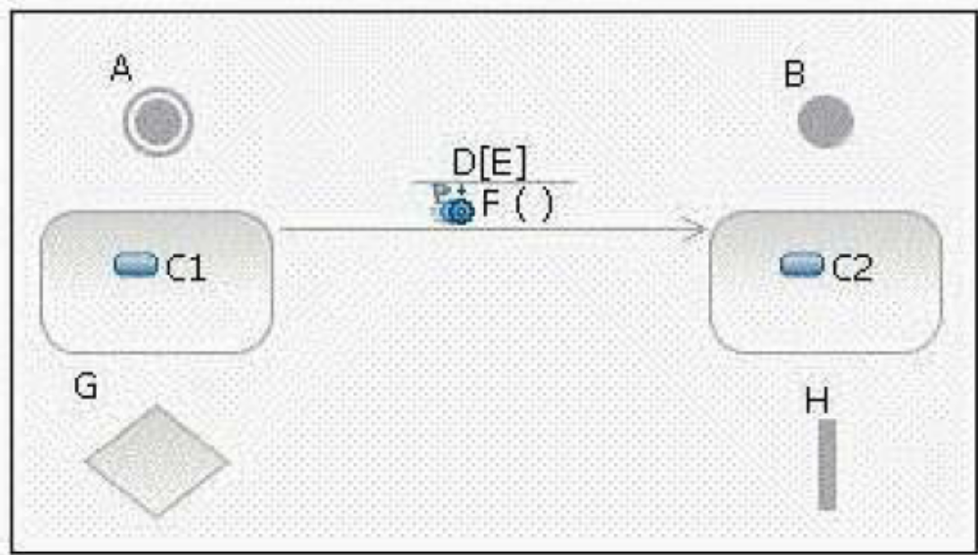
A. fork
B. initial state
C. decision
D. transition
E. final state
F. event
G. state
H. guard condition

Q. 14 What is the relationship between operation and method?
A. The terms are synonymous.
B. An operation describes how a method is implemented.
C. A method describes how an operation is implemented.
D. There is no relationship.

Q. 15 Why would you use subsystem interfaces rather than subsystem instances on
sequence diagrams?
A. to make it easier to model subsystems during Subsystem Design
B. to make use-case realizations easier to change
C. to ease sequence diagram maintenance when message signatures change
D. to reduce the number of classes needed to implement the subsystem

Q. 16 Which is an input artifact to the Identify Design Elements activity?
A. Deployment Model
B. Implementation Model
C. Reference Architecture
D. Software Architecture Document

Q. 17 What is an important consideration when allocating processes to nodes?
A. minimizing network traffic
B. minimizing power consumption
C. utilizing all available nodes
D. physical distance between nodes

Q. 18 Which type of mechanism is a connector on a deployment diagram?
A. backup
B. communication
C. transaction
D. computation

Q. 19 A design mechanism _____.
A. captures the key aspects of a solution in a way that is implementation-independent
B. specifies the exact implementation of the mechanism and is bound to a certain technology, implementation
language, or vendor
C. is the same as a design pattern
D. assumes some details of the implementation environment, but is not tied to a specific implementation

Q. 20 When identifying interfaces during the Identify Design Elements activity,
which statement is true?
A. Classes should not realize an interface.
B. Each subsystem realizes only one interface.
C. Interfaces should be identified before subsystems are created.
D. Interfaces should be packaged separately from the elements that realize them.

Q. 21 Additional subsystems can be discovered during Use Case Design by noting
_____.
A. common subflows between objects on several sequence diagrams
B. similar objects on several sequence diagrams
C. a consistent series of state transitions for multiple classes involved in a use-case realization
D. the same design classes involved in more than one use-case realization

Q. 22 Which activities are performed during Use Case Design?
A. converting analysis classes into design classes and design subsystems
B. describing persistence-related behavior
C. describing object interactions that implement interface operations
D. simplifying sequence diagrams using design classes

Q. 23 On a sequence diagram, what is used to represent a specific subsystem?
A. an interface that the subsystem realizes
B. a subsystem proxy
C. a subsystem component
D. a subsystem class

Q. 24 Which UML elements are used to describe the physical architecture of a
system?
A. classes and relationships
B. objects and messages
C. subsystems and dependencies
D. nodes and connectors

Q. 25 Which artifact is used to describe use-case realizations?
A. textual use-case descriptions
B. communication diagrams
C. state charts
D. activity diagrams

Q. 26 What defines a subsystems responsibilities?
A. its internal class behavior
B. the operations of the interfaces it implements
C. the use-case realizations in which the subsystem appears
D. the operations on a class contained within the subsystem
Q. 27 Which is a design mechanism?
A. Persistency
B. ObjectStore Object-oriented Database
C. Distribution
D. Remote Method Invocation

Q. 28 To begin identifying design mechanisms, you start by categorizing analysis
mechanisms. What are three steps in the process of Categorizing Analysis Mechanisms? (Choose three.)
A. identify characteristic profiles for each analysis mechanism
B. identify the clients of each analysis mechanism
C. assign a vendor implementation to each analysis mechanism
D. group clients according to their use of characteristic profiles

Q. 29 In Subsystem Design, what happens in the step, Distribute Subsystem
Responsibilities?
A. The subsystems responsibilities are allocated to its internal design elements.
B. Each subsystem is checked to ensure it has a consistent set of responsibilities and inconsistent
responsibilities are reassigned to other subsystems.
C. Libraries and external APIs are identified to realize the subsystem behavior.
D. Distribution mechanisms are detailed for exposing subsystem interfaces.

Q. 30 Which entity has a well-defined boundary and identity that encapsulates state
and behavior?
A. class
B. object
C. component
D. package

Q. 31 What is the purpose of the Identify Design Mechanisms activity?
A. to refine the analysis mechanisms and specify the exact implementation of the mechanism
B. to provide a conceptual set of services that is used by analysis objects
C. to refine analysis mechanisms into design mechanisms, based on the constraints imposed by the
implementation environment
D. to define design placeholders in the architecture so the architecting effort remains focused and is less likely
to become sidetracked

Q. 32 In a dependency, through what reference does the client class gain visibility to
the supplier?
A. local reference
B. parameter reference
C. global reference
D. field reference

Q. 33 In which Analysis and Design activity are subsystems mapped to analysis
classes?
A. Architectural Analysis
B. Identify Design Elements
C. Identify Subsystems
D. Incorporate Existing Design Elements

Q. 34 Which design element is used to represent a concurrent object?
A. active class
B. capsule
C. design class
D. event

Q. 35 The Describe Distribution activity is where the processes defined in the
Describe the Run-time Architecture activity are allocated to _____.
A. physical nodes
B. components
C. classes
D. activities

Q. 36 During Subsystem Design, how many interaction diagrams (sequence or
communication) should be created?
A. at least one interaction diagram per interface operation
B. one interaction diagram per interface realization
C. at least one interaction diagram for each use of an external interface
D. one interaction diagram for each realizing class

Q. 37 A directed graph of nodes connected by transitions is a _____ diagram.
A. communication
B. sequence
C. component
D. state machine

Q. 38 Click on the exhibit button
In the diagram, what is F?
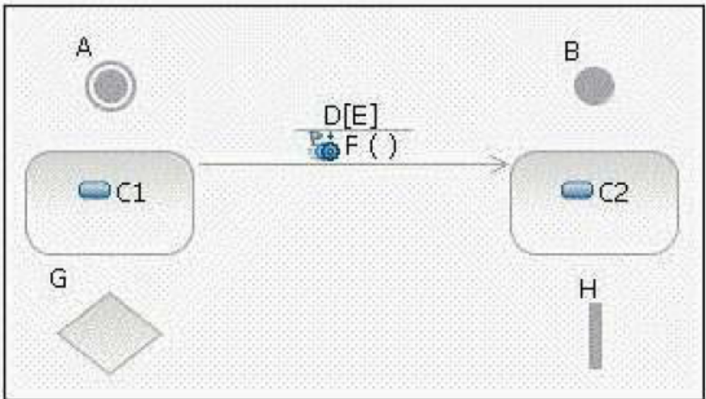
A. fork
B. initial state
C. decision
D. transition
E. final state
F. event
G. state
H. guard condition

Q. 39 Use Case Design is part of which workflow detail?
A. Design Use Cases
B. Analyze Behavior
C. Design Components
D. Design Classes and Subsystems

Q. 40 When does an analysis class map directly to a design class?
A. when the analysis class uses the <entity> stereotype
B. when the analysis class represents a single logical abstraction
C. when the modeling tool supports transformation of Analysis Models to Design
D. when an analyst has strong design skills

Q. 41 What is a design subsystems primary purpose?
A. provides configuration management and model organization
B. encapsulates behavior
C. packages similar design classes together
D. represents external systems

Q. 42 What is the purpose of subsystem design?
A. finalizes the details of each interface implemented by the subsystems in an application
B. breaks the system up into subsystems in order to allocate subsystems to development teams
C. defines the behaviors specified in the subsystem's interfaces in terms of collaborations of contained design elements
D. defines on which tier each subsystem will be implemented and the communication mechanisms used between them
Q. 43 Click on the exhibit button
In the diagram, what are C1 and C2?
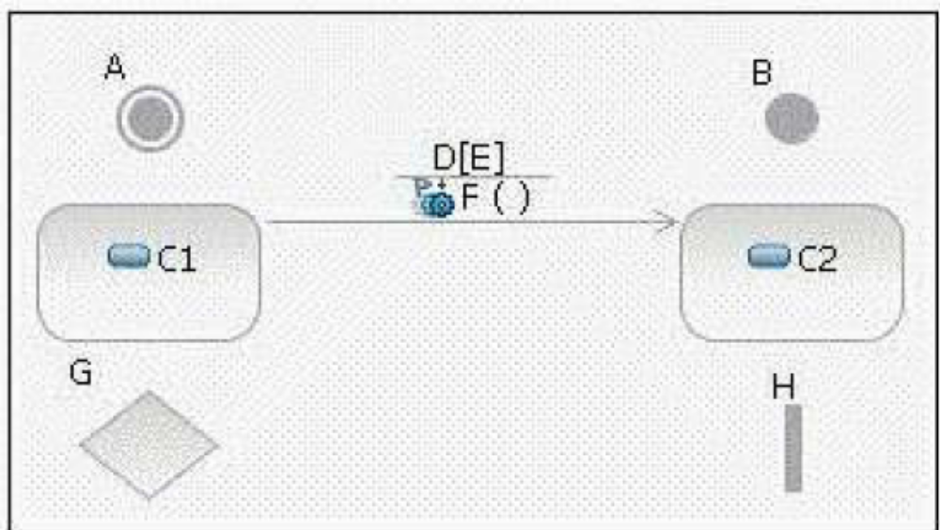
A. forks
B. initial states
C. decisions
D. transitions
E. final states
F. events
G. states
H. guard conditions

Q. 44 Defining the network configuration is the _____ step of the Describe the
Distribution activity.
A. final
B. first
C. second
D. fifth

Q. 45 Click on the exhibit button
In the diagram, what is B?
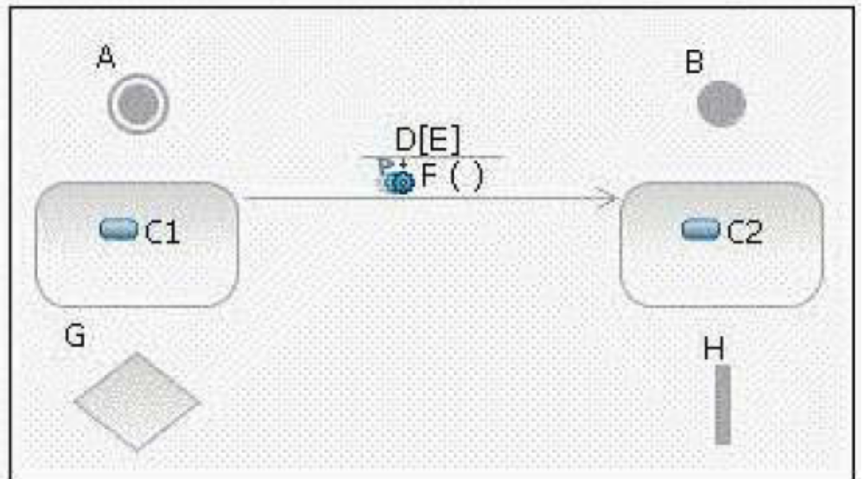
A. fork
B. initial state
C. decision
D. transition
E. final state
F. event
G. state
H. guard condition

Q. 46 Which statement is true about packages and subsystems?
A. A package cannot contain a subsystem.
B. A package provides behavior.
C. A subsystem provides behavior.
D. You use a package when you need to encapsulate behavior.

Q. 47 How many physical nodes should be identified in order to perform the
Describe Distribution activity?
A. zero nodes only
B. one node only
C. zero nodes or one node
D. more than one node

Q. 48 Supplemental sequence diagram documentation, in the form of notes and
scripts, is commonly used for _____. (Choose three.)
A. describing required timing between messages
B. providing details about conditional behavior
C. specifying the attributes for objects that appear in the diagram
D. correlating extension points in the use case with specific locations in the sequence diagrams

Q. 49 What is used to describe the process of applying a distribution mechanism
during implementation?
A. activity diagram
B. flowchart
C. UML pattern and written steps
D. use-case diagram

Q. 50 Click on the exhibit button
Given information provided in the diagram, which statement is true?
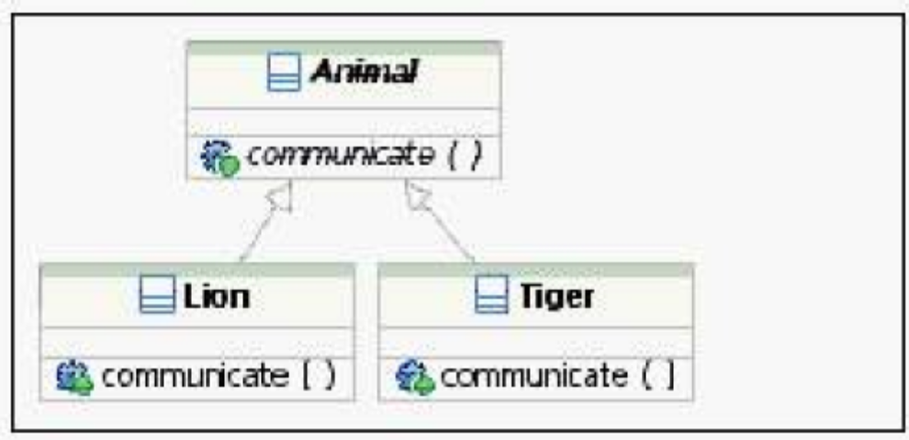
A. Lion and Tiger communicate with each other.
B. Lion and Tiger communicate with Animal.
C. Animal may not have direct instances.
D. Instances of Animal communicate differently than instances of Lion or Tiger.

Q. 51 What does an underlined attribute indicate?
A. The attribute is read-only.
B. The attribute is derived from other attributes.
C. The attribute uniquely identifies instances.
D. The attribute is defined at the classifier level instead of the instance level.

Q. 52 Click on the exhibit button
In the diagram, the attribute CourseOffering.numberOfStudents is an example of _____.
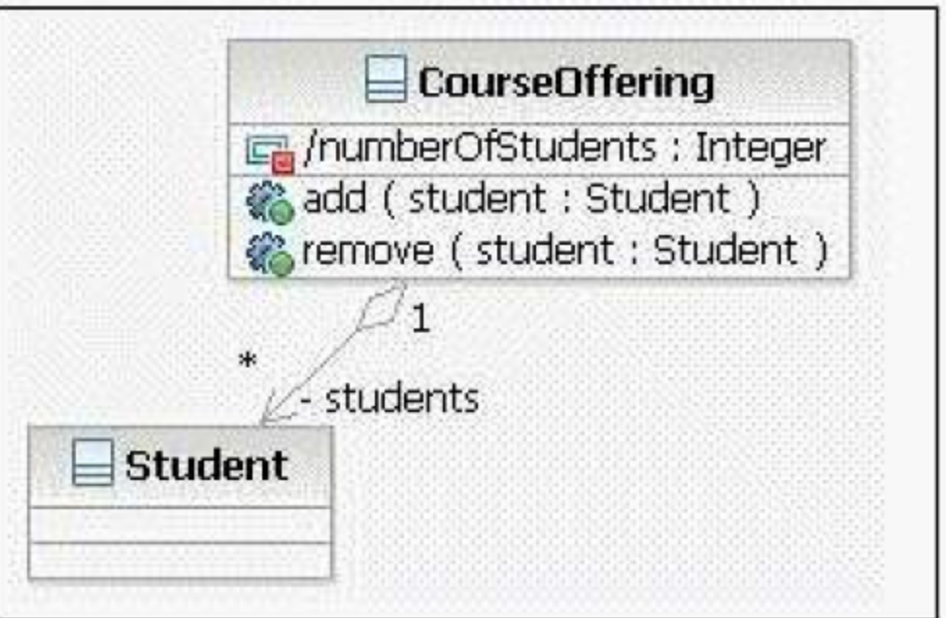
A. a bad design
B. a static attribute
C. a derived attribute
D. non-standard naming

Q. 53 Click on the exhibit button
In the diagram, what is A?
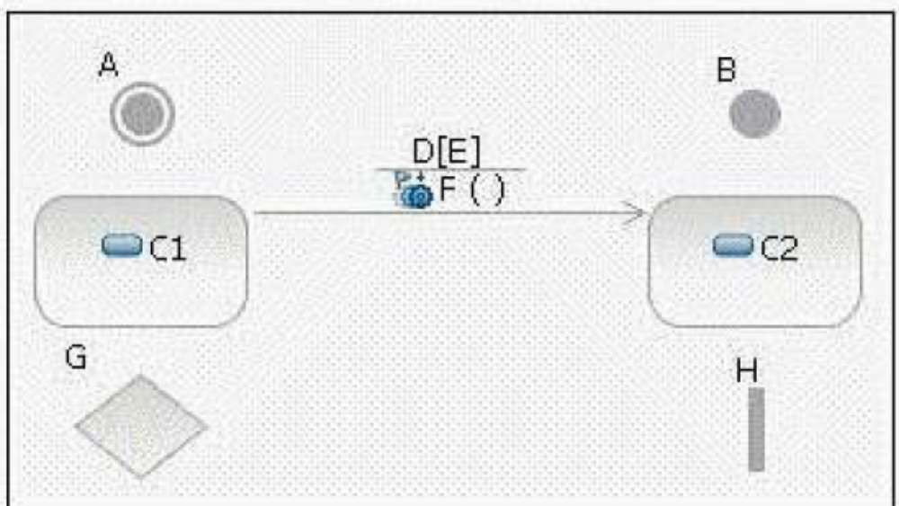
A. fork
B. initial state
C. decision
D. transition
E. final state
F. event
G. state
H. guard condition

Q. 54 With respect to persistence, what are two functions of transactions? (Choose
two.)
A. ensure that a set of operations is performed either in total, or not at all
B. enable a designer to selectively define operations that will be executed with priority when there is a shortage of system resources
C. ensure that sets of objects move from one consistent state to another
D. simplify design work, so that persistence does not need to be explicitly considered during Use Case Design
E. simply design work, by providing standardized approaches for representing persistent objects in UML

Q. 55 What are three purposes of Use Case Design? (Choose three)
A. to refine use-case realizations in terms of interactions
B. to ensure the completeness of the View of Participating Classes diagrams for each use-case realization
C. to refine requirements on the operations of design classes
D. to refine requirements on the operations of design subsystems and/or their interfaces

Q. 56 Which is a Use Case Design output artifact?
A. analysis classes
B. design classes
C. interfaces
D. the Design Model
Q. 57 Which is an example of an Execution Environment?
A. Gigabit network switch
B. virtual private network
C. J2EE application server
D. handheld computer

Q. 58 The purpose of Unify Classes and Subsystems is to ensure _____.
A. each subsystem has a corresponding subsystem component
B. all classes are assigned to at most one subsystem
C. the responsibilities of design elements do not overlap
D. each defined interface has a cohesive and coherent API

Q. 59 Which is a guideline for encapsulating subsystem interactions on sequence
diagrams?
A. Messages to subsystems should correspond to subsystem interface operations.
B. Messages from subsystems should correspond to operations of the subsystem component.
C. During Use Case Design, secondary sequence diagrams should be created to model the interactions within subsystems.
D. A subsystem should be represented on sequence diagrams using its subsystem component.

Q. 60 Which is an example of a connector?
A. SCSI Hard Disk
B. Uninterruptible Power Supply
C. HTTP protocol*
D. JDBC class

Q. 61 Which is an input artifact to the Identify Design Elements activity?
A. Deployment Model
B. Implementation Model
C. Reference Architecture
D. Software Architecture Document

Q. 62 Additional subsystems can be discovered during Use Case Design by noting
_____.
A. common subflows between objects on several sequence diagrams
B. similar objects on several sequence diagrams
C. a consistent series of state transitions for multiple classes involved in a use-case realization
D. the same design classes involved in more than one use-case realization

Q. 63 What is the purpose of the Identify Design Mechanisms activity?
A. to refine the analysis mechanisms and specify the exact implementation of the mechanism
B. to provide a conceptual set of services that is used by analysis objects
C. to refine analysis mechanisms into design mechanisms, based on the constraints imposed by the implementation environment
D. to define design placeholders in the architecture so the architecting effort remains focused and is less likely to become sidetracked

Q. 64 Which is a design mechanism?
A. Persistency
B. ObjectStore Object-oriented Database
C. Distribution
D. Remote Method Invocation

Q. 65 During Subsystem Design, how many interaction diagrams (sequence or
communication) should be created?
A. at least one interaction diagram per interface operation
B. one interaction diagram per interface realization
C. at least one interaction diagram for each use of an external interface
D. one interaction diagram for each realizing class

Q. 66 Which UML elements are used to describe the physical architecture of a
system?
A. classes and relationships
B. objects and messages
C. subsystems and dependencies
D. nodes and connectors

Q. 67 When identifying interfaces during the Identify Design Elements activity,
which statement is true?
A. Classes should not realize an interface.
B. Each subsystem realizes only one interface.
C. Interfaces should be identified before subsystems are created.
D. Interfaces should be packaged separately from the elements that realize them.

Q. 68 A design mechanism _____.
A. captures the key aspects of a solution in a way that is implementation-independent
B. specifies the exact implementation of the mechanism and is bound to a certain technology, implementation language, or vendor
C. is the same as a design pattern
D. assumes some details of the implementation environment, but is not tied to a specific implementation

Q. 69 Which statement is true about design subsystems?
A. They partially encapsulate behavior.
B. They represent an independent capability with clear interfaces.
C. They model a single implementation variant.
D. They can only contain design classes.

Q. 70 Which statement is true about packages and subsystems?
A. A package cannot contain a subsystem.
B. A package provides behavior.
C. A subsystem provides behavior.
D. You use a package when you need to encapsulate behavior.

Q. 71 Why would you use subsystem interfaces rather than subsystem instances on
sequence diagrams?
A. to make it easier to model subsystems during Subsystem Design
B. to make use-case realizations easier to change
C. to ease sequence diagram maintenance when message signatures change
D. to reduce the number of classes needed to implement the subsystem

Q. 72 Which is a Use Case Design output artifact?
A. analysis classes
B. design classes
C. interfaces
D. the Design Model

Q. 73 On a sequence diagram, what is used to represent a specific subsystem?
A. an interface that the subsystem realizes
B. a subsystem proxy
C. a subsystem component
D. a subsystem class

Q. 74 Click on the exhibit button
In the diagram, what is G?
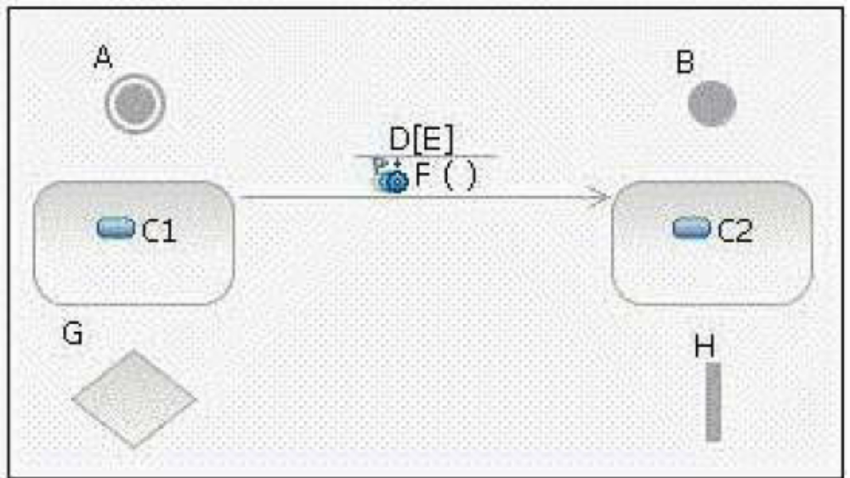
A. fork
B. initial state
C. decision
D. transition
E. final state
F. event
G. state
H. guard condition

Q. 75 Which design element is used to represent a concurrent object?
A. active class
B. capsule
C. design class
D. event

Q. 76 Click on the exhibit button
In the diagram, the attribute CourseOffering.numberOfStudents is an example of _____.
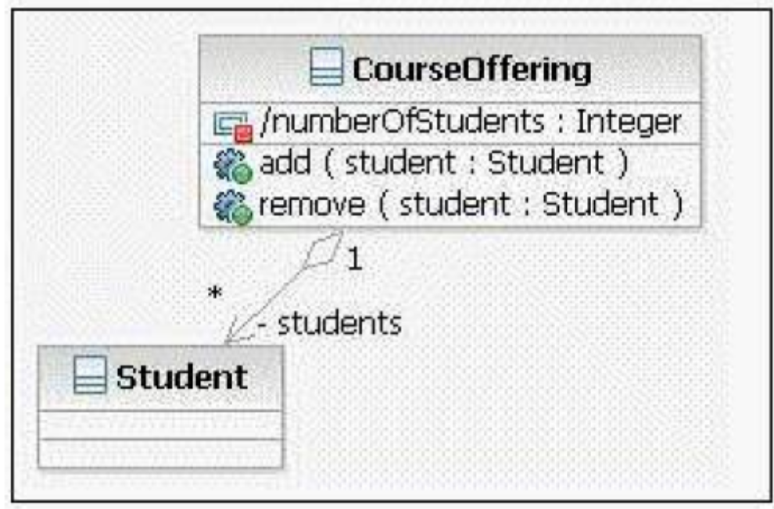
A. a bad design
B. a static attribute
C. a derived attribute
D. non-standard naming

Q. 77 Which activities are performed during Use Case Design?
A. converting analysis classes into design classes and design subsystems
B. describing persistence-related behavior
C. describing object interactions that implement interface operations
D. simplifying sequence diagrams using design classes

Q. 78 A directed graph of nodes connected by transitions is a _____ diagram.
A. communication
B. sequence
C. component
D. state machine

Q. 79 In the state of a state machine, a behavior can be defined _____.
A. before reaching a state
B. upon reaching a state
C. upon leaving a state
D. inside a state

Q. 80 Which entity has a well-defined boundary and identity that encapsulates state
and behavior?
A. class
B. object
C. component
D. package

Q. 81 Supplemental sequence diagram documentation, in the form of notes and
scripts, is commonly used for _____. (Choose three.)
A. describing required timing between messages
B. providing details about conditional behavior
C. specifying the attributes for objects that appear in the diagram
D. correlating extension points in the use case with specific locations in the sequence diagrams

Q. 82 What is a design subsystems primary purpose?
A. provides configuration management and model organization
B. encapsulates behavior
C. packages similar design classes together
D. represents external systems

Q. 83 What are the two types of dependency that can be used from a subsystem?
(Choose two.)
A. <<uses>> dependency to a subsystem interface
B. an <<import>> dependency to a package containing used classes
C. a <<manifest>> relationship to a node in the Deployment model
D. a <<realize>> relationship to one or more collaboration occurrences

Q. 84 When does an analysis class map directly to a design class?
A. when the analysis class uses the <entity> stereotype
B. when the analysis class represents a single logical abstraction
C. when the modeling tool supports transformation of Analysis Models to Design
D. when an analyst has strong design skills

Q. 85 Identify Design Elements is part of which workflow detail?
A. Define a Candidate Architecture
B. Design Components
C. Perform Architectural
D. Refine the Architecture

Q. 86 Which is a guideline for encapsulating subsystem interactions on sequence
diagrams?
A. Messages to subsystems should correspond to subsystem interface operations.
B. Messages from subsystems should correspond to operations of the subsystem component.
C. During Use Case Design, secondary sequence diagrams should be created to model the interactions within subsystems.
D. A subsystem should be represented on sequence diagrams using its subsystem component.

Q. 87 Use Case Design is part of which workflow detail?
A. Design Use Cases
B. Analyze Behavior
C. Design Components
D. Design Classes and Subsystems

Q. 88 Click on the exhibit button
In the diagram, what are C1 and C2?
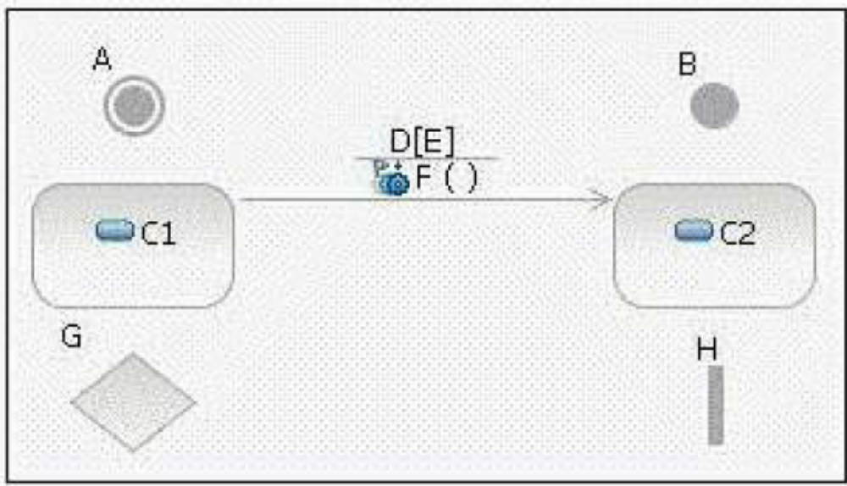
A. forks
B. initial states
C. decisions
D. transitions
E. final states
F. events
G. states
H. guard conditions

Q. 89 Which statement is true about elements within the subsystem and public
visibility?
A. Only the subset of elements that define the subsystems API should have public visibility.
B. Only the subsystem proxy class should have public visibility.
C. No elements inside the subsystem should have public visibility.
D. Only the elements that reference external classes should have public visibility.

Q. 90 Which task is performed during use-case realization refinement?
A. identify participating classes
B. allocate responsibilities among classes
C. model messages between classes
D. model associated class relationships

Q. 91 The Describe Distribution activity is where the processes defined in the
Describe the Run-time Architecture activity are allocated to _____.
A. physical nodes
B. components
C. classes
D. activities

Q. 92 What is used to describe the process of applying a distribution mechanism
during implementation?
A. activity diagram
B. flowchart
C. UML pattern and written steps
D. use-case diagram

Q. 93 Defining the network configuration is the _____ step of the Describe the
Distribution activity.
A. final
B. first
C. second
D. fifth

Q. 94 What defines a subsystems responsibilities?
A. its internal class behavior
B. the operations of the interfaces it implements
C. the use-case realizations in which the subsystem appears
D. the operations on a class contained within the subsystem

Q. 95 Click on the exhibit button
In the diagram, what is F?
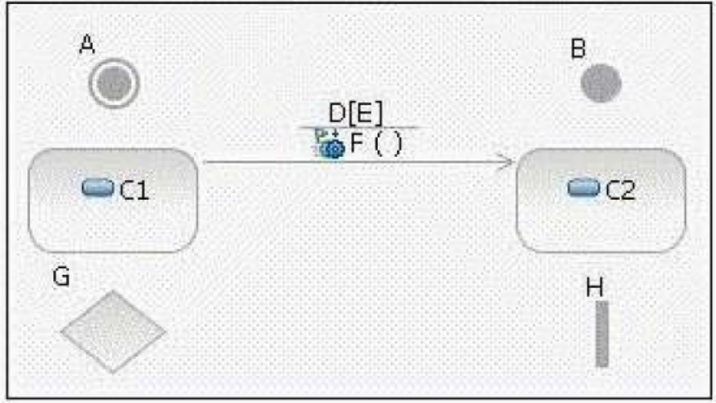
A. fork
B. initial state
C. decision
D. transition
E. final state
F. event
G. state
H. guard condition

Q. 96 In which Analysis and Design activity are subsystems mapped to analysis
classes?
A. Architectural Analysis
B. Identify Design Elements
C. Identify Subsystems
D. Incorporate Existing Design Elements

Q. 97 What are three purposes of Use Case Design? (Choose three)
A. to refine use-case realizations in terms of interactions
B. to ensure the completeness of the View of Participating Classes diagrams for each use-case realization
C. to refine requirements on the operations of design classes
D. to refine requirements on the operations of design subsystems and/or their interfaces

Q. 98 Which is a device?
A. database server
B. web server
C. virtual private network
D. handheld computer

Q. 99 In which OOAD activity is the distribution mechanism identified?
A. Identify Design Elements
B. Identify Design Mechanisms
C. Class Design
D. Architectural Analysis

Q. 100 The purpose of Unify Classes and Subsystems is to ensure _____.
A. each subsystem has a corresponding subsystem component
B. all classes are assigned to at most one subsystem
C. the responsibilities of design elements do not overlap
D. each defined interface has a cohesive and coherent API

Q. 101 Click on the exhibit button
In the diagram, what is A?
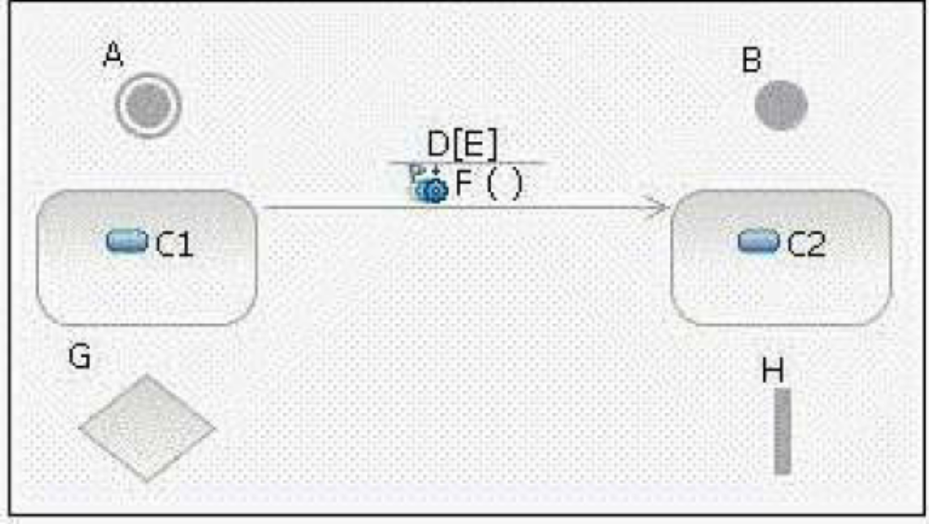
A. fork
B. initial state
C. decision
D. transition
E. final state
F. event
G. state
H. guard condition

Q. 102 To begin identifying design mechanisms, you start by categorizing analysis
mechanisms. What are three steps in the process of Categorizing Analysis Mechanisms? (Choose three.)
A. identify characteristic profiles for each analysis mechanism
B. identify the clients of each analysis mechanism
C. assign a vendor implementation to each analysis mechanism
D. group clients according to their use of characteristic profiles

Q. 103 What is a gate?
A. a parameter that represents a message that crosses the boundary of an interaction or interaction fragment
B. a defined protocol for accessing the internals of a subsystem
C. a decision point in a state machine that has more than two alternatives
D. a set of checkpoints each subsystem design must satisfy before it can be assigned for implementation

Q. 104 Which 4+1 view is the focus of the Describe Distribution activity?
A. Logical View
B. Deployment View
C. Use Case View
D. Implementation View

Q. 105 Click on the exhibit button
Given information provided in the diagram, which statement is true?
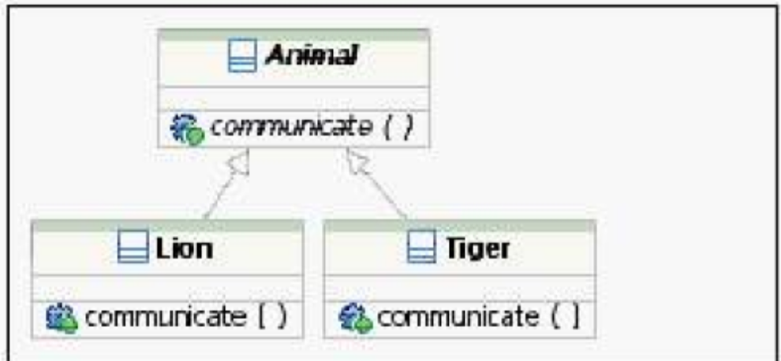
A. Lion and Tiger communicate with each other.
B. Lion and Tiger communicate with Animal.
C. Animal may not have direct instances.
D. Instances of Animal communicate differently than instances of Lion or Tiger.

Q. 106 With respect to persistence, what are two functions of transactions? (Choose
two.)
A. ensure that a set of operations is performed either in total, or not at all
B. enable a designer to selectively define operations that will be executed with priority when there is a shortage of system resources
C. ensure that sets of objects move from one consistent state to another
D. simplify design work, so that persistence does not need to be explicitly considered during Use Case Design
E. simply design work, by providing standardized approaches for representing persistent objects in UML

Q. 107 Which artifact is used to describe use-case realizations?
A. textual use-case descriptions
B. communication diagrams
C. state charts
D. activity diagrams

Q. 108 What is the purpose of subsystem design?
A. finalizes the details of each interface implemented by the subsystems in an application
B. breaks the system up into subsystems in order to allocate subsystems to development teams
C. defines the behaviors specified in the subsystem's interfaces in terms of collaborations of contained design elements
D. defines on which tier each subsystem will be implemented and the communication mechanisms used between them

Q. 109 Which is an example of an Execution Environment?
A. Gigabit network switch
B. virtual private network
C. J2EE application server
D. handheld computer

Q. 110 Which three activities are elements of Class Design? (Choose three.)
A. identify classes and relationships that support implementation of an architecture
B. identify and analyze state transitions in objects of state-controlled classes
C. identify classes that model the problem domain
D. refine relationships, operations and attributes

Q. 111 Click on the exhibit button
In the diagram, what is D?
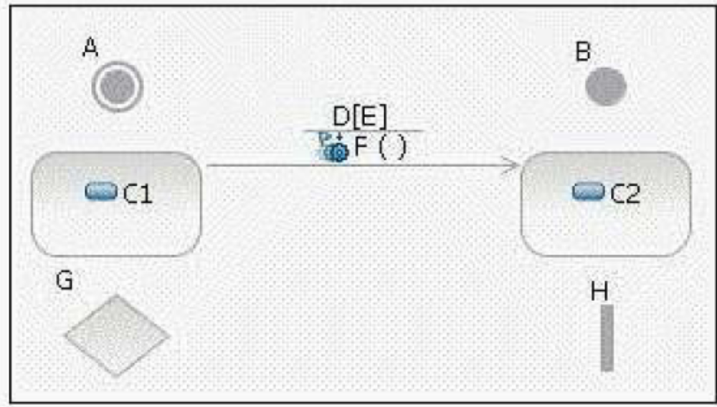
A. fork
B. initial state
C. decision
D. transition
E. final state
F. event
G. state
H. guard condition

Q. 112 In a dependency, through what reference does the client class gain visibility
to the supplier?
A. local reference
B. parameter reference
C. global reference
D. field reference

Q. 113 Given the following configuration: Package A, which contains class aClass is
in the presentation layer. Package B, which contains a class bClass and an interface bInterface is in the business layer. Package C, which contains cClass is in the data layer. Which is a poor practice?
A. aClass calls a method in bClass.
B. aClass has an attribute of type cClass.
C. aClass realizes bInterface.
D. bClass realizes bInterface.

Q. 114 Click on the exhibit button
In the diagram, what is E?
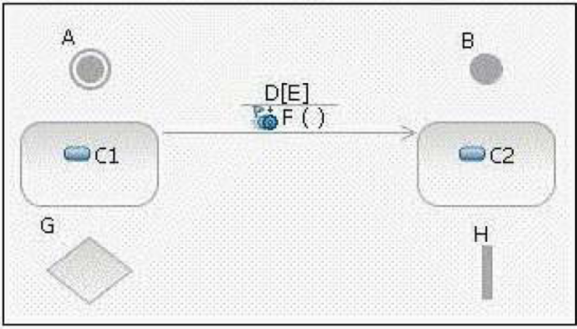
A. fork
B. initial state
C. decision
D. transition
E. final state
F. event
G. state
H. guard condition

Q. 115 How many physical nodes should be identified in order to perform the
Describe Distribution activity?
A. zero nodes only
B. one node only
C. zero nodes or one node
D. more than one node

Q. 116 In Subsystem Design, what happens in the step, Distribute Subsystem
Responsibilities?
A. The subsystems responsibilities are allocated to its internal design elements.
B. Each subsystem is checked to ensure it has a consistent set of responsibilities and inconsistent
responsibilities are reassigned to other subsystems.
C. Libraries and external APIs are identified to realize the subsystem behavior.
D. Distribution mechanisms are detailed for exposing subsystem interfaces.

Q. 117 When identifying design elements, a simple analysis class will map to
a(n)_____.
A. active class
B. interface
C. design class
D. subsystem

Q. 118 What does an underlined attribute indicate?
A. The attribute is read-only.
B. The attribute is derived from other attributes.
C. The attribute uniquely identifies instances.
D. The attribute is defined at the classifier level instead of the instance level.

Q. 119 Artifacts are entities that _____.
A. host running software
B. are deployed onto physical nodes
C. are the result of model transformations
D. are stored in a browser cache

Q. 120 Which process document describes design mechanisms, any mappings
between design mechanisms, and the details regarding their use?
A. Software Architecture Document
B. Design Guidelines
C. Vision Document
D. Software Development Plan

Q. 121 Which statement is true about packages and subsystems?
A. A package cannot contain a subsystem.
B. A package provides behavior.
C. A subsystem provides behavior.
D. You use a package when you need to encapsulate behavior.

Q. 122 Click on the exhibit button
In the diagram, the attribute CourseOffering.numberOfStudents is an example of _____.
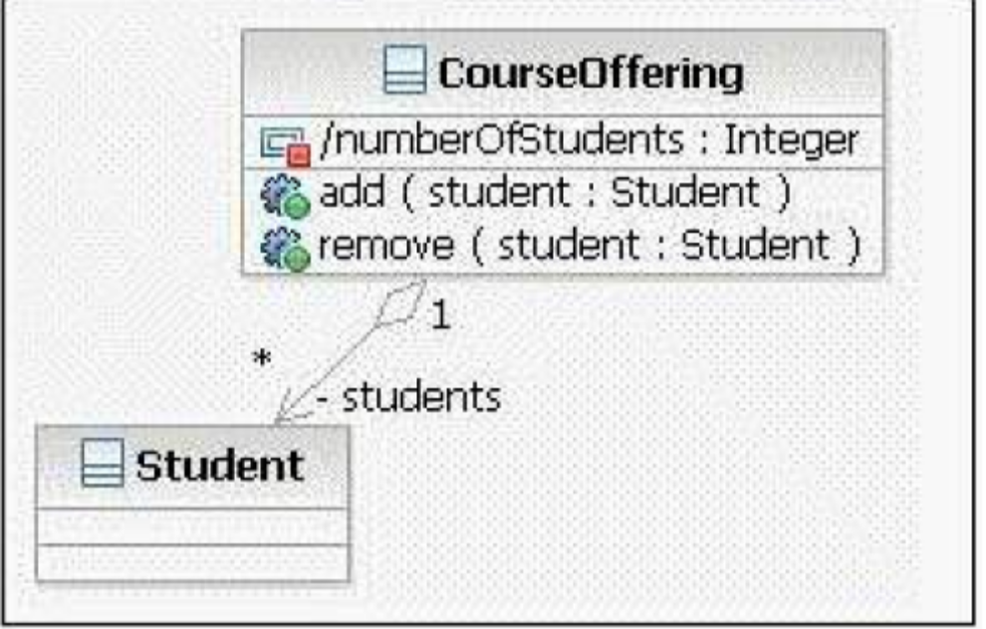
A. a bad design
B. a static attribute
C. a derived attribute
D. non-standard naming

Q. 123 Which task is performed during use-case realization refinement?
A. identify participating classes
B. allocate responsibilities among classes
C. model messages between classes
D. model associated class relationships

Q. 124 Click on the exhibit button
In the diagram, what is H?
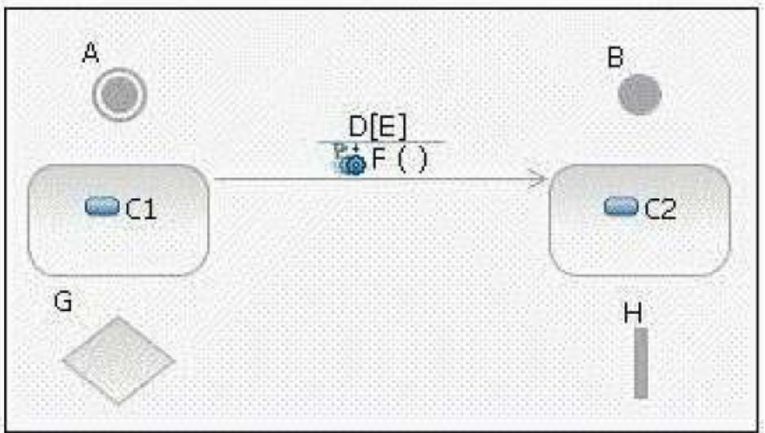
A. fork
B. initial state
C. decision
D. transition
E. final state
F. event
G. state
H. guard condition

Q. 125 Which activities are performed during Use Case Design?
A. converting analysis classes into design classes and design subsystems
B. describing persistence-related behavior
C. describing object interactions that implement interface operations
D. simplifying sequence diagrams using design classes

Q. 126 Identify Design Elements is part of which workflow detail?
A. Define a Candidate Architecture
B. Design Components
C. Perform Architectural
D. Refine the Architecture

Q. 127 Supplemental sequence diagram documentation, in the form of notes and
scripts, is commonly used for _____. (Choose three.)
A. describing required timing between messages
B. providing details about conditional behavior
C. specifying the attributes for objects that appear in the diagram
D. correlating extension points in the use case with specific locations in the sequence diagrams

Q. 128 In the diagram, what is G?
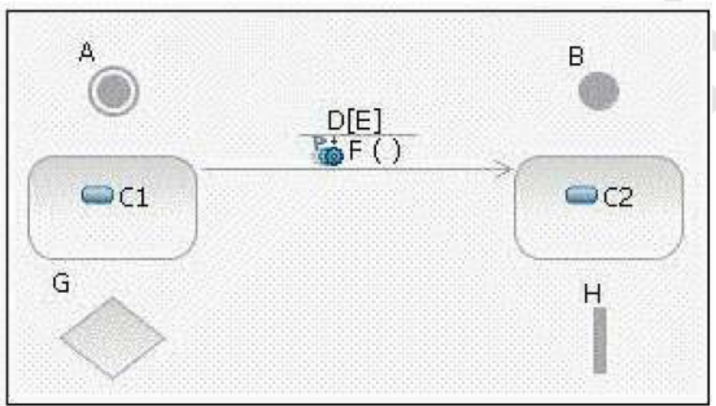
A. fork
B. initial state
C. decision
D. transition
E. final state
F. event
G. state
H. guard condition

Q. 129 Which type of mechanism is a connector on a deployment diagram?
A. backup
B. communication
C. transaction
D. computation

Q. 130 In the diagram, what is A?
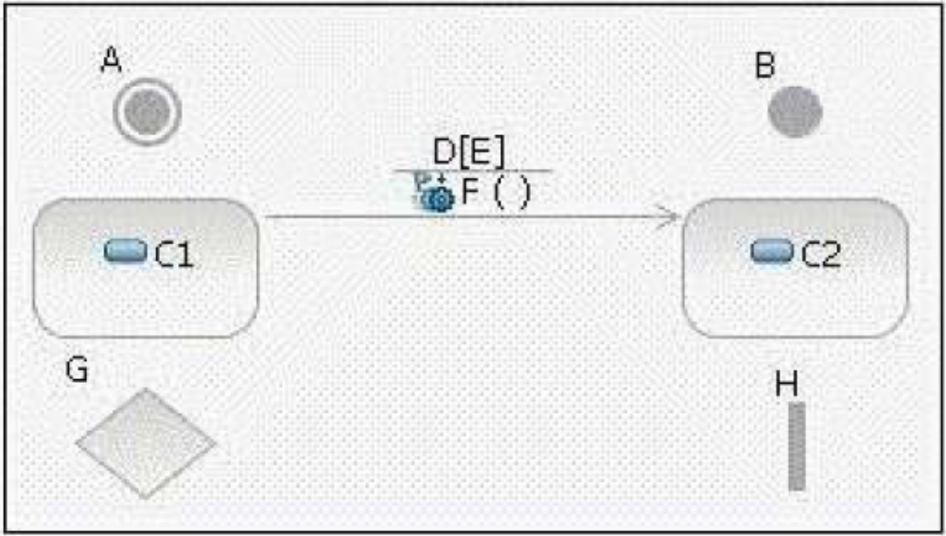
A. fork
B. initial state
C. decision
D. transition
E. final state
F. event
G. state
H. guard condition

Q. 131 In the diagram, what are C1 and C2?
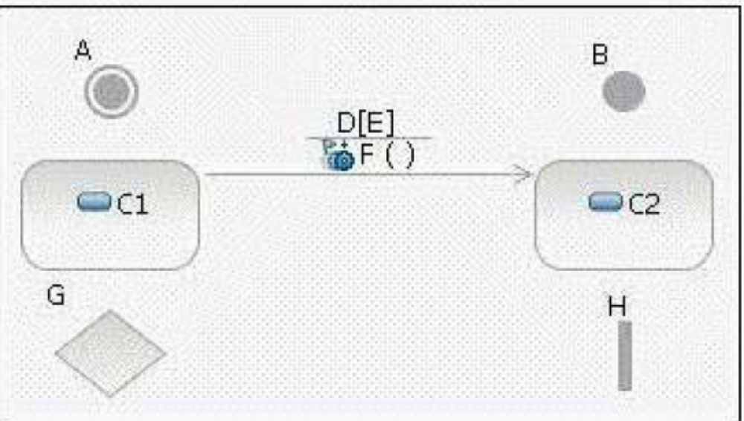
A. forks
B. initial states
C. decisions
D. transitions
E. final states
F. events
G. states
H. guard conditions

Q. 132 In a dependency, through what reference does the client class gain visibility
to the supplier?
A. local reference
B. parameter reference
C. global reference
D. field reference

Q. 133 In which Analysis and Design activity are subsystems mapped to analysis
classes?
A. Architectural Analysis
B. Identify Design Elements
C. Identify Subsystems
D. Incorporate Existing Design Elements

Q. 134 In the diagram, what is F?
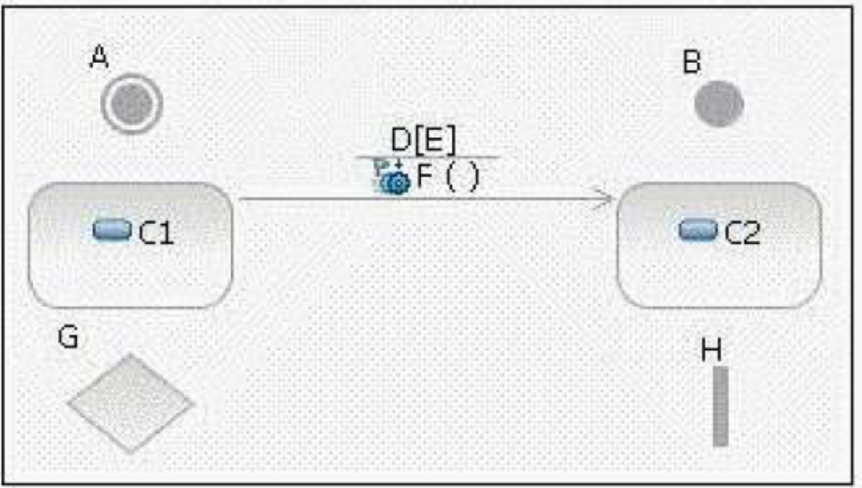
A. fork
B. initial state
C. decision
D. transition
E. final state
F. event
G. state
H. guard condition

Q. 135 In the diagram, what is B?
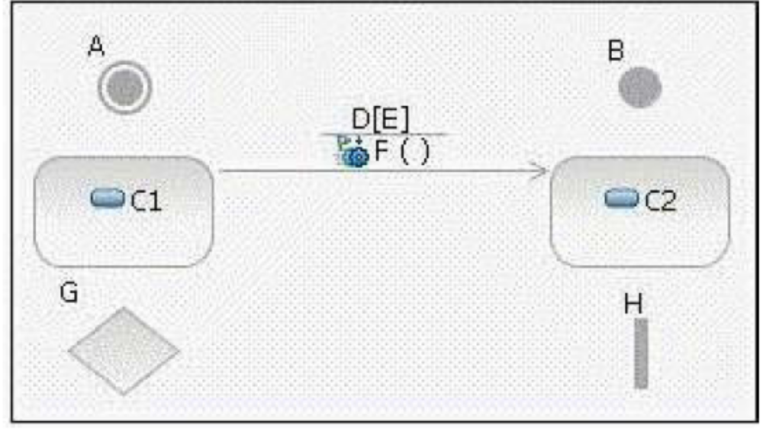
A. fork
B. initial state
C. decision
D. transition
E. final state
F. event
G. state
H. guard condition

Q. 136 A design mechanism _____.
A. captures the key aspects of a solution in a way that is implementation-independent
B. specifies the exact implementation of the mechanism and is bound to a certain technology, implementation language, or vendor
C. is the same as a design pattern
D. assumes some details of the implementation environment, but is not tied to a specific implementation

Q. 137 Which is a design mechanism?
A. Persistency
B. ObjectStore Object-oriented Database
C. Distribution
D. Remote Method Invocation

Q. 138 What is the purpose of the Identify Design Mechanisms activity?
A. to refine the analysis mechanisms and specify the exact implementation of the mechanism
B. to provide a conceptual set of services that is used by analysis objects
C. to refine analysis mechanisms into design mechanisms, based on the constraints imposed by the implementation environment
D. to define design placeholders in the architecture so the architecting effort remains focused and is less likely to become sidetracked

Q. 139 The Describe Distribution activity is where the processes defined in the
Describe the Run-time Architecture activity are allocated to _____.
A. physical nodes
B. components
C. classes
D. activities

Q. 140 Which entity has a well-defined boundary and identity that encapsulates
state and behavior?
A. class
B. object
C. component
D. package

Q. 141 Why would you use subsystem interfaces rather than subsystem instances on
sequence diagrams?
A. to make it easier to model subsystems during Subsystem Design
B. to make use-case realizations easier to change
C. to ease sequence diagram maintenance when message signatures change
D. to reduce the number of classes needed to implement the subsystem

Q. 142 Artifacts are entities that _____.
A. host running software
B. are deployed onto physical nodes
C. are the result of model transformations
D. are stored in a browser cache

Q. 143 Given the following configuration: Package A, which contains class aClass is
in the presentation layer. Package B, which contains a class bClass and an interface bInterface is in the business layer. Package C, which contains cClass is in the data layer. Which is a poor practice?
A. aClass calls a method in bClass.
B. aClass has an attribute of type cClass.
C. aClass realizes bInterface.
D. bClass realizes bInterface.

Q. 144 When identifying design elements, a simple analysis class will map to
a(n)_____.
A. active class
B. interface
C. design class
D. subsystem

Q. 145 Which statement is true about elements within the subsystem and public
visibility?
A. Only the subset of elements that define the subsystems API should have public visibility.
B. Only the subsystem proxy class should have public visibility.
C. No elements inside the subsystem should have public visibility.
D. Only the elements that reference external classes should have public visibility.

Q. 146 Which is a guideline for encapsulating subsystem interactions on sequence
diagrams?
A. Messages to subsystems should correspond to subsystem interface operations.
B. Messages from subsystems should correspond to operations of the subsystem component.
C. During Use Case Design, secondary sequence diagrams should be created to model the interactions within subsystems.
D. A subsystem should be represented on sequence diagrams using its subsystem component.

Q. 147 What defines a subsystems responsibilities?
A. its internal class behavior
B. the operations of the interfaces it implements
C. the use-case realizations in which the subsystem appears
D. the operations on a class contained within the subsystem

Q. 148 Which statement is true about design subsystems?
A. They partially encapsulate behavior.
B. They represent an independent capability with clear interfaces.
C. They model a single implementation variant.
D. They can only contain design classes.

Q. 149 Which is an example of an Execution Environment?
A. Gigabit network switch
B. virtual private network
C. J2EE application server
D. handheld computer

Q. 150 Use Case Design is part of which workflow detail?
A. Design Use Cases
B. Analyze Behavior
C. Design Components
D. Design Classes and Subsystems

Q. 151 How many physical nodes should be identified in order to perform the
Describe Distribution activity?
A. zero nodes only
B. one node only
C. zero nodes or one node
D. more than one node

Q. 152 To begin identifying design mechanisms, you start by categorizing analysis
mechanisms. What are three steps in the process of Categorizing Analysis Mechanisms? (Choose three.)
A. identify characteristic profiles for each analysis mechanism
B. identify the clients of each analysis mechanism
C. assign a vendor implementation to each analysis mechanism
D. group clients according to their use of characteristic profiles

Q. 153 What is a design subsystems primary purpose?
A. provides configuration management and model organization
B. encapsulates behavior
C. packages similar design classes together
D. represents external systems

Q. 154 Which artifact is used to describe use-case realizations?
A. textual use-case descriptions
B. communication diagrams
C. state charts
D. activity diagrams

Q. 155 Additional subsystems can be discovered during Use Case Design by noting
_____.
A. common subflows between objects on several sequence diagrams
B. similar objects on several sequence diagrams
C. a consistent series of state transitions for multiple classes involved in a use-case realization
D. the same design classes involved in more than one use-case realization

Q. 156 In the diagram, what is E?
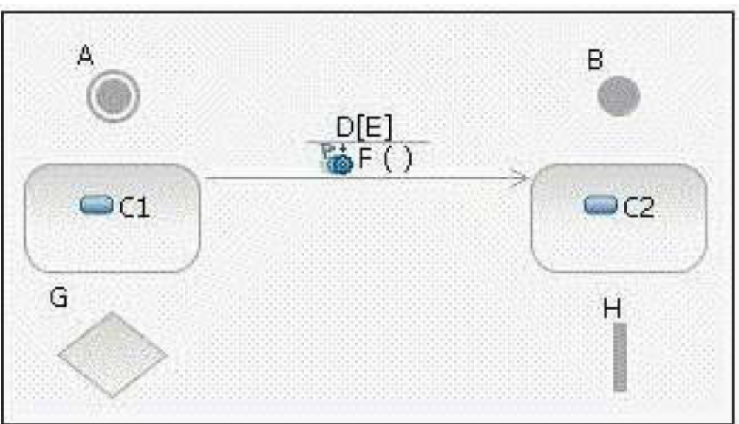
A. fork
B. initial state
C. decision
D. transition
E. final state
F. event
G. state
H. guard condition

Q. 157 The purpose of Unify Classes and Subsystems is to ensure _____.
A. each subsystem has a corresponding subsystem component
B. all classes are assigned to at most one subsystem
C. the responsibilities of design elements do not overlap
D. each defined interface has a cohesive and coherent API

Q. 158 What are three purposes of Use Case Design? (Choose three)
A. to refine use-case realizations in terms of interactions
B. to ensure the completeness of the View of Participating Classes diagrams for each use-case realization
C. to refine requirements on the operations of design classes
D. to refine requirements on the operations of design subsystems and/or their interfaces

Q. 159 On a sequence diagram, what is used to represent a specific subsystem?
A. an interface that the subsystem realizes
B. a subsystem proxy
C. a subsystem component
D. a subsystem class

Q. 160 When does an analysis class map directly to a design class?
A. when the analysis class uses the <entity> stereotype
B. when the analysis class represents a single logical abstraction
C. when the modeling tool supports transformation of Analysis Models to Design
D. when an analyst has strong design skills

Q. 161 Click on the exhibit button
In the diagram, what is D?
A. fork
B. initial state
C. decision
D. transition
E. final state
F. event
G. state
H. guard condition

Q. 162 Which is an example of a connector?
A. SCSI Hard Disk
B. Uninterruptible Power Supply
C. HTTP protocol*
D. JDBC class

Q. 163 Which 4+1 view is the focus of the Describe Distribution activity?
A. Logical View
B. Deployment View
C. Use Case View
D. Implementation View

Q. 164 Which is a Use Case Design output artifact?
A. analysis classes
B. design classes
C. interfaces
D. the Design Model

Q. 165 Which is a device?
A. database server
B. web server
C. virtual private network
D. handheld computer

Q. 166 What does an underlined attribute indicate?
A. The attribute is read-only.
B. The attribute is derived from other attributes.
C. The attribute uniquely identifies instances.
D. The attribute is defined at the classifier level instead of the instance level.

Q. 167 Which is an input artifact to the Identify Design Elements activity?
A. Deployment Model
B. Implementation Model
C. Reference Architecture
D. Software Architecture Document

Q. 168 With respect to persistence, what are two functions of transactions? (Choose
two.)
A. ensure that a set of operations is performed either in total, or not at all
B. enable a designer to selectively define operations that will be executed with priority when there is a
shortage of system resources
C. ensure that sets of objects move from one consistent state to another
D. simplify design work, so that persistence does not need to be explicitly considered during Use Case Design
E. simply design work, by providing standardized approaches for representing persistent objects in UML

Q. 169 In which OOAD activity is the distribution mechanism identified?
A. Identify Design Elements
B. Identify Design Mechanisms
C. Class Design
D. Architectural Analysis

Q. 170 What is the purpose of subsystem design?
A. finalizes the details of each interface implemented by the subsystems in an application
B. breaks the system up into subsystems in order to allocate subsystems to development teams
C. defines the behaviors specified in the subsystem's interfaces in terms of collaborations of contained design elements
D. defines on which tier each subsystem will be implemented and the communication mechanisms used between them

Q. 171 What are the two types of dependency that can be used from a subsystem?
(Choose two.)
A. <<uses>> dependency to a subsystem interface
B. an <<import>> dependency to a package containing used classes
C. a <<manifest>> relationship to a node in the Deployment model
D. a <<realize>> relationship to one or more collaboration occurrences

Q. 172 What is used to describe the process of applying a distribution mechanism
during implementation?
A. activity diagram
B. flowchart
C. UML pattern and written steps
D. use-case diagram

Q. 173 When identifying interfaces during the Identify Design Elements activity,
which statement is true?
A. Classes should not realize an interface.
B. Each subsystem realizes only one interface.
C. Interfaces should be identified before subsystems are created.
D. Interfaces should be packaged separately from the elements that realize them.

Q. 174 Which design element is used to represent a concurrent object?
A. active class
B. capsule
C. design class
D. event

Q. 175 In the state of a state machine, a behavior can be defined _____.
A. before reaching a state
B. upon reaching a state
C. upon leaving a state
D. inside a state

Q. 176 Which process document describes design mechanisms, any mappings
between design mechanisms, and the details regarding their use?
A. Software Architecture Document
B. Design Guidelines
C. Vision Document
D. Software Development Plan

Q. 177 In Subsystem Design, what happens in the step, Distribute Subsystem
Responsibilities?
A. The subsystems responsibilities are allocated to its internal design elements.
B. Each subsystem is checked to ensure it has a consistent set of responsibilities and inconsistent responsibilities are reassigned to other subsystems.
C. Libraries and external APIs are identified to realize the subsystem behavior.
D. Distribution mechanisms are detailed for exposing subsystem interfaces.

Q. 178 What is a gate?
A. a parameter that represents a message that crosses the boundary of an interaction or interaction fragment
B. a defined protocol for accessing the internals of a subsystem
C. a decision point in a state machine that has more than two alternatives
D. a set of checkpoints each subsystem design must satisfy before it can be assigned for implementation

Q. 179 During Subsystem Design, how many interaction diagrams (sequence or
communication) should be created?
A. at least one interaction diagram per interface operation
B. one interaction diagram per interface realization
C. at least one interaction diagram for each use of an external interface
D. one interaction diagram for each realizing class

Q. 180 What is the relationship between operation and method?
A. The terms are synonymous.
B. An operation describes how a method is implemented.
C. A method describes how an operation is implemented.
D. There is no relationship.

