**Screen 1 – Home Page**

1)The home page is similar for public and login user.

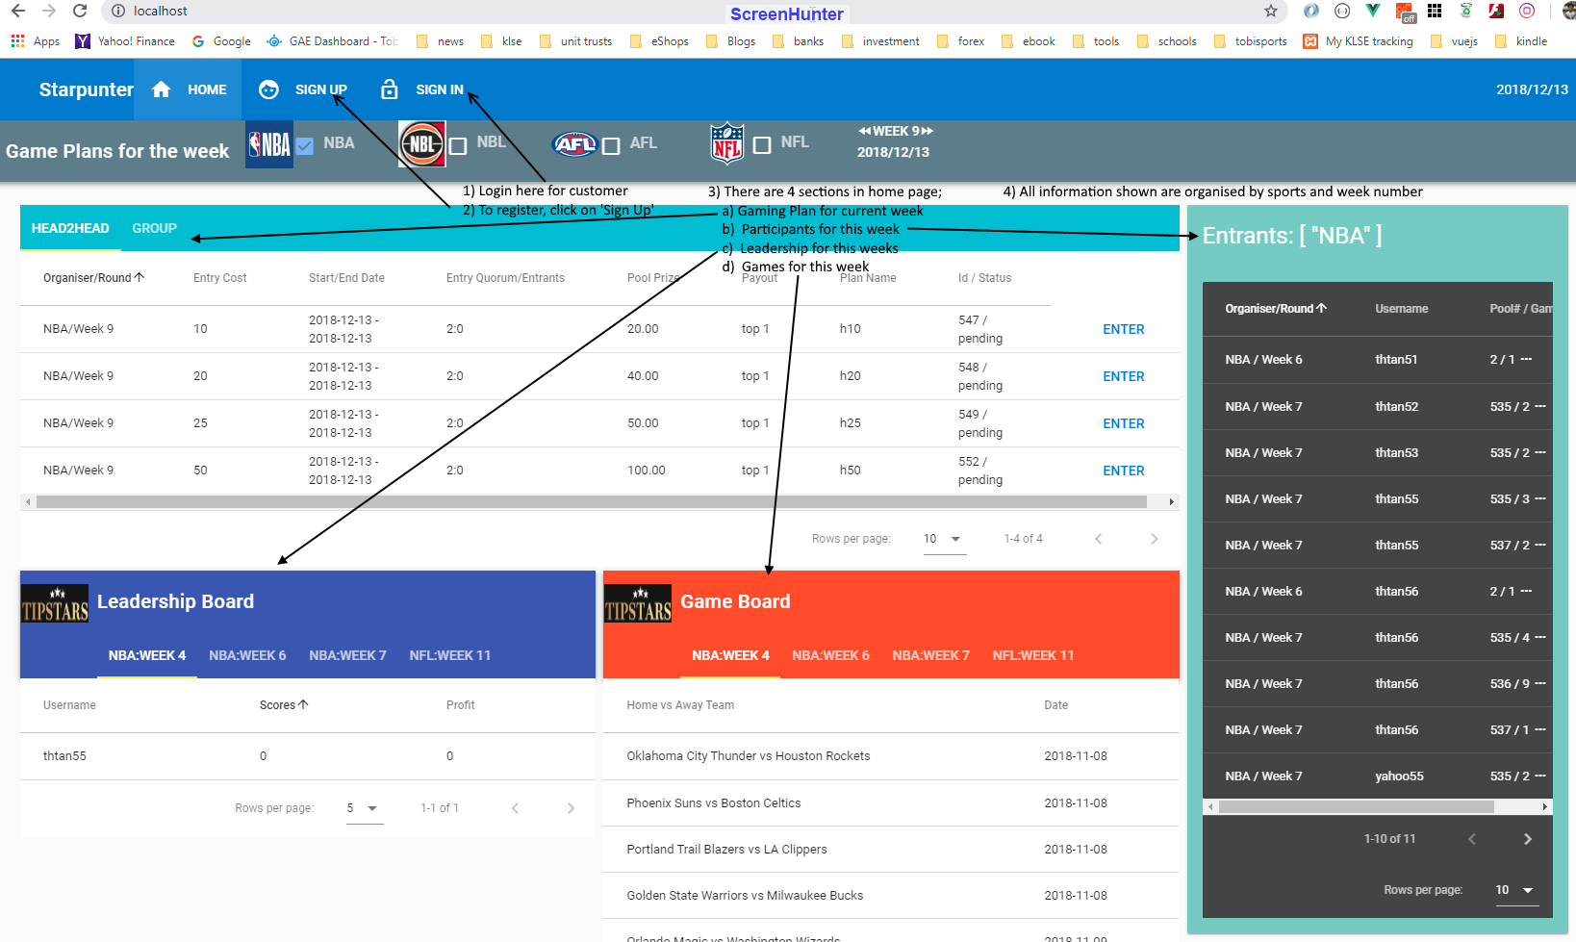

1. Plan (or Game Plan)
2. The home page shows the plans available to participate.

* This week, there are 4 different plans available ie $10, $20, $25 and $50 plans.

1. To join a plan, you have to buy a ticket for the chosen plan.

* When a participant buys a plan, the money will be deducted from his account.
* As such you need to deposit money into your account first.

1. a $25 plan (entry cost) may has a quorum of 2 (head to head)

to 50 or more entrants (group)

* the name ‘pool’ and ‘plan’ are the same and interchangeable
* the pool type is either ‘head to head’ or ‘group’
* other information in the pool are payout (top 1, 2, etc), pool prize.

1. Entrants

* This section shows the participants for current week and the plan bought (column 3)
* Beside the plan number, it shows the number of games selected for betting by the participant.

1. Leadership Board

This board displays the betting score and income by participants for the week.

1. Game Board

This displays the matches playing for this week.

**Screen 2 – Pool / Plan**

* When you selected ‘Enter’ in the pool plan, more information on the plan will be displayed as shown below.

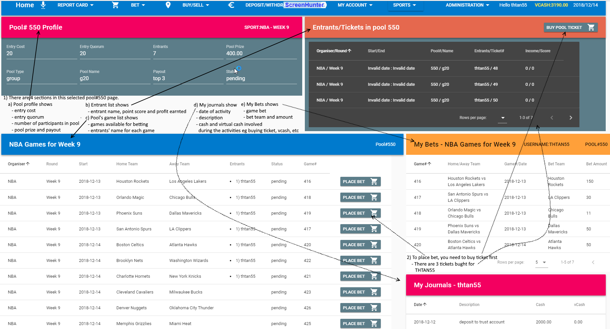

* It also shows the participants betting in this pool.
* The winning score and profit are also available here.
* My Bets shows the game, team and amount bet for each game during the week
* My Journals give a log of your activities like
  1. deposit cash,
  2. withdraw cash,
  3. buy and sell virtual cash,
  4. buy ticket for gaming and
  5. any winnings as well.

**Screen 2.1 – Buy Ticket**

* You can also ‘buy ticket’ for the pool here.

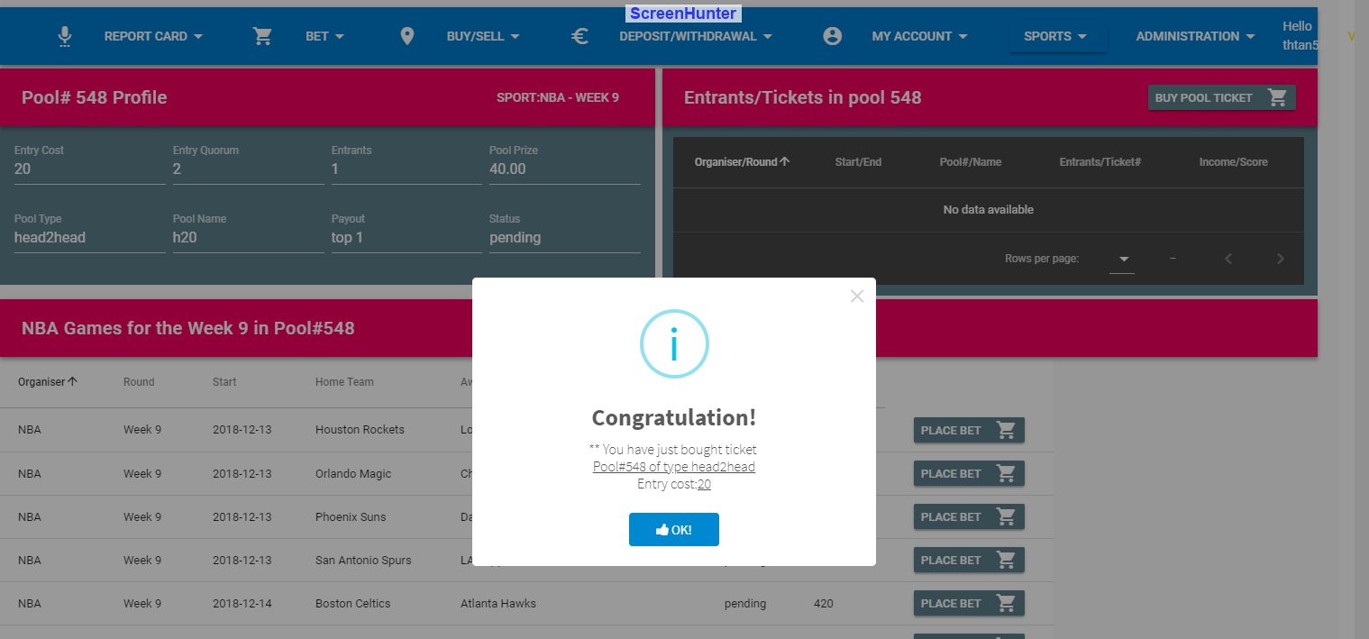

Upon clicking on ‘Buy Pool Ticket’, an alert will pop-up to indicate that the purchase is successful as shown above.

**Screen 2.2 – Place Bet**

* You can select the game to ‘place bet’ in this screen.

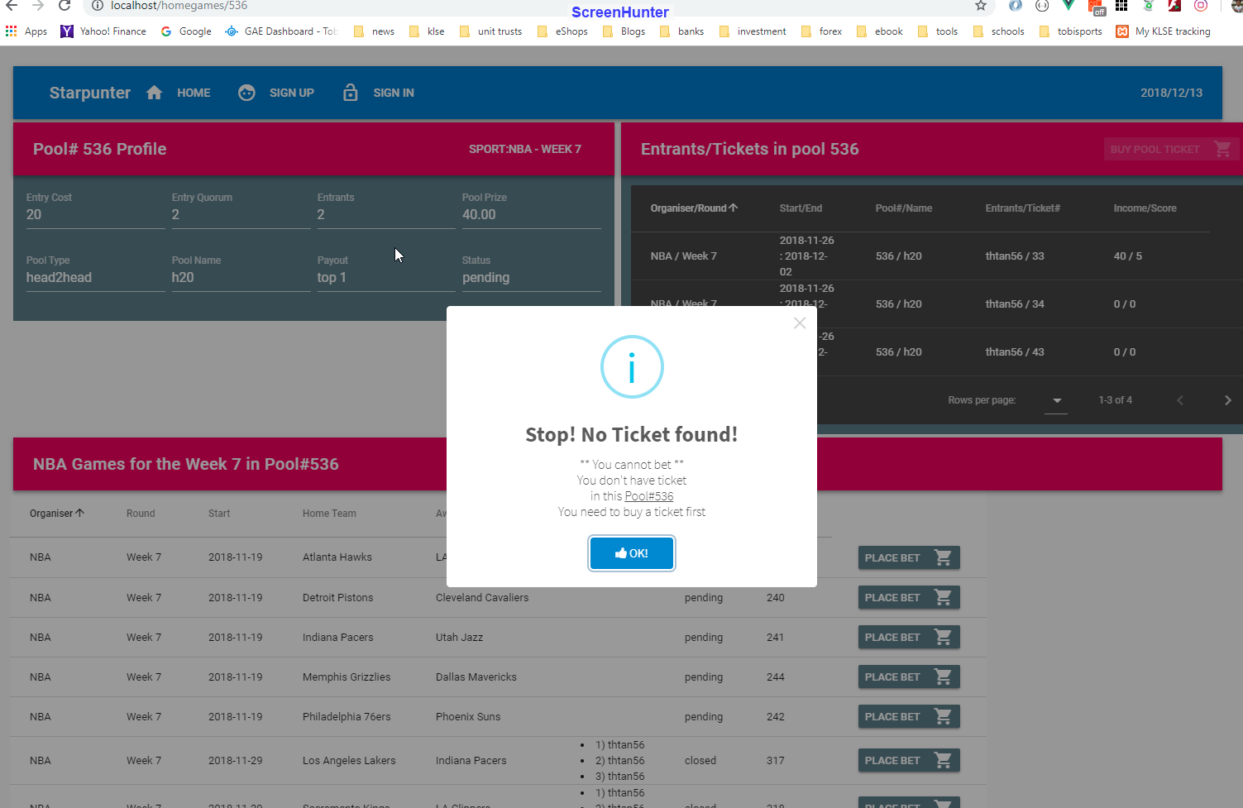

The above screen indicates that the user has not bought ticket to do betting yet.

For this case, the user has not login to his account to place bet.

On successful click of ‘place bet’ button on ‘Selected Plan’ screen (screen 2), you will be presented with the screen below:

4) a ticket has information about the pool (pool id) and users in that pool.

5) ticketgames will have games selected by the players with their favorite team.

a) the players need to indicate the amount to bet using virtual currency.

b) currency used in the pool is hard currency.

1. Buy Ticket (1)

There are two ways to buy a ticket.

1. On the home page,

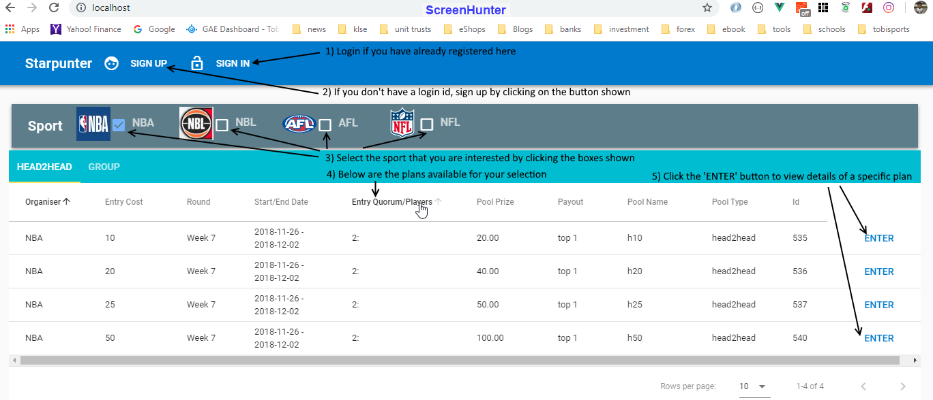

a) select your plan;

b) on the entrant section, there is a button to 'buy ticket' for that selected plan.

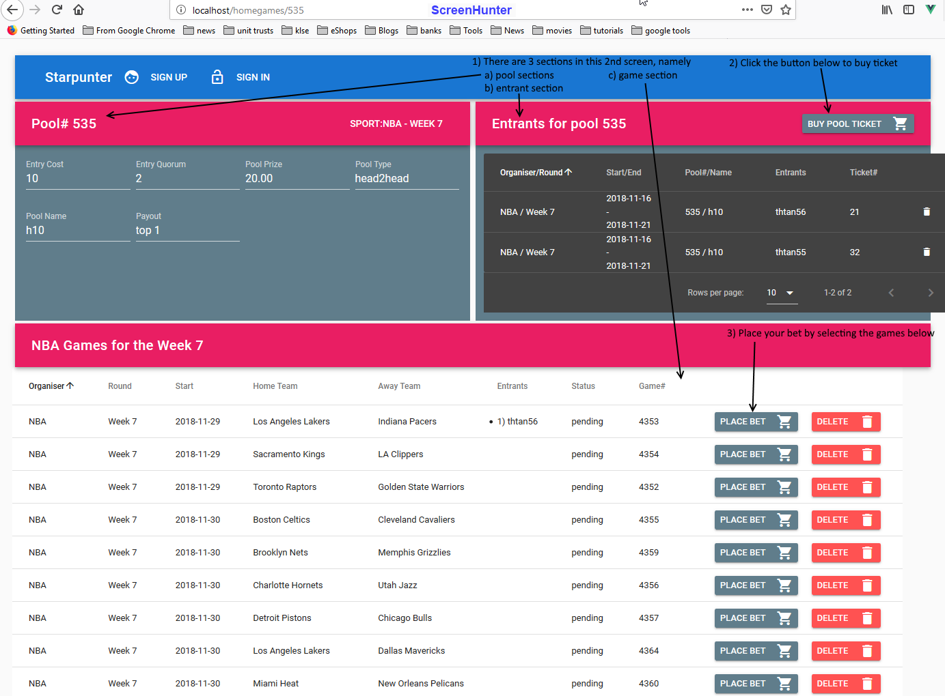

1. Buy Ticket (2)

From the top menu, you can select the ‘buy’ button and chose ‘Ticket’.

