Homework 1 Image Matching (Detecting Motion Vectors)

Description

* Given two images:  [trucka.bmp](http://cv2.csie.ntu.edu.tw/CV/_private/trucka.bmp), [truckb.bmp](http://cv2.csie.ntu.edu.tw/CV/_private/truckb.bmp)
* Detect motions vectors between trucka.bmp and truckb.bmp.
* Use trucka.bmp as the basis, sample it by an 8×8, 11×11, 15×15, 21×21, 31×31 block.

Algorithm:

* Use Block Matching Algorithm
* Sum of Absolute Difference is used as the cost function.
* Segment the image into blocks with a given size, e.g., 8x8. Redundant pixels are ignored. The location of top-left point for each block is recorded.

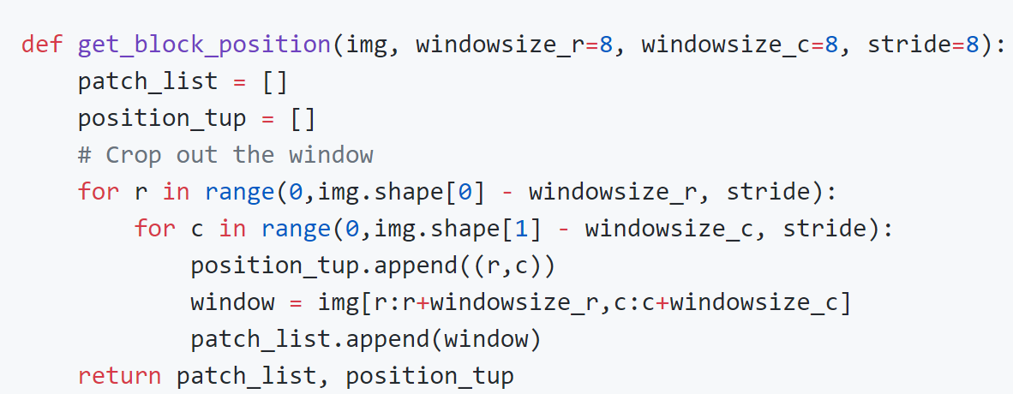

* Define a search range (50 pixels here) and find the block in basis image that can minimize the cost function.

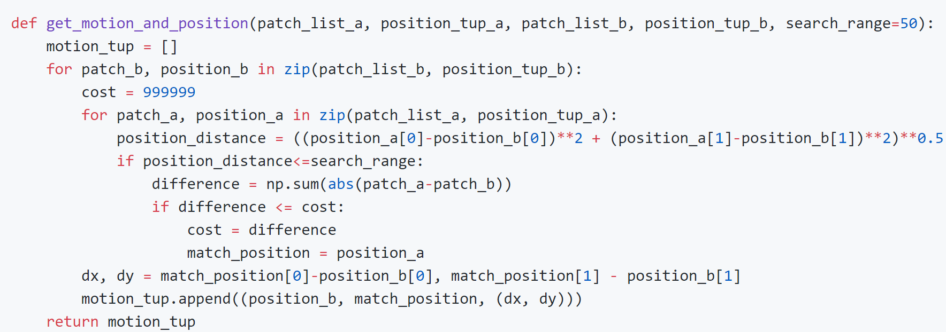

Result:

|  |  |
| --- | --- |
| **Block size** | **Motion vector** |
| **8x8** |  |
| **11x11** |  |
| **15x15** |  |
| **21x21** |  |
| **31x31** |  |