Calculating Optical Flow

Task description:

1. Implement Horn & Schunck optical flow estimation.
2. Synthetically translate lena.im one pixel to the right and downward.
3. Try λ of 0.1, 1, 10.

Method:

1. The Horn-Schunck method of estimating optical flow is a global method which introduces a global constraint of smoothness to solve the aperture problem
2. Translate lena.im to lena_shift.im by moving one pixel to the right and downward. Then crop the last row and column of lena_shift.im.
3. Use Horn-Schunck algorithm to find estimate the optical flow. The method with suggested iterative scheme is shown below:

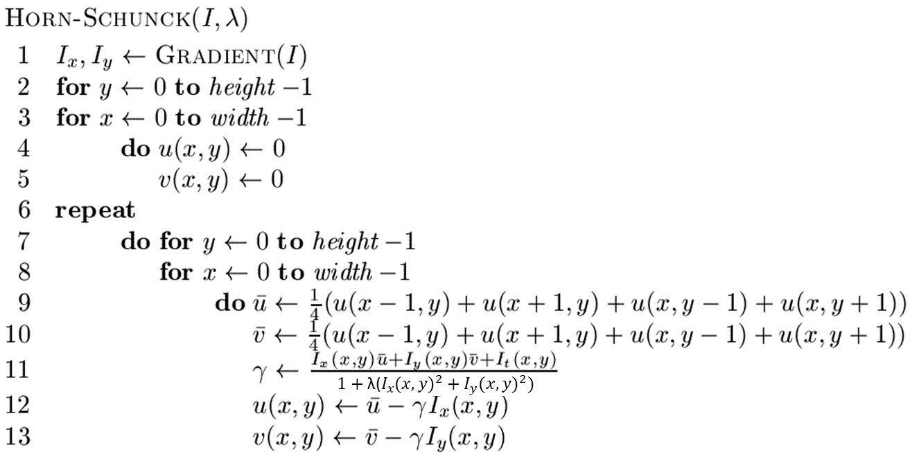

Experiment results:

Various settings of smoothing parameter lambda (λ) which affects the weight of the gradient in the calculation of the motion vector. Here we’ve tried 0.1, 1 and 10 of it. The results are shown below. We can find out that greater lambda produces (1) greater directional accuracy in the vectors (2) shorter direction vectors, distorting the displacement magnitudes slightly.

