

RESEARCH PROPOSAL
AI-Assisted Resilience for SDN-Enabled Intelligent Transportation Systems
Network Anomaly Detection, Reversible Mitigation, and Camera-Assisted Physical Context
A Prototype-Backed Research Proposal with Preliminary Experimental Evidence
Proposed Category: Transportation | AI | Internet Security | IoT | Cloud/Edge Computing
Role | Name and affiliation
Project Advisor | Prof. Kris Singh — Visiting Professor, Tsinghua University; Founder and CEO, SRII, Silicon Valley
Author | Trinh Hoang Tu — Ho Chi Minh City University of Foreign Languages and Information Technology (HUFLIT); Software Engineering Intern, Grab

August 28, 2026

Abstract
Software-defined networking enables programmable control for intelligent transportation systems, but its logically centralized control plane remains vulnerable to flooding attacks, low-rate probing, and controller overload. The protected asset in this study is RSU-based ITS/V2X connectivity: an attacker aims to exhaust control-plane or edge-network resources and degrade legitimate vehicle-to-infrastructure communication. Permanent blacklist or DROP responses can also harm legitimate mobility traffic during rush-hour surges that elevate the same coarse counters used for intrusion signals. This research proposes a lightweight resilience framework that combines flow-level telemetry, temporal anomaly detection, adaptive thresholding, and reversible OpenFlow mitigation. A hybrid TCN-GRU model processes short telemetry windows without deep packet inspection, while a safety-aware policy applies temporary containment and automatic rollback rather than permanent blocking. A camera covering the same RSU service zone provides an independent physical observation that helps the policy judge whether abnormal network demand is consistent with observable transportation activity; the camera does not inspect packets and must not override network evidence. A prototype operations console and reproducible experiments assess detection quality, response latency, reversible containment, and fusion-policy behavior. Preliminary evaluation on an InSDN-shaped holdout reports classifier-head accuracy of 96.2%, F1-score of approximately 97.7%, and ROC-AUC of 0.977, with a decision-path response time below 10 ms in the evaluated environment. Mininet experiments demonstrate temporary rule installation and rollback. Camera-fusion experiments provide scripted policy-validation evidence and, when RTSP hosts resolve, live object-track observation; labeled-video false-positive reduction is not claimed. These results support technical feasibility and define remaining work for transportation-scale validation.
Metric definition note. Primary detection tables cite classifier-head binary metrics (prediction = argmax(class) > 0). Precision/Recall/F1 use sklearn average='binary'; ROC-AUC uses score = Σ P(class ≠ Normal). Do not interpret these as multiclass macro averages.
Keywords— Software-defined networking; intelligent transportation systems; V2X; RSU; anomaly detection; TCN-GRU; OpenFlow; reversible mitigation; physical-context fusion.

Contents

Abstract 2
Table of Contents 3
1. Introduction 1
1.1 Background and Motivation 1
1.2 Problem Statement 1
1.3 Research Gap 2
1.4 Research Questions 2
1.5 Research Contributions 3
1.6 Scope of the Study 3
2. Related Work 4
2.1 SDN Security in Intelligent Transportation Systems 4
2.2 Flow-Based Anomaly Detection 4
2.3 Lightweight Temporal Models at the Edge 4
2.4 Safety-Aware and Reversible Mitigation 4
2.5 Camera–Network Context Fusion 5
3. Threat Model and System Design 5
3.1 System Assumptions 5
3.2 Threat Model 5
3.3 End-to-End Architecture 6
3.4 Telemetry and Feature Pipeline 6
3.5 Detection and Adaptive Thresholding 7
3.6 Mitigation and Rollback Policy 7
3.7 Camera-Assisted Physical Context 7
4. Research Methodology 7
4.1 Research Design 7
4.2 Datasets and Scenario Construction 7
4.3 Data Preprocessing and Windowing 8
4.4 TCN-GRU Model Configuration 8
4.5 Baselines and Ablation Design 8
4.6 Experimental Environment 9
4.7 Evaluation Metrics 9
4.8 Evidence-Grading Protocol 9
5. Prototype Implementation 10
5.1 Software Stack 10
5.2 Operations Console 10
5.3 OpenFlow Actuation Paths 10
5.4 Runtime Configuration 10
5.5 Reproducibility Artifacts 10
6. Preliminary Experimental Results 11
6.1 InSDN Detection Performance 11
6.2 Synthetic Sanity-Check Evaluation 11
6.3 Latency and Model Footprint 12
6.4 Reversible OpenFlow Containment 12
6.5 Camera–Network Fusion 13
6.6 Threshold Sensitivity 13
6.7 Ablation Results 13
6.8 Research-Question Evaluation 13
7. Prototype Demonstration 14
7.1 Nominal Monitoring 15
7.2 PacketIn Flood Detection and Containment 15
7.3 Rush-Hour False-Positive Avoidance 16
7.4 Scenario Replay 17
7.5 Topology and Event Audit 17
7.6 Camera Context and Evidence Labels 18
8. Discussion 19
8.1 Interpretation of Results 19
8.2 Transportation-Safety Implications 19
8.3 Threats to Validity 19
8.4 Limitations 20
9. Proposed Research Extension 20
10. Conclusion 20
References 21
Appendix A. Model and Training Parameters 23
Appendix B. Feature Definitions 23
Appendix C. Experiment Artifact Manifest 23
Appendix D. Camera Evidence Grades (Detail) 24

1. Introduction

1.1 Background and Motivation
The protected asset is RSU-based ITS/V2X connectivity that carries low-latency vehicle-to-infrastructure and related edge services. Software-defined networking simplifies coordination on OpenFlow fabrics, but a logically centralized controller becomes a critical dependency: an attacker who generates PacketIn floods, low-rate probes, or RSU-side flow bursts can exhaust control-plane or edge-network resources and degrade legitimate communication even when data-plane bandwidth remains available. A second, equally important failure mode is over-aggressive mitigation. Permanent blacklists and hard DROP policies may stop an attacker, yet they can also interrupt legitimate mobility traffic during rush-hour surges that elevate the same coarse counters used for intrusion signals. This research therefore targets lightweight non-DPI detection, temporary containment with automatic rollback, and an independent physical observation of the same RSU service zone—via roadside camera tracks—so that the mitigation policy can test whether abnormal network demand is consistent with observable transportation activity. The camera is a physical-context sensor for mitigation decisions, not a standalone AI vision or DDoS detector.
Data splitting and leakage prevention. Raw records were partitioned into mutually exclusive training, validation, and test subsets before sliding-window construction (protocol rows_before_window_v1). A gap of (L−1) rows separates partitions so that overlapping windows (L=10, stride 1) cannot span train/test boundaries. StandardScaler statistics were fitted exclusively on the training partition and applied unchanged to validation and test data. Reported cls_binary_* metrics are binary Normal-vs-Anomaly scores (sklearn average='binary'), not 5-class macro F1/AUC; multiclass macro/weighted and OvR AUC are exported separately by evaluate.py. Default loss weight α=1.0 and threshold k=2.0; seed=42. See docs/METHODOLOGY.md.

1.2 Problem Statement
Existing SDN intrusion-detection approaches frequently optimize classification performance without jointly addressing three operational requirements of transportation networks: low-latency inference at the edge, avoidance of service disruption during legitimate load surges, and verifiable rollback of mitigation actions. This research addresses the problem of detecting control-plane anomalies from non-DPI telemetry and applying temporary mitigation while preserving legitimate transportation traffic.

1.3 Research Gap
- Many studies stop at offline classification accuracy and do not evaluate detect → contain → rollback loops.
- False-positive cost in ITS is higher than in generic enterprise networks because mitigation can interrupt safety-relevant flows.
- Camera context is often over-claimed as traffic census or accident intelligence, without separating synthetic, live, and labeled evidence.
- Actuation evidence is frequently conflated: mock in-memory rules, scripted policy tests, and switch-verified OpenFlow outcomes are not graded explicitly.
The present work targets these gaps with a prototype-backed evidence protocol rather than a demo-only narrative.

1.4 Research Questions
- RQ1. How effectively can non-DPI SDN telemetry identify abnormal control-plane and flow behavior in an ITS edge network?
- RQ2. Can a lightweight TCN-GRU model satisfy edge-level latency and memory constraints while maintaining useful in-domain anomaly-detection performance?
- RQ3. To what extent can temporary containment and automatic rollback reduce attack impact without disrupting legitimate rush-hour traffic?
- RQ4. How should public SDN intrusion datasets be combined with simulated ITS/VANET scenarios to improve transportation relevance and cross-scenario evaluation?
- RQ5. Can camera-observed physical traffic context of the same RSU service zone reduce unnecessary mitigation during legitimate demand surges without weakening containment of network-originated attacks?

1.5 Research Contributions
Research contributions
- A lightweight flow-telemetry framework for detecting SDN anomalies in ITS environments without relying on deep packet inspection.
- A reversible mitigation loop that combines temporary containment, cooldown control, and automatic rollback.
- A cyber-physical mitigation policy that combines network anomaly evidence with independent physical traffic context from the same RSU zone to reduce false containment without weakening source isolation under high dominance.
- An evidence-grading protocol that explicitly distinguishes model output, scripted policy validation, mock actuation, and switch-verified OpenFlow outcomes.
- A prototype-backed evaluation covering detection quality, latency, containment, rollback, fusion sensitivity, and system ablation.
Engineering artifacts
The research is supported by a modular implementation (src/sdn_its), reproducible experiment scripts, an operations console, dataset preparation utilities, and tracked result artifacts under artifacts/results/.

1.6 Scope of the Study
In scope: flow-level (non-DPI) telemetry for an RSU/ITS-edge zone; TCN-GRU detection with adaptive thresholding; temporary OpenFlow-style mitigation with cooldown rollback; camera object-track context as an independent physical observation of the same service zone; Mininet laboratory verification for reversible DROP; Windows mock actuation for interactive demonstration. Out of scope for this stage: city-wide camera networks, vehicle-identity/Sybil correspondence, full controller compromise, adversarial video attacks, production PacketIn/s measurement on Ryu, surveyed queue meters, and labeled-video false-positive rate claims.

2. Related Work

2.1 SDN Security in Intelligent Transportation Systems
OpenFlow-based SDN enables programmable campus and edge fabrics [1][5], and ITS/V2X deployments increasingly rely on RSUs and centralized wireless policy [8]. Prior surveys of cyber-physical intrusion detection emphasize that control-plane overload and false alarms have asymmetric safety costs [6][7]. This work focuses on ITS-edge PacketIn stress and reversible containment rather than deep packet inspection of application payloads.

2.2 Flow-Based Anomaly Detection
Flow and counter-based detectors avoid DPI overhead and privacy exposure. Public SDN intrusion corpora such as InSDN [3] and CIC-IDS2017 (cross-dataset holdout) [4][13] provide labeled traffic for supervised evaluation, yet they are not natively VANET mobility traces. The present study maps such corpora into a canonical ten-feature schema and treats synthetic ITS scenarios as separate sanity checks rather than as substitutes for in-domain holdouts.

2.3 Lightweight Temporal Models at the Edge
Temporal convolutional networks provide long effective history with causal convolutions [2], while GRU/LSTM variants remain strong sequential baselines [14]. This research investigates a hybrid TCN-GRU as a design candidate for joint reconstruction and multi-class prediction. The hybrid architecture is investigated as a design candidate rather than assumed to outperform all recurrent baselines; current ablation artifacts do not yet prove universal superiority and are reported with that caveat.

2.4 Safety-Aware and Reversible Mitigation
Permanent blacklists maximize attack suppression but raise false-positive blast radius. Rate limiting and temporary DROP with idle/hard timeouts, followed by explicit DELETE, better match transportation continuity requirements. Experiment A in this proposal measures ICMP delivery under none / permanent / temporary arms with ovs-ofctl verification, separating policy intent from switch-verified outcomes.

2.5 Camera–Network Context Fusion
Multimodal fusion can reduce false containment when physical congestion in the same RSU service zone co-occurs with counter spikes. Unlike vision systems that claim accident or unusual-event detection, this prototype treats the camera as a physical-context sensor: YOLO+IoU object tracks summarize whether observable transportation activity is present. Visible tracks are not veh/h census counts. Scripted fusion wiring, live RTSP observation, and labeled-video false-positive evaluation are graded separately so camera evidence cannot be mistaken for an independent cyber detector.

3. Threat Model and System Design

3.1 System Assumptions
The prototype assumes an authenticated telemetry path within the lab, trusted switch forwarding for Experiment A, and a controller that remains benign but may be overloaded. Camera streams may be unavailable, stale, or synthetic. Fusion never treats camera context as absolute ground truth that can unconditionally override network evidence.

3.2 Threat Model
Component | Assumption
SDN controller | Trusted but may be overloaded
RSU / source host | May be compromised or generate floods
OpenFlow switch | Trusted for Experiment A verification
Telemetry collector | Authenticated within prototype scope
Camera source | Independent physical view of the RSU service zone; may be unavailable, stale, or unreliable
Fusion engine | Uses same-zone camera context to test cyber–physical consistency; never overrides network evidence
Attacker | Can generate floods or low-rate probes
Out of scope | Full controller compromise; adversarial video; key theft

Table 3.1. Threat-model assumptions for the prototype-backed study.
Attacker objective: degrade availability of legitimate ITS/V2X communication by exhausting controller or edge-network resources (for example PacketIn floods and low-rate probes). The attacker does not need to control the camera; camera feeds may be unavailable, stale, or unreliable, and the system must fail safely by falling back to network evidence. Attack scenarios considered: PacketIn flooding; low-rate probing (LOFT-style); RSU link failure; mixed legitimate surge plus attack; misleading or absent camera context. Camera rush-hour preserve must not become an attacker-controlled bypass: high source dominance still isolates the dominant attacker under fusion rules.

3.3 End-to-End Architecture
The implemented path is scoped to an RSU service zone: Vehicles/RSU/OVS telemetry windows → TCN-GRU scoring → multimodal fusion with a camera observing the same zone in parallel → policy → actuation. Cameras are not upstream of the data plane and do not classify cyber attacks. Actuation splits into Mininet/OpenFlow (lab) and Windows in-memory mock rules (interactive demo).
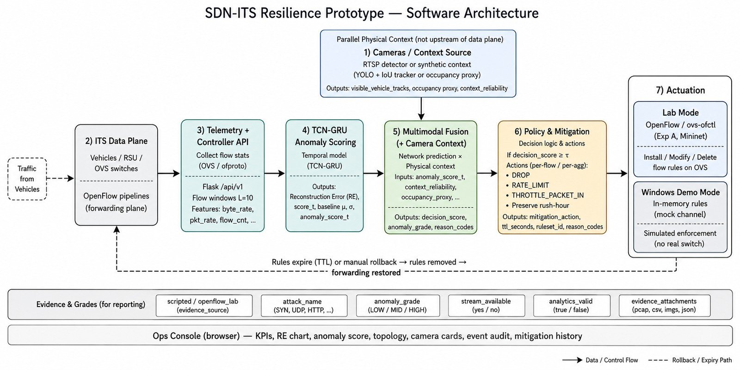
Figure 3.1. Prototype software architecture with parallel camera context and graded actuation paths.

3.4 Telemetry and Feature Pipeline
Telemetry is collected as sliding windows of length L=10 over ten non-DPI features (Section 4.3). Features are standardized with a scaler fit on training data only.

3.5 Detection and Adaptive Thresholding
The model emits reconstruction error RE(x)=||x−x̂||₂² and class logits. An adaptive threshold τ=μ_RE + kσ_RE is maintained for RE-based flags; the primary reported InSDN metrics use the classifier head. Online τ adaptation may update μ and σ from recent normal windows when enabled in the console.

3.6 Mitigation and Rollback Policy
Policy maps alerts to temporary DROP, RATE_LIMIT, THROTTLE_PACKET_IN, preserve/ignore for rush-hour, or observe. Cooldown timers expire rules; Experiment A also verifies explicit DELETE and post-rollback reachability.

3.7 Camera-Assisted Physical Context
When physical_mode=rtsp_detector, allow-listed RTSP frames from the same RSU service zone are scored by YOLOv8 with an IoU tracker [15]. The camera answers a decision question—whether abnormal network demand is consistent with observable transportation activity—not “is there a DDoS?” Hosts that fail DNS/TCP fall back to the last cached JPEG and/or scripted scenario replay so demos remain reproducible. Exported fields emphasize visible_vehicle_tracks and context_reliability (heuristic composite). Occupancy and queue proxies are zone estimates, not surveyed meters. Object detection is not unusual-event or accident AI.

4. Research Methodology

4.1 Research Design
The study combines (i) in-domain supervised evaluation on InSDN-mapped windows, (ii) cross-dataset transfer checks on CIC-mapped windows, (iii) controlled synthetic sanity scenarios, (iv) Mininet reversible mitigation trials, and (v) scripted camera–network fusion and threshold sensitivity tests with explicit evidence grades.

4.2 Datasets and Scenario Construction
InSDN records were transformed into a canonical flow-feature schema (datasets/processed/insdn_windows.npz). Synthetic ITS scenarios were generated separately and were not mixed into the primary holdout unless explicitly stated. CIC windows support zero-shot and adapted transfer experiments. Label space includes Normal, DDoS_PacketIn_Flood, LOFT_LowRate_Attack, RSU_Link_Fault, and RushHour_Burst.

4.3 Data Preprocessing and Windowing
Sliding windows use seq_len L=10 with stride 1. Protocol rows_before_window_v1 (seed 42): 50,000 InSDN rows were partitioned before windowing, with a gap of L−1 rows. Resulting windows: train 34,978 / validation 7,488 / test 7,489. StandardScaler was fit on the training partition only. Table values below are binary classifier-head metrics (Normal vs anomaly; sklearn average='binary'), not 5-class macro scores. This subsample contains only Normal and DDoS_PacketIn_Flood. The reported checkpoint is epoch 8, saved before training loss became NaN.

4.4 TCN-GRU Model Configuration
Layer / hyperparameter | Configuration
Input | 10 × F (F=10 features)
TCN channels | [32, 64]; kernel_size=3; dilations 1,2
GRU AE | hidden_dim=64; reconstruct to feature space
Classifier | Linear 64→32→5; Dropout=0.2
Optimizer | Adam lr=1e-3; weight_decay=1e-4
Batch / epochs (defaults) | 64 / up to 10–15 with early stopping
Loss | reconstruction + classification
Quantization | dynamic INT8 export path available

Table 4.1. Default TCN-GRU configuration from src/sdn_its/ai/tcn_gru.py and train.py.

4.5 Baselines and Ablation Design
scripts/run_sweep.py compares RNN/LSTM/GRU and TCN-GRU and sweeps k for τ=μ+kσ. Ablation outputs are treated as exploratory; they do not alone justify claiming TCN-GRU dominance.

4.6 Experimental Environment
Detection latency numbers in Section 6 were measured in the author workstation environment with PyTorch checkpoints (CUDA available for camera YOLO; CPU path used for reported IDL/T_response in exp_insdn metrics). Mininet/OpenFlow verification ran in a Linux/WSL lab path. Interactive console demos commonly run on Windows with mock OpenFlow.

4.7 Evaluation Metrics
- Detection: accuracy, precision, recall, F1, ROC-AUC (classifier head preferred).
- Latency: inference ms; IDL (collect+preprocess+score); T_response (includes policy/API path).
- Mitigation: attack/legit ICMP delivery ratios; switch dump verification; rollback success.
- Fusion: recommended_action agreement on scripted cases; threshold sensitivity action flips.

4.8 Evidence-Grading Protocol
Grade | Meaning | Allowed claim
model_output | Classifier/RE scores on datasets | In-domain / transfer metrics
scripted | Forced physical/network inputs | Policy wiring / sensitivity
live_observation | Unmodified detector/camera aggregate | Context availability only
mock_actuation | In-memory rules on Windows | UI/policy intent, not switch fact
openflow_lab | ovs-ofctl verified install/delete | Reversible containment evidence

Table 4.2. Evidence-grading protocol used throughout Results and Demonstration.

5. Prototype Implementation

5.1 Software Stack
Layer | Technology
AI model | PyTorch TCN-GRU (FP32 + dynamic INT8 path)
API / controller | Flask REST (/api/v1/*)
Dashboard | Ops console (evidence strip, Chart.js)
Datasets | Synthetic + InSDN/CIC → canonical features
Camera | RTSP allow-list → YOLO+IoU (detector_tracker_v1) or synthetic
Fusion | Rule-based FusionEngine + injectable FusionThresholds
Experiments | Exp A/B/C/D scripts + ablation sweep

5.2 Operations Console
The console exposes live RE vs τ, intended mitigation rules, camera cards, fusion decisions, topology, and an event audit stream. The evidence strip reports MODEL, OF backend, and NET evidence state so reviewers do not confuse mock rules with switch installs.

5.3 OpenFlow Actuation Paths
Windows demos default to a mock OpenFlow channel (in-memory rules). Experiment A uses Mininet + ovs-ofctl to install temporary DROP, verify dumps, DELETE, and measure post-rollback reachability.

5.4 Runtime Configuration
Settings synchronize poll interval, τ, cooldowns, lab mode, scenario-label override, and online τ adapt. Lab mode disables silent simulation fallbacks that would invent RE for demos.

5.5 Reproducibility Artifacts
Primary metric files include:
- artifacts/results/exp_insdn/metrics.json
- cross_dataset/eval_metrics.json
- cross_dataset/adapted_metrics.json
- exp_a/exp_a_metrics.json
- exp_bc/*.json
- exp_d/exp_d_phases.json.
Model card: artifacts/models/model_card.json.

6. Preliminary Experimental Results

6.1 InSDN Detection Performance
These results represent the primary in-domain classifier-head evaluation on an InSDN-mapped holdout (n_test=7500; artifact exp_insdn/metrics.json).
Metric | Result
Classifier accuracy | 96.02%
Precision | 95.69%
Recall | 99.52%
F1-score | 97.56%
ROC-AUC | 0.975
Inference (batch=1 mean) | ~0.16 ms
IDL (collect+preprocess+score) | ~6.36 ms
T_response (incl. policy/API path) | ~9.86 ms

Table 6.1. Primary InSDN holdout metrics (classifier head).

6.2 Synthetic Sanity-Check Evaluation
Controlled synthetic class separation yields high multi-class accuracy (including 100% in deliberately separated demos). This value reflects deliberately separated synthetic classes and is not interpreted as evidence of real-world generalization. Binary synthetic summary figures occasionally cited in earlier drafts (e.g., ~97% accuracy) are secondary to Table 6.1.

6.3 Latency and Model Footprint
Metric | FP32 (approx.) | Notes
Checkpoint size | ~0.98 MB | tcn_gru_best.pt order of magnitude
INT8 quantized path | ~0.17 MB | dynamic quantization artifact
T_response | ~9.86 ms | InSDN eval path; host-dependent

Table 6.2. Latency and footprint notes.

6.4 Reversible OpenFlow Containment
Experiment A (Mininet ITS-edge topology; ping_count=20 per probe) compares none / permanent DROP / temporary DROP+DELETE. Metrics are ICMP delivery ratios (data plane), not controller PacketIn/s. The recovery_ms≈5.02 value is the measured rule-deletion / harness recovery latency after DELETE (not end-to-end application QoS or traffic RTT).
Arm | Legit delivery | Attack delivery | Switch dump | Notes
none | 0.95 | 1.00 | — | baseline
permanent DROP | 0.85 | 0.00 | verified | install≈3.2 ms
temporary (during) | 1.00 | 0.00 | verified | install≈4.6 ms
after DELETE | 0.95 | 1.00 | rule cleared | recovery≈5.0 ms

Table 6.3. Experiment A — reversible mitigation (openflow_lab grade).

6.5 Camera–Network Fusion
Experiments B/C validate explainable fusion rules on scripted physical contexts; the operations console can additionally show live RTSP detector tracks when streams are reachable. Pass on B/C indicates policy wiring, not labeled-video false-positive reduction.
Case | Dominance | Action
Legitimate surge (rush) | 0.30 | preserve_rush_hour
PacketIn flood (stable cam) | 0.82 | temporary_drop
Mixed rush + attack | 0.82 | isolate source (temporary_drop)

Table 6.4. Scripted fusion outcomes (scripted grade).

6.6 Threshold Sensitivity
FusionThresholds are injected into FusionEngine. At fixed probe dominance 0.62, lowering dominance_mixed_isolate increases temporary_drop on rush+mid-dom; raising dominance_stable_contain softens stable+mid-dom from temporary_drop to rate_limit.
Threshold | Rush+DDoS @0.62 | Stable+DDoS @0.60
0.55 | temporary_drop | temporary_drop
≥0.65 | preserve_rush_hour | rate_limit
Table 6.5. Sensitivity summary (actions vary with injected cutoffs).

6.7 Ablation Results
Architecture × k·σ sweeps are stored under artifacts/results/ablation/. They are exploratory and currently insufficient to claim that TCN-GRU strictly dominates RNN/LSTM/GRU on all transportation metrics.

6.8 Research-Question Evaluation
RQ | Evidence | Current conclusion
RQ1 | InSDN classifier metrics | Supported in-domain
RQ2 | IDL/T_response; model size | Provisionally supported
RQ3 | Exp A + rush-hour policy cases | Supported in lab; broader traffic validation pending
RQ4 | Dataset pipeline + CIC transfer | Partially answered (zero-shot weak; adapted stronger)
RQ5 | Exp B/C/D | Policy effect shown on scripted same-zone cases; labeled FP reduction pending
Table 6.6. RQ–evidence matrix (graded support, not binary yes/no).

Evaluation | Key result | Interpretation
InSDN holdout | F1≈97.6%, AUC≈0.975; n=7,489; binary | Primary in-domain
CIC zero-shot | Acc≈37%, F1≈0.47, AUC≈0.52 | Weak transfer
CIC adapted holdout | F1≈0.977, AUC≈0.998 | Post-adaptation (not zero-shot)
Synthetic | High / separated classes | Sanity check only
Table 6.7. Cross-setting comparison (honesty over cherry-picking).

7. Prototype Demonstration
Screenshots illustrate operator-facing evidence states. They complement, but do not replace, Section 6 metrics. Captures include the August 2026 console and refreshed 28 August 2026 live-night camera panels when RTSP hosts resolve.

7.1 Nominal Monitoring
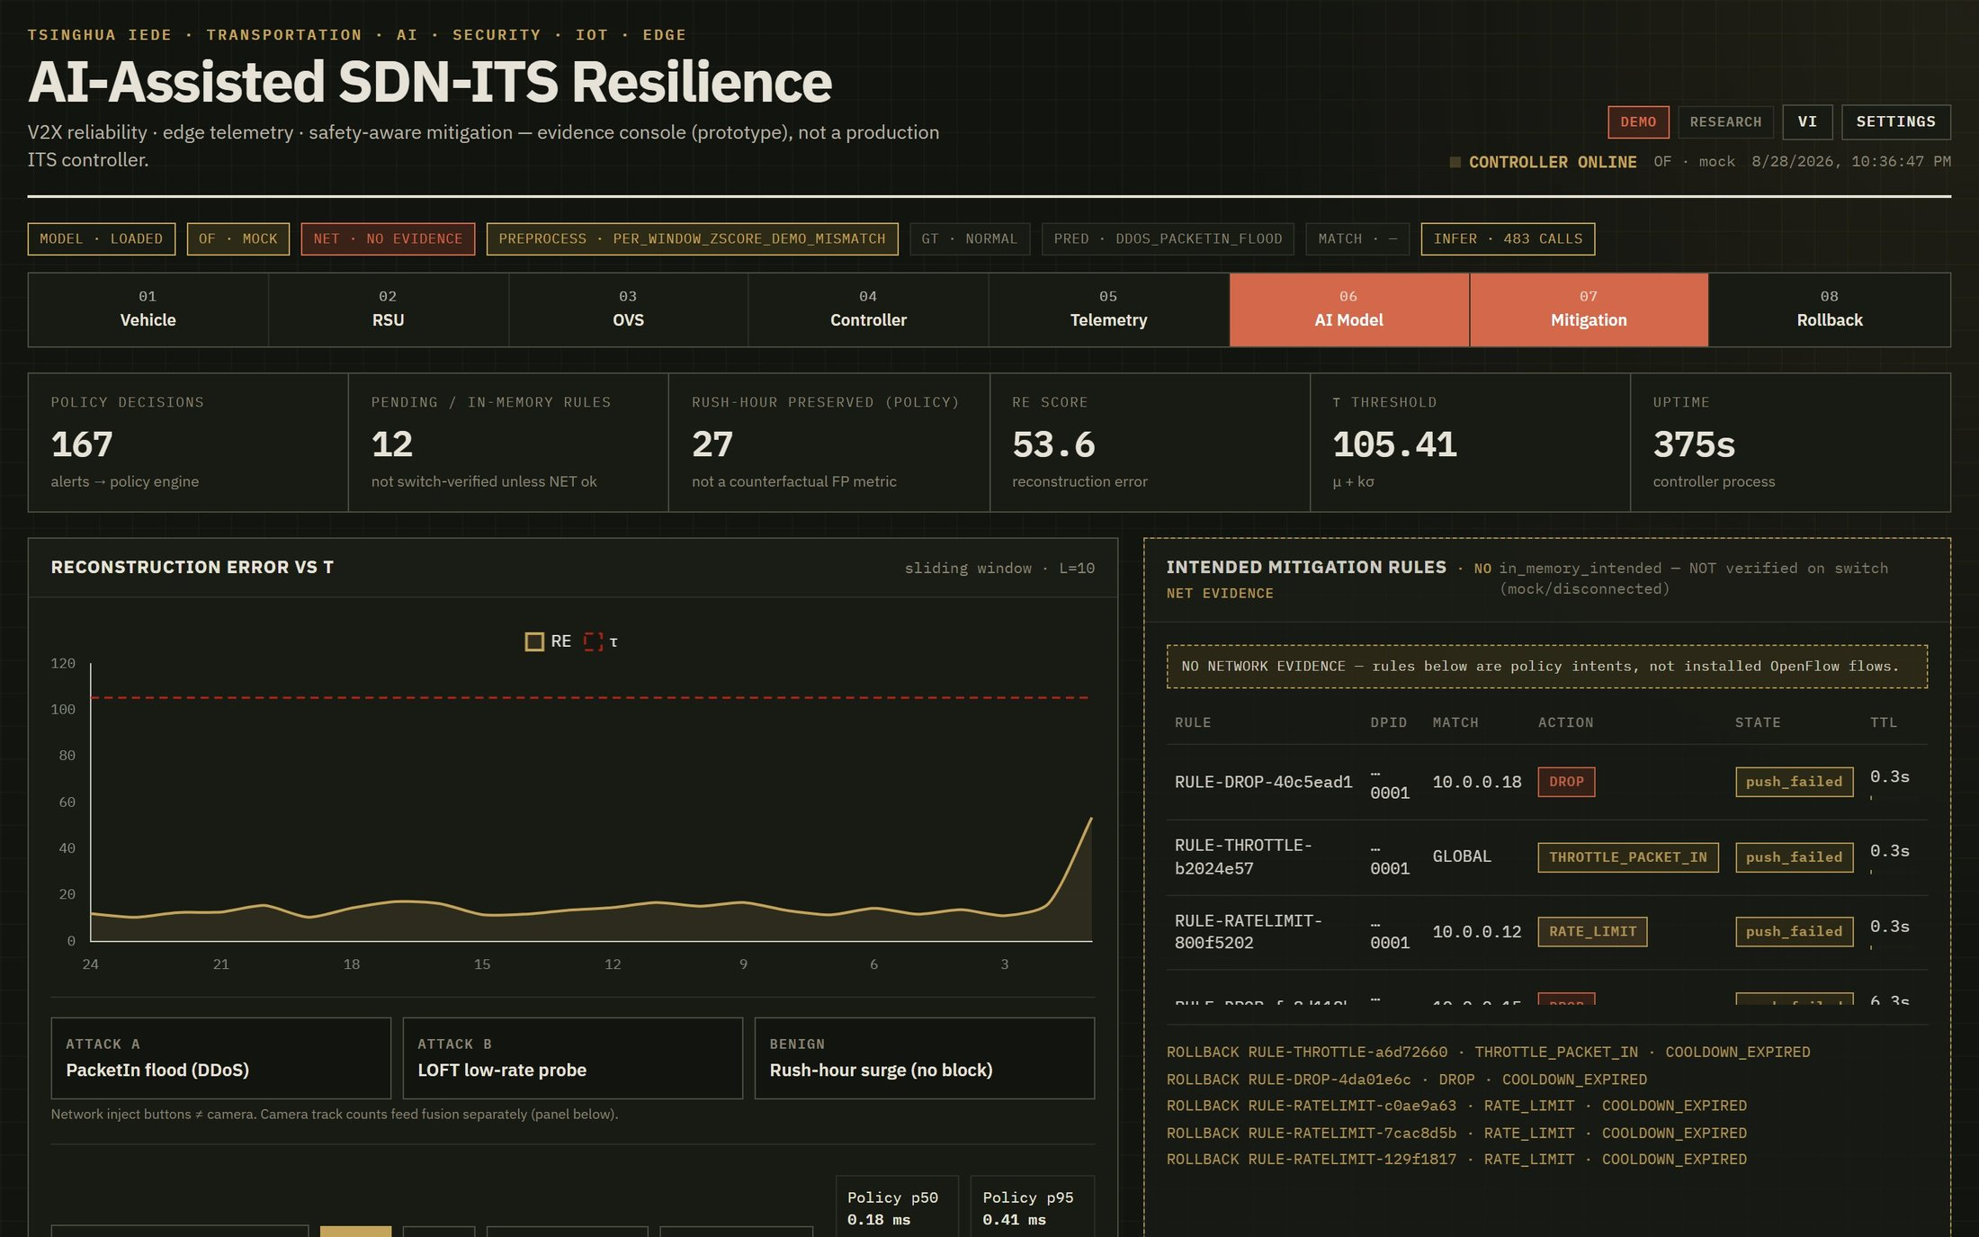
Figure 7.1. Nominal monitoring view with evidence strip (MODEL / OF·mock / NET·NO EVIDENCE on Windows) and KPI cards.

7.2 PacketIn Flood Detection and Containment
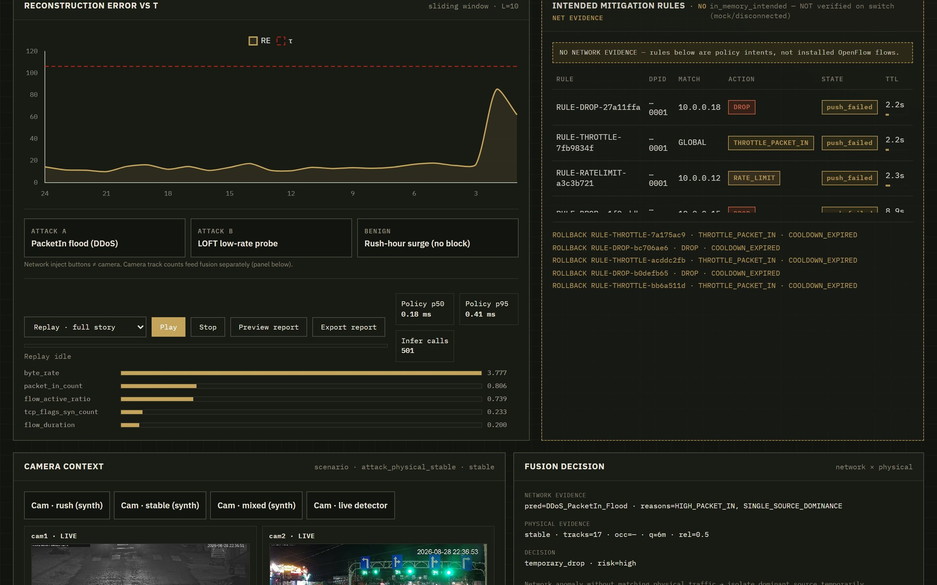
Figure 7.2. PacketIn flood inject: reconstruction-error rise and intended mitigation panel (mock OpenFlow on Windows).

7.3 Rush-Hour False-Positive Avoidance
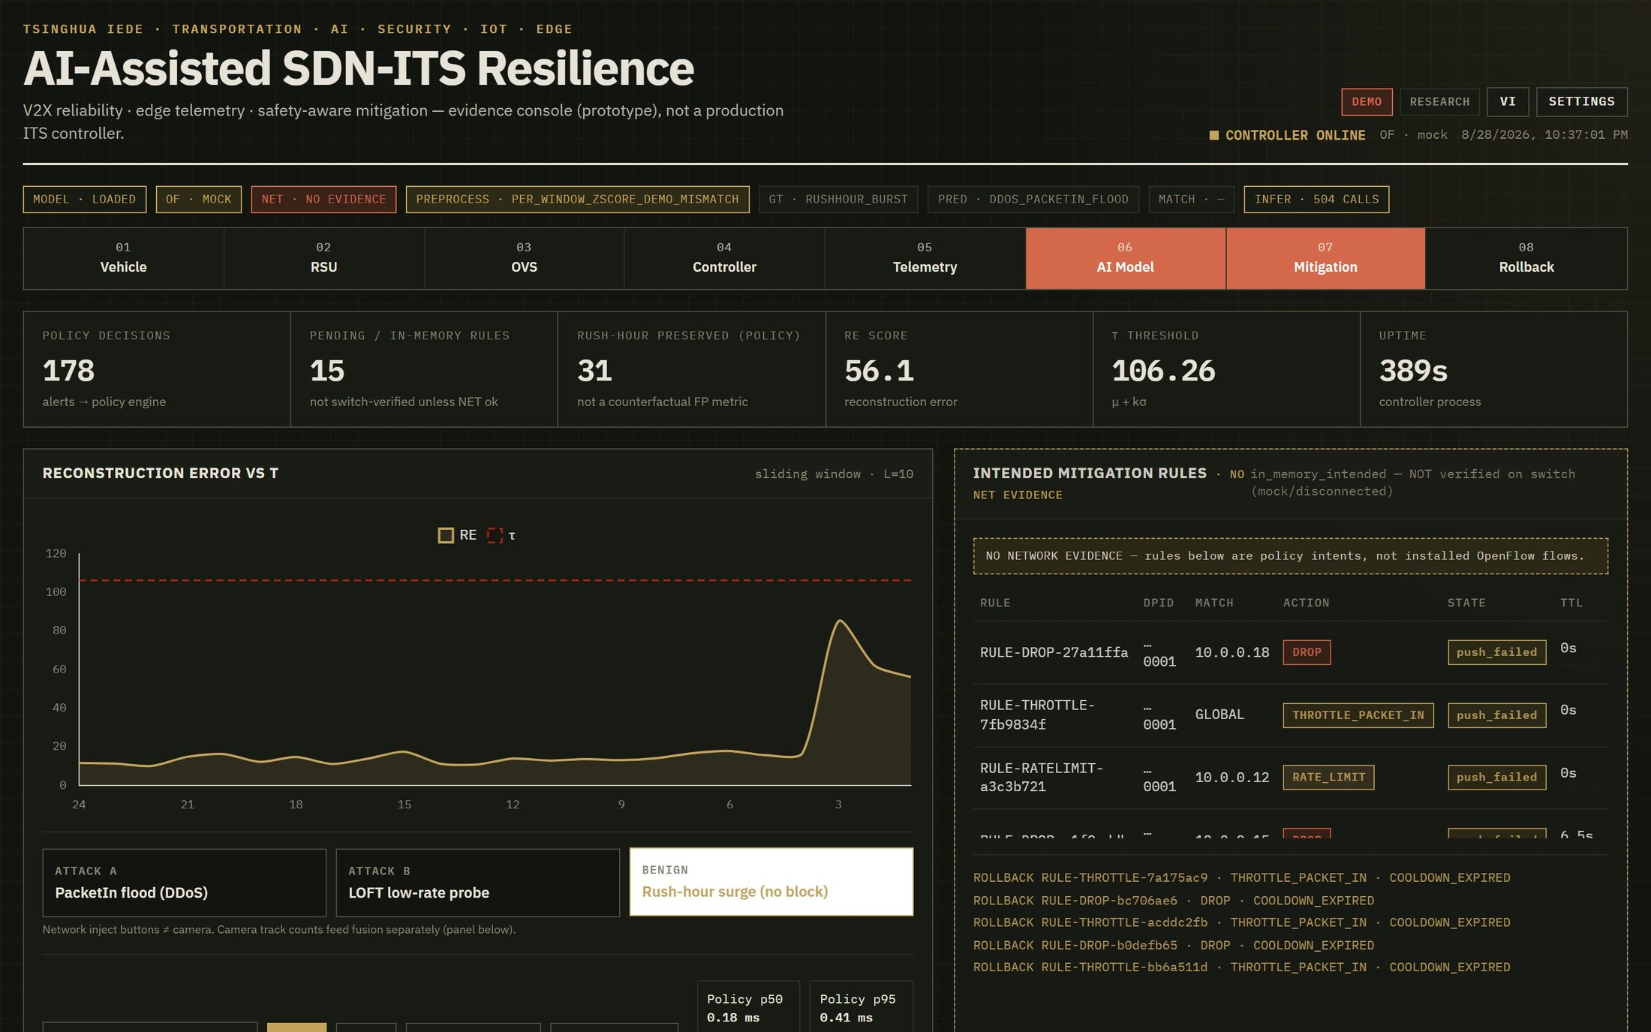
Figure 7.3. Rush-hour network-label path with GT/PRED/MATCH honesty and preserve-oriented policy.

7.4 Scenario Replay
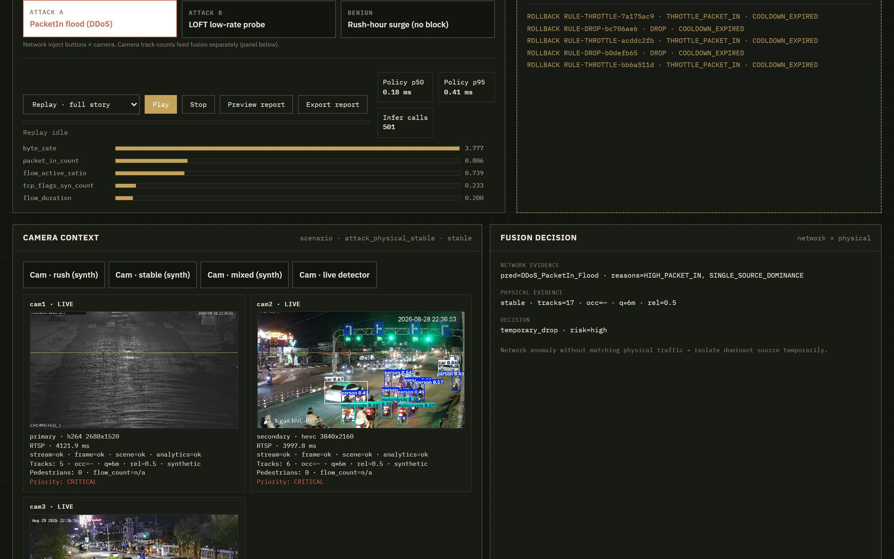
Figure 7.4. PacketIn flood containment view: intended mitigation rules under OF·mock (Windows demo).

7.5 Topology and Event Audit
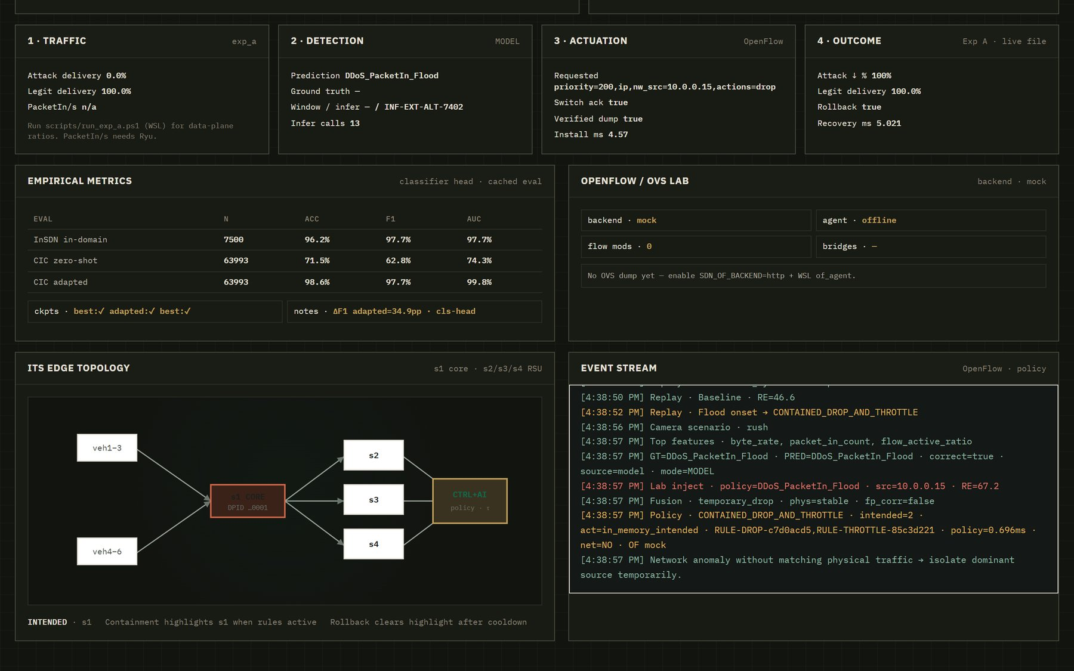
Figure 7.5. ITS edge topology and chronological containment/rollback event stream.

7.6 Camera Context and Evidence Labels
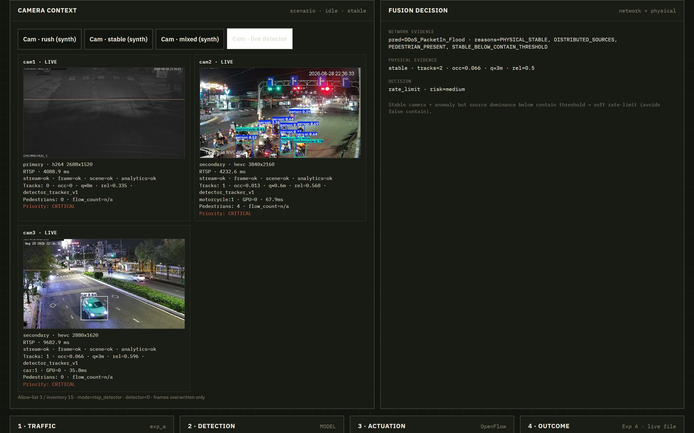
Figure 7.6. Live RTSP night frames (28 Aug 2026) with YOLO boxes. Object tracks support fusion only — not unusual-event AI or veh/h census.
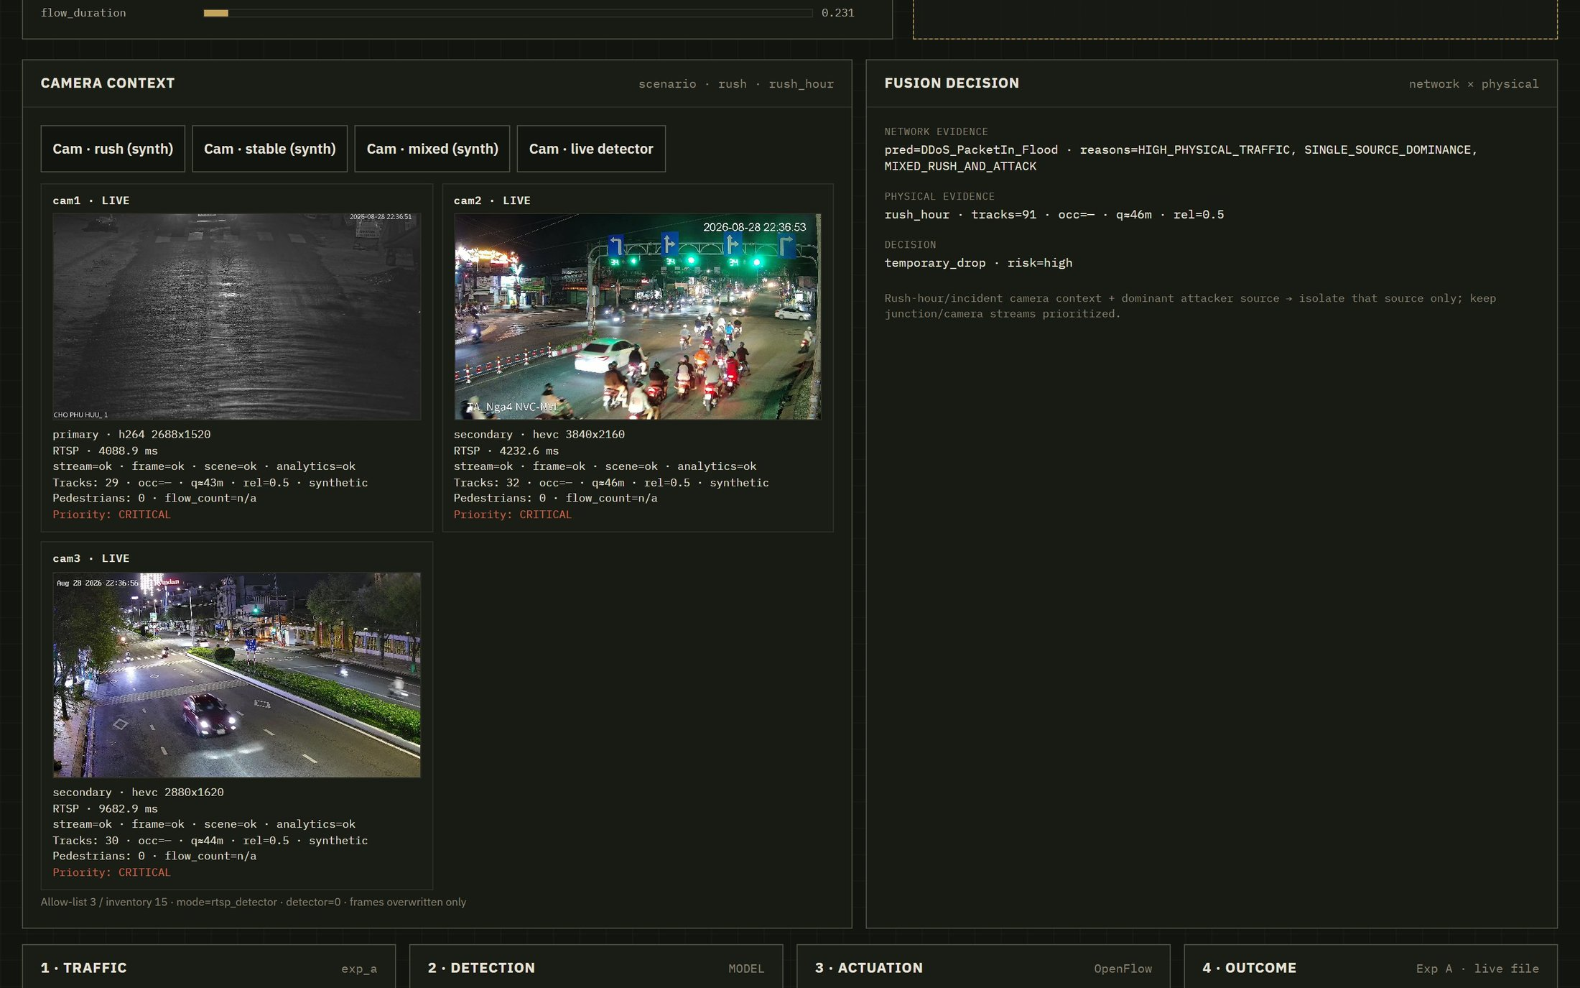
Figure 7.7. Fusion decision panel with live/scripted physical evidence and recommended action (preserve vs temporary contain).
Settings drawer and additional crops are available in assets/images/report/ for the appendix dossier; they are omitted here to keep demonstration focused on RQ-relevant views.

8. Discussion

8.1 Interpretation of Results
In-domain InSDN classifier performance is strong, while CIC zero-shot transfer is weak—an expected outcome that motivates adaptation and transportation-specific scenario design. Sub-10 ms T_response supports feasibility of a lightweight decision path on the evaluated host, not a claim of certified edge deployment. Experiment A shows that temporary DROP can suppress attacker ICMP delivery and that DELETE restores reachability, reducing the blast radius of permanent blocking. Fusion sensitivity demonstrates that mid-dominance decisions actually flip when thresholds are injected, which is a prerequisite for meaningful safety–security trade-off analysis.

8.2 Transportation-Safety Implications
False positives can interrupt V2X and camera streams that operators rely on during congestion. Temporary actions, cooldown, and rollback shrink that blast radius. Camera context must remain supporting evidence: an attacker should not be able to force preserve-by-default merely by spoofing a busy scene if source dominance indicates a concentrated flood.

8.3 Threats to Validity
- Internal validity: synthetic scenario construction and threshold choices can favor scripted passes.
- External validity: results are not yet validated on production ITS controllers or city-scale traffic.
- Construct validity: visible_vehicle_tracks ≠ vehicle flow (veh/h); ICMP delivery ≠ PacketIn/s.
- Conclusion validity: limited seeds; confidence intervals not yet reported for all tables.
- Reproducibility: depends on tracked artifacts, configs, and environment notes in Section 5.5.

8.4 Limitations
- Windows console OF path is mock unless Experiment A (or Ryu) is used.
- Camera fusion Exp B/C/D scripted pass ≠ labeled-video FP reduction; live RTSP tracks ≠ surveyed traffic counts.
- Cross-dataset zero-shot remains weak without adaptation.
- Ablation does not yet prove TCN-GRU superiority over all recurrent baselines.

9. Proposed Research Extension
The next phase couples the current prototype to production-style controller telemetry and mobility simulators (SUMO / Mininet-WiFi) [9][10][11][12], then closes the loop from labeled camera evaluation to switch-verified actuation.
Phase | Work | Deliverable
1 | Multi-seed baseline evaluation | Mean ± SD benchmark table
2 | Real Ryu PacketIn pipeline | Controller-load evidence
3 | SUMO/VANET coupling | Mobility-aware scenario dataset
4 | Labeled camera evaluation | FP/FN metrics on video labels
5 | Cross-dataset adaptation | Generalization study
6 | Integrated closed-loop test | Camera + network + switch evidence
7 | Manuscript preparation | Final research report / paper draft
Table 9.1. Proposed work packages for the next research phase.

10. Conclusion
This research proposes a lightweight and safety-aware resilience framework for SDN-enabled intelligent transportation systems. The prototype integrates non-DPI flow telemetry, TCN-GRU-based anomaly detection, adaptive thresholding, temporary mitigation, automatic rollback, and optional camera-derived physical context. Preliminary results demonstrate strong in-domain detection performance, sub-10 ms decision-path response in the evaluated environment, and reversible OpenFlow containment in a Mininet laboratory setup. The evidence also shows that camera–network fusion policies can be tested transparently while distinguishing scripted inputs, live observations, mock actuation, and switch-verified outcomes. However, cross-dataset generalization, production controller-load reduction, labeled-video false-positive evaluation, and full camera-to-switch closed-loop validation remain open research tasks. The proposed next phase will address these limitations through multi-seed baselines, Ryu/SUMO integration, and transportation-scale experiments.

References
[1] N. McKeown et al., “OpenFlow: Enabling innovation in campus networks,” ACM SIGCOMM CCR, 2008.
[2] S. Bai, J. Z. Kolter, and V. Koltun, “An empirical evaluation of generic convolutional and recurrent networks for sequence modeling,” arXiv:1803.01271, 2018.
[3] M. S. Elsayed, N.-A. Le-Khac, and A. D. Jurcut, “InSDN: A novel SDN intrusion dataset,” IEEE Access, 2020.
[4] I. Sharafaldin, A. H. Lashkari, and A. A. Ghorbani, “Toward generating a new intrusion detection dataset and intrusion traffic characterization (CIC-IDS2017).”
[5] Open Networking Foundation, “OpenFlow Switch Specification,” v1.3.0, 2012.
[6] P. Sommer and V. Paxson, “Outside the closed world: On using machine learning for network intrusion detection,” IEEE S&P, 2010.
[7] R. Mitchell and I.-R. Chen, “A survey of intrusion detection techniques for cyber-physical systems,” ACM Comput. Surv., 2014.
[8] M. Amadeo, C. Campolo, and A. Molinaro, “Enhancing IEEE 802.11p/WAVE to provide infotainment applications in VANETs,” Ad Hoc Networks, 2012.
[9] P. A. Lopez et al., “Microscopic traffic simulation using SUMO,” IEEE ITSC, 2018.
[10] R. R. Fontes et al., “Mininet-WiFi: Emulating software-defined wireless networks,” CNSM, 2015.
[11] Eclipse SUMO, “Simulation of Urban MObility,” documentation, 2026.
[12] Mininet-WiFi Project, “Emulation platform for software-defined wireless networks,” documentation, 2026.
[13] Canadian Institute for Cybersecurity, “CIC-IDS2017 Dataset,” University of New Brunswick, 2018.
[14] K. Cho, B. van Merriënboer, et al., “Learning phrase representations using RNN encoder–decoder for statistical machine translation,” EMNLP, 2014. (GRU)
[15] Ultralytics, “YOLOv8 documentation,” 2023–2026. (edge object detection used as context only)

Appendix A. Model and Training Parameters
Defaults follow Table 4.1.
Training entrypoint: python -m sdn_its.ai.train with --epochs/--batch_size/--lr. Checkpoint: models/checkpoints/tcn_gru_best.pt.
Scaler: models/checkpoints/scaler.joblib when present.

Appendix B. Feature Definitions
Feature | Definition | Unit / notes
flow_duration | Observed flow duration | seconds
packet_rate | Packets per interval | packets/s
byte_rate | Bytes per interval | bytes/s
pkt_iat_mean | Mean packet inter-arrival time | ms
pkt_iat_std | Std. packet inter-arrival time | ms
packet_len_mean | Mean packet length | bytes
packet_in_count | Controller PacketIn-related count | count/window
tcp_flags_syn_count | SYN flag count proxy | count/window
flow_active_ratio | Active vs idle ratio | ratio
rsu_channel_occupancy | Wireless/RSU load proxy | ratio
Table B.1. Canonical FEATURE_COLUMNS used by the prototype.

Appendix C. Experiment Artifact Manifest
Artifact | Path
InSDN metrics | artifacts/results/exp_insdn/metrics.json
CIC zero-shot | artifacts/results/cross_dataset/eval_metrics.json
CIC adapted | artifacts/results/cross_dataset/adapted_metrics.json
Exp A OpenFlow | artifacts/results/exp_a/exp_a_metrics.json
Exp B/C fusion | artifacts/results/exp_bc/exp_bc_fusion.json
Sensitivity | artifacts/results/exp_bc/exp_bc_sensitivity.json
Exp D grades | artifacts/results/exp_d/exp_d_phases.json
Model card | artifacts/models/model_card.json
Table C.1. Reproducibility manifest for preliminary results.

Appendix D. Camera Evidence Grades (Detail)
Experiment | Camera source | Context modified | OpenFlow | Claim allowed
B/C | scripted | yes | no | fusion rule behavior / sensitivity
D-live | live/synth observation | no | no | live detector/context availability (when RTSP resolves)
D-scripted | forced congestion | yes | optional | policy wiring
A | none | no | yes | reversible OpenFlow mitigation
Table D.1. Camera/network evidence grades (expanded).

