**ENTRUST**

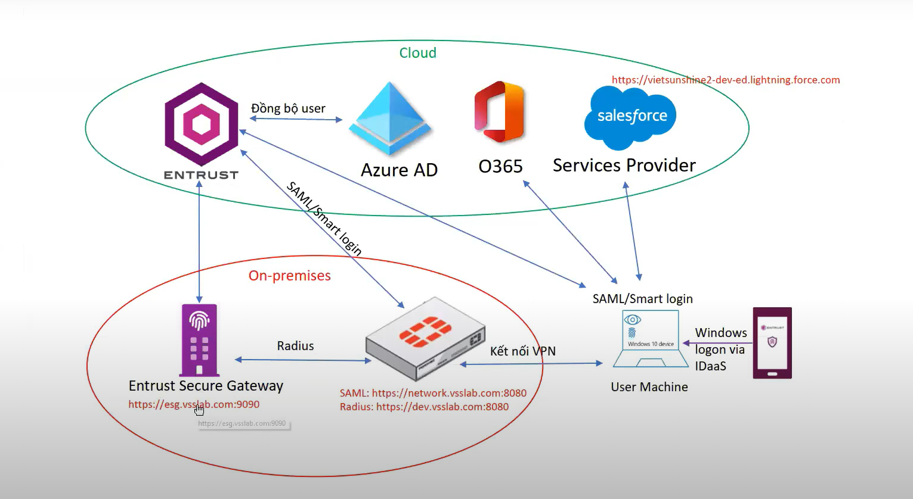

Inntall admin:

<https://vcs.us.trustedauth.com/documentation/help/admin/index.htm#t=Resources%2FPA_Integrate.htm>

<https://vcs.us.trustedauth.com/>