**Radius OTP**

1. LoginTC: <https://www.logintc.com/docs/connectors/radius.html>

* Mô hình:

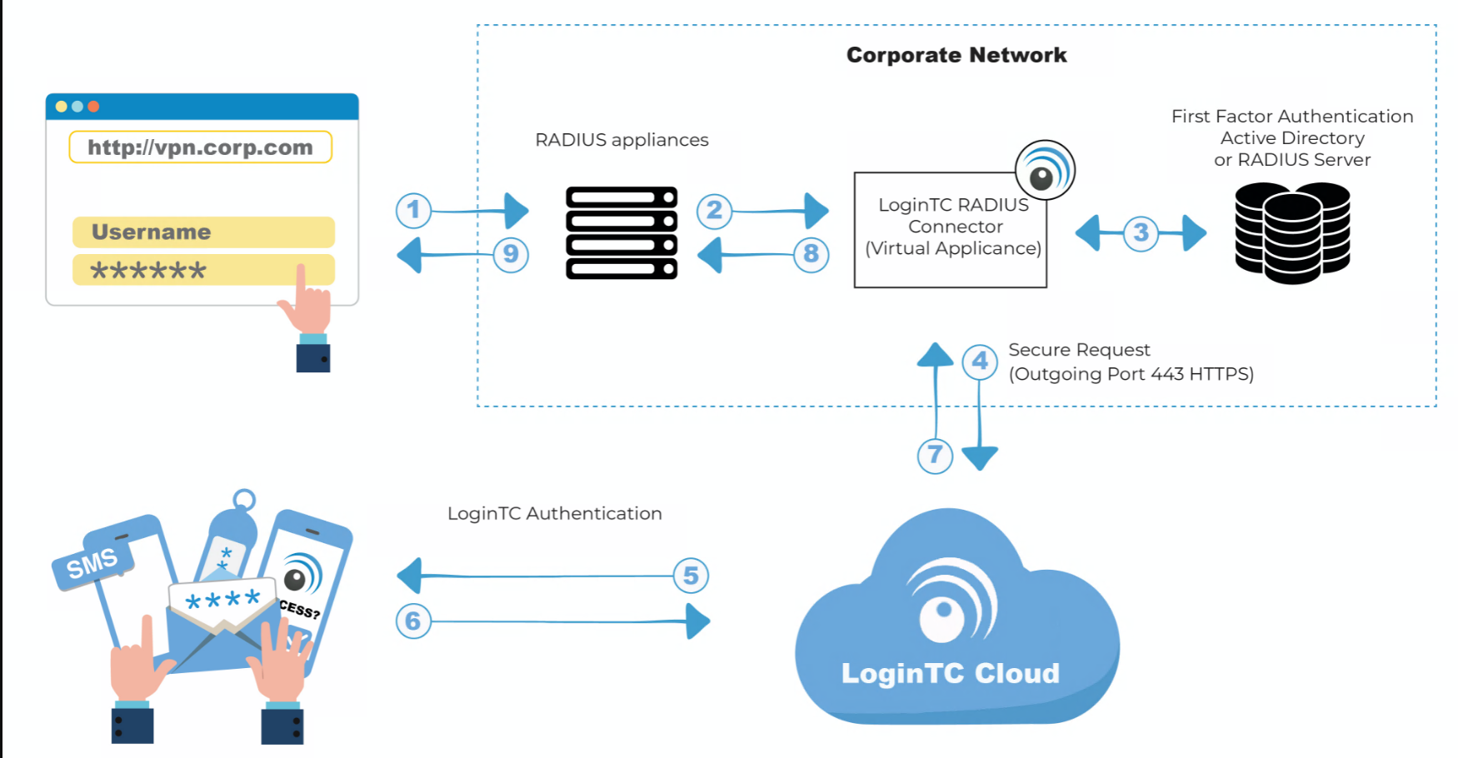

1. Pfsense gg authen: <https://devopstales.github.io/linux/pfsense-2fa/>