Họ và tên: Cao Tống Thiên Thư

MSSV: 1150070041

Lớp: 11_ĐH_TMĐT

**BÀI TẬP LÝ THUYẾT 2**

Framelayout

Bước 1: Chọn New Project để tạo dự án mới > Chọn Empty Views Activity

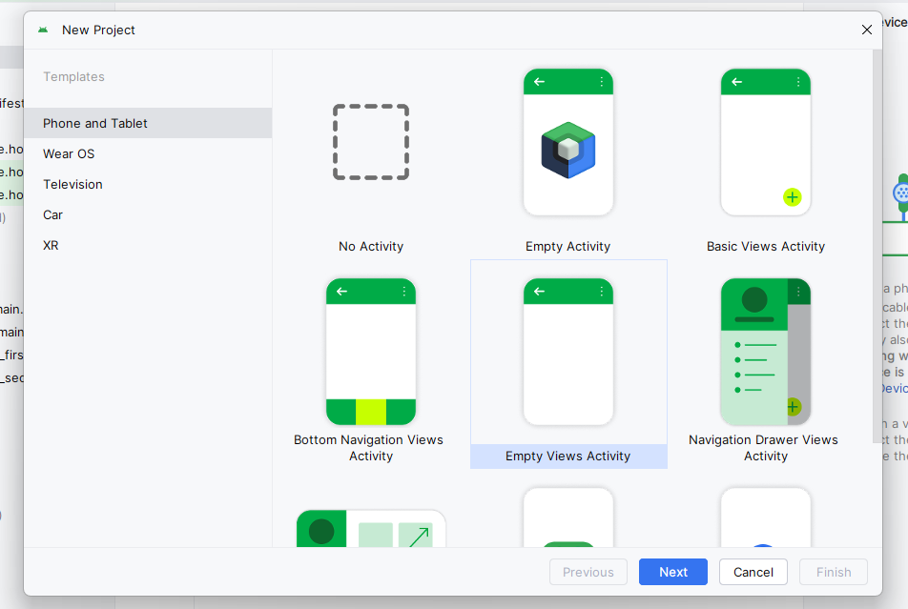

Bước 2: Ở trong MainActivity.java dùng đoạn code

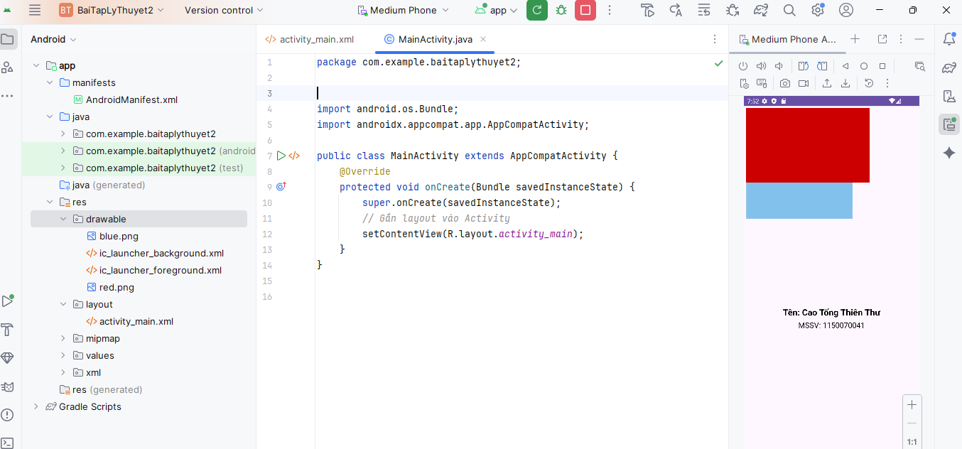

package com.example.baitaplythuyet2;  
  
import android.os.Bundle;  
import androidx.appcompat.app.AppCompatActivity;  
  
public class MainActivity extends AppCompatActivity {  
 @Override  
 protected void onCreate(Bundle savedInstanceState) {  
 super.onCreate(savedInstanceState);  
 *// Gắn layout vào Activity* setContentView(R.layout.*activity_main*);  
 }  
}

Bước 3: ở trong App > res > layout > Activity_main.xml có code

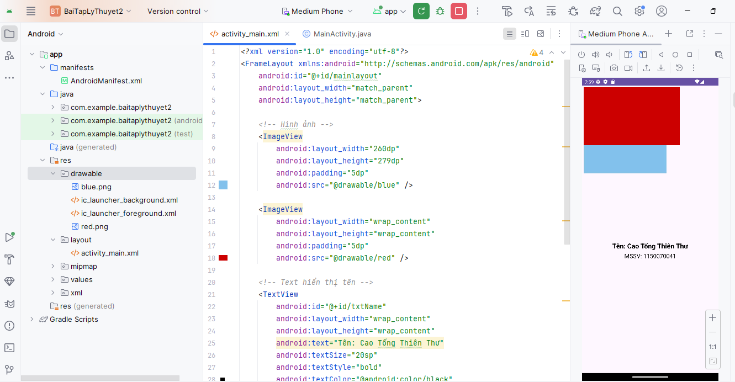

*<?*xml version="1.0" encoding="utf-8"*?>*<FrameLayout xmlns:android="http://schemas.android.com/apk/res/android"  
 android:id="@+id/mainlayout"  
 android:layout_width="match_parent"  
 android:layout_height="match_parent"><ImageView  
 android:layout_width="260dp"  
 android:layout_height="279dp"  
 android:padding="5dp"  
 android:src="@drawable/blue" />  
 <ImageView  
 android:layout_width="wrap_content"  
 android:layout_height="wrap_content"  
 android:padding="5dp"  
 android:src="@drawable/red" /><TextView  
 android:id="@+id/txtName"  
 android:layout_width="wrap_content"  
 android:layout_height="wrap_content"  
 android:text="Tên: Cao Tống Thiên Thư"  
 android:textSize="20sp"  
 android:textStyle="bold"  
 android:textColor="@android:color/black"  
 android:layout_gravity="center_horizontal|center_vertical"  
 android:layout_marginTop="50dp"/><TextView  
 android:id="@+id/txtMSSV"  
 android:layout_width="wrap_content"  
 android:layout_height="wrap_content"  
 android:text="MSSV: 1150070041"  
 android:textSize="18sp"  
 android:textColor="@android:color/black"  
 android:layout_gravity="center_horizontal|center_vertical"  
 android:layout_marginTop="80dp"/>  
</FrameLayout>

Bước 4: tải 2 hình xanh và đỏ lưu đuôi là .png trong thư mục Drawable

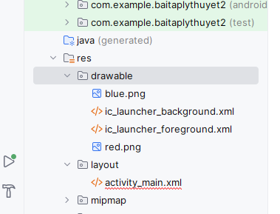

**Linear Layout**

Bước 1: trong activity_main.xml

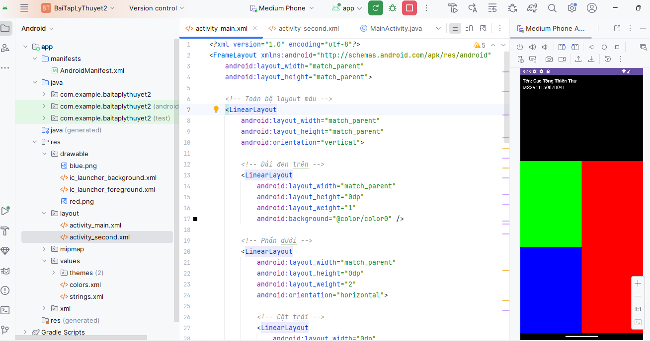

*<?*xml version="1.0" encoding="utf-8"*?>*<FrameLayout xmlns:android="http://schemas.android.com/apk/res/android"  
 android:layout_width="match_parent"  
 android:layout_height="match_parent">  
  
 *<!-- Toàn bộ layout màu -->* <LinearLayout  
 android:layout_width="match_parent"  
 android:layout_height="match_parent"  
 android:orientation="vertical">  
  
 *<!-- Dải đen trên -->* <LinearLayout  
 android:layout_width="match_parent"  
 android:layout_height="0dp"  
 android:layout_weight="1"  
 android:background="@color/color0" />  
  
 *<!-- Phần dưới -->* <LinearLayout  
 android:layout_width="match_parent"  
 android:layout_height="0dp"  
 android:layout_weight="2"  
 android:orientation="horizontal">  
  
 *<!-- Cột trái -->* <LinearLayout  
 android:layout_width="0dp"  
 android:layout_height="match_parent"  
 android:layout_weight="1"  
 android:orientation="vertical">  
  
 <LinearLayout  
 android:layout_width="match_parent"  
 android:layout_height="0dp"  
 android:layout_weight="1"  
 android:background="@color/color2" />  
  
 <LinearLayout  
 android:layout_width="match_parent"  
 android:layout_height="0dp"  
 android:layout_weight="1"  
 android:background="@color/color3" />  
 </LinearLayout>  
  
 *<!-- Cột phải -->* <LinearLayout  
 android:layout_width="0dp"  
 android:layout_height="match_parent"  
 android:layout_weight="1"  
 android:background="@color/color1" />  
 </LinearLayout>  
 </LinearLayout>  
  
 *<!-- Text hiển thị tên + MSSV (đè lên trên) -->* <LinearLayout  
 android:layout_width="wrap_content"  
 android:layout_height="wrap_content"  
 android:orientation="vertical"  
 android:layout_gravity="top|start"  
 android:padding="8dp">  
  
 <TextView  
 android:id="@+id/txtName"  
 android:layout_width="wrap_content"  
 android:layout_height="wrap_content"  
 android:text="Tên: Cao Tống Thiên Thư"  
 android:textColor="@android:color/white"  
 android:textStyle="bold"  
 android:textSize="16sp" />  
  
 <TextView  
 android:id="@+id/txtMSSV"  
 android:layout_width="wrap_content"  
 android:layout_height="wrap_content"  
 android:text="MSSV: 1150070041"  
 android:textColor="@android:color/white"  
 android:textSize="16sp" />  
 </LinearLayout>  
  
</FrameLayout>

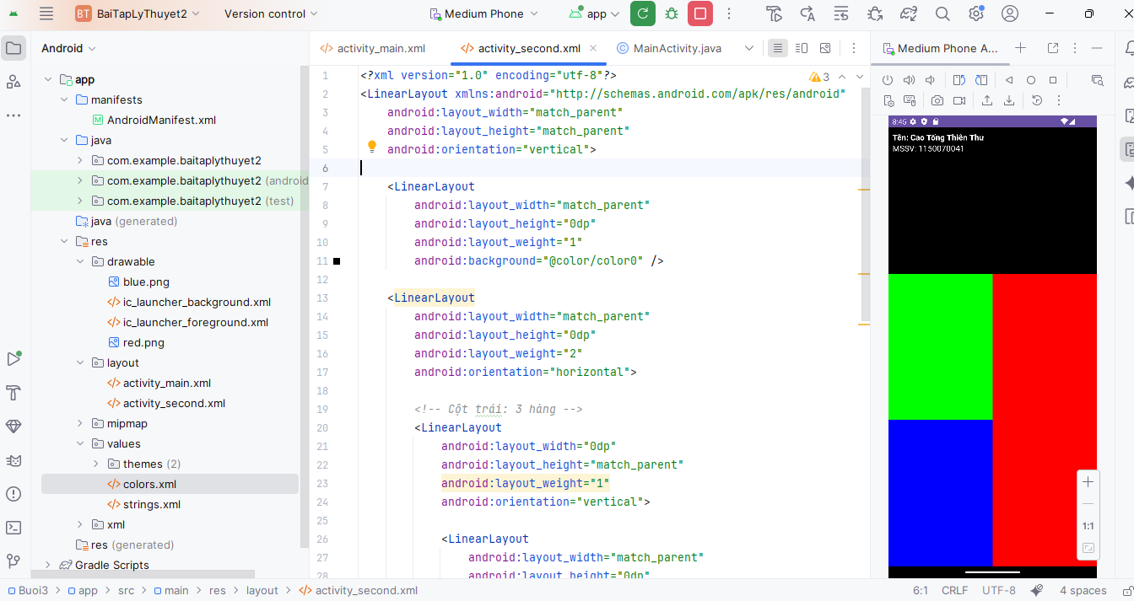

*<?*xml version="1.0" encoding="utf-8"*?>*<LinearLayout xmlns:android="http://schemas.android.com/apk/res/android"  
 android:layout_width="match_parent"  
 android:layout_height="match_parent"  
 android:orientation="vertical">  
  
 <LinearLayout  
 android:layout_width="match_parent"  
 android:layout_height="0dp"  
 android:layout_weight="1"  
 android:background="@color/color0" />  
  
 <LinearLayout  
 android:layout_width="match_parent"  
 android:layout_height="0dp"  
 android:layout_weight="2"  
 android:orientation="horizontal">  
  
 *<!-- Cột trái: 3 hàng -->* <LinearLayout  
 android:layout_width="0dp"  
 android:layout_height="match_parent"  
 android:layout_weight="1"  
 android:orientation="vertical">  
  
 <LinearLayout  
 android:layout_width="match_parent"  
 android:layout_height="0dp"  
 android:layout_weight="1"  
 android:background="@color/colorCyan" />  
  
 <LinearLayout  
 android:layout_width="match_parent"  
 android:layout_height="0dp"  
 android:layout_weight="1"  
 android:background="@color/colorWhite" />  
  
 <LinearLayout  
 android:layout_width="match_parent"  
 android:layout_height="0dp"  
 android:layout_weight="1"  
 android:background="@color/color3" />  
 </LinearLayout>  
  
 *<!-- Cột phải: đỏ -->* <LinearLayout  
 android:layout_width="0dp"  
 android:layout_height="match_parent"  
 android:layout_weight="1"  
 android:background="@color/color1" />  
 </LinearLayout>  
</LinearLayout>

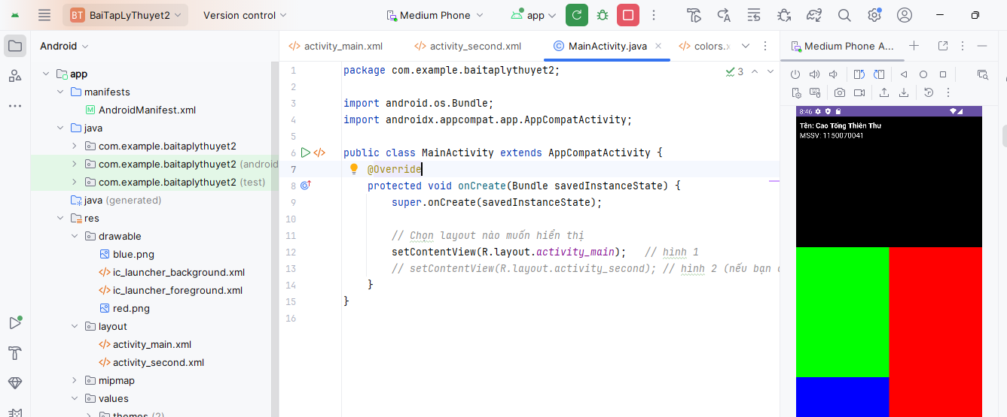

package com.example.baitaplythuyet2;  
  
import android.os.Bundle;  
import androidx.appcompat.app.AppCompatActivity;  
  
public class MainActivity extends AppCompatActivity {  
 @Override  
 protected void onCreate(Bundle savedInstanceState) {  
 super.onCreate(savedInstanceState);  
  
 *// Chọn layout nào muốn hiển thị* setContentView(R.layout.*activity_main*); *// hình 1  
 // setContentView(R.layout.activity_second); // hình 2 (nếu bạn có file activity_second.xml)* }  
}

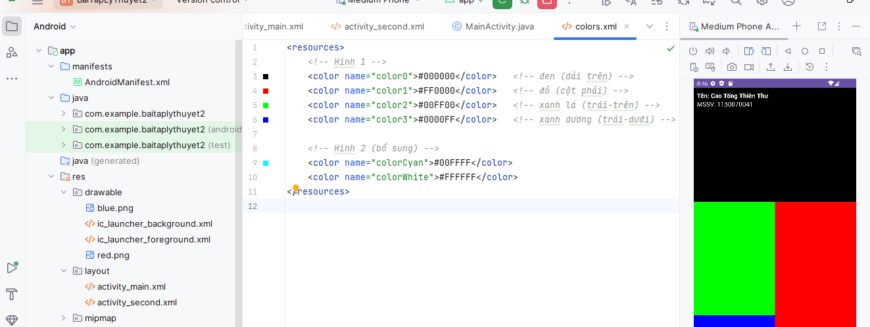

<resources>  
 *<!-- Hình 1 -->* <color name="color0">#000000</color> *<!-- đen (dải trên) -->* <color name="color1">#FF0000</color> *<!-- đỏ (cột phải) -->* <color name="color2">#00FF00</color> *<!-- xanh lá (trái-trên) -->* <color name="color3">#0000FF</color> *<!-- xanh dương (trái-dưới) -->  
  
 <!-- Hình 2 (bổ sung) -->* <color name="colorCyan">#00FFFF</color>  
 <color name="colorWhite">#FFFFFF</color>  
</resources>