Họ tên: Cao Tống Thiên Thư

MSSV: 1150070041

Lớp: 11ĐHTMĐT

Bài tập lý thuyết 4

Tạo Project

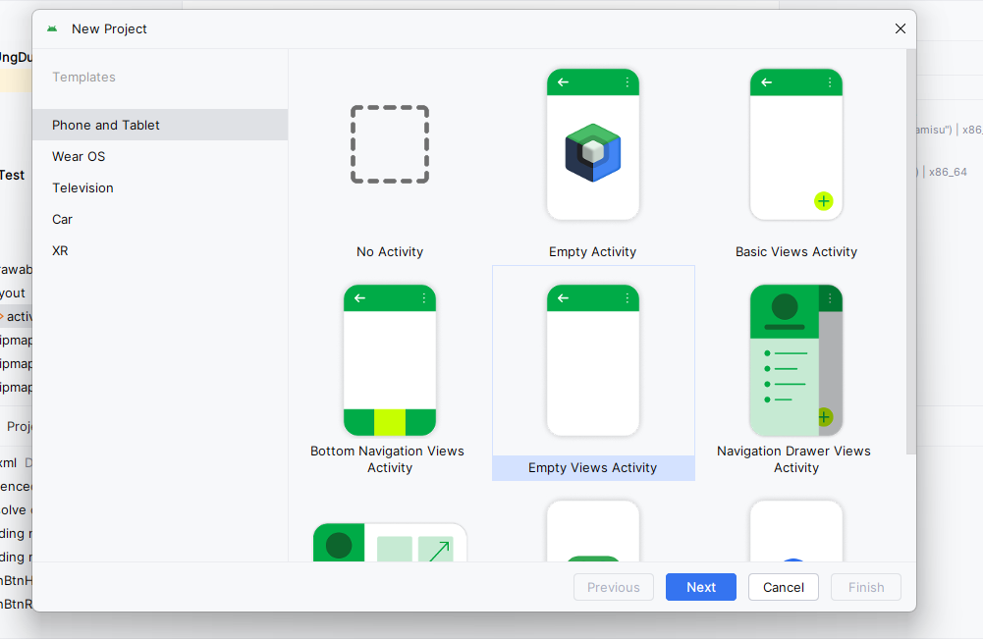

Tải LDPlayer

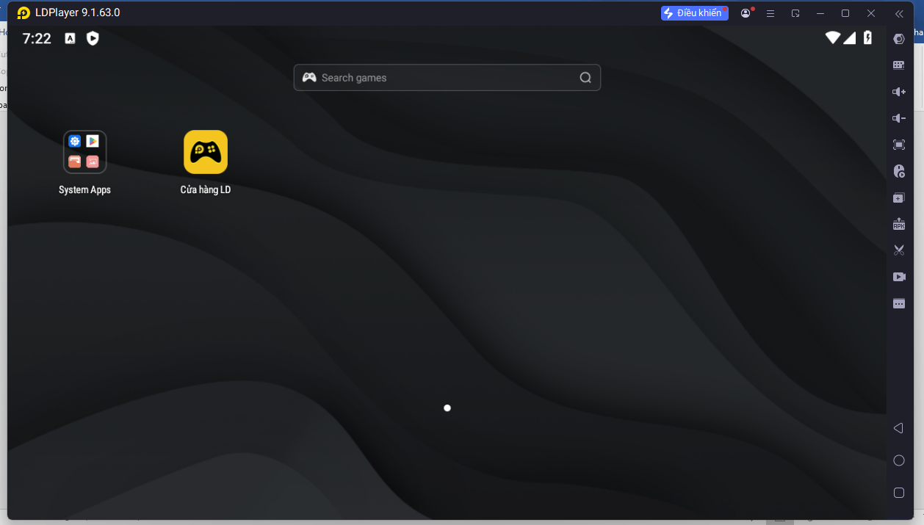

Trong cài đặt chọn dọc chọn như hình

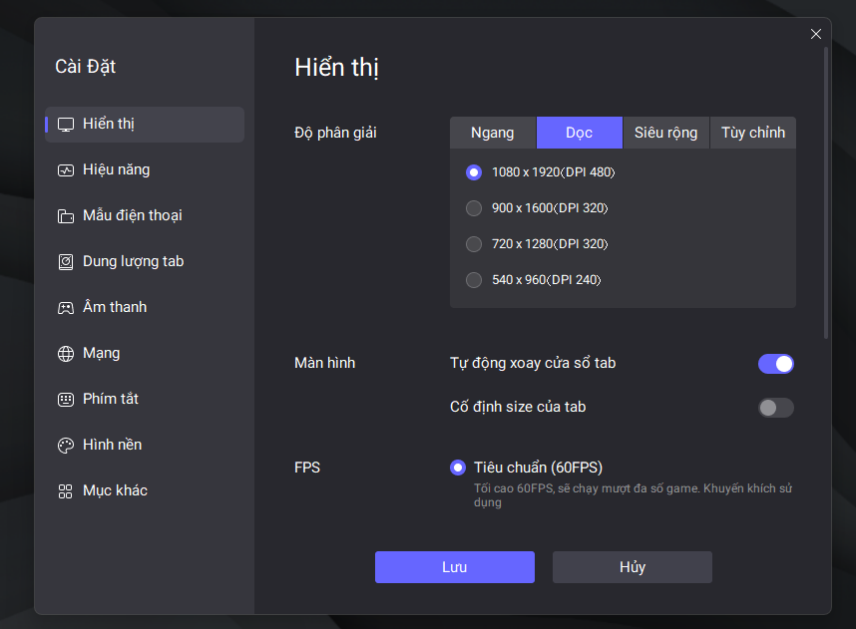

ở mục khác > debug ADB chọn bật kết nối

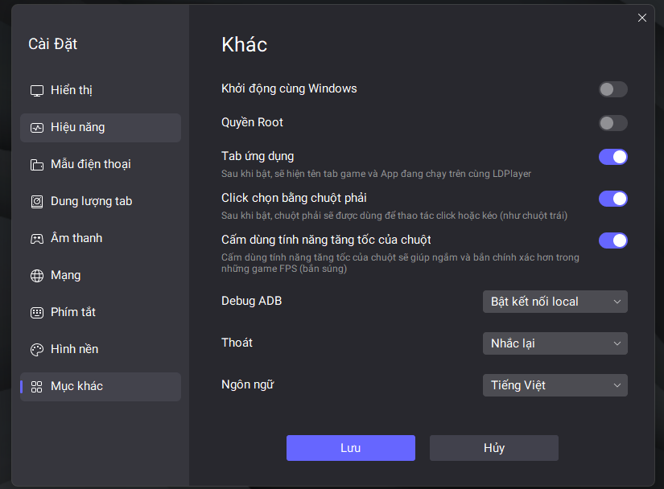

Trong Android Studio sẽ xuất hiện máy Oppo PJJ110

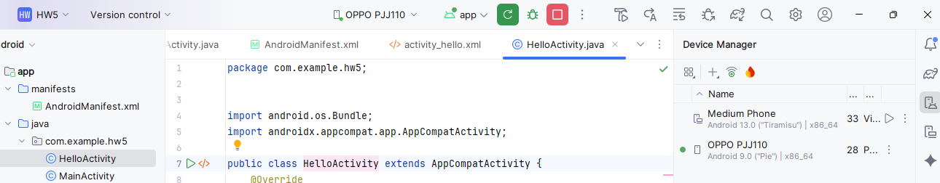

Trở lại Android Studio tạo 2 new android activity

Đặt tên file mới tạo là HelloActivity > finish

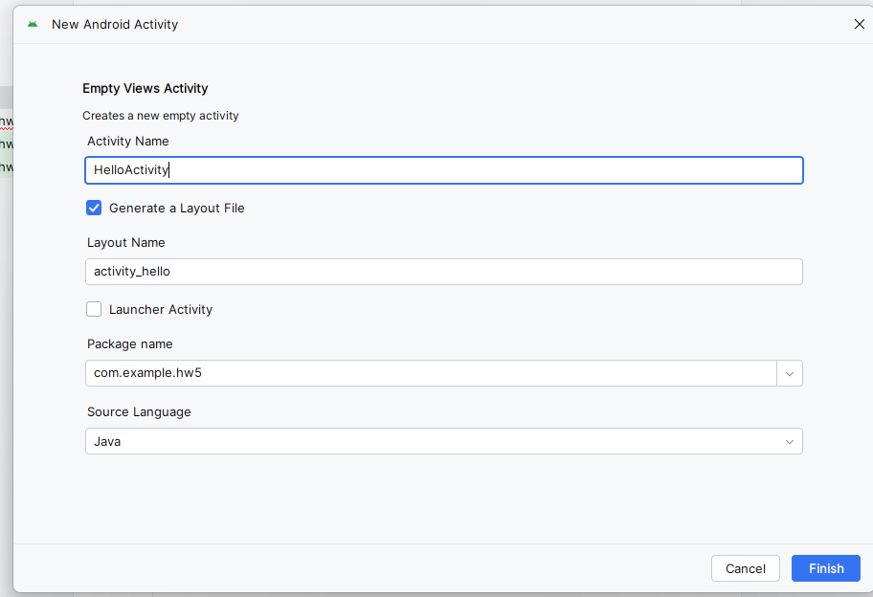

RegisterActivity > finish

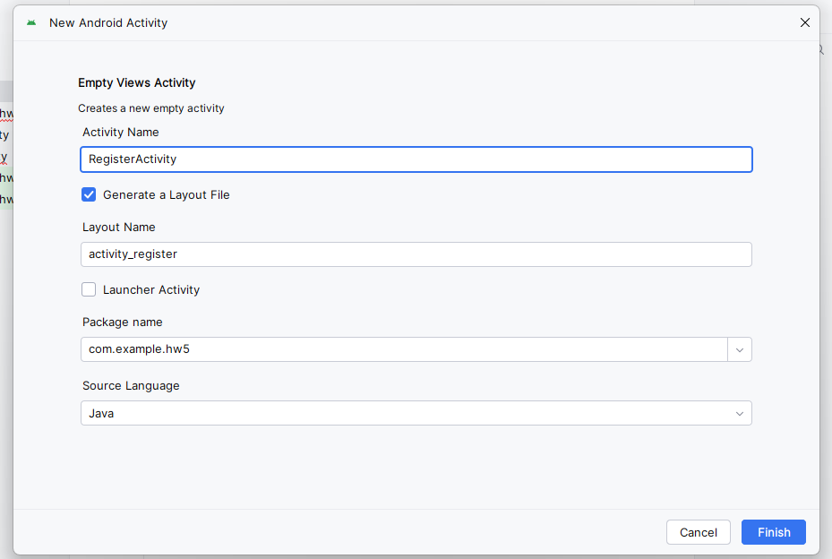

Sẽ được như hình

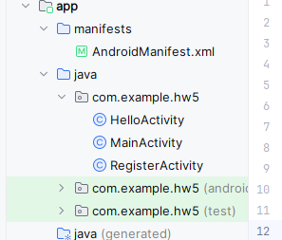

Trong HelloActivity.java

package com.example.hw5;  
  
  
import android.os.Bundle;  
import androidx.appcompat.app.AppCompatActivity;  
  
public class HelloActivity extends AppCompatActivity {  
 @Override  
 protected void onCreate(Bundle savedInstanceState) {  
 super.onCreate(savedInstanceState);  
 setContentView(R.layout.*activity_hello*);  
 }  
}

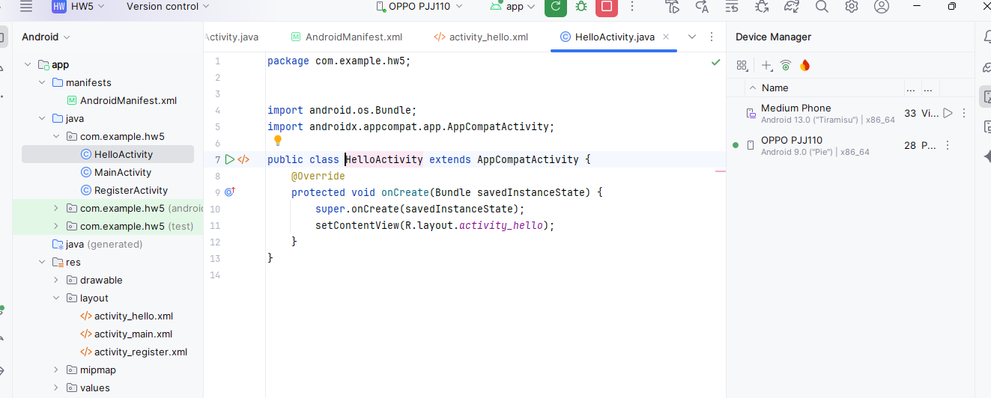

Trong MainActivity.java

package com.example.hw5;  
  
import android.content.Intent;  
import android.os.Bundle;  
import android.view.View;  
import androidx.appcompat.app.AppCompatActivity;  
  
public class MainActivity extends AppCompatActivity {  
  
 @Override  
 protected void onCreate(Bundle savedInstanceState) {  
 super.onCreate(savedInstanceState);  
 setContentView(R.layout.*activity_main*);  
 }  
  
 *// Nút HelloWorld* public void onBtnHelloClick(View view) {  
 Intent intent = new Intent(this, HelloActivity.class);  
 startActivity(intent);  
 }  
  
 *// Nút Register* public void onBtnRegisterClick(View view) {  
 Intent intent = new Intent(this, RegisterActivity.class);  
 startActivity(intent);  
 }  
}

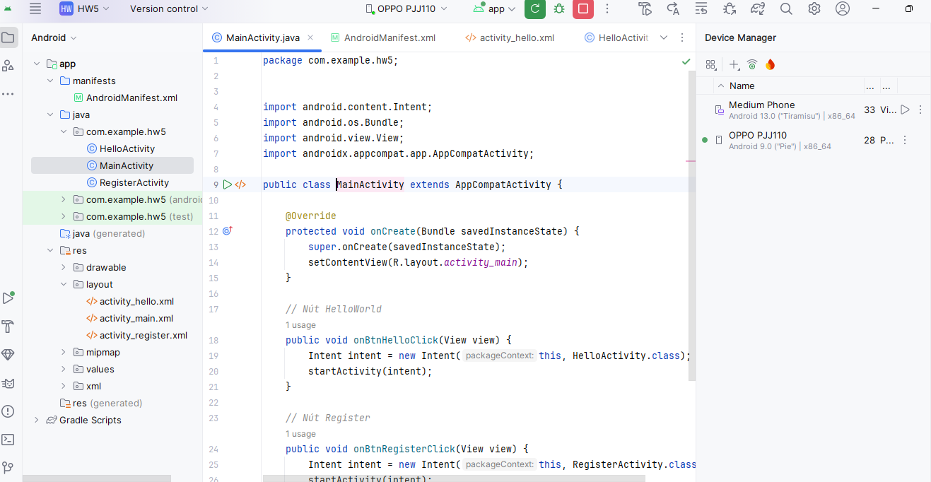

Trong RegisterActivity.java

package com.example.hw5;  
  
import android.os.Bundle;  
import androidx.appcompat.app.AppCompatActivity;  
  
public class RegisterActivity extends AppCompatActivity {  
 @Override  
 protected void onCreate(Bundle savedInstanceState) {  
 super.onCreate(savedInstanceState);  
 setContentView(R.layout.*activity_register*);  
 }  
}

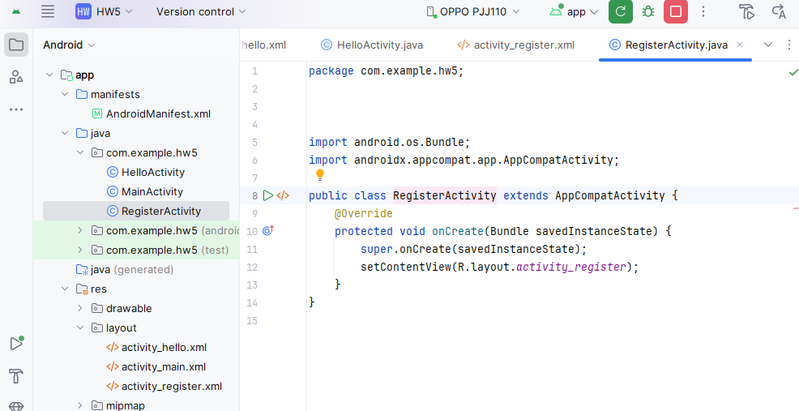

Layout/activity_hello.xml

*<?*xml version="1.0" encoding="utf-8"*?>*<androidx.constraintlayout.widget.ConstraintLayout  
 xmlns:android="http://schemas.android.com/apk/res/android"  
 xmlns:app="http://schemas.android.com/apk/res-auto"  
 android:layout_width="match_parent"  
 android:layout_height="match_parent">  
  
 <TextView  
 android:id="@+id/tvHello"  
 android:layout_width="wrap_content"  
 android:layout_height="wrap_content"  
 android:text="Xin chào em tên là Cao Tống Thiên Thư đến từ lớp 11_ĐH_TMĐT"  
 android:textSize="20sp"  
 app:layout_constraintTop_toTopOf="parent"  
 app:layout_constraintStart_toStartOf="parent"  
 app:layout_constraintEnd_toEndOf="parent"  
 android:layout_marginTop="24dp"/>  
</androidx.constraintlayout.widget.ConstraintLayout>

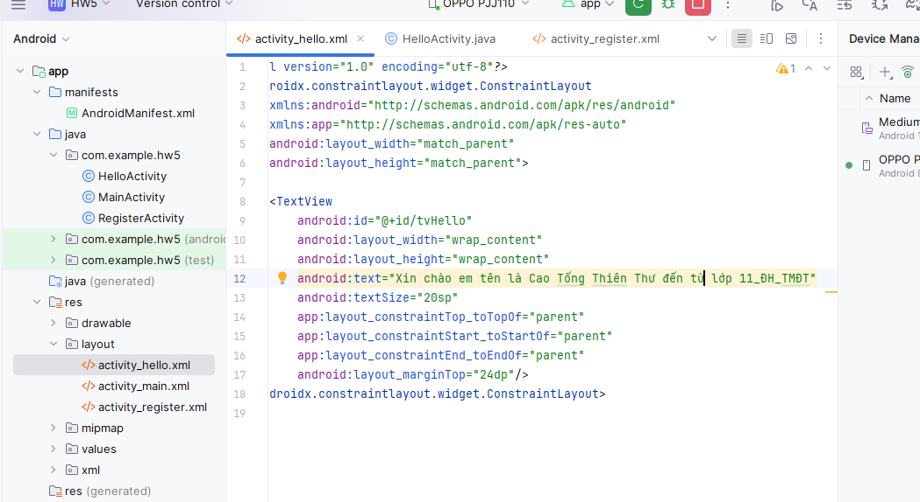

Trong Activity_main.xml

*<?*xml version="1.0" encoding="utf-8"*?>*<androidx.constraintlayout.widget.ConstraintLayout  
 xmlns:android="http://schemas.android.com/apk/res/android"  
 xmlns:app="http://schemas.android.com/apk/res-auto"  
 xmlns:tools="http://schemas.android.com/tools"  
 android:id="@+id/main"  
 android:layout_width="match_parent"  
 android:layout_height="match_parent"  
 tools:context=".MainActivity">  
  
 <Button  
 android:id="@+id/btnHelloWorld"  
 android:layout_width="wrap_content"  
 android:layout_height="wrap_content"  
 android:text="HelloWorld"  
 android:onClick="onBtnHelloClick"  
 app:layout_constraintTop_toTopOf="parent"  
 app:layout_constraintStart_toStartOf="parent"  
 app:layout_constraintEnd_toEndOf="parent"  
 android:layout_marginTop="228dp"/>  
  
 <Button  
 android:id="@+id/btnRegister"  
 android:layout_width="wrap_content"  
 android:layout_height="wrap_content"  
 android:text="Register"  
 android:onClick="onBtnRegisterClick"  
 app:layout_constraintTop_toBottomOf="@id/btnHelloWorld"  
 app:layout_constraintStart_toStartOf="parent"  
 app:layout_constraintEnd_toEndOf="parent"  
 android:layout_marginTop="80dp"/>  
  
 *<!-- 👇 Thêm dòng thông tin sinh viên -->* <TextView  
 android:id="@+id/tvInfo"  
 android:layout_width="wrap_content"  
 android:layout_height="wrap_content"  
 android:text="Cao Tống Thiên Thư - MSSV: 1150070041"  
 android:textSize="16sp"  
 android:textStyle="bold"  
 android:layout_marginBottom="24dp"  
 app:layout_constraintBottom_toBottomOf="parent"  
 app:layout_constraintStart_toStartOf="parent"  
 app:layout_constraintEnd_toEndOf="parent"/>  
  
</androidx.constraintlayout.widget.ConstraintLayout>

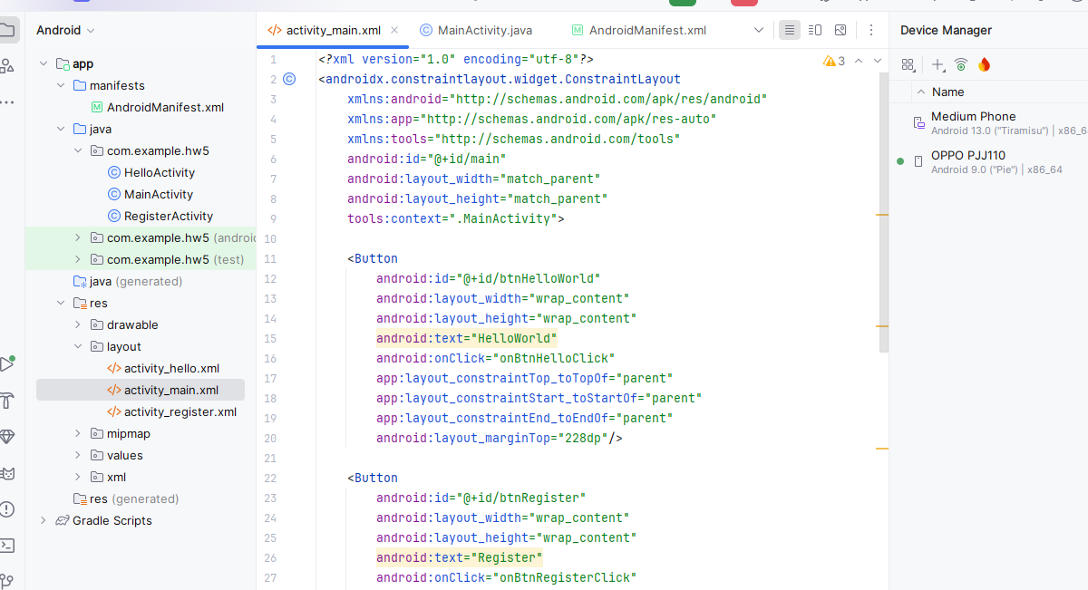

Trong activity_register.xml

*<?*xml version="1.0" encoding="utf-8"*?>*<androidx.constraintlayout.widget.ConstraintLayout  
 xmlns:android="http://schemas.android.com/apk/res/android"  
 xmlns:app="http://schemas.android.com/apk/res-auto"  
 android:layout_width="match_parent"  
 android:layout_height="match_parent">  
  
 <TextView  
 android:id="@+id/tvRegister"  
 android:layout_width="wrap_content"  
 android:layout_height="wrap_content"  
 android:text="Em là Cao Tống Thiên Thư 1150070041"  
 android:textSize="20sp"  
 app:layout_constraintTop_toTopOf="parent"  
 app:layout_constraintStart_toStartOf="parent"  
 app:layout_constraintEnd_toEndOf="parent"  
 android:layout_marginTop="24dp"/>  
</androidx.constraintlayout.widget.ConstraintLayout>

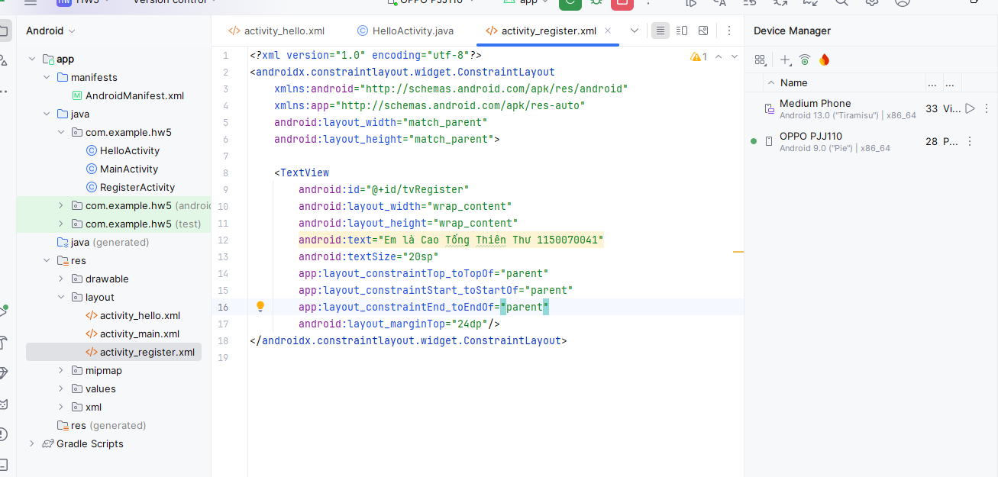

Sau đó bấm run để chạy ra giao diện

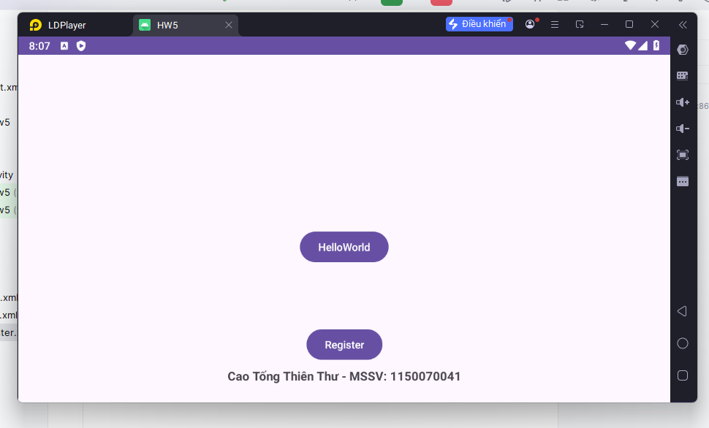

Sau khi click vào HelloWorld

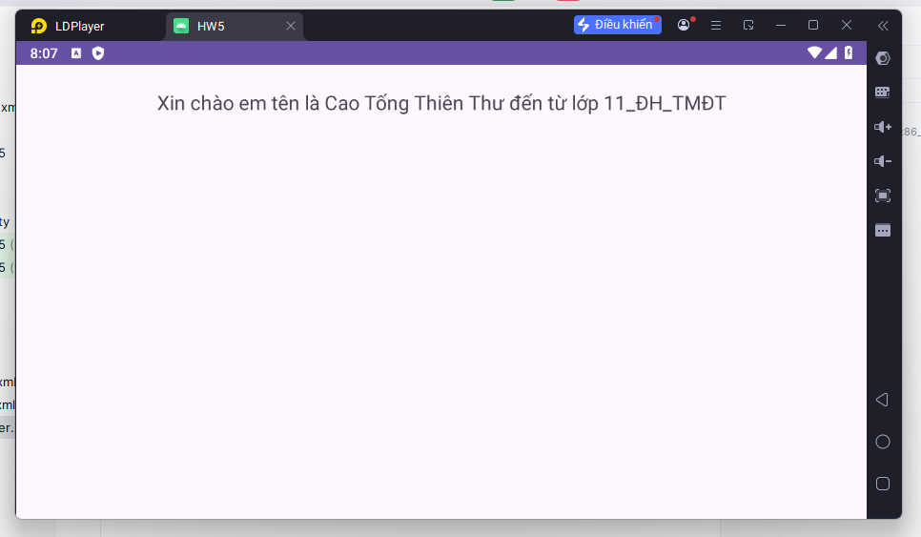

Sau khi click vào Register

