Họ tên: Cao Tống Thiên Thư

MSSV: 1150070041

Lớp: 11_ĐH_TMĐT

Bài tập lý thuyết 7

Tạo Project mới

Ở trong java/com/example/downloadmanagerlab7/ tạo file mới downloadserveice.java

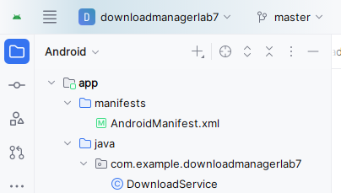

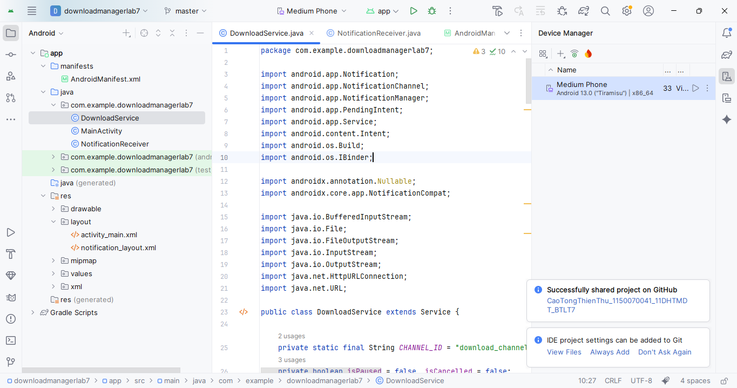

Trong đó viết

package com.example.downloadmanagerlab7;  
  
import android.app.Notification;  
import android.app.NotificationChannel;  
import android.app.NotificationManager;  
import android.app.PendingIntent;  
import android.app.Service;  
import android.content.Intent;  
import android.os.Build;  
import android.os.IBinder;  
  
import androidx.annotation.Nullable;  
import androidx.core.app.NotificationCompat;  
  
import java.io.BufferedInputStream;  
import java.io.File;  
import java.io.FileOutputStream;  
import java.io.InputStream;  
import java.io.OutputStream;  
import java.net.HttpURLConnection;  
import java.net.URL;  
  
public class DownloadService extends Service {  
  
 private static final String *CHANNEL_ID* = "download_channel";  
 private boolean isPaused = false, isCancelled = false;  
 private int progress = 0;  
 private final String fileName = "file_downloaded.bin";  
  
 @Override  
 public void onCreate() {  
 super.onCreate();  
 createNotificationChannel(); *// tạo channel trước khi startForeground* }  
  
 @Override  
 public int onStartCommand(Intent intent, int flags, int startId) {  
 if (intent.getAction() != null) {  
 handleAction(intent.getAction());  
 return *START_STICKY*;  
 }  
  
 String url = intent.getStringExtra("url");  
 if (url == null || url.isEmpty()) {  
 stopSelf();  
 return *START_NOT_STICKY*;  
 }  
  
 *// ⚙️ Tạo thông báo đầu tiên* Notification startNotification = buildNotification("Chuẩn bị tải...", 0);  
 startForeground(1, startNotification);  
  
 *// ⚙️ Chạy thread tải file* new Thread(() -> downloadFile(url)).start();  
  
 return *START_STICKY*;  
 }  
  
 private void downloadFile(String fileUrl) {  
 try {  
 URL url = new URL(fileUrl);  
 HttpURLConnection conn = (HttpURLConnection) url.openConnection();  
 conn.connect();  
  
 if (conn.getResponseCode() != HttpURLConnection.*HTTP_OK*) {  
 updateNotification("Lỗi kết nối server!", progress);  
 stopSelf();  
 return;  
 }  
  
 int length = conn.getContentLength();  
 InputStream in = new BufferedInputStream(conn.getInputStream());  
 File outFile = new File(getFilesDir(), fileName);  
 OutputStream out = new FileOutputStream(outFile);  
  
 byte[] buffer = new byte[4096];  
 int count;  
 long total = 0;  
 int lastProgress = 0;  
  
 while ((count = in.read(buffer)) != -1) {  
 if (isCancelled) break;  
 if (isPaused) {  
 Thread.*sleep*(300);  
 continue;  
 }  
  
 total += count;  
 out.write(buffer, 0, count);  
  
 *// Tính phần trăm tải* int newProgress = (int) (total * 100 / length);  
  
 *// ⚙️ Chỉ update khi tiến trình thay đổi ≥ 1%* if (newProgress - lastProgress >= 1) {  
 lastProgress = newProgress;  
 progress = newProgress;  
 updateNotification("Đang tải... (" + progress + "%)", progress);  
 }  
 }  
  
 out.flush();  
 out.close();  
 in.close();  
  
 if (!isCancelled) updateNotification("✅ Tải hoàn tất! (100%)", 100);  
 stopSelf();  
  
 } catch (Exception e) {  
 e.printStackTrace();  
 updateNotification("❌ Lỗi khi tải!", progress);  
 stopSelf();  
 }  
 }  
  
 *// 🔔 Xây Notification có progress bar & text %* private Notification buildNotification(String text, int progress) {  
 Intent pauseIntent = new Intent(this, NotificationReceiver.class).setAction("PAUSE");  
 Intent resumeIntent = new Intent(this, NotificationReceiver.class).setAction("RESUME");  
 Intent cancelIntent = new Intent(this, NotificationReceiver.class).setAction("CANCEL");  
  
 PendingIntent pPause = PendingIntent.*getBroadcast*(this, 0, pauseIntent, PendingIntent.*FLAG_IMMUTABLE*);  
 PendingIntent pResume = PendingIntent.*getBroadcast*(this, 1, resumeIntent, PendingIntent.*FLAG_IMMUTABLE*);  
 PendingIntent pCancel = PendingIntent.*getBroadcast*(this, 2, cancelIntent, PendingIntent.*FLAG_IMMUTABLE*);  
  
 return new NotificationCompat.Builder(this, *CHANNEL_ID*)  
 .setContentTitle("Download Manager")  
 .setContentText(text)  
 .setSmallIcon(android.R.drawable.*stat_sys_download*)  
 .setProgress(100, progress, false) *// ⚙️ thanh tiến trình* .addAction(android.R.drawable.*ic_media_pause*, "Pause", pPause)  
 .addAction(android.R.drawable.*ic_media_play*, "Resume", pResume)  
 .addAction(android.R.drawable.*ic_menu_close_clear_cancel*, "Cancel", pCancel)  
 .setOnlyAlertOnce(true) *// không rung mỗi lần update* .setOngoing(!text.contains("hoàn tất") && !text.contains("Lỗi") && !text.contains("hủy"))  
 .build();  
 }  
  
 *// 🔁 Cập nhật thông báo (hiển thị progress mới)* private void updateNotification(String text, int progress) {  
 NotificationManager nm = (NotificationManager) getSystemService(*NOTIFICATION_SERVICE*);  
 if (nm != null) nm.notify(1, buildNotification(text, progress));  
 }  
  
 *// 🔧 Tạo Notification Channel cho Android 8+* private void createNotificationChannel() {  
 if (Build.VERSION.*SDK_INT* >= Build.VERSION_CODES.*O*) {  
 NotificationChannel channel = new NotificationChannel(  
 *CHANNEL_ID*,  
 "Download Channel",  
 NotificationManager.*IMPORTANCE_LOW* );  
 channel.setDescription("Hiển thị tiến trình tải file");  
 NotificationManager manager = getSystemService(NotificationManager.class);  
 if (manager != null) manager.createNotificationChannel(channel);  
 }  
 }  
  
 *// ▶ Xử lý các nút Pause / Resume / Cancel* private void handleAction(String action) {  
 switch (action) {  
 case "PAUSE":  
 isPaused = true;  
 updateNotification("⏸️ Tạm dừng...", progress);  
 break;  
 case "RESUME":  
 isPaused = false;  
 updateNotification("▶️ Tiếp tục tải...", progress);  
 break;  
 case "CANCEL":  
 isCancelled = true;  
 updateNotification("🛑 Đã hủy tải!", progress);  
 stopSelf();  
 break;  
 }  
 }  
  
 @Nullable  
 @Override  
 public IBinder onBind(Intent intent) {  
 return null;  
 }  
}

trong MainActivity.java

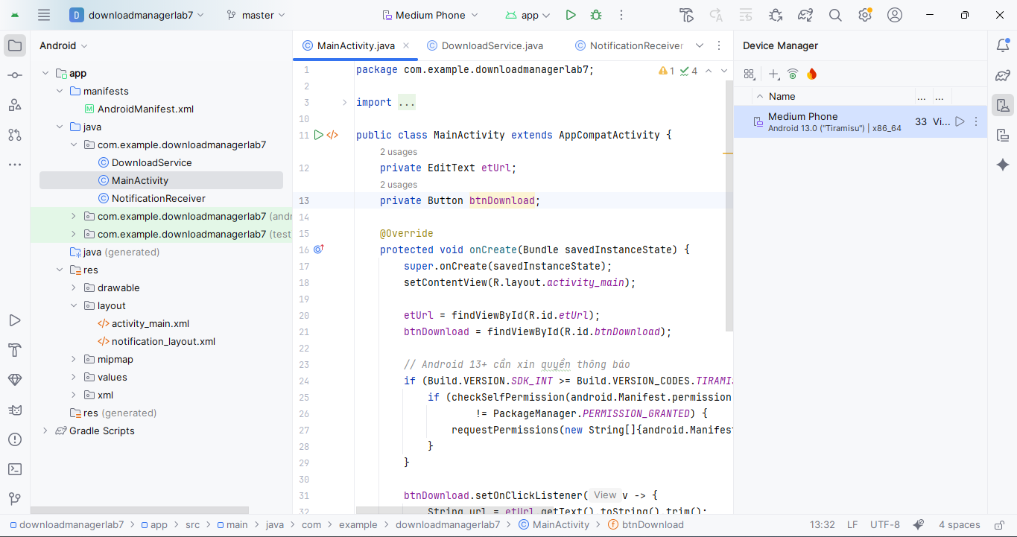

package com.example.downloadmanagerlab7;  
  
import androidx.appcompat.app.AppCompatActivity;  
import android.content.Intent;  
import android.content.pm.PackageManager;  
import android.os.Build;  
import android.os.Bundle;  
import android.widget.Button;  
import android.widget.EditText;  
  
public class MainActivity extends AppCompatActivity {  
 private EditText etUrl;  
 private Button btnDownload;  
  
 @Override  
 protected void onCreate(Bundle savedInstanceState) {  
 super.onCreate(savedInstanceState);  
 setContentView(R.layout.*activity_main*);  
  
 etUrl = findViewById(R.id.*etUrl*);  
 btnDownload = findViewById(R.id.*btnDownload*);  
  
 *// Android 13+ cần xin quyền thông báo* if (Build.VERSION.*SDK_INT* >= Build.VERSION_CODES.*TIRAMISU*) {  
 if (checkSelfPermission(android.Manifest.permission.*POST_NOTIFICATIONS*)  
 != PackageManager.*PERMISSION_GRANTED*) {  
 requestPermissions(new String[]{android.Manifest.permission.*POST_NOTIFICATIONS*}, 1);  
 }  
 }  
  
 btnDownload.setOnClickListener(v -> {  
 String url = etUrl.getText().toString().trim();  
 if (!url.isEmpty()) {  
 Intent i = new Intent(this, DownloadService.class);  
 i.putExtra("url", url);  
 *// Kiểm tra phiên bản để gọi đúng hàm* if (Build.VERSION.*SDK_INT* >= Build.VERSION_CODES.*O*) {  
 startForegroundService(i);  
 } else {  
 startService(i);  
 }  
 }  
 });  
 }  
}

Tạo file mới NotificationReceiver.java

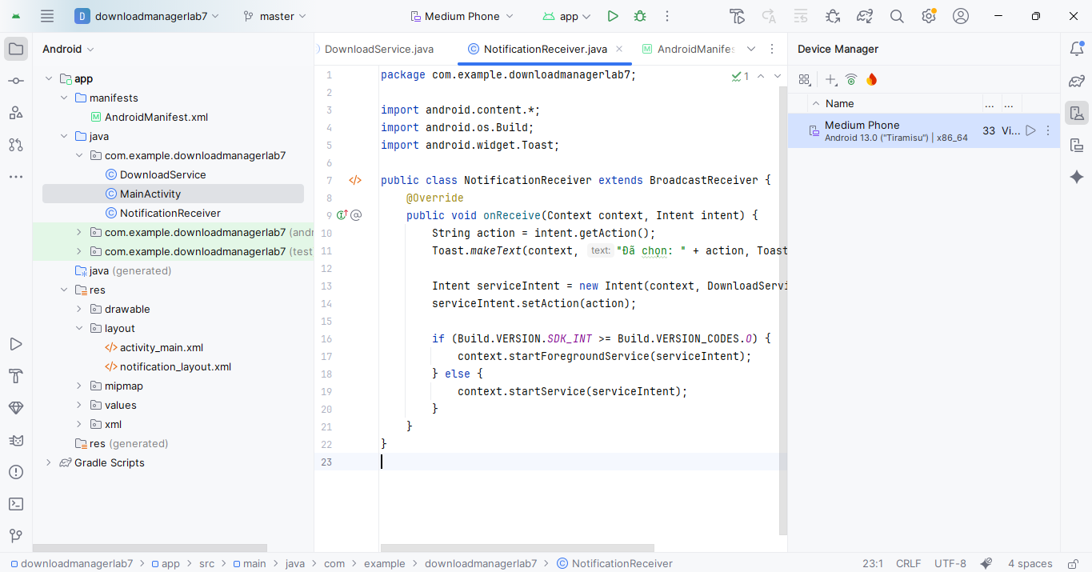

package com.example.downloadmanagerlab7;  
  
import android.content.*;  
import android.os.Build;  
import android.widget.Toast;  
  
public class NotificationReceiver extends BroadcastReceiver {  
 @Override  
 public void onReceive(Context context, Intent intent) {  
 String action = intent.getAction();  
 Toast.*makeText*(context, "Đã chọn: " + action, Toast.*LENGTH_SHORT*).show();  
  
 Intent serviceIntent = new Intent(context, DownloadService.class);  
 serviceIntent.setAction(action);  
  
 if (Build.VERSION.*SDK_INT* >= Build.VERSION_CODES.*O*) {  
 context.startForegroundService(serviceIntent);  
 } else {  
 context.startService(serviceIntent);  
 }  
 }  
}

trong res/layout/ ở activity_main.xml

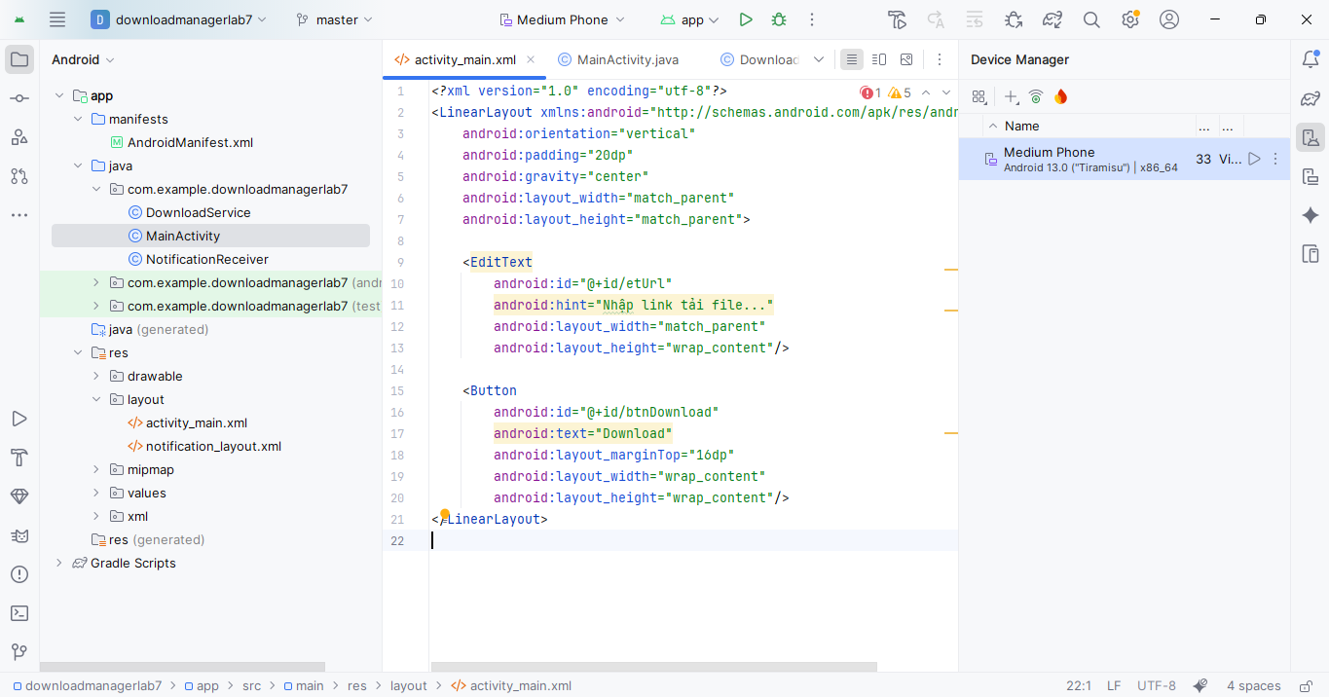

*<?*xml version="1.0" encoding="utf-8"*?>*<LinearLayout xmlns:android="http://schemas.android.com/apk/res/android"  
 android:orientation="vertical"  
 android:padding="20dp"  
 android:gravity="center"  
 android:layout_width="match_parent"  
 android:layout_height="match_parent">  
  
 <EditText  
 android:id="@+id/etUrl"  
 android:hint="Nhập link tải file..."  
 android:layout_width="match_parent"  
 android:layout_height="wrap_content"/>  
  
 <Button  
 android:id="@+id/btnDownload"  
 android:text="Download"  
 android:layout_marginTop="16dp"  
 android:layout_width="wrap_content"  
 android:layout_height="wrap_content"/>  
</LinearLayout>

Tạo file mới notification_layout.xml

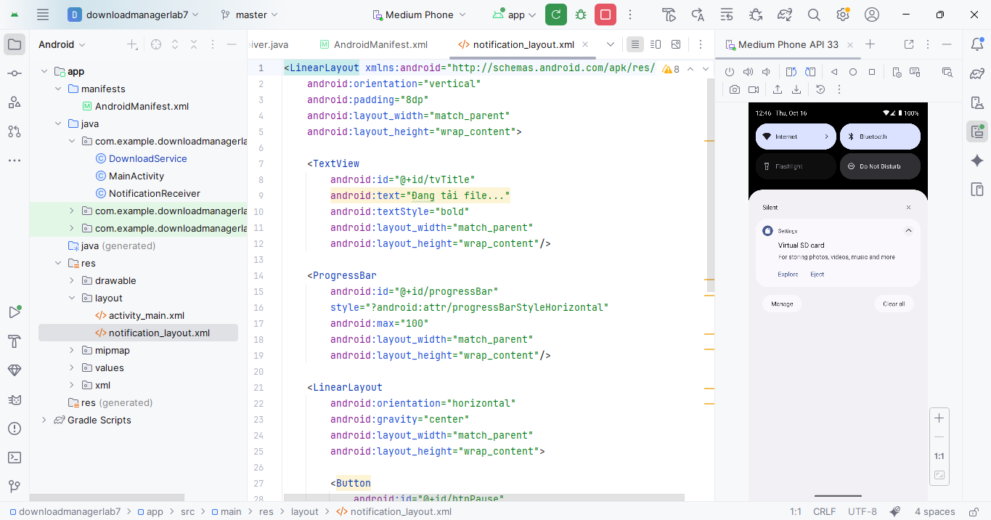

<LinearLayout xmlns:android="http://schemas.android.com/apk/res/android"  
 android:orientation="vertical"  
 android:padding="8dp"  
 android:layout_width="match_parent"  
 android:layout_height="wrap_content">  
  
 <TextView  
 android:id="@+id/tvTitle"  
 android:text="Đang tải file..."  
 android:textStyle="bold"  
 android:layout_width="match_parent"  
 android:layout_height="wrap_content"/>  
  
 <ProgressBar  
 android:id="@+id/progressBar"  
 style="?android:attr/progressBarStyleHorizontal"  
 android:max="100"  
 android:layout_width="match_parent"  
 android:layout_height="wrap_content"/>  
  
 <LinearLayout  
 android:orientation="horizontal"  
 android:gravity="center"  
 android:layout_width="match_parent"  
 android:layout_height="wrap_content">  
  
 <Button  
 android:id="@+id/btnPause"  
 android:text="Pause"  
 android:layout_width="wrap_content"  
 android:layout_height="wrap_content"  
 android:layout_margin="4dp"/>  
  
 <Button  
 android:id="@+id/btnResume"  
 android:text="Resume"  
 android:layout_width="wrap_content"  
 android:layout_height="wrap_content"  
 android:layout_margin="4dp"/>  
  
 <Button  
 android:id="@+id/btnCancel"  
 android:text="Cancel"  
 android:layout_width="wrap_content"  
 android:layout_height="wrap_content"  
 android:layout_margin="4dp"/>  
 </LinearLayout>  
</LinearLayout>

Sau đó bấm Run để chạy

Sẽ chạy ra giao diện đầu tiên

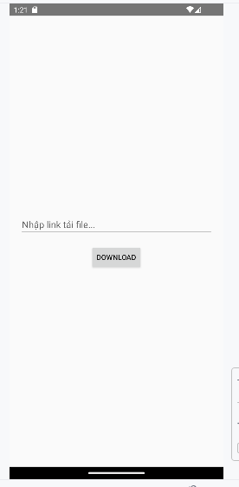

Sau đó đưa 1 link nào đó để tải

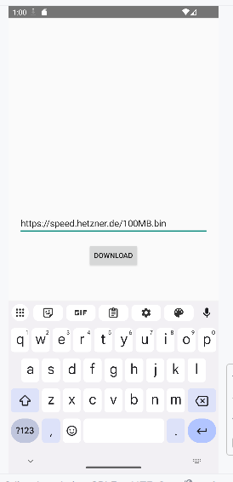

Bấm Download và vuốt từ trên xuống

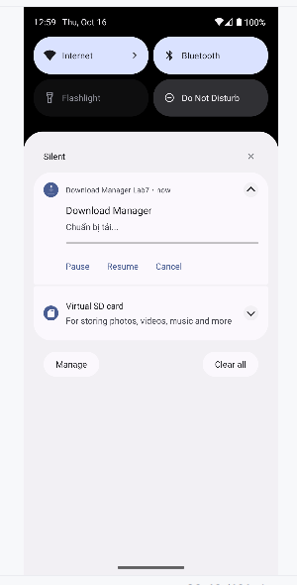

Nếu chọn Pause để tạm dừng tải

