1. **Here is the excel file about Q&A to make clear for requirements of a Ticket Vendor Machine:**

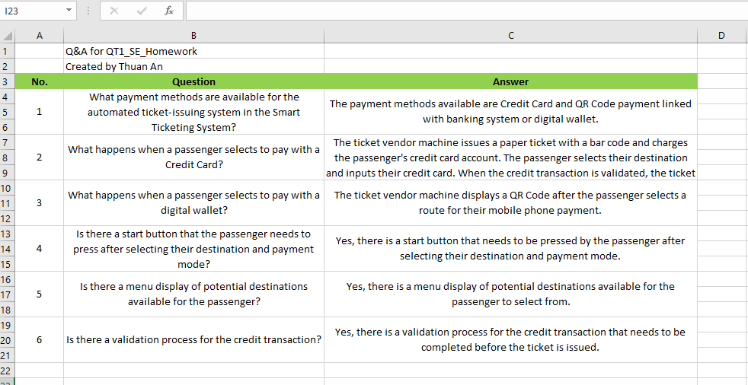

1. **A set of functional, non-functional, and domain requirements for a Ticket Vendor Machine:**

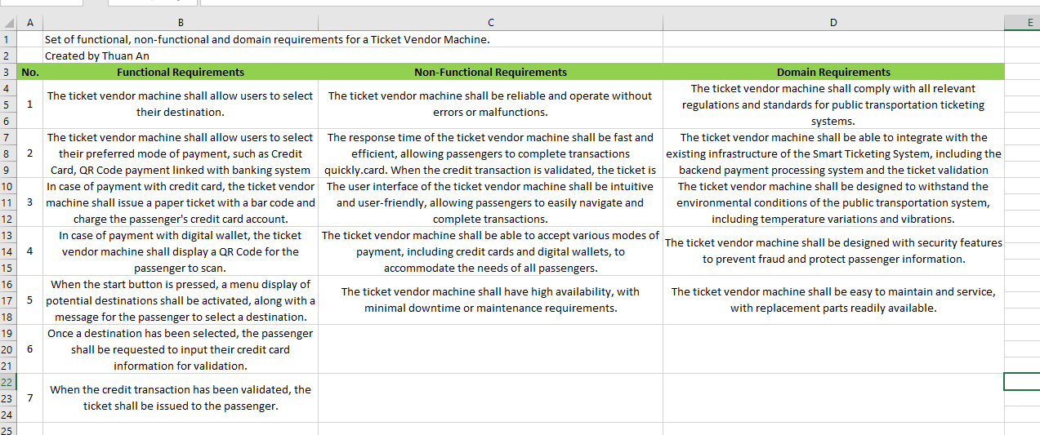

1. **Use Case Diagram:**

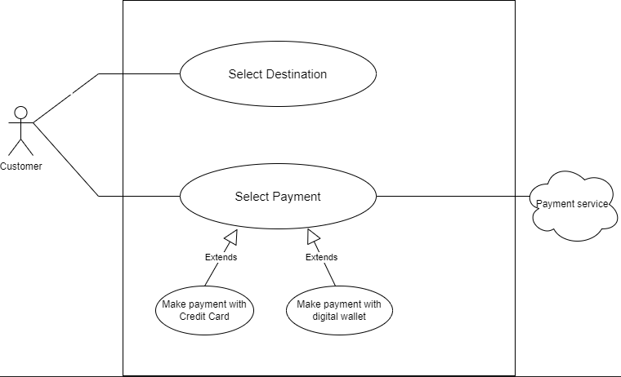

Use Case Descriptions:

Select Destination:

* Actors: User
* Description: The user selects their desired destination from a menu display.
* Preconditions: The Ticket Vendor Machine is turned on and has loaded the menu of potential destinations.
* Postconditions: The selected destination is stored in the system and displayed on the ticket.

Payment

* Actors: User, Ticket Vendor Machine
* Description: The user selects a mode of payment for their selected transportation option.
* Pre-conditions: The machine is on and operational, and the user has selected their desired transportation option and mode of payment.
* Post-conditions: The machine processes the payment and issues a ticket to the user.

1. **Use case: Buy a ticket activity diagram:**

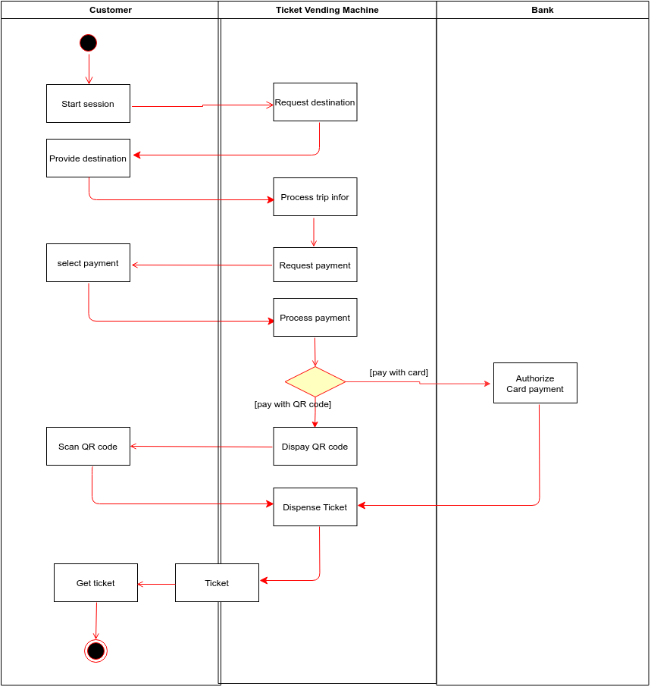

Activity diagram among systems (Ticket vending machine and online payment services):

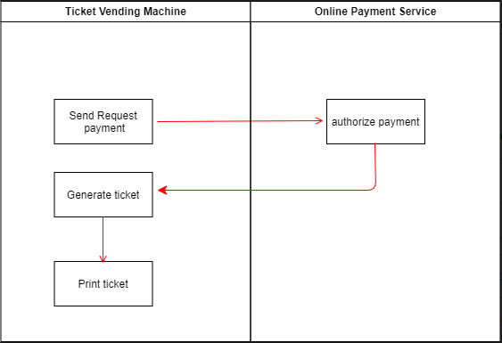

1. **Sequence diagram, State chart diagram, and Class diagram**

Use case: Buy a ticket Sequence Diagram:

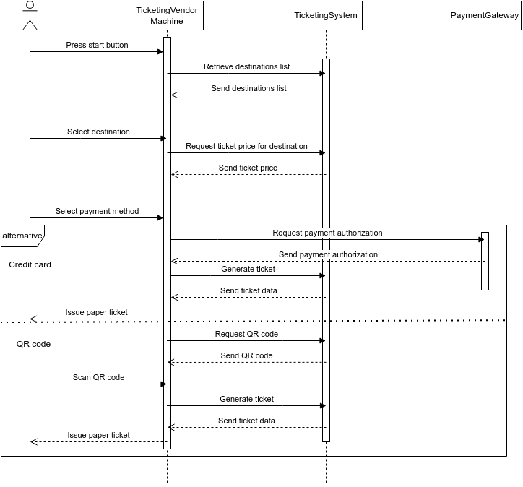

Use case: Buy a ticket Class Diagram:

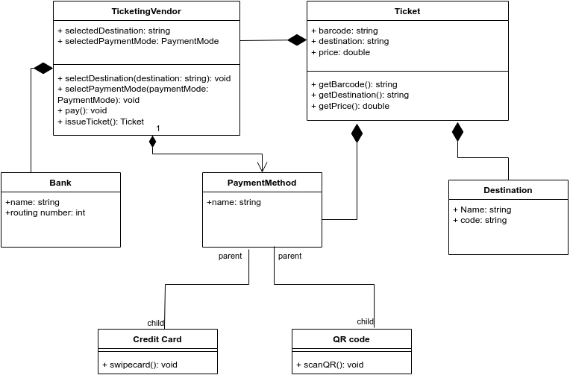

Use case: Buy a ticket State transition diagram:

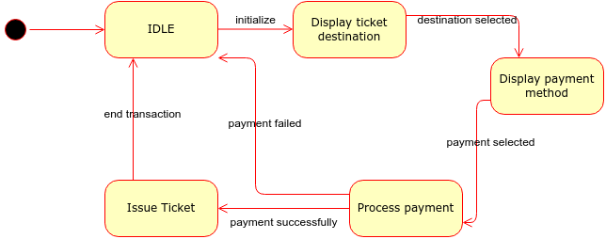

1. **Architecture design and Deployment diagram for Ticket Vendor Machine**

MVC model for Ticket Vendor Machine:

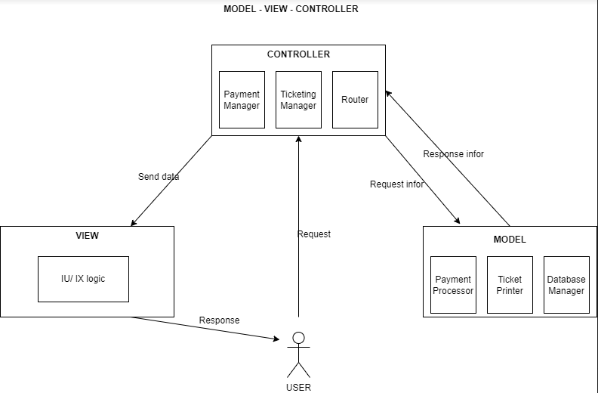

Deployment Diagram for Ticket Vendor Machine:

