----Part 1 (Fresh HTML)
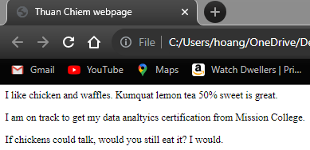

-----Part 2 (Some work done)
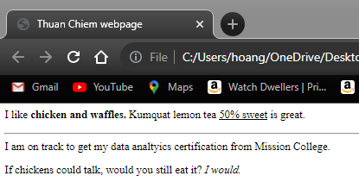

-----Part 3
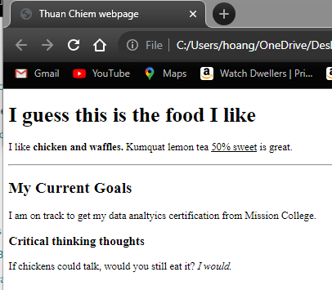

----PART 4
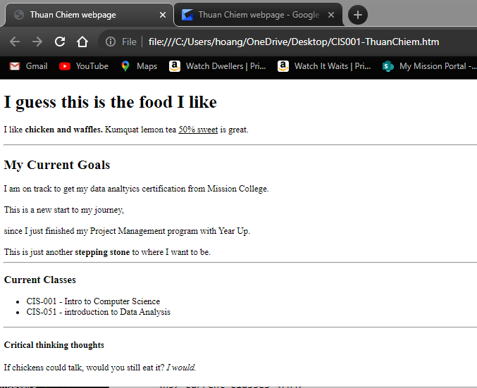

What went in my notepad: Code provided below
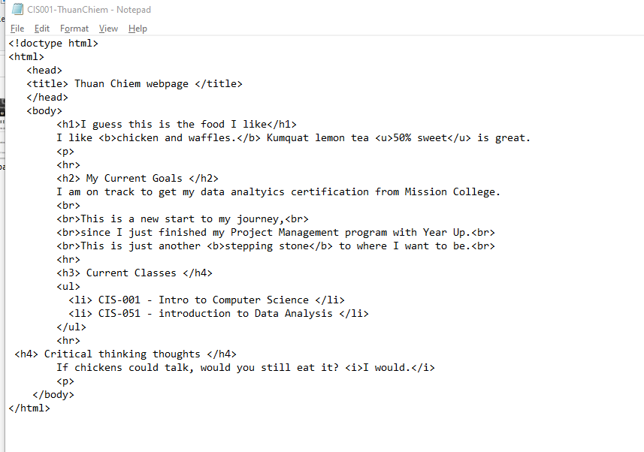
<!doctype html>
<html>
<head>
<title> Thuan Chiem webpage </title>
</head>
<body>
<h1>I guess this is the food I like</h1>
I like <b>chicken and waffles.</b> Kumquat lemon tea <u>50% sweet</u> is great.
<p>
<hr>
<h2> My Current Goals </h2>
I am on track to get my data analtyics certification from Mission College.
<br>
<br>This is a new start to my journey,<br>
<br>since I just finished my Project Management program with Year Up.<br>
<br>This is just another <b>stepping stone</b> to where I want to be.<br>
<hr>
<h3> Current Classes </h4>
<ul>
<li> CIS-001 - Intro to Computer Science </li>
<li> CIS-051 - introduction to Data Analysis </li>
</ul>
<hr>
<h4> Critical thinking thoughts </h4>
If chickens could talk, would you still eat it? <i>I would.</i>
<p>
</body>
</html>

