

<Criminal Management>

Documentation

|  |  |
| --- | --- |
| Authors | C2209I - Group 1 |
| 1.Đặng Đình Thuận  2. Lê Tiến Tài  3. Phạm Doãn Toàn  4. Lê Thành Đạt  5. Nguyễn Quang Dũng |
| Date | 18/09/2023 |
| Intructor | Trần Văn Điệp |

* Hà Nội, 2023 -

Index

B

Boundaries of the System

C

Customer Requirements Specification

D

Database Design

E

Entity Relationship Diagram

H

Hardware and Software Requirements

P

Problem Abstraction

Problem Definition:

S

**Sitemap**

System Designs

System function

T

**Task sheet**

The Current System

The Proposes Sytem

U

Users of the System

V

**Validation Checklists**

1. **Problem Definition**:
   1. *Problem Abstraction*

- With population growth in modern society, prisons constantly have to admit more prisoners and have to manage a lot of criminal records. To help complete the job more efficiently and accurately, we decided to build a Criminal Records Management software to provide to prisons.

- The software helps you easily add case records, prisoner records and necessary searches and statistics to make your work easier.

* 1. *The Current System*
* Application that allows administrators to manage criminal in the prison.

+ The interface on the Application home page will display basic information about the case file of prison.

+ The toolbar on the left allows managers to edit information as desired.

* 1. *The Proposes System*

- The purpose is to help managers add, edit, delete case and criminal :

* Edit information.
* Add and edit new case, criminal.
* Log out.

1.3.1 Boundaries of the System

Only allows administrators to edit case and track criminal information.

1.3.2 Hardware and Software Requirements

Hardware:

* A minimum computer system that will help you access all the tools in the courses is a intel core i5 or better
* 8GB of RAM or better

Software:

* Apache NetBeans IDE
* MySQL Work Bench
* Fork
* SceneBuilder

**2**. **Customer Requirements Specification**

*2.1* *Users of the System*

The software is only used for criminal management.

Admin:

* Case file management.
* Information management criminal.

*2.2* *System function*:

* Admin:
  + Case file

|  |  |
| --- | --- |
| Input | Select a case file to display items. |
| Process | Access the data to get information at the table |
| Output | Displays case file id, number of criminal, type of case. |

* + Add case file

|  |  |
| --- | --- |
| Input | Enter information for case file |
| Process | Validate and insert new record into the database |
| Output | Display the case file table again |

* + Update case file

|  |  |
| --- | --- |
| Input | Select a case file to update |
| Process | Validate and update database |
| Output | Display the case file table again |

* + Delete case file

|  |  |
| --- | --- |
| Input | Select a case file to update |
| Process | Delete the record in the database. |
| Output | Display the case file table again |

* + Criminal file

|  |  |
| --- | --- |
| Input | Select a criminal to display items. |
| Process | Access the data to get information at the table |
| Output | Displays identify, information about criminal |

* + Add criminal file

|  |  |
| --- | --- |
| Input | Enter information for criminal file |
| Process | Validate and insert new record into the database |
| Output | Display the criminal file table again |

* + Update criminal file

|  |  |
| --- | --- |
| Input | Select a criminal file to update |
| Process | Validate and update database |
| Output | Display the criminal file table again |

* + Delete case file

|  |  |
| --- | --- |
| Input | Select a case file to update |
| Process | Delete the record in the database |
| Output | Display the case file table again |

1. **System Designs**
   1. *Entity Relationship Diagram*

* Entity-relationship
* Entity-relationship of tables in product

Admin

Case file

Has_crime

Criminal file

* 1. *Database Design*
* Table relationship

The relationship between the tables in the database is represented through a diagram:

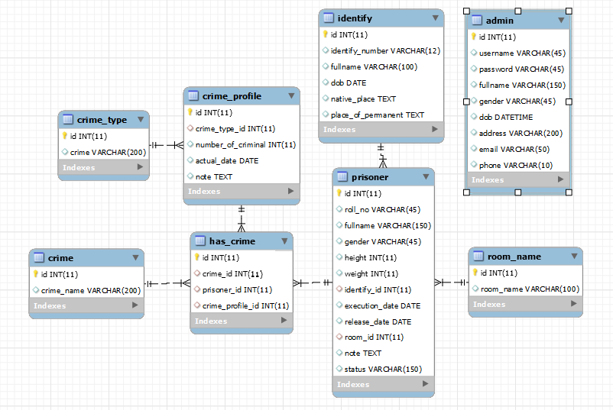

**Image 3: Table Relationship**

* **Table detail**
* **Prisoner**

|  |  |  |  |
| --- | --- | --- | --- |
| **Column** | **Data type** | **Constraint** | **Description** |
| **id** | **INT** | **Primary Key** | **Prisoner id** |
| **roll_no** | **VARCHAR(45)** |  | **Roll Number** |
| **fullname** | **VARCHAR(150)** |  | **Full name** |
| **gender** | **VARCHAR(45)** |  | **Gender** |
| **height** | **INT** |  | **Height** |
| **weight** | **INT** |  | **Weight** |
| **identify_id** | **INT** | **Foreign Key** | **identify.id** |
| **execution_date** | **DATE** |  | **Execution date** |
| **release_date** | **DATE** |  | **Release date** |
| **room_id** | **INT** | **Foreign Key** | **room_name.id** |
| **note** | **TEXT** |  | **Note** |
| **status** | **VARCHAR(150)** |  | **Status** |

* **Identify**

|  |  |  |  |
| --- | --- | --- | --- |
| **Column** | **Data type** | **Constraint** | **Description** |
| **id** | **INT** | **Primary Key** | **Identify id** |
| **identify_number** | **VARCHAR(45)** |  | **Identify number** |
| **fullname** | **VARCHAR(150)** |  | **Full name** |
| **dob** | **VARCHAR(45)** |  | **Date of Birth** |
| **native_place** | **INT** |  | **Native place** |
| **place_of_permanent** | **INT** |  | **Place of permanent** |

* **room_name**

|  |  |  |  |
| --- | --- | --- | --- |
| **Column** | **Data type** | **Constraint** | **Description** |
| **Id** | **INT** | **Primary Key** | **Room name id** |
| **room_name** | **VARCHAR(100)** |  | **room_name** |

* **crime**

|  |  |  |  |
| --- | --- | --- | --- |
| **Column** | **Data type** | **Constraint** | **Description** |
| **Id** | **INT** | **Primary Key** | **Crime id** |
| **crime_name** | **VARCHAR(200)** |  | **Crime name** |

* **crime_type**

|  |  |  |  |
| --- | --- | --- | --- |
| **Column** | **Data type** | **Constraint** | **Description** |
| **Id** | **INT** | **Primary Key** | **Crime id** |
| **crime** | **VARCHAR(200)** |  | **Crime name** |

* **crime_profile**

|  |  |  |  |
| --- | --- | --- | --- |
| **Column** | **Data type** | **Constraint** | **Description** |
| **id** | **INT** | **Primary Key** | **Crime profile id** |
| **crime_type_id** | **INT** | **Foreign Key** | **crime_type.id** |
| **number_of_criminal** | **INT** |  | **Number of criminal** |
| **actual_date** | **DATE** |  | **Actual date** |
| **note** | **TEXT** |  | **Note** |

* **has_crime**

|  |  |  |  |
| --- | --- | --- | --- |
| **Column** | **Data type** | **Constraint** | **Description** |
| **id** | **INT** | **Primary Key** | **Crime profile id** |
| **crime_id** | **INT** | **Foreign Key** | **crime_type.id** |
| **prisoner_id** | **INT** | **Foreign Key** | **prisoner.id** |
| **crime_profile_id** | **INT** | **Foreign Key** | **crime_profile.id** |

* **admin**

|  |  |  |  |
| --- | --- | --- | --- |
| **Column** | **Data type** | **Constraint** | **Description** |
| **Id** | **INT** | **Primary Key** | **Admin id** |
| **username** | **VARCHAR(45)** |  | **Username** |
| **password** | **VARCHAR(45)** |  | **Password** |
| **fullname** | **VARCHAR(150)** |  | **Full name** |
| **gender** | **VARCHAR(45)** |  | **Gender** |
| **dob** | **DATE** |  | **Date of birth** |
| **email** | **VARCHAR(50)** |  | **Email** |
| **address** | **VARCHAR(200)** |  | **Address** |
| **phone** | **VARCHAR(10)** |  | **Phone** |

* 1. *Sitemap*

Case file

Image 4: Site map

* 1. System functions design
* Admin interface
* Home

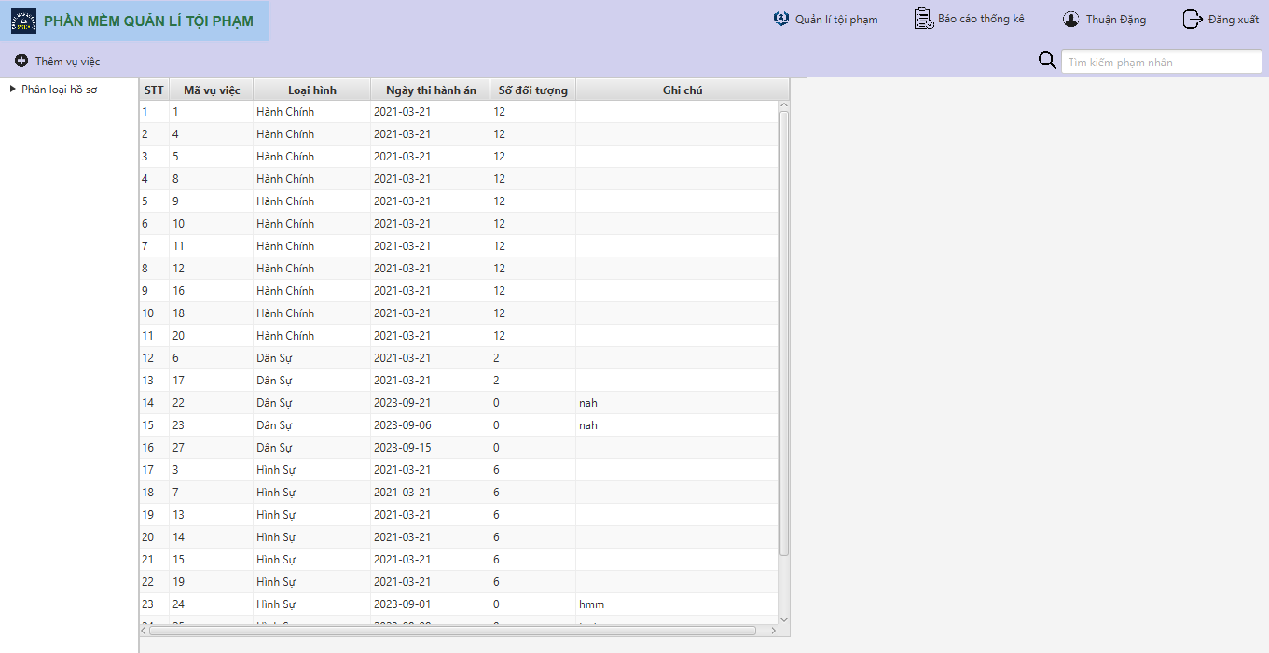

* Add & update case file list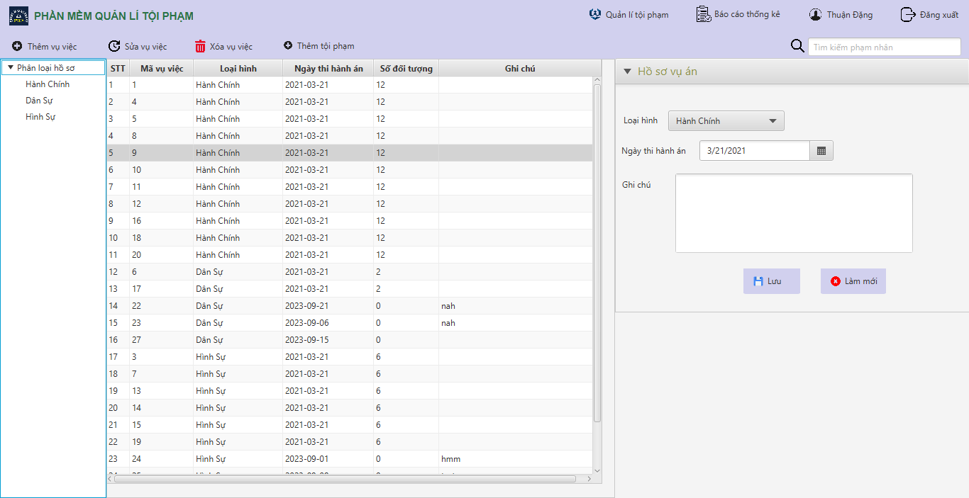
* Criminal file list

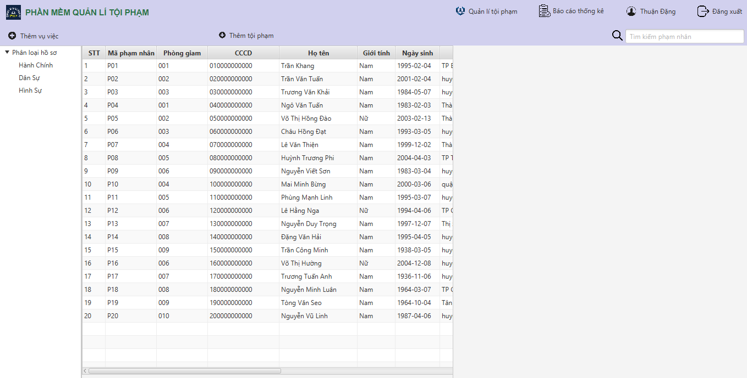

* Add & update criminal file

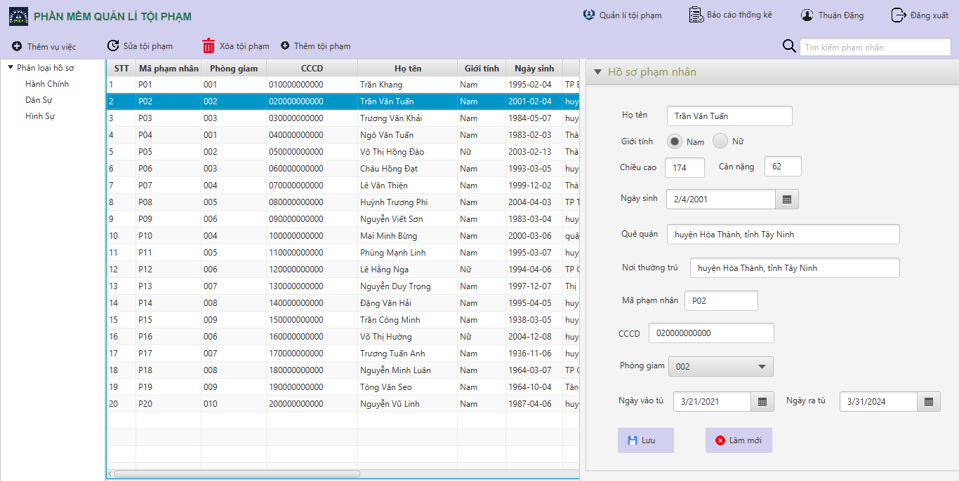

* Statistic list

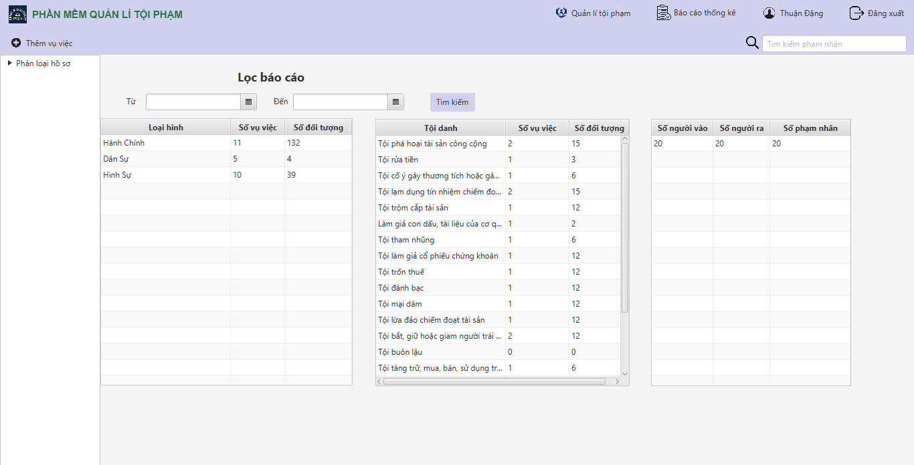

* Login

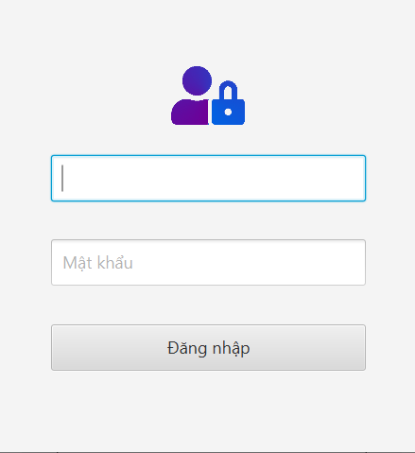

* Algorithm
* Rules for drawing diagram handling of business prodcedures

|  |  |
| --- | --- |
|  | Steps to take |
|  | Check/Approve/Decide |
|  | Begin |
|  | End |

1. Admin/Manager

* Login

This process occurs when the administrator logs in to the application

|  |  |  |
| --- | --- | --- |
| User Login | | |
|  | Admin | BackEnd |
| Fail  Correct  Home Page  Error message  Valid login information  Fill in your login information  Login | Check login information |

* Describe the steps in the business process

|  |  |  |  |
| --- | --- | --- | --- |
| Step code | Step name | Group of people | Describe |
| 1 | The manager chooses to log in | Admin | When the administrator logs in to the system management library |
| 2 | Fill in your account information | Admin | The account information includes:   * Username * Password |
| 3 | Error message | System | Display an error message to the user when one of the two pieces of information is missing |
| 4 | Check login information | System | The system checks the validity of the information |
| 5 | Error message | System | Display an error message the user when the login credentials check fails |
| 6 | Follow the next procedure | System |  |

* List case file function

|  |  |
| --- | --- |
| List case file | |
| FrontEnd | BackEnd |
| Display case file list  Click on home page | Select information section |

* Describe the steps in the business process

|  |  |  |  |
| --- | --- | --- | --- |
| Step code | Step name | Group of people | Describe |
| 1 | Click on home page | Admin |  |
| 2 | Display case file list | Admin | See information of item |

* Add case file

|  |  |
| --- | --- |
| Adding new event | |
| Admin | BackEnd |
| Fill case file form  Successfully post  Fail show error message  Posting information  Submit after filling informations  Click add case file | Insert information  Show add case file form |

* Describe the step in business process

|  |  |  |  |
| --- | --- | --- | --- |
| Step code | Step name | Group of people | Describe |
| 1 | Click add case file | Admin |  |
| 2 | Fill in the information | Admin | Fill in form |
| 3 | Send information | System |  |
| 3.1 | Error message | System | If the upload process fails |
| 4 | Successful message | System | If the new event is successfully posted and insert new record in database |

* Edit case file

|  |  |
| --- | --- |
| Adding new event | |
| Admin | BackEnd |
| Click edit button  Click case file record  Fill case file form  Successfully post  Fail show error message  Posting information  Submit after filling informations | Update information  Show edit case file form |

* Describe the step in business process

|  |  |  |  |
| --- | --- | --- | --- |
| Step code | Step name | Group of people | Describe |
| 1 | Click case file record | Admin |  |
| 2 | Fill in the information | Admin | Fill in form |
| 3 | Send information | System |  |
| 3.1 | Error message | System | If the upload process fails |
| 4 | Successful message | System | If the new event is successfully posted and update information in record selected. |

* Delete case file

|  |  |
| --- | --- |
| Delete event | |
| Admin | BackEnd |
| Click case file record  Click delete  Remove successfully | Remove case file from database |

* Describe the steps in the business process

|  |  |  |  |
| --- | --- | --- | --- |
| Step code | Step name | Group of people | Describe |
| 1 | Select case file record want to delete | Admin |  |
| 2 | Remove record from database | System |  |
| 3 | Remove successfully | System |  |
| 4 | Return to case file list | System | Show updated list of event |

* Add criminal into case file

|  |  |
| --- | --- |
| Adding new event | |
| Admin | BackEnd |
| Fill add criminal form  Click add criminal button  Click case file record  Successfully post  Fail show error message  Posting information  Submit after filling informations | Show add criminal into case file form  Insert information |

* Describe the step in business process

|  |  |  |  |
| --- | --- | --- | --- |
| Step code | Step name | Group of people | Describe |
| 1 | Click case file record | Admin |  |
| 2 | Fill in the information | Admin | Fill in form |
| 3 | Send information | System |  |
| 3.1 | Error message | System | If the upload process fails |
| 4 | Successful message | System | If the new event is successfully posted and insert new record in database |

* List criminal file function

|  |  |
| --- | --- |
| List crimial file | |
| FrontEnd | BackEnd |
| Display criminal file list  Click on criminal page | Select information section |

* Describe the steps in the business process

|  |  |  |  |
| --- | --- | --- | --- |
| Step code | Step name | Group of people | Describe |
| 1 | Click on criminal file page | Admin |  |
| 2 | Display criminal file list | Admin | See information of item |

* Add criminal file

|  |  |
| --- | --- |
| Adding new event | |
| Admin | BackEnd |
| Fill crimianl file form  Click add criminal file  Successfully post  Fail show error message  Posting information  Submit after filling informations | Insert information  Show add case file form |

* Describe the step in business process

|  |  |  |  |
| --- | --- | --- | --- |
| Step code | Step name | Group of people | Describe |
| 1 | Click add criminal file | Admin |  |
| 2 | Fill in the information | Admin | Fill in form |
| 3 | Send information | System |  |
| 3.1 | Error message | System | If the upload process fails |
| 4 | Successful message | System | If the new event is successfully posted and insert new record in database |

* Edit criminal file

|  |  |
| --- | --- |
| Adding new event | |
| Admin | BackEnd |
| Fill criminal file form  Click edit button  Click criminal file record  Successfully post  Fail show error message  Posting information  Submit after filling informations | Show edit criminal file form  Update information |

* Describe the step in business process

|  |  |  |  |
| --- | --- | --- | --- |
| Step code | Step name | Group of people | Describe |
| 1 | Click criminal file record | Admin |  |
| 2 | Fill in the information | Admin | Fill in form |
| 3 | Send information | System |  |
| 3.1 | Error message | System | If the upload process fails |
| 4 | Successful message | System | If the new event is successfully posted and update information in record selected. |

* Delete case file

|  |  |
| --- | --- |
| Delete event | |
| Admin | BackEnd |
| Click criminal file record  Click delete  Remove successfully | Remove criminal file from database |

* Describe the steps in the business process

|  |  |  |  |
| --- | --- | --- | --- |
| Step code | Step name | Group of people | Describe |
| 1 | Select crimianl file record want to delete | Admin |  |
| 2 | Remove record from database | System |  |
| 3 | Remove successfully | System |  |
| 4 | Return to case file list | System | Show updated list of event |

* List statistic function

|  |  |
| --- | --- |
| List statistic | |
| FrontEnd | BackEnd |
| Display statistic list  Click on statistic page | Select information section |

* Describe the steps in the business process

|  |  |  |  |
| --- | --- | --- | --- |
| Step code | Step name | Group of people | Describe |
| 1 | Click on statistic page | Admin |  |
| 2 | Display statistic list | Admin | See information of item |

* Log out

|  |  |
| --- | --- |
| Log out | |
|  | Admin |
| Success  Exit back to the home page  Fail  Error message  Logout success  Logout |

* Describe the steps in the logout

|  |  |  |  |
| --- | --- | --- | --- |
| Step code | Step name | Group of people | Describe |
| 1 | Option to log out of the system | Admin |  |
| 2 | Proceed to log out users from the system | System |  |
| 3 | Successfully logged out of the system | System |  |

1. **Task sheet:**

|  |  |  |  |  |
| --- | --- | --- | --- | --- |
| Task | Start time | Finish time | Implemented by | Evaluation  (%) |
| ***Feasibility study phase*** | | | | |
| Create memo | 14/08/2023 | 16/08/2023 | Dang Dinh Thuan | 20 |
| Create opinions | 14/08/2023 | 16/08/2023 | Le Tien Tai | 20 |
| Create opinions | 14/08/2023 | 16/08/2023 | Pham Doan Toan | 20 |
| Create opinions | 14/08/2023 | 16/08/2023 | Le Thanh Dat | 20 |
| Create opinions | 14/08/2023 | 16/08/2023 | Nguyen Quang Dung | 20 |
| ***Requirement Analysis phase*** | | | | |
| Create memo | 14/08/2023 | 16/08/2023 | Dang Dinh Thuan | 20 |
| Create opinions | 14/08/2023 | 16/08/2023 | Le Tien Tai | 20 |
| Create opinions | 14/08/2023 | 16/08/2023 | Pham Doan Toan | 20 |
| Create opinions | 14/08/2023 | 16/08/2023 | Le Thanh Dat | 20 |
| Create opinions | 14/08/2023 | 16/08/2023 | Nguyen Quang Dung | 20 |
| ***Development phase*** | | | | |
| BA- Create Database | 14/08/2023 | 16/08/2023 | Dang Dinh Thuan | 10 |
| FE + BE Home Page | 17/08/2023 | 26/08/2023 | Le Tien Tai  Le Thanh Dat  Nguyen Quang Dung | 20 |
| FE + BE Login | 17/08/2023 | 26/08/2023 | Nguyen Quang Dung  Le Thanh Dat | 10 |
| FE + BE Case file | 17/08/2023 | 26/08/2023 | Dang Dinh Thuan  Pham Doan Toan  Nguyen Quang Dung | 20 |
| FE + BE Criminal file | 17/08/2023 | 26/08/2023 | Le Tien Tai  Pham Doan Toan  Le Thanh Dat | 20 |
| FE + BE Statistic | 17/08/2023 | 26/08/2023 | Pham Doan Toan  Le Tien Tai  Dang Dinh Thuan | 20 |
| ***Testing phase*** | | | | |
| FE- fix case file page | 27/08/2023 | 08/09/2023 | Pham Doan Toan  Le Thanh Dat | 25 |
| BE- fix criminal file logic | 27/08/2023 | 08/09/2023 | Le Tien Tai  Le Thanh Dat | 25 |
| FE- fix login page | 27/08/2023 | 08/09/2023 | Pham Doan Toan  Nguyen Quang Dung | 25 |
| FE- Complete web layout | 27/08/2023 | 08/09/2023 | Le Thanh Dat  Nguyen Quang Dung  Dang Dinh Thuan | 25 |
| ***Deployment phase*** | | | | |
| BE- Submit Source code | 09/09/2023 | 12/09/2023 | Dang Dinh Thuan | 15 |
| BA- Submit project doc and Slide | 09/09/2023 | 12/09/2023 | Le Tien Tai  Pham Doan Toan  Nguyen Quang Dung  Le Thanh Dat | 70 |
| Be- Submit Task Sheet | 09/09/2023 | 12/09/2023 | Dang Dinh Thuan | 15 |

1. **Validation Checklists**:

|  |  |
| --- | --- |
| Option | Validated |
| Do all image links lead to the appropriate App? | Yes |
| Are all the images and link visible on the page? | Yes |
| Is the App page taking too long to load? | Yes |
| All form has been validated? | Yes |