EX1-slot3

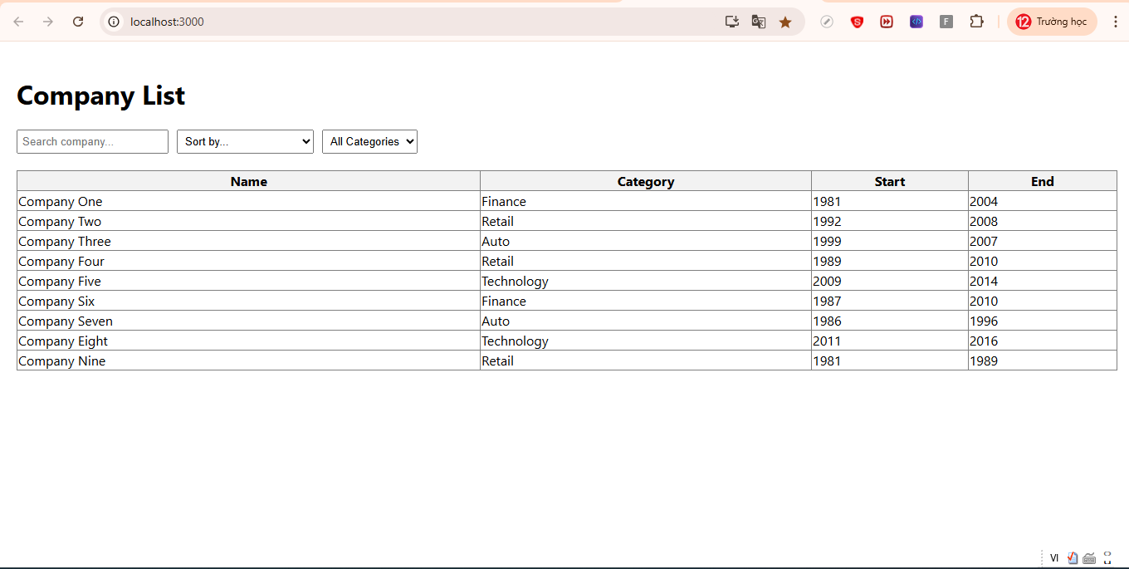
import React, { useState } from "react";

const companies = [
{ name: "Company One", category: "Finance", start: 1981, end: 2004 },
{ name: "Company Two", category: "Retail", start: 1992, end: 2008 },
{ name: "Company Three", category: "Auto", start: 1999, end: 2007 },
{ name: "Company Four", category: "Retail", start: 1989, end: 2010 },
{ name: "Company Five", category: "Technology", start: 2009, end: 2014 },
{ name: "Company Six", category: "Finance", start: 1987, end: 2010 },
{ name: "Company Seven", category: "Auto", start: 1986, end: 1996 },
{ name: "Company Eight", category: "Technology", start: 2011, end: 2016 },
{ name: "Company Nine", category: "Retail", start: 1981, end: 1989 }
];

function App() {
const [search, setSearch] = useState("");
const [sortOption, setSortOption] = useState("");
const [categoryFilter, setCategoryFilter] = useState("");

const filteredCompanies = companies
.filter((c) => c.name.toLowerCase().includes(search.toLowerCase()))
.filter((c) => (categoryFilter ? c.category === categoryFilter : true))
.sort((a, b) => {
if (sortOption === "yearAsc") return a.start - b.start;
if (sortOption === "yearDesc") return b.start - a.start;
if (sortOption === "startEnd")
return (a.end - a.start) - (b.end - b.start);
return 0;
});

return (
<div style={{ padding: "20px" }}>
<h1>Company List</h1>

<input
type="text"
placeholder="Search company..."
value={search}
onChange={(e) => setSearch(e.target.value)}
style={{ marginRight: "10px", padding: "5px" }}
/>

<select
value={sortOption}
onChange={(e) => setSortOption(e.target.value)}
style={{ marginRight: "10px", padding: "5px" }}
>
<option value="">Sort by...</option>
<option value="yearAsc">Start Year Ascending</option>
<option value="yearDesc">Start Year Descending</option>
<option value="startEnd">Start-End Range</option>
</select>

<select
value={categoryFilter}
onChange={(e) => setCategoryFilter(e.target.value)}
style={{ padding: "5px" }}
>
<option value="">All Categories</option>
<option value="Finance">Finance</option>
<option value="Retail">Retail</option>
<option value="Auto">Auto</option>
<option value="Technology">Technology</option>
</select>

{filteredCompanies.length > 0 ? (
<table
border="1"
style={{
marginTop: "20px",
borderCollapse: "collapse",
width: "100%"
}}
>
<thead>
<tr style={{ backgroundColor: "#f2f2f2" }}>
<th>Name</th>
<th>Category</th>
<th>Start</th>
<th>End</th>
</tr>
</thead>
<tbody>
{filteredCompanies.map((company, index) => (
<tr key={index}>
<td>{company.name}</td>
<td>{company.category}</td>
<td>{company.start}</td>
<td>{company.end}</td>
</tr>
))}
</tbody>
</table>
) : (
<p style={{ marginTop: "20px", color: "red" }}>No result</p>
)}
</div>
);
}

export default App;

EX2- slot3
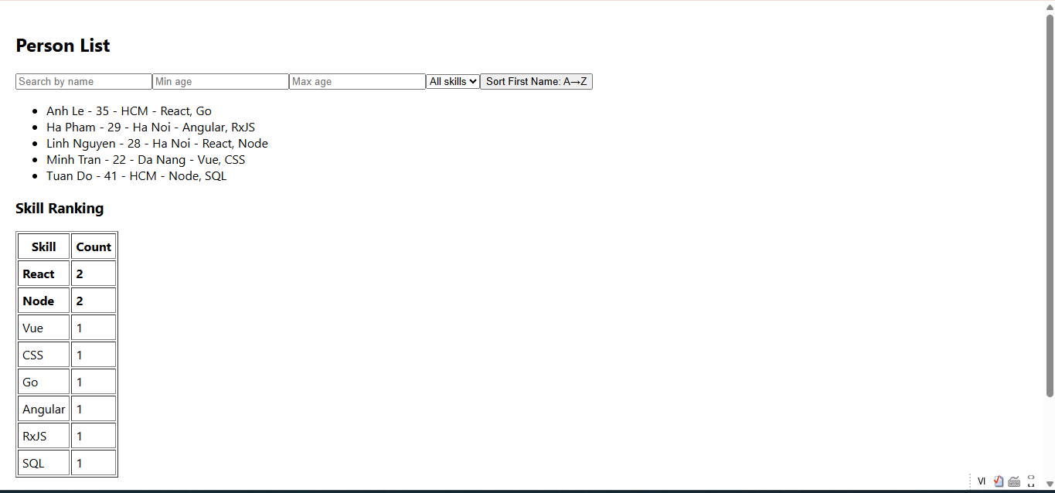
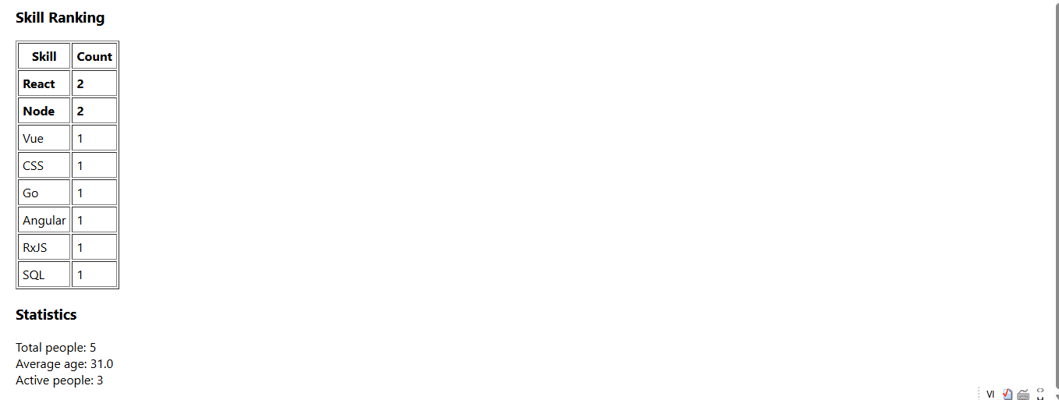
export const persons = [
{ id: 1, firstName: 'Linh', lastName: 'Nguyen', age: 28, city: 'Ha Noi', skills: ['React', 'Node'], isActive: true },
{ id: 2, firstName: 'Minh', lastName: 'Tran', age: 22, city: 'Da Nang', skills: ['Vue', 'CSS'], isActive: false },
{ id: 3, firstName: 'Anh', lastName: 'Le', age: 35, city: 'HCM', skills: ['React', 'Go'], isActive: true },
{ id: 4, firstName: 'Ha', lastName: 'Pham', age: 29, city: 'Ha Noi', skills: ['Angular', 'RxJS'], isActive: true },
{ id: 5, firstName: 'Tuan', lastName: 'Do', age: 41, city: 'HCM', skills: ['Node', 'SQL'], isActive: false },
];

import React, { useState, useMemo } from "react";
import { persons } from "./person";

export default function App() {
const [sortAZ, setSortAZ] = useState(true);
const [minAge, setMinAge] = useState("");
const [maxAge, setMaxAge] = useState("");
const [selectedSkill, setSelectedSkill] = useState("");
const [searchTerm, setSearchTerm] = useState("");

const allSkills = [...new Set(persons.flatMap(p => p.skills))];

const filteredList = useMemo(() => {
return persons
.filter(p => {
const minCheck = minAge ? p.age >= parseInt(minAge) : true;
const maxCheck = maxAge ? p.age <= parseInt(maxAge) : true;
const skillCheck = selectedSkill ? p.skills.includes(selectedSkill) : true;
const searchCheck = (p.firstName + " " + p.lastName)
.toLowerCase()
.includes(searchTerm.toLowerCase());
return minCheck && maxCheck && skillCheck && searchCheck;
})
.sort((a, b) => {

if (a.isActive !== b.isActive) return b.isActive - a.isActive; // true trước
if (a.age !== b.age) return a.age - b.age; // tuổi tăng dần
return a.lastName.localeCompare(b.lastName); // A→Z
})
.sort((a, b) => {

return sortAZ
? a.firstName.localeCompare(b.firstName)
: b.firstName.localeCompare(a.firstName);
});
}, [minAge, maxAge, selectedSkill, searchTerm, sortAZ]);

const skillCount = useMemo(() => {
return persons.reduce((acc, p) => {
p.skills.forEach(skill => {
acc[skill] = (acc[skill] || 0) + 1;
});
return acc;
}, {});
}, []);

const sortedSkillCount = Object.entries(skillCount).sort((a, b) => b[1] - a[1]);
const topSkillCount = sortedSkillCount[0]?.[1];

const statistics = useMemo(() => {
const total = persons.length;
const avgAge = (persons.reduce((sum, p) => sum + p.age, 0) / total).toFixed(1);
const activeCount = persons.filter(p => p.isActive).length;
return { total, avgAge, activeCount };
}, []);

return (
<div style={{ padding: "20px" }}>
<h2>Person List</h2>

<input
placeholder="Search by name"
value={searchTerm}
onChange={e => setSearchTerm(e.target.value)}
/>

<input
type="number"
placeholder="Min age"
value={minAge}
onChange={e => setMinAge(e.target.value)}
/>
<input
type="number"
placeholder="Max age"
value={maxAge}
onChange={e => setMaxAge(e.target.value)}
/>

<select
value={selectedSkill}
onChange={e => setSelectedSkill(e.target.value)}
>
<option value="">All skills</option>
{allSkills.map(skill => (
<option key={skill} value={skill}>{skill}</option>
))}
</select>

<button onClick={() => setSortAZ(!sortAZ)}>
Sort First Name: {sortAZ ? "A→Z" : "Z→A"}
</button>

<ul>
{filteredList.length > 0 ? (
filteredList.map(p => (
<li key={p.id}>
{p.firstName} {p.lastName} - {p.age} - {p.city} - {p.skills.join(", ")}
</li>
))
) : (
<li>No found.</li>
)}
</ul>

<h3>Skill Ranking</h3>
<table border="1" cellPadding="5">
<thead>
<tr>
<th>Skill</th>
<th>Count</th>
</tr>
</thead>
<tbody>
{sortedSkillCount.map(([skill, count]) => (
<tr
key={skill}
style={{ fontWeight: count === topSkillCount ? "bold" : "normal" }}
>
<td>{skill}</td>
<td>{count}</td>
</tr>
))}
</tbody>
</table>

<h3>Statistics</h3>
<div>Total people: {statistics.total}</div>
<div>Average age: {statistics.avgAge}</div>
<div>Active people: {statistics.activeCount}</div>
</div>
);
}

