**Key Word I use :**

**Device :** index of esp32 which you choose ( 0 < device < 2^32-1)

**sensor :** which give data of enviroment ( orther microprocessing, sensor DHT21,...)

**euipment :** which you can control througth send command to server ( didital , non-digital)

**ID :** Identify of unique User , User can have many device but only 1 ID, remember

**Protocal I use :** http

**Type Of devide :** I divide into 2 type ( can be expanse in the future ) , basic is : 0 ( to get command and do it ) and 1 ( to send data to server ). It is GET and POST in HTTP

**Device type 0 manage Equipment ( receive command),device type 1 manage Sensor ( read data).**

**ConFig** : it help you announce your device and add it to you profile

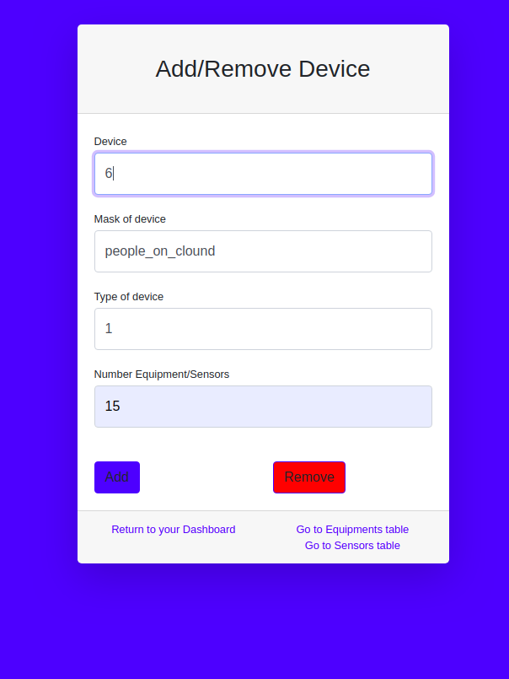

@param:

+ Devide : this is the index device you config for ESP32 ( 0,1,2,..,2^32-1)

+ Mask of Device : to can be easily release esp32(Ex: chicken,..)

+ Type of device : 0 or 1

+ Number Equipment/sensors: now , just 20 max on 1 device( if you choose type 0 ( read Block document below)