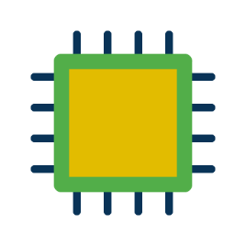

ADC,DAC,PWM

Json, Protobuf

User

Equipment

Sensor

IoT Core

Database

Device

View engine

HTTP

Mongoose

I2C,UART,CAN,SPI

HTTP