# Password authentication was removed

# <https://dev.to/shafia/support-for-password-authentication-was-removed-please-use-a-personal-access-token-instead-4nbk>

# Support for password authentication was removed. Please use a personal access token instead.

While pushing some codes into your GitHub repository you may encounter the error **"Support for password authentication was removed. Please use a personal access token instead."** as shown in the picture below

[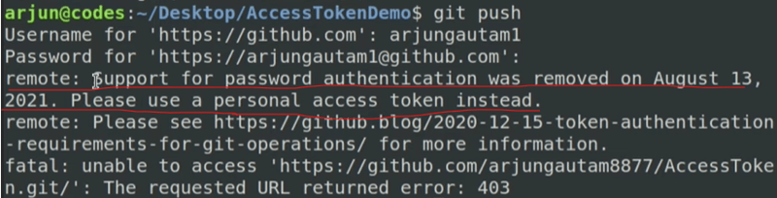](https://media.dev.to/dynamic/image/width=800%2Cheight=%2Cfit=scale-down%2Cgravity=auto%2Cformat=auto/https%3A%2F%2Fdev-to-uploads.s3.amazonaws.com%2Fuploads%2Farticles%2F1vg44dnbnb1tufy752xw.png)

Starting from August 13, 2021, GitHub has stopped accepting passwords for verifying Git operations on user accounts. Instead, you will need to use a Personal Access Token (PAT) in place of your password. To add a PAT to your system, you can follow the steps outlined below.

**Step 1:** Go to your **GitHub Account** and then go to the **Settings**(click on your profile account and you will find the Settings option there)

**Step 2:** Scroll down and at the sidebar you will see the **Developer Settings** option. Click on **Developer Settings**.

[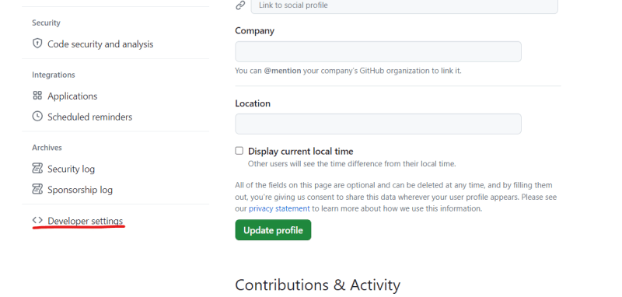](https://media.dev.to/dynamic/image/width=800%2Cheight=%2Cfit=scale-down%2Cgravity=auto%2Cformat=auto/https%3A%2F%2Fdev-to-uploads.s3.amazonaws.com%2Fuploads%2Farticles%2Ft534ukqape6hpj8aooeo.png)

**Step 3:** Click on **Personal access tokens** and then click on **Tokens (classic)**

[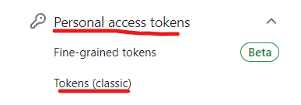](https://media.dev.to/dynamic/image/width=800%2Cheight=%2Cfit=scale-down%2Cgravity=auto%2Cformat=auto/https%3A%2F%2Fdev-to-uploads.s3.amazonaws.com%2Fuploads%2Farticles%2F51v3o8zuxa4nhw0ry65b.png)

**Step 4:** Click on **Generate new token** and then click on **Generate new token (classic)**

[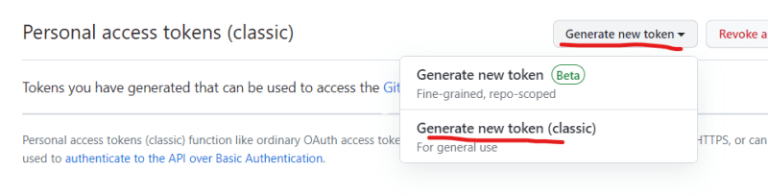](https://media.dev.to/dynamic/image/width=800%2Cheight=%2Cfit=scale-down%2Cgravity=auto%2Cformat=auto/https%3A%2F%2Fdev-to-uploads.s3.amazonaws.com%2Fuploads%2Farticles%2Fnaek7ocg6qchiir0nmot.png)

Step 5: Fill-up the **Note** field, select **No expiration** and then select the checkboxes as shown in the picture

[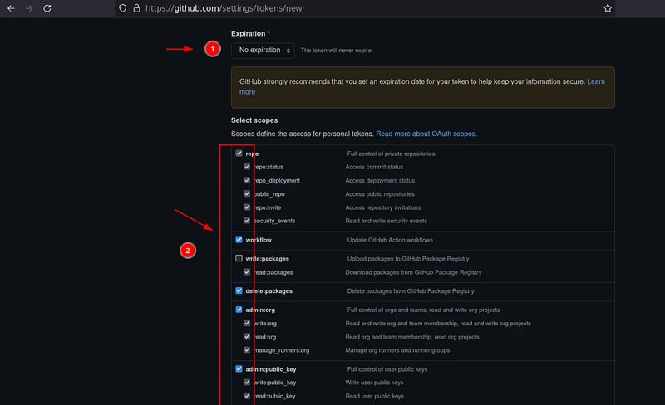](https://media.dev.to/dynamic/image/width=800%2Cheight=%2Cfit=scale-down%2Cgravity=auto%2Cformat=auto/https%3A%2F%2Fdev-to-uploads.s3.amazonaws.com%2Fuploads%2Farticles%2Fsv1jvy9a82iudnypkxsd.png)

[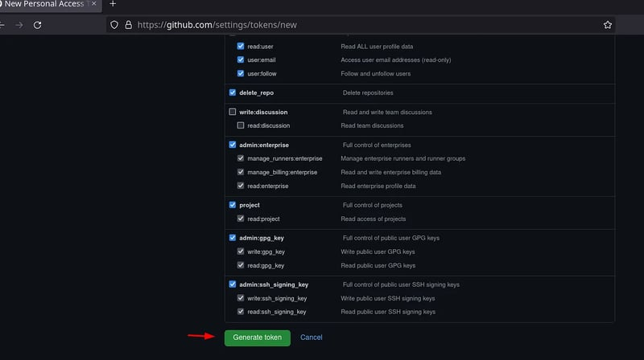](https://media.dev.to/dynamic/image/width=800%2Cheight=%2Cfit=scale-down%2Cgravity=auto%2Cformat=auto/https%3A%2F%2Fdev-to-uploads.s3.amazonaws.com%2Fuploads%2Farticles%2F9zz6nzqcdiccv7j6gnag.png)

**Step 6:** Click on the **Generate token**. Your token is created!.

[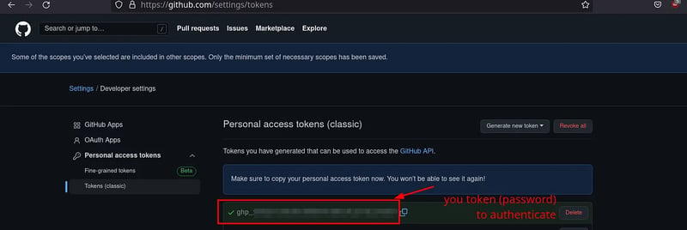](https://media.dev.to/dynamic/image/width=800%2Cheight=%2Cfit=scale-down%2Cgravity=auto%2Cformat=auto/https%3A%2F%2Fdev-to-uploads.s3.amazonaws.com%2Fuploads%2Farticles%2Fd63uyh66kiq3i6ukcqeg.png)

**Step 7:** Copy the token and paste it on the password field of the terminal.

[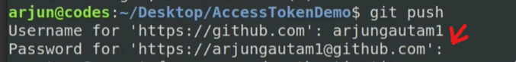](https://media.dev.to/dynamic/image/width=800%2Cheight=%2Cfit=scale-down%2Cgravity=auto%2Cformat=auto/https%3A%2F%2Fdev-to-uploads.s3.amazonaws.com%2Fuploads%2Farticles%2Fugbtc566khdh76p6re8v.png)

Your code got successfully pushed into your repository!

[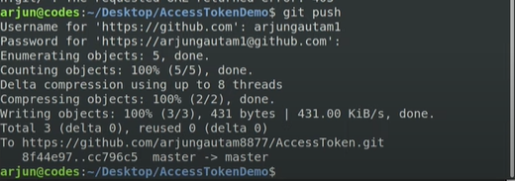](https://media.dev.to/dynamic/image/width=800%2Cheight=%2Cfit=scale-down%2Cgravity=auto%2Cformat=auto/https%3A%2F%2Fdev-to-uploads.s3.amazonaws.com%2Fuploads%2Farticles%2Ftpyf3l9p3c06lc2ybfnj.png)

However, after applying your token you may face this error.

[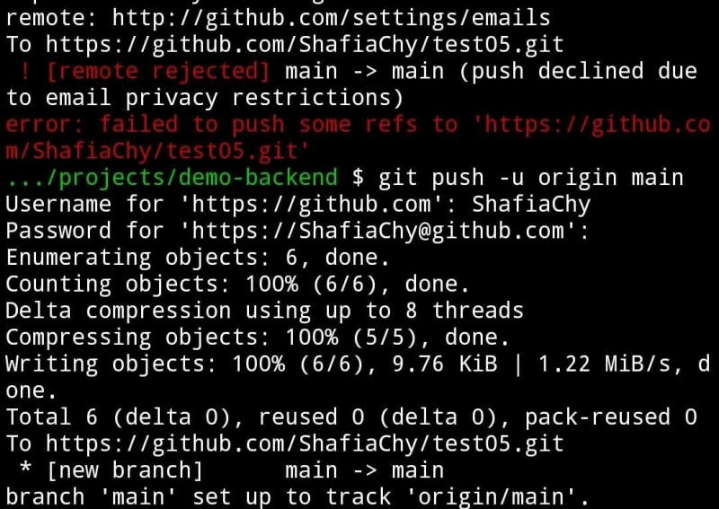](https://media.dev.to/dynamic/image/width=800%2Cheight=%2Cfit=scale-down%2Cgravity=auto%2Cformat=auto/https%3A%2F%2Fdev-to-uploads.s3.amazonaws.com%2Fuploads%2Farticles%2F8jlspmqvzfo8djhu9jik.png)

Visit this blog(<https://dev.to/shafia/common-github-issues-beginners-may-face-29bb>) and follow the steps given in **Error 3 Solution 1**.

Happy coding!