|  |  |
| --- | --- |
|  | FPT ACADEMY INTERNATIONAL  FPT – APTECH COMPUTER EDUCATION |

Centre Name: ACE-HCMC-2-FPT.

Address: 590 Cach Mang Thang 8, District 3, Ho Chi Minh City, Viet Nam.



|  |  |  |
| --- | --- | --- |
| Supervisor: | Phạm Thị Lánh | |
| Term: | 1 | |
| Batch No: | T1.2112.E0 | |
| Group No: | 5 | |
| Order: | Full name | Roll No. |
| 1. | Đặng Trí Thức | Student1438991 |
| 2. | Nguyễn Ngọc Thành Đạt | Student1438966 |
| 3. | Nguyễn Tấn Anh | Student1438976 |

Month 04 Year 2023



This is to certify that

**Mr. ĐẶNG TRÍ THỨC**

**Mr. NGUYỄN NGỌC THÀNH ĐẠT**

**Mr. NGUYỄN TẤN ANH**

Have successfully Designed & Developed

**????**

Submitted by: **Ms. PHAM THI LANH**

Date Of Issue: April, 2023

Authorized Signature:

# Content

[Content](https://docs.google.com/document/d/10y4P0oLcQYHZgpfAzd_tl_8BRxON78rV/edit#heading=h.1y810tw)

[Ackn](https://docs.google.com/document/d/1SHFEHtdolUZ_igHcjdXVkjX1jgeBDVfj/edit#heading=h.30j0zll)owledge

Synopsis

**REVIEW**

Problem Definition

Customer Requirements Specifications

Architecture and Design of the project

Site map

Website Design Layout

I. Homepage

II. Sign in and Sign up

III. Main

IV. Design

V. Contact

Task Sheet

Testing document

Final checklist

# Acknowledge

# eProject is a step-by-step learning environment that closely simulates the classroom

# and Lab based learning environment into actual implementation. It is a project

# implementation at your fingertips!! An electronic, live juncture on the machine that

# allows you to

# o Practice step by step i.e. laddered approach.

# o Build a larger more robust application.

# o Usage of certain utilities in applications designed by user.

# o Single program to unified code leading to a complete application.

# o Learn implementation of concepts in a phased manner.

# o Enhance skills and add value.

# o Work on real life projects.

# o Give a real life scenario and help to create applications more complicated and

# useful.

# o Mentoring through email support.

# The students at the centre are expected to complete this eProject and send complete

# project along with the documentation to eProjects GROUP 5

# Looking forward to a positive response from your end!!

# Synopsis

The Objective of this program is to give a sample project to work on real life

projects. These applications help you build a larger more robust application.

The objective is not to teach you JSON/JavaScript/Dreamweaver/HTML5 but to

provide you with a real life scenario and help you create basic applications using the tools.

You can revise the chapters before you start with the project.

This project is meant for students who have completed the module of HTML5. These

programs should be done in the Lab sessions with assistance of the faculty if required.

It is very essential that a student has a clear understanding of the subject. Students

should go through the project and solve the assignments as per requirements given.

Kindly get back to eProjects Team in case of any doubts regarding the application or its objectives.

# REVIEW 1

## Problem Definition

There are so many aspects of creating art that are fun an enjoyable – the practice,

experimentation, and work to make each piece – that hours pass as if they were

minutes. Sharing and engaging with the amazing writing community to help other create

their own masterpieces is also incredibly rewarding.

Calligraphy has become very popular recently – examples of it can be seen in many

advertising areas, restaurant menus, posters and even party invitations. It’s very loosely

based on Copperplate calligraphy, which is a lot stricter in form and design.

Scratchy Nib is one place, which brings together the art of Calligraphy along with the

knowledge and history.

You are supposed to create a Single-Page-Application and responsive Website for

them with the below mentioned requirement specifications.

The website is to be developed for the Windows Platform using HTML5, JSON,

Angular JS, JavaScript and Geolocation. The site should work well in all leading

browsers including Chrome, IE, Firefox etc.

## Customer Requirements Specifications

|  |
| --- |
| USER: |
| Input:  ● Input consumer’s address of residence or office  ● Send questions/requests to the company |
| Process:  ● Process consumer’s address data  ● Collect questions/requests sent by consumers |
| Output:  ● Show the store address to consumers  ● Reply to the consumer’s requests/questions |

|  |
| --- |
| WEBMASTER: |
| Input:  ● Control website database, input product information,… |
| Process:  ● Analyse website |
| Output:  ● Website interface, images, forms, …  ● Giving interaction |

|  |
| --- |
| HARDWARE / SOFTWARE REQUIREMENT: |
| Software:  ● Notepad/HTML editor  ● Dreamweaver/Javascript |
| Hardware:  ● A minimum computer system that will help you access all the tools in the courses is a Pentium 166 or better  ● 64 Megabytes of RAM or better |

## Architecture and Design of the project

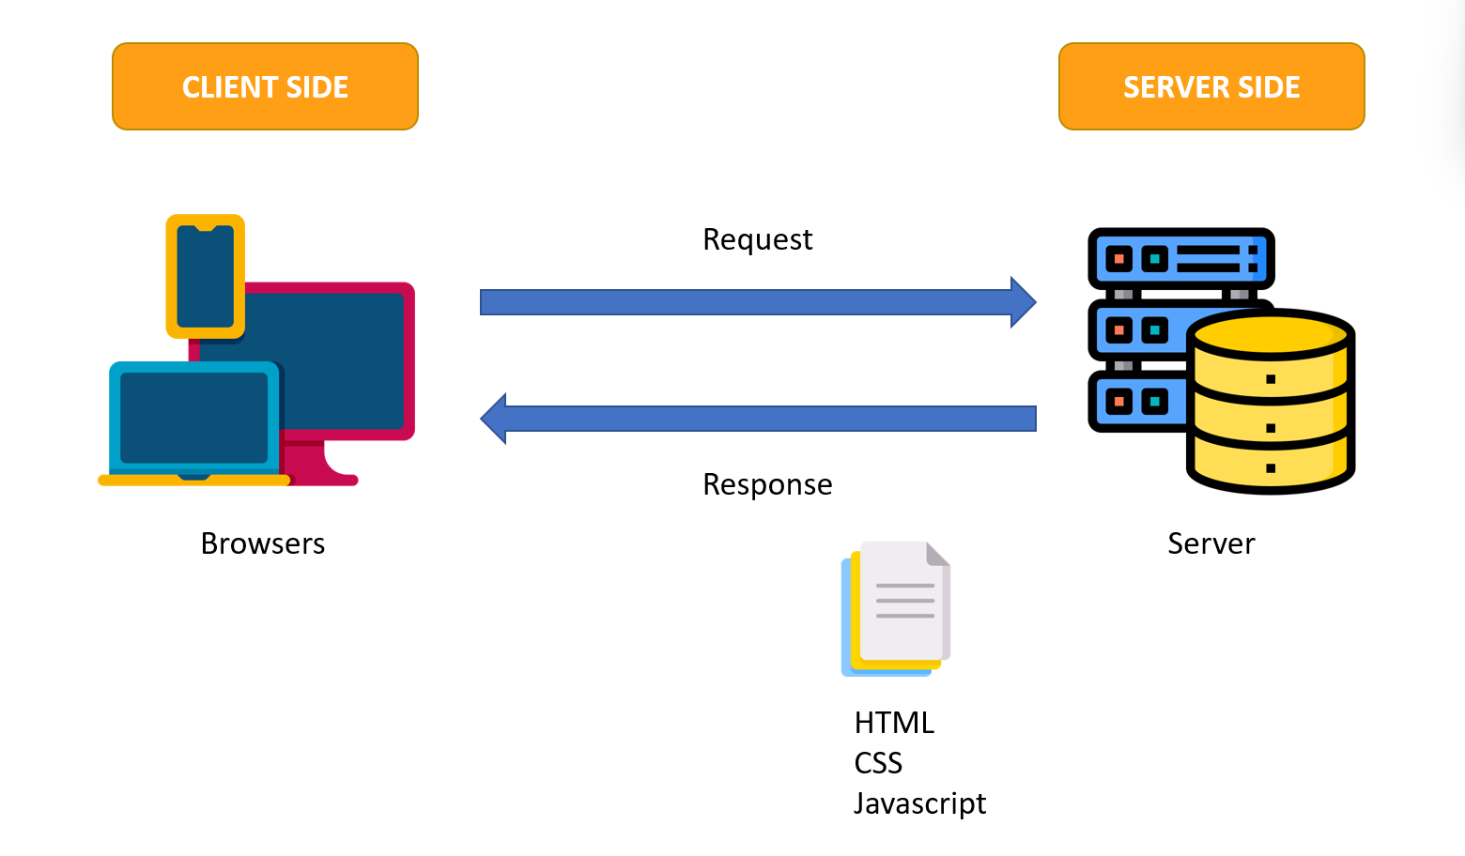

## Site map

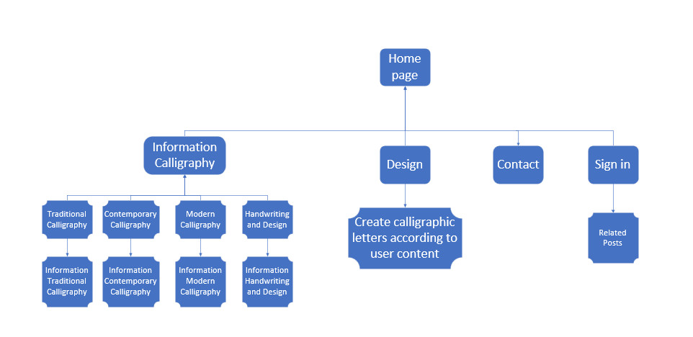

## Website Design Layout

### Homepage

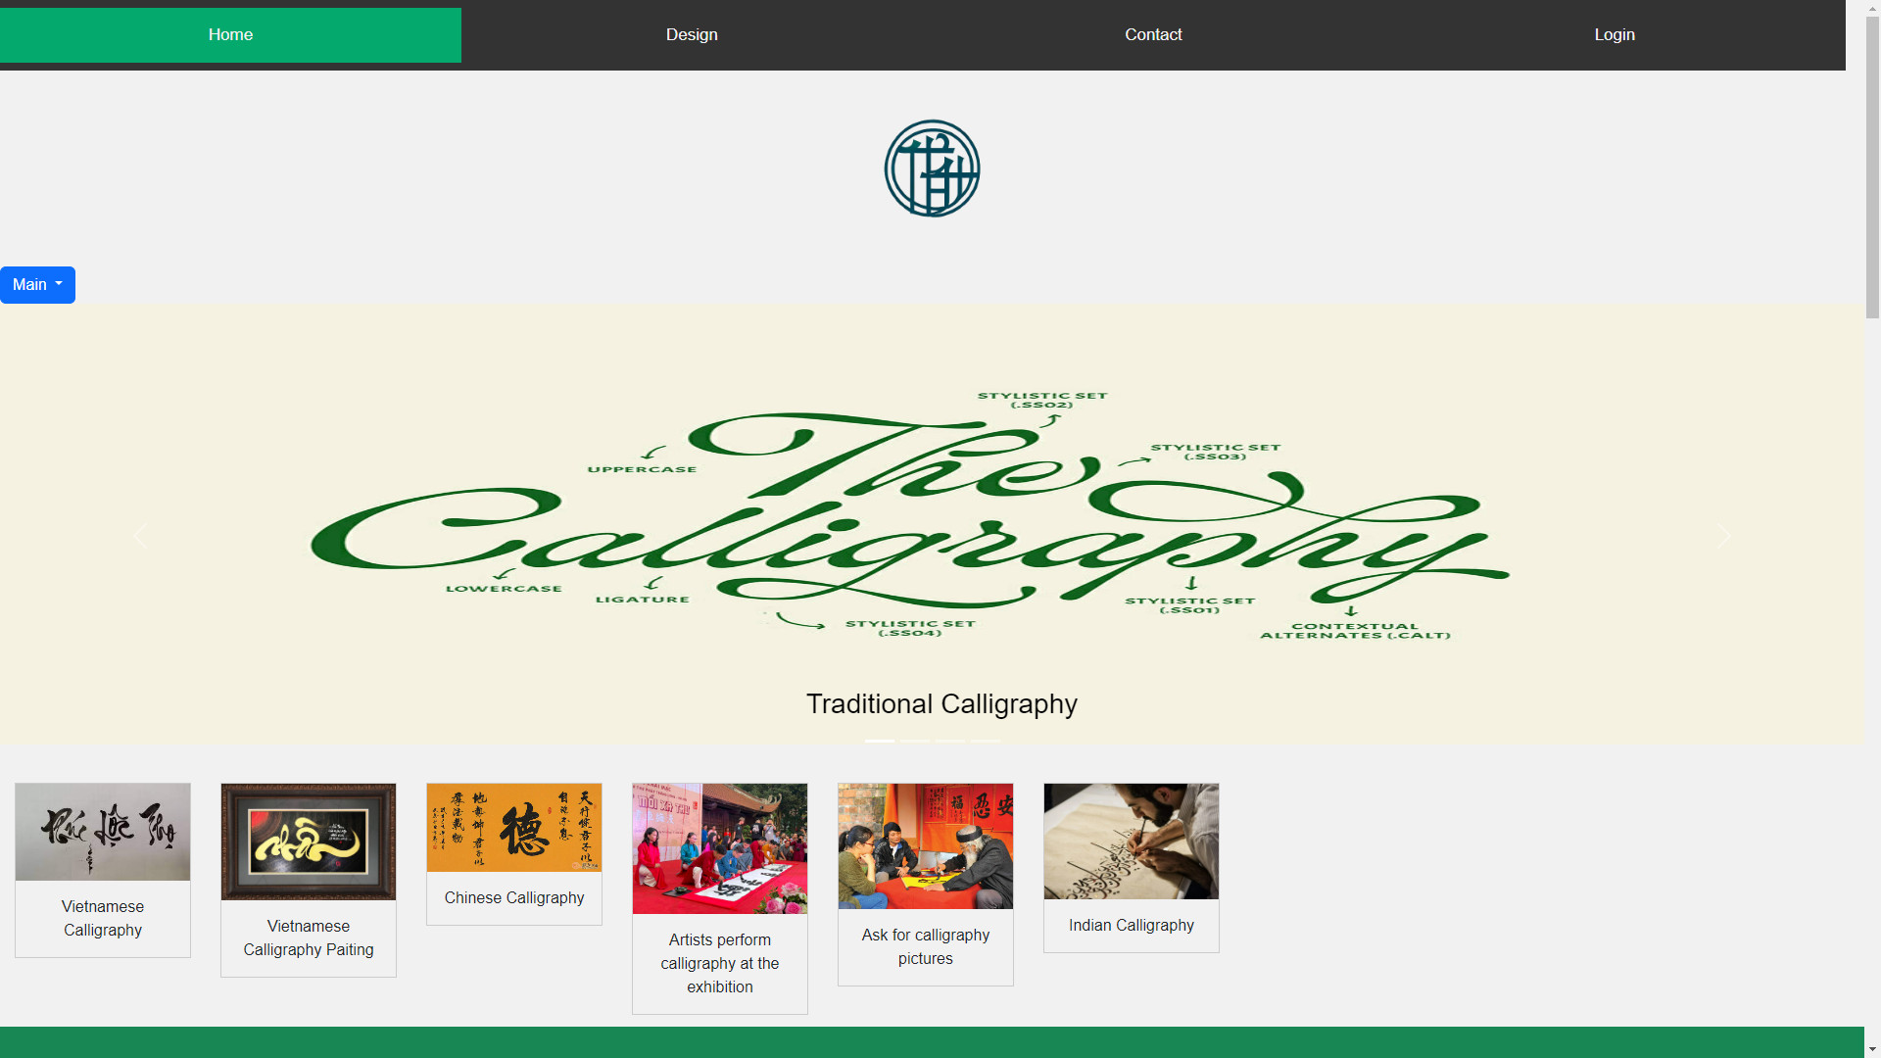

**Description:** This is a homepage of eProject’s Group 5, the top of this page is a header, after that is a navigation bar. Beside slideshow we have the button dropdown Main with five sections includes: Conception, History, How to write and pen and Benefits. Below slideshow we also have some pictures about activities related to calligraphy.

### Sign in

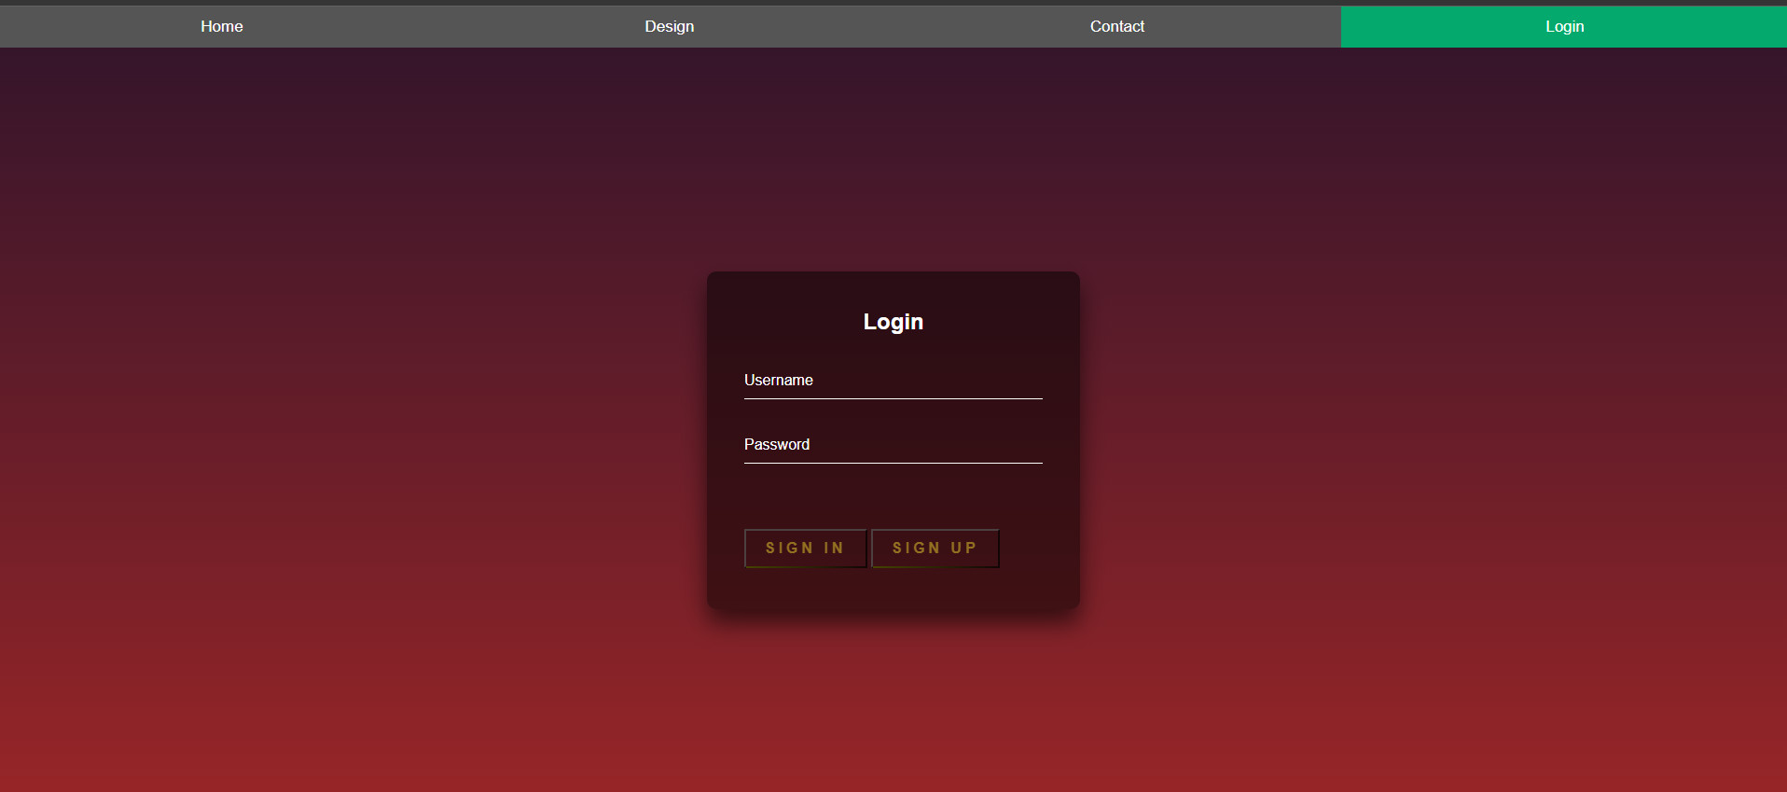

**Description:** When the user clicks on the human icon in the header, it leads to a sign in page. This form requires the user to enter an username and a password. After clicking the Sign in button, the user will be redirected to the homepage. At once when you clicks on Sign up, the user will be redirected to the homepage too.

### Main

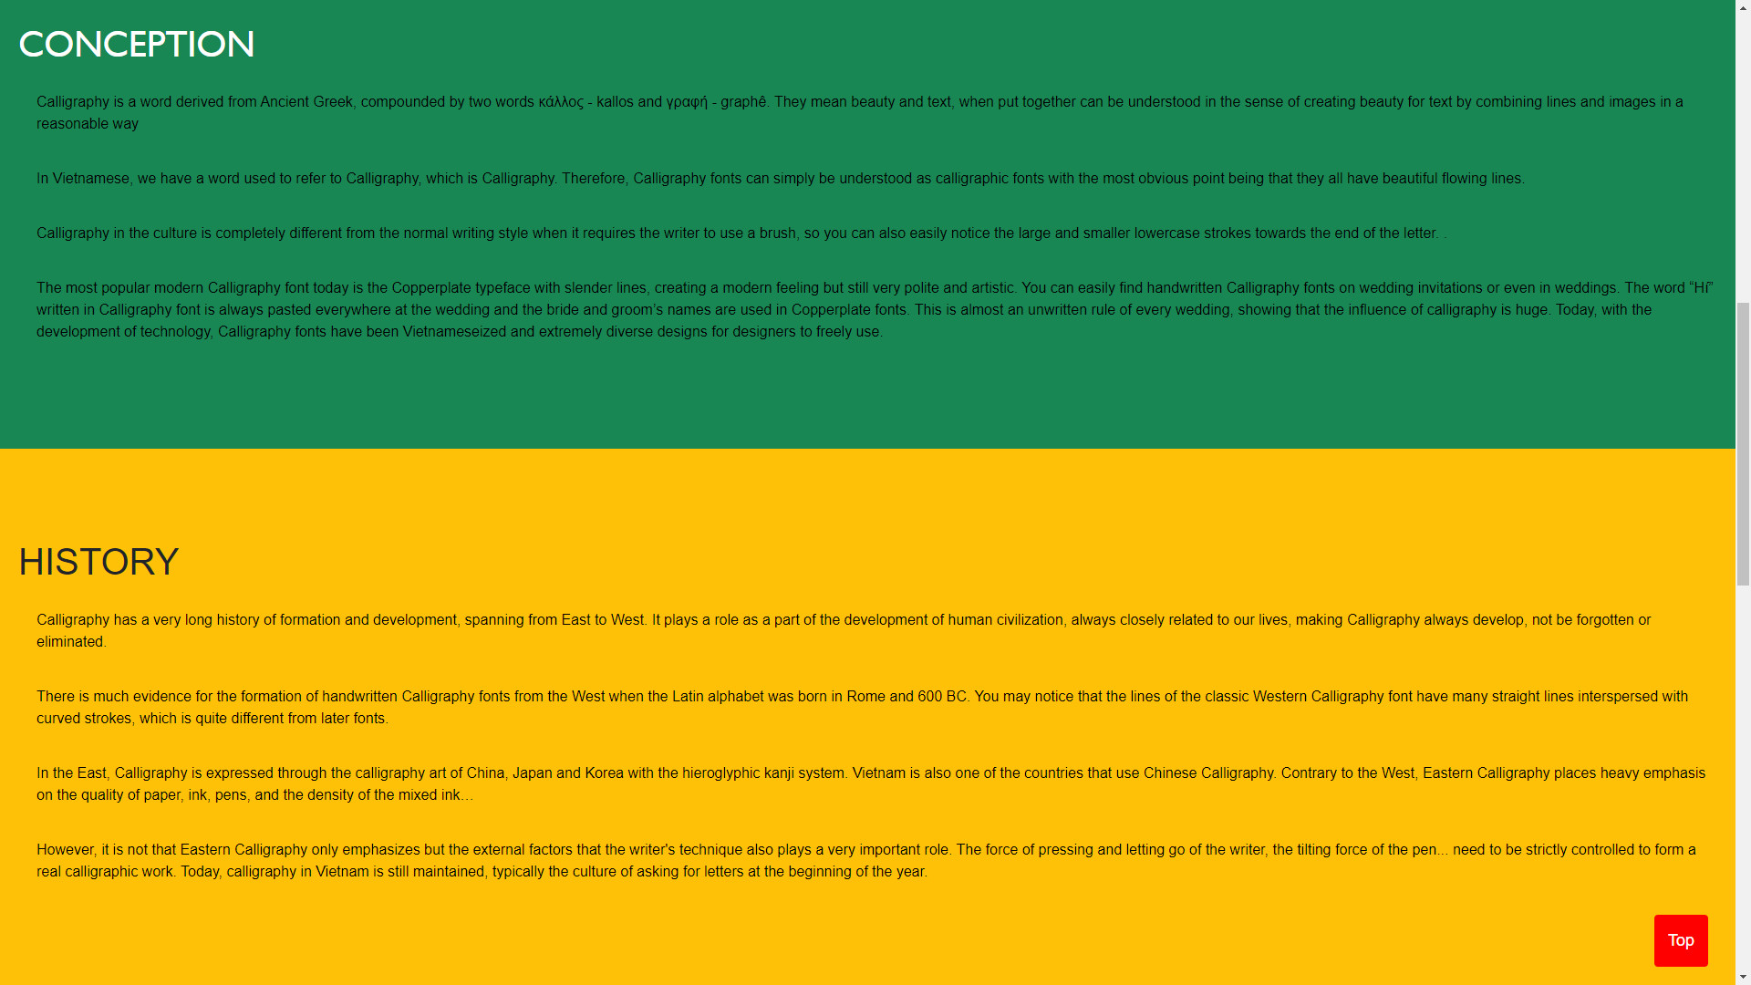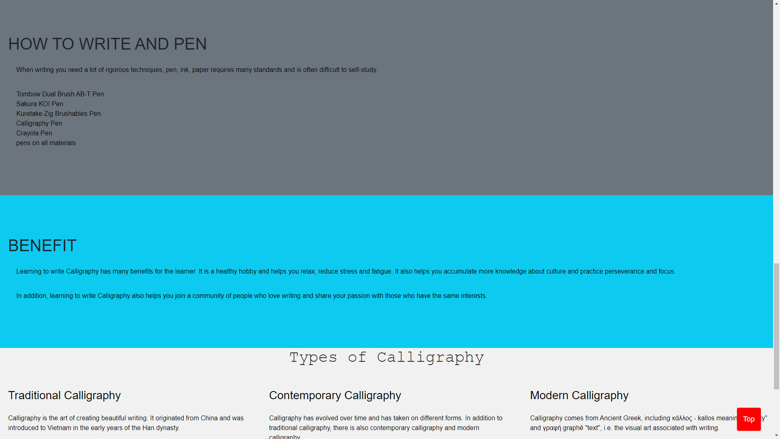

**Description:** After the user clicks on the Main buttpn on the navigation bar, it will lead to this main page. This page contains detailed information about Calligraphy.

### DESIGN

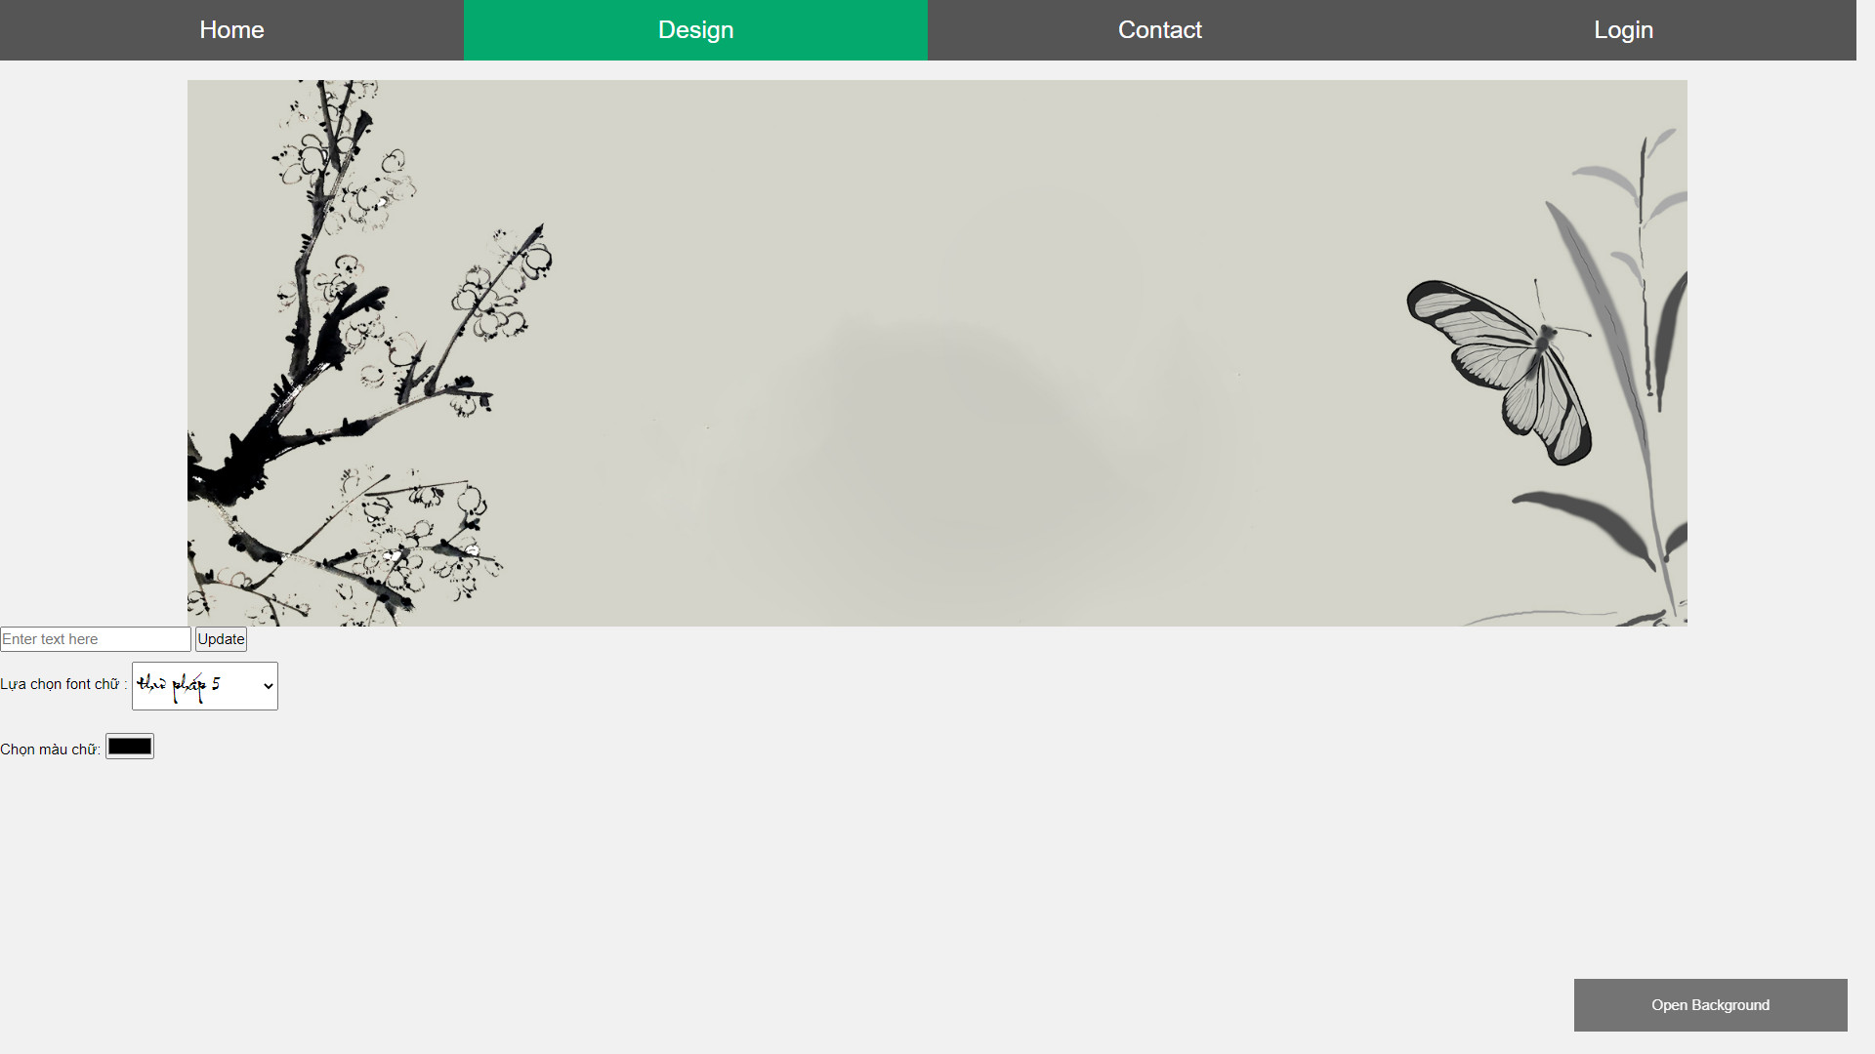

**Description: This design is confidential of group 5. We have researched thoroughly about this, we want everyone can know about calligraphy more, they can write it by real way, you can choose the font text calligraphy and the color, then just enter the text in box.**

### Contact

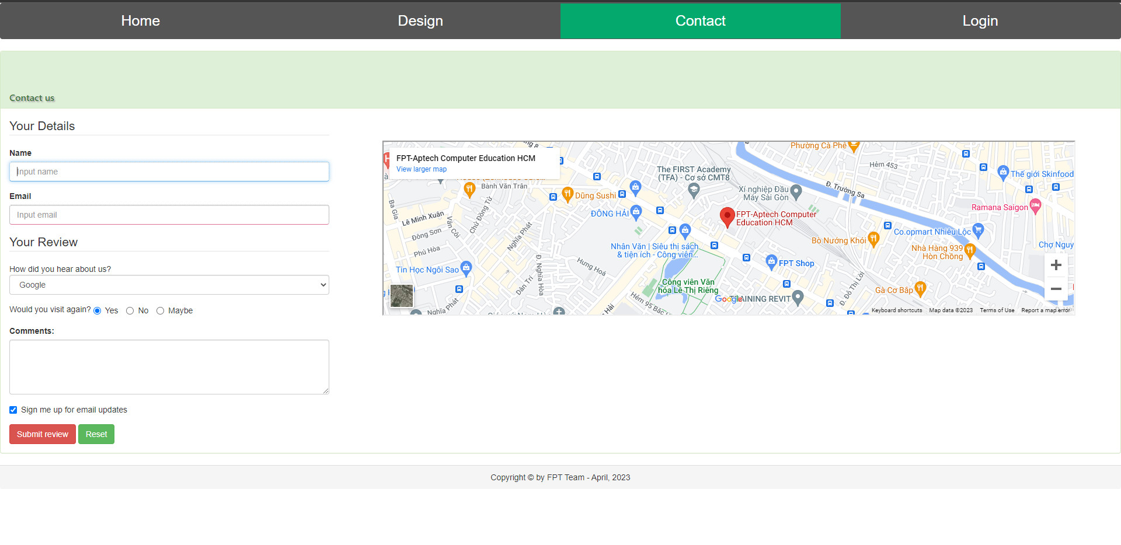

## Task Sheet

|  |  |  |  |  |  |  |
| --- | --- | --- | --- | --- | --- | --- |
| **Project Ref No.** | **Project Title – Ask Me Mobile** | **Activity Plan Prepared by** | **Date of preparation of Activity Plan** | | | |
| **Task** | **Actual Start Date** | **Actual Days** | **Teammate Names** | **Status** |
| Brainstorming ideas for layouts and Project Object | | Thức, Đạt, Anh | 30/03/2023 | 1 days | Thức, Đạt, Anh | Completed |
| Draw site maps and architecture design | | Thức, Đạt, Anh | 30/03/2023 | 1 days | Thức, Đạt, Anh | Completed |
| Wire framing general page layout | | Thức, Đạt, Anh | 02/04/2023 | 3 days | Thức, Đạt, Anh | Completed |
| Collect static assets (pictures, mp4, documentation,…) | | Thức, Đạt, Anh | 02/04/2023 | 5 days | Thức, Đạt, Anh | Completed |