EXT: Timezones
Extension Key: timezones
Copyright 2000-2002, Ralph Schuster, <rs.eschborn@gmx.de>

This document is published under the Open Content License
available from http://www.opencontent.org/opl.shtml

The content of this document is related to TYPO3
- a GNU/GPL CMS/Framework available from www.typo3.com

Table of Contents
EXT: Timezones 1
Introduction 1
What does it do? 1
Screenshots 1
Users manual 2
FAQ 2
Administration 2
Configuration 3
FAQ 3
Reference 3
Known problems 3
To-Do list 3
Changelog 3
Important guidelines 4
Issues with Open Office documentation for TYPO3 4
Inserting images 4
Paragraph styles 4
Linking 5
Meta data and updates 5

Introduction

What does it do?
This extension enables other extension programmers to take care of user's timezones. It provides an interface that formats dates and times according to current website reader's preferences.
Furthermore, it provides a frontend plugin that enables website users to set their preferred timezone.

Screenshots
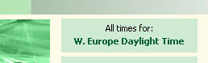
Display of current timezone in frontend

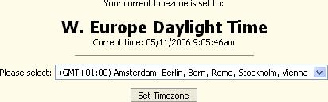
Form for website users to set their preferred timezone.

Users manual
Just install the extension. It will install a library that takes care of all frontend-related issues for timezones.
As an extension programmer:
- Create a central function in your extension where you format dates and times, e.g. a function formatDateTime($format, $timestamp):
function formatDateTime($format, $tstamp) {
if (is_callable(array('tx_timezones_pi1', 'formatDate'))) {
$rc = tx_timezones_pi1::formatDate($format, $tstamp);
} else {
$rc = date($format, $tstamp);
}
return $rc;
}

- Use this function wherever u need to display dates and/or times.
- That's it. No more need to take care of anything else
As a website designer:
This extension provides a frontend plugin that can be included so that website users can set their preferred timezone.
- In TypoScript: use tx_timezones_pi2 (see Configuration section for details)
- As page content:
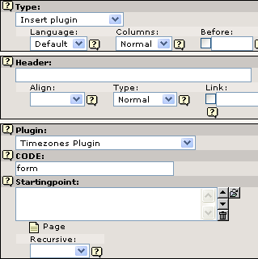
CODE field must contain valid configuration values for property select_key
- That's it. No more things to do.

FAQ
Q: Does the extension work for frontend users only?
A: Yes and no! Yes because this is a frontend plugin and works on frontend only. No because a logged-in user is not required. This extension stores preferred timezone setting in a cookie sent to the client. For backup reasons, logged-in frontend users will have this setting stored in their database record additionally.
Q: Does this extension require special PHP version?
A: No. Timezone settings are stored in a special PHP array. PHP timezone specific functions (available >= PHP5) are not used.

Administration
No administration required, see Users Manual for details.

Configuration

Reference
Property: | Data type: | Description: | Default:
select_key | string | form – Displays form for setting timezone preference  info – Displays current timezone setting | info
changePage | integer | ID of page where website user can change his timezone preference.

Example
page = PAGE
page.typeNum = 0
page.10 < plugin.tx_timezones_pi2
page.10.select_key = info
page.10.changePage = 23

Known problems
- Default Timezone cannot be set with TypoScript yet.

To-Do list
- Apply configuration of default timezone by TypoScript

Changelog
V1.0.1:
- User's profile value takes precedence over cookie when user logs in
- “Europe/London” is used when no default value exists

