T2S
Implementation Specification
Production-First Enterprise NL-to-SQL
September 2026 · Implementation Baseline
Implementation principle — Start with the smallest production-safe system that can be measured. Optional agentic, semantic and IR mechanisms are extension points, not prerequisites.

Core flow — Secure -> Ground -> Generate -> Verify -> Preflight/Execute -> Decide; loop only when a targeted action can obtain new evidence.

Executive Implementation Summary
This document turns the current candidate architecture into a buildable modular monolith. The online path owns authorization-aware grounding, gpt-oss-120b direct-SQL generation, SQL/authorization verification, a controlled database gateway, risk decisions, bounded recovery, audit and evaluation. OpenMetadata, vLLM and analytical databases remain behind ports/adapters.
The first production baseline intentionally does not require Wren, a semantic model, a custom IR, multiple solvers or an LLM verifier. Those mechanisms are enabled only after the baseline error budget shows where additional complexity can create measurable production value.

Implementation decisions
Decision | v1 implementation
Service topology | Modular monolith `t2s-api` + separate stateless metadata indexer/CronJob
Main generation path | Authorized compact context -> gpt-oss-120b -> structured Direct SQL output
Metadata | OpenMetadata adapter + versioned OpenSearch retrieval index
SQL safety | SQLGlot AST defense-in-depth + DB-specific EXPLAIN/dry-run + read-only DB role
Recovery | Bounded state machine; targeted evidence/action only
Risk | Rule-based conservative policy first; calibrated model only after labels
Optional mechanisms | Alternative solver, semantic verifier, Wren/semantic runtime, typed IR behind feature flags/ports

1. Runtime Architecture
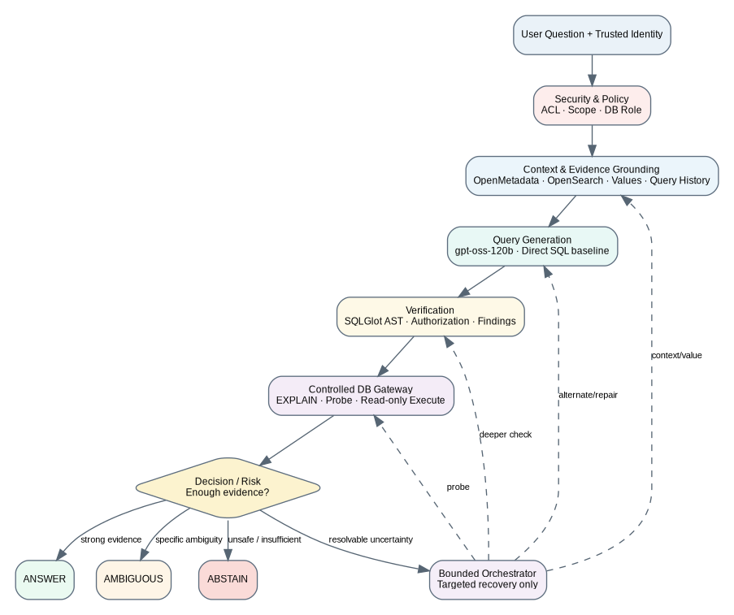
Figure 1. Implementation baseline with bounded recovery loop.
The architecture is capability-oriented. The orchestrator is not an autonomous agent: it maps diagnosed failures to a finite set of actions and consumes explicit budgets.

1.1 Deployment shape
Component | Responsibility
t2s-api | FastAPI modular monolith: query use case, grounding, solver, verification, risk, response
t2s-indexer | Scheduled full/incremental OpenMetadata -> OpenSearch sync
PostgreSQL | Run/audit/config/feedback/evaluation state
OpenSearch | Schema/table/column retrieval index
OpenMetadata | Authoritative metadata source for available catalog metadata
vLLM / gpt-oss-120b | Reasoning/generation runtime; no DB credentials
DatabaseGateway adapters | Only allowed path to ClickHouse/StarRocks/PostgreSQL warehouses

1.2 Baseline stack
Python 3.12 + FastAPI + Pydantic v2; PostgreSQL/Alembic; OpenSearch; SQLGlot; psycopg v3; clickhouse-connect; StarRocks client/MySQL protocol adapter; OpenTelemetry + Prometheus; pytest. Pin versions in a lock file and record them in every benchmark/run artifact.
Important — SQLGlot officially supports ClickHouse, Postgres and StarRocks, but it is not a complete SQL validator. Database preflight and least-privilege accounts remain mandatory. [R13–R14]

2. Repository and Dependency Boundaries
src/t2s/
api/ # HTTP only
domain/ # models, enums, errors
ports/ # Protocol interfaces
services/ # query/grounding/solver/verify/orchestrate/risk
adapters/
auth/
openmetadata/
opensearch/
vllm/
sqlglot/
db/{postgres,clickhouse,starrocks}.py
persistence/
indexing/
observability/
tests/{unit,contract,integration,security,regression}/
eval/{datasets,runners,reports}/
Dependency rule: `api -> services -> domain/ports`; concrete adapters implement ports and are injected at startup. Services must not import OpenMetadata SDK, OpenSearch, vLLM or driver classes directly.

3. Core Contracts

3.1 Query and identity
class QueryRequest(BaseModel):
question: str
locale: Literal['vi','en','auto'] = 'auto'
target_hint: str | None = None
class UserContext(BaseModel):
subject: str
groups: set[str]
roles: set[str]
claims_hash: str
class AuthorizedScope(BaseModel):
scope_id: str
allowed_services: set[str]
allowed_databases: set[str]
allowed_schemas: set[str]
allowed_table_fqns: set[str] | None
Security rule — User identity is constructed from trusted authentication middleware. The request body never chooses the effective user/role.

3.2 Grounding contract
`GroundingContext` contains authorized selected tables/columns, relationship provenance, glossary hits, value bindings, validated examples, unresolved issues, evidence references and retrieval signals. Local retrieval scores are not named “correctness confidence”.

3.3 Solver contract
class SolverOutput(BaseModel):
sql: str
dialect: Literal['postgres','clickhouse','starrocks','sqlite']
expected_columns: list[str] = []
assumptions: list[str] = []
unresolved: list[str] = []
This is a small operational envelope, not a mandatory semantic IR. It gives reliable parsing without restricting SQL expressiveness.

4. API and Request Lifecycle

4.1 Public endpoints
Endpoint | Purpose
POST /v1/query | Run one question through the full safe pipeline
GET /v1/query/{id} | Retrieve sanitized status/result when async/stream mode is enabled
POST /v1/query/{id}/feedback | Capture correctness/usefulness feedback
GET /health/live | Process liveness
GET /health/ready | Dependency readiness according to environment policy

4.2 Normal path
Trusted Identity -> Scope -> Ground -> 120B Direct SQL -> AST/Auth Verify -> EXPLAIN -> Risk -> Execute -> Answer

4.3 Failure behavior
- Auth/ACL failure: fail closed before metadata/LLM access.
- Metadata unavailable: use only an explicitly approved snapshot fallback; otherwise abstain/error.
- vLLM unavailable: no generated answer.
- DB timeout/error: no fabricated result.
- Optional verifier/semantic runtime unavailable: follow an explicit feature/fallback policy, never silently bypass controls.

5. Security Implementation

5.1 Defense layers
Apply authorization before retrieval, post-filter retrieval hits, re-check referenced tables from the SQL AST, then execute under a least-privilege DB identity. The LLM receives no credentials and cannot grant itself access.

5.2 SQL guard
- Single statement only.
- Allow read query expressions only; block DML/DDL/admin/session commands.
- Block SELECT INTO/write-equivalent constructs.
- Block disallowed external/system/table functions by dialect policy.
- Referenced objects must be a subset of AuthorizedScope.
- Final security remains the DB role/RLS/read-only configuration.

5.3 Database enforcement
PostgreSQL: READ ONLY transaction plus per-request statement timeout [R15–R16]. StarRocks: dedicated SELECT/USAGE role using its RBAC/IBAC model [R20]. ClickHouse: dedicated restricted account and per-query settings through the official driver [R17–R18].

5.4 vLLM boundary
Run vLLM only on trusted internal networks/ingress. Current vLLM documentation states that API-key authentication does not protect every endpoint, so API keys alone are insufficient isolation. [R2]

6. OpenMetadata Indexing and Grounding

6.1 Catalog adapter
Use OpenMetadata through a `CatalogPort`. Pin the SDK/ingestion package version to the server version as recommended by OpenMetadata. Tables can carry columns, profile/sample data and lineage; search endpoints exist under `/v1/search`. Query history/profiles/sample data are conditional on ingestion/configuration. [R5–R12]

6.2 Versioned retrieval index
OpenMetadata -> t2s-indexer -> normalize table/column docs -> t2s-schema-vNN -> alias t2s-schema-current
Build table and column documents. Full sync must be resumable. Switch the OpenSearch alias only after the new index passes count/sanity checks. Store the active index snapshot on every query run.

6.3 Retrieval v1
authorized scope -> BM25 table/column search -> merge -> hydrate top tables -> relationship expansion -> context budgeter
Dense embeddings and rerankers are optional ports. A missing approved embedding model must not block a lexical baseline.

6.4 Query history and values
Keep `QueryLogPort` separate because logs may live outside OpenMetadata. Historical SQL is a prior/example only when it satisfies a trust/validation policy. Value grounding starts with literals/dates/glossary/profile evidence and may use typed DB probes for unresolved values if policy allows.

7. gpt-oss-120b Solver

7.1 vLLM contract
Call the company vLLM through its OpenAI-compatible API. Use current structured-output support (`response_format`/`structured_outputs`), not deprecated guided-json fields. gpt-oss supports structured outputs and configurable reasoning effort. [R1–R4]

7.2 Prompt contract
SYSTEM:
- read-only enterprise SQL solver
- use only supplied authorized evidence
- never invent table/column/business definition/value
- if critical evidence is missing, populate unresolved
- output exactly one query for the requested dialect
- obey structured SolverOutput schema
CONTEXT:
selected schema + joins/provenance + grounded values + business evidence + few validated examples
USER:
original question

7.3 Context policy
Do not exploit the large context window by dumping the catalog. Serialize only selected evidence. Use descriptions primarily for relevant entities. Log reasoning-effort mode and compare accuracy/latency by complexity slice.

7.4 Repair policy
At most one targeted repair initially, and only after concrete evidence such as unknown column, dialect error, proven invalid literal or a specific verifier finding. Generic “review and improve” retries are not part of the baseline.

8. Verification and Database Gateway

8.1 Verification order
parse(dialect) -> read-only AST -> refs -> auth recheck -> dialect policy -> EXPLAIN/dry-run -> risk decision -> execute

8.2 Safe probes
Expose typed probes such as `ValueExistsProbe` and bounded `DistinctValuesProbe`. The model never supplies arbitrary probe SQL; the gateway compiles parameterized templates. Sensitive/high-cardinality columns require explicit policy.

8.3 Preflight
Use PostgreSQL EXPLAIN without ANALYZE by default. StarRocks EXPLAIN supports logical/verbose/cost modes [R21]. ClickHouse also exposes plan-oriented EXPLAIN variants; exact settings must be tested against the installed version. Preflight is evidence, not semantic proof.

8.4 Execution
Execute the selected SQL once under the effective authorized context. Return bounded rows/types/diagnostics. Do not reorder user results just to fingerprint them; ordered top-k semantics must be preserved.

9. Orchestrator and Risk Controller

9.1 Bounded actions
Diagnosed issue | Allowed action
Missing schema/context | EXPAND_SCHEMA
Unresolved value | PROBE_VALUE
Concrete SQL/dialect error | REPAIR_SQL
Semantic uncertainty | SEMANTIC_VERIFY (optional)
Need independent solution | ALTERNATIVE_SOLVER (optional)
No resolvable path / budget exhausted | ABSTAIN

9.2 Initial budgets
max_rounds: 2
max_solver_calls: 3
max_schema_expansions: 2
max_db_probes: 4
max_repairs: 1
max_verifier_calls: 1
All numbers are configuration defaults, not facts. Record budgets and consumption per request.

9.3 Risk policy v0
Do not fabricate a probability before labeled data exists. Start with a conservative rule policy: security/AST/auth/preflight/critical-grounding failures block; answer only when required checks pass. Escalate only if an allowed action can plausibly resolve the diagnosed uncertainty.

9.4 Risk model v1
After enough labeled runs, fit a transparent correctness model from logged signals and calibrate on held-out/cross-validated data. Evaluate with risk–coverage and calibration, not model self-confidence.

10. Persistence and Audit
Use PostgreSQL for `query_run`, `candidate`, `verification_finding`, `operation_event`, `feedback` and `metadata_snapshot`. Each run records git/config/model/prompt/index/SQLGlot versions. Raw questions/results must follow privacy/retention policy; hashed/redacted storage is acceptable when full payload retention is unnecessary.

10.1 Cache rule
Cache metadata first. Any data/result cache must include authorization scope and freshness/version. Do not allow a cache to become an ACL bypass.

11. Observability
query
├── auth.resolve
├── grounding.search / hydrate
├── llm.solve
├── verify.ast
├── db.explain
├── risk.decide
├── db.execute
└── response.build
Track calls/question, tokens, reasoning effort, retrieval sizes, verification blocks, probes, DB latency/errors, answer/abstain/escalation rates and delayed precision/coverage. Optional mechanisms must be independently switchable for rollback.

12. Testing and Evaluation
Level | Required coverage
Unit | AST policy, authorization filtering, context serializer, budget/risk logic
Contract | Every port adapter obeys normalized outputs/fail-closed behavior
Integration | Test OM, OpenSearch, vLLM stub, PostgreSQL and available ClickHouse/StarRocks
Security | Unauthorized FQN, metadata leakage, prompt injection, DML/DDL, dangerous functions, role bypass
Regression | End-to-end benchmark/eval manifests, fixed/broke, error taxonomy, risk–coverage

12.1 Minimum E2E cases
- single-table lookup
- aggregate + date filter
- multi-table join
- unresolved literal -> probe
- missing schema -> expansion
- unauthorized table -> safe refusal
- parse/dialect error -> one targeted repair
- DB timeout -> no fabricated answer
- specific ambiguity
- budget exhausted -> abstain

13. Implementation Roadmap
Stage | Build | Exit condition
A | Repo/config/API/contracts/Postgres migrations | Typed stub query run with trace
B | Identity/auth + SQL guard + first DB adapter | Hand-written SELECT safe; writes impossible
C | OpenMetadata + versioned OpenSearch index + grounding | Question -> authorized compact schema context
D | vLLM structured direct SQL + verify + preflight + execute | Reproducible end-to-end baseline
E | Observability + evaluation integration | Every change measurable/debuggable
F | Value/history/profile/probe grounding | Keep only measured improvements
G | Bounded adaptive escalation | Core vs adaptive comparison
H | Optional semantic/Wren or IR branch | Keep only if production utility improves
I | Shadow/pilot hardening | Security/load/rollback/risk gates pass

14. First Concrete Build Checklist
- Create repository with the module tree in this pack.
- Implement Pydantic contracts and Protocol ports from `examples/`.
- Create Alembic tables for run/candidate/finding/event/feedback/snapshot.
- Wire trusted auth middleware -> `AuthorizationPort`.
- Implement SQLGlot guard and one DB adapter before any LLM generation.
- Implement OpenMetadata adapter + full sync + OpenSearch alias switch.
- Implement lexical grounding and compact context serialization.
- Implement vLLM `SolverOutput` structured response.
- Wire QueryService normal path end to end.
- Add conservative risk/abstain policy.
- Add evaluation runner and regression tests.
- Only after baseline numbers: enable probes/alternative solver/verifier/semantic branch one mechanism at a time.
Definition of done — A working T2S baseline is not “LLM produced SQL”. It must demonstrate authorized grounding, read-only execution, reproducible versions, observable verification, safe failure and measurable precision/coverage.

15. Optional Extension Boundaries
Alternative solvers implement `SolverStrategy`; semantic verifier implements `SemanticVerifierPort`; Wren/semantic runtime implements `SemanticRuntimePort`; typed IR is another strategy feeding the common verification/DB/risk stack. Dense retrievers/rerankers sit behind retrieval ports. None is allowed to bypass security, DB gateway or evaluation.

16. Current External Reference Notes
[R1] OpenAI gpt-oss-120b model docs. 131,072 context, configurable reasoning effort, function calling and structured outputs. https://developers.openai.com/api/docs/models/gpt-oss-120b
[R2] vLLM OpenAI-compatible server. OpenAI-compatible serving; structured_outputs/response_format; API-key hardening caveat. https://docs.vllm.ai/en/latest/serving/online_serving/openai_compatible_server/
[R3] vLLM Structured Outputs. Current structured_outputs API; older guided-decoding fields are deprecated/removed. https://docs.vllm.ai/en/latest/features/structured_outputs/
[R4] vLLM Harmony/gpt-oss parser. gpt-oss output/tool/reasoning parsing is handled through Harmony-aware parser support. https://docs.vllm.ai/en/latest/api/vllm/parser/harmony/
[R5] OpenMetadata Python SDK. Use SDK version matching server; typed access to entities. https://docs.open-metadata.org/v1.12.x/api-reference/sdk/python
[R6] OpenMetadata Tables API. Table hierarchy, columns, profiles, sample data and entity APIs. https://docs.open-metadata.org/v1.12.x/api-reference/data-assets/tables
[R7] OpenMetadata Search APIs. /v1/search/query and suggest APIs; entity APIs. https://docs.open-metadata.org/v1.12.x/api-reference/main-concepts/metadata-standard/apis
[R8] OpenMetadata Discovery. Keyword, association and advanced search across assets. https://docs.open-metadata.org/v1.12.x/how-to-guides/data-discovery
[R9] OpenMetadata Data Asset Details. Queries, sample data and profiler availability depend on ingestion/configuration. https://docs.open-metadata.org/v1.12.x/how-to-guides/guide-for-data-users/data-asset-tabs
[R10] OpenMetadata Profiler. Table/column profiles and statistics. https://docs.open-metadata.org/v1.12.x/how-to-guides/data-quality-observability/profiler
[R11] OpenMetadata Lineage. Lineage graph retrieval and column mappings. https://docs.open-metadata.org/v1.12.x/api-reference/lineage/index
[R12] OpenMetadata Query Logs. Query-log support varies by source; external query-log files are possible. https://docs.open-metadata.org/v1.13.x-SNAPSHOT/connectors/ingestion/workflows/usage/usage-workflow-query-logs
[R13] SQLGlot docs. Official ClickHouse, Postgres, StarRocks dialect support; AST/optimizer/transpilation. https://sqlglot.com/sqlglot.html
[R14] SQLGlot README. Parser is not a complete SQL validator; specify source/target dialect explicitly. https://github.com/tobymao/sqlglot/blob/main/README.md
[R15] PostgreSQL 18 client connection defaults. transaction_read_only/default_transaction_read_only and statement_timeout. https://www.postgresql.org/docs/18/runtime-config-client.html
[R16] PostgreSQL SET TRANSACTION. READ ONLY transaction semantics; EXPLAIN ANALYZE can execute and is restricted for write statements. https://www.postgresql.org/docs/18/sql-set-transaction.html
[R17] ClickHouse Connect Python driver. Official Python integration/driver. https://clickhouse.com/integrations/python
[R18] ClickHouse Connect Driver API. Connection, query, parameters, settings and async support. https://github.com/ClickHouse/clickhouse-docs/blob/main/docs/integrations/language-clients/python/driver-api.md
[R19] StarRocks system limits. StarRocks uses the MySQL protocol. https://docs.starrocks.io/docs/sql-reference/System_limit/
[R20] StarRocks privileges. RBAC/IBAC privilege model. https://docs.starrocks.io/docs/administration/user_privs/authorization/user_privs/
[R21] StarRocks EXPLAIN. EXPLAIN logical/physical plan modes. https://docs.starrocks.io/docs/sql-reference/sql-statements/cluster-management/plan_profile/EXPLAIN/
[R22] StarRocks Python client. Python SQLAlchemy/async connection options. https://github.com/StarRocks/starrocks/blob/main/contrib/starrocks-python-client/README.md

