EASTERN INTERNATIONAL UNIVERSITY  SCHOOL OF COMPUTING AND INFORMATION TECHNOLOGY | Practice Assignment – Quarter 3, 2025-2026 Course Name: Advanced Mobile Programming Course Code: CSW 434  Student’s Full Name: Student ID:

Practice Assignment 6

Practice Assignment: Authentication and User-Specific Notes with Firebase Authentication.

Objectives:
- Integrate Firebase Authentication into a React Native app.
- Authenticate users using Email/Password and Google Sign-In.
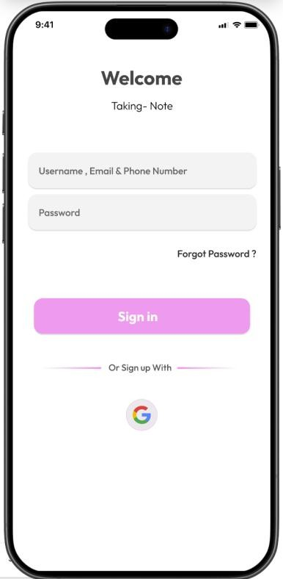
- Display and manage notes specific to each user.

Exercise Requirements:

Integrate Firebase Authentication
  - Configure Firebase Authentication in React Native.
  - Support Email/Password and Google Sign-In authentication.
  - If the user is not logged in, show the login screen.

Manage User-Specific Notes
  - Once logged in, display only the notes of the logged-in user.
  - When adding a new note, store the userId in Firestore to identify the owner.

Main Features of the App
  - Register, login, logout.
  - Add, display, and delete notes (users can only see their own notes).
  - Receive notifications when a new note is added (continue using Firebase Cloud Messaging from Lab 5).

Submission Requirements:
- Source Code (StudentID_Lab6.rar).

Demonstration Video (3-5 minutes):
  - Register, login.
  - Add, display, and delete notes (only viewing own notes).

