EASTERN INTERNATIONAL UNIVERSITY  SCHOOL OF COMPUTING AND INFORMATION TECHNOLOGY   | Practice Assignment – Quarter 2, 2025-2026  Course Name: Advanced Mobile Programming  Course Code: CSW 434  Student’s Full Name: Student ID:
Practice Assignment 2

This practice assignment aims to help students understand and apply Native Module
in a React Native project by building a simple app that:
- Displays the current battery percentage of the device.
- Provides a slider to adjust the screen brightness.
Students will implement platform-specific features by writing native code (Java/Kotlin for Android) and integrating it into React Native using the Native Module.
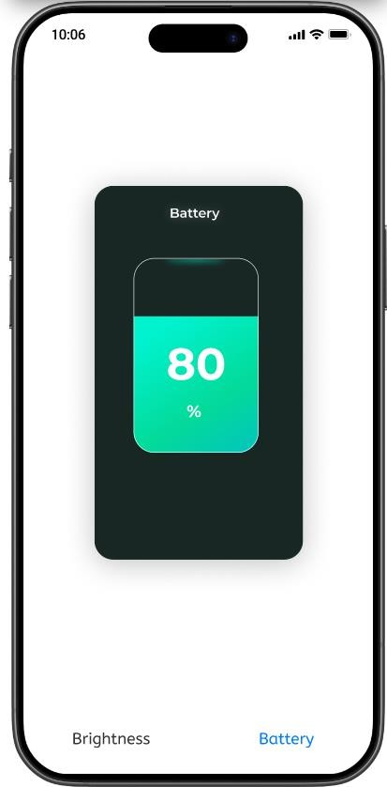
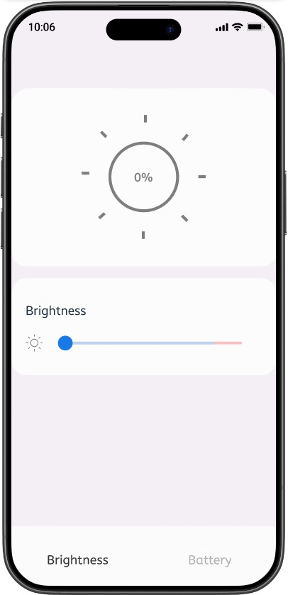

Screen 1 Screen 2

Exercise 1: Display Battery Percentage
Using Native Modules in React Native, implement a feature that displays the current
battery percentage of the device.

Key Requirements:
    - Write platform-specific code to fetch the battery percentage:
      - Use the BatteryManager API.
    - Expose this functionality as a Native Module that can be accessed in JavaScript.
    - Display the battery percentage in a simple React Native UI like Screen 1.

Exercise 2: Adjust Screen Brightness
Using Native Modules in React Native, implement a feature that allows users to adjust the screen brightness of the device using a slider.

Key Requirements:
    - Write platform-specific code to modify the screen brightness. You can choose one of the following approaches:
      - Use WindowManager.LayoutParams to adjust brightness within the app (does not require permissions).
      - Use Settings.System to modify system-wide brightness (requires WRITE_SETTINGS permission).
      - Use a third-party library that provides brightness control functionality (e.g., react-native-brightness).
    - Expose this functionality as a Native Module that can be accessed in JavaScript.
    - Create a React Native UI with a slider to adjust brightness like screen 2.
    - Reflect the brightness changes immediately as the slider value changes.

