Homework 05

**Problem 1:** *Mini-max Search in Game Trees.* Given the game tree above, it illustrates a position reached in a mini-max game. Inside each leaf node is the estimated score of that resulting position returned by the heuristic static evaluator. It’s MIN’s turn to move.

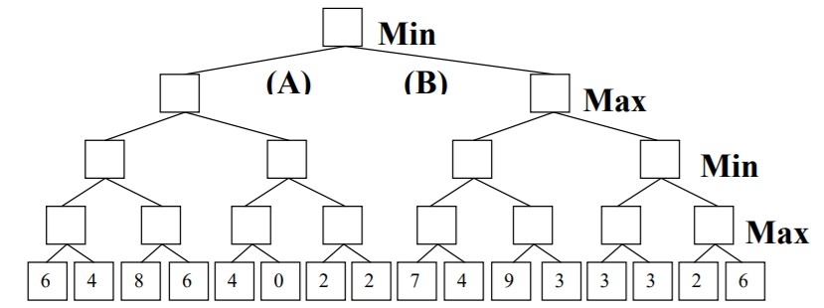

1. Please fill in the blank squares correct values according to mini-max search.

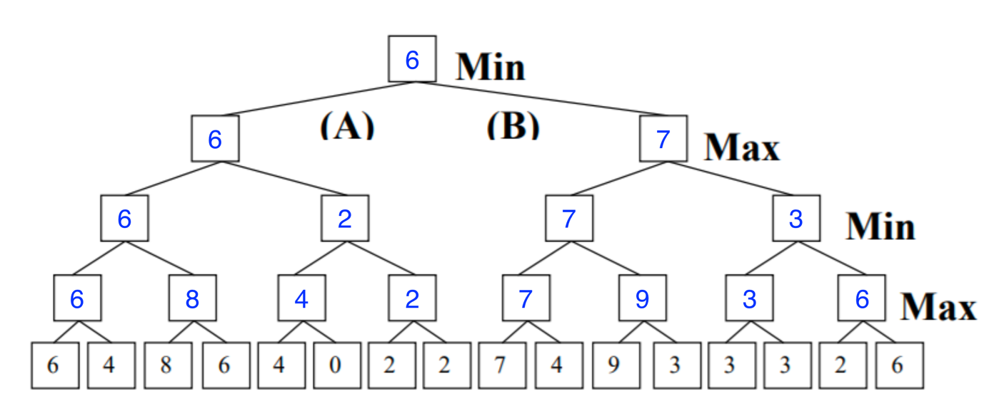

1. What’s the best move for MIN? Answer (A or B): The best move for MIN is A.
2. Please add a cross (X) to each leaf node that will not be examined because it’s pruned by Alpha-Beta Pruning.

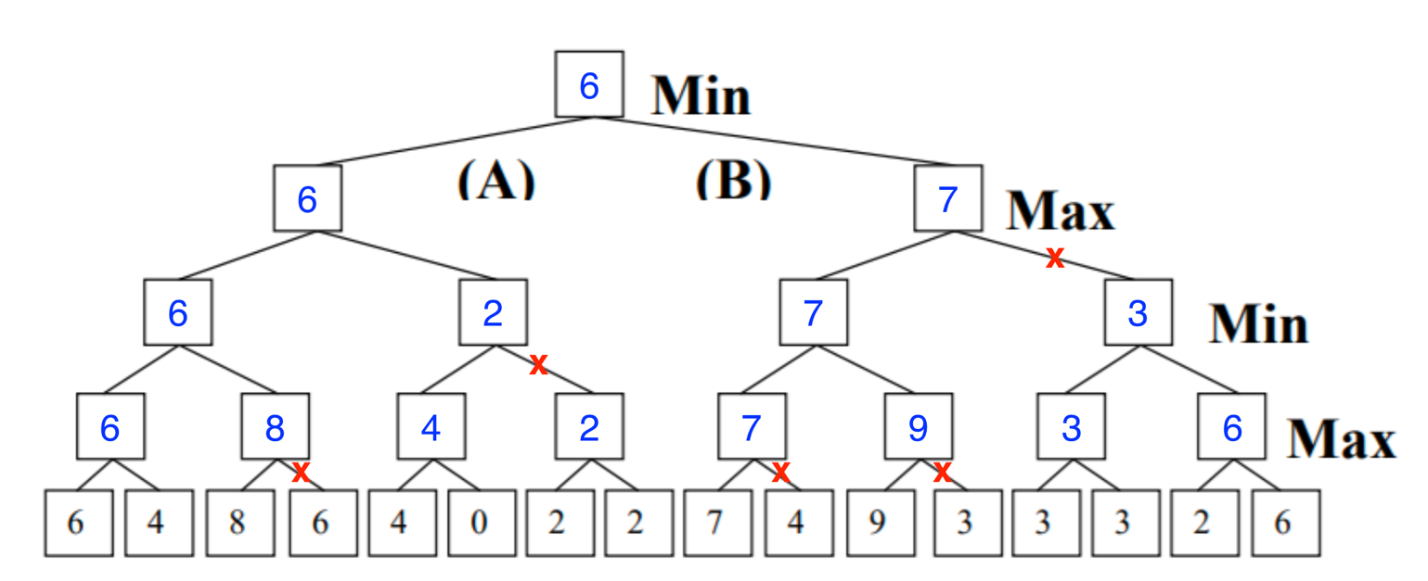

**Problem 2:**

Repeat the task in problem 1 for the following game. It’s MAX turn to move.

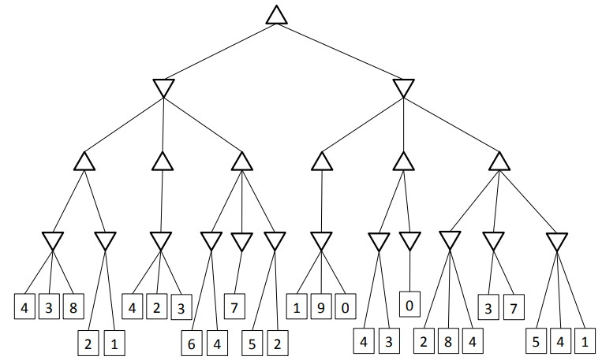

1. Please fill in the blank squares correct values according to mini-max search.

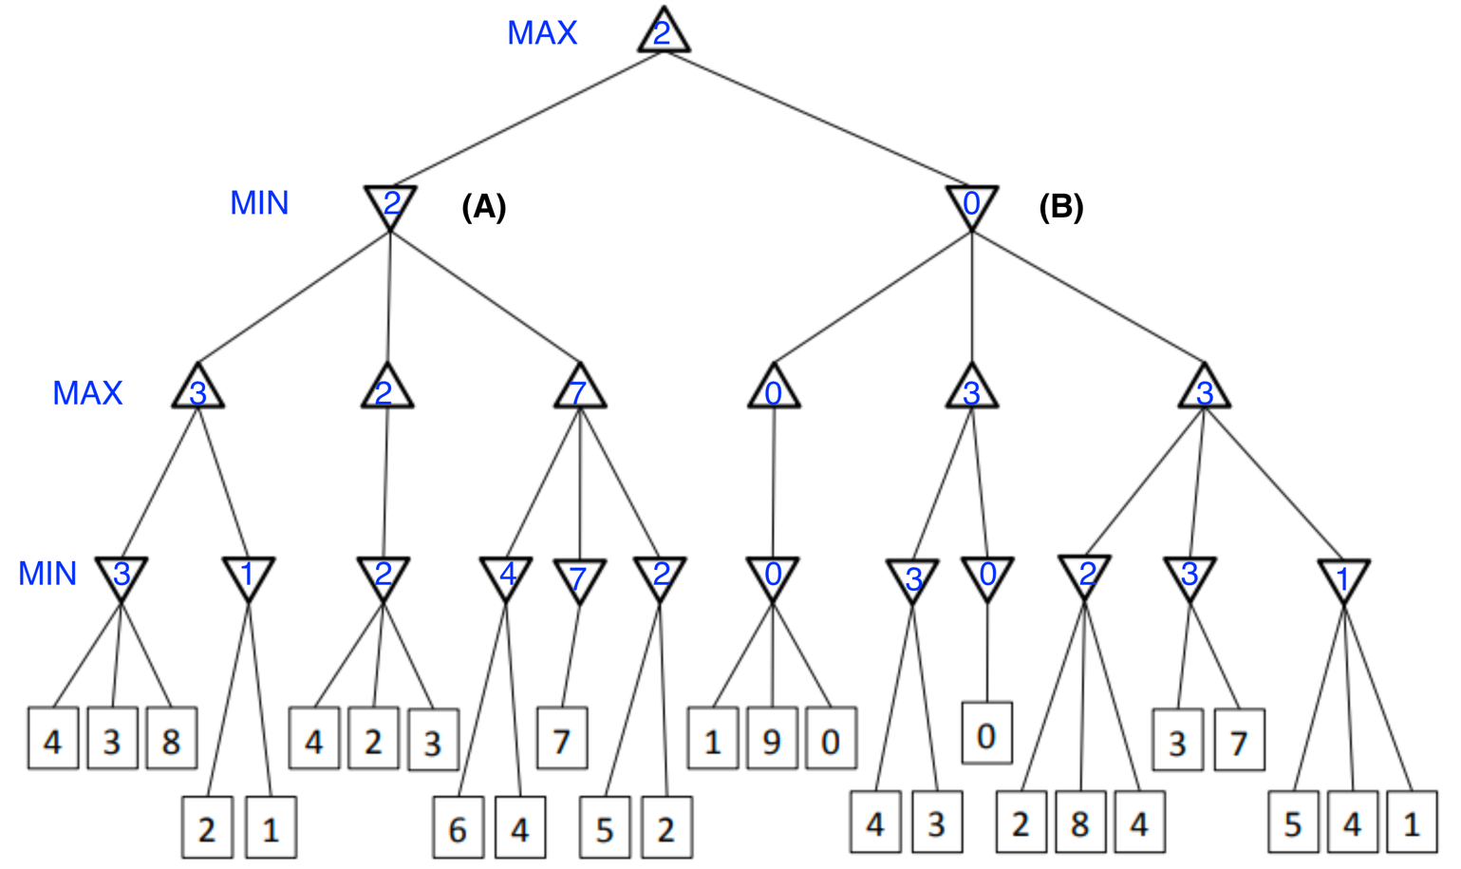

1. What’s the best move for MAX? Answer (A or B): The best move for MAX is A.
2. Please add a cross (X) to each leaf node that will not be examined because it’s pruned by Alpha-Beta Pruning.

