**Question 1:**

Find the path from ***S*** to ***G*** using the UCS algorithm for the graph below. Please show the transformation of ***fringe*** and the path found.

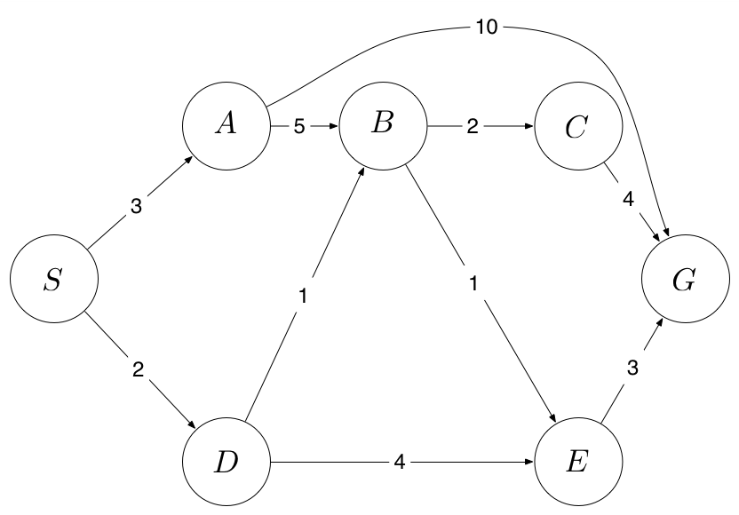

UCS expands the node 𝑛 with the lowest path cost. Its implementation: frontier is a priority queue ordered by cost.

Fringe = {(S;0)}

Fringe = {(D;2), (A;3)}

Fringe = {(A;3), (B;3), (E;6)}

Fringe = {(B;3), (E;6), (G;13)}

Fringe = (E;4), (C;5), (G;13)}

Fringe = {(C;5), (G;7)}

Fringe = {(G;7)}

Fringe = ∅

Path = {(S;0), (D;2), (B;3), (E;4), (G;7)}

**Question 2**

Given the maze as shown below. Bold lines represent impassable wall.

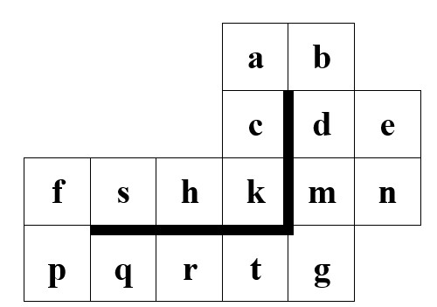

Find your way from ***s*** to ***g*** with the search strategies as below. Show the expanded order of each cells according to format ***<b1, b2,..., bn>***, with ***bi*** is the expanded cell. a. BFS

BFS expands shallowest unexpanded node. Its implementation: frontier is a FIFO queue.

Expanded cell = <s, f, h, p, k, q, c, r, a, t>

Path = {s, f, p, q, r, t, g}

b. DFS with state checks along the way to avoid loops. The expansion order is Right

-> Bottom -> Left -> Top

DFS expands deepest unexpanded node. Its implementation: frontier is a LIFO Stack.

Expanded cell = <s, h, k, c, a, b, d, m>

Path = {s, h, k, c, a, b, d, m, g}

**Question 3:**

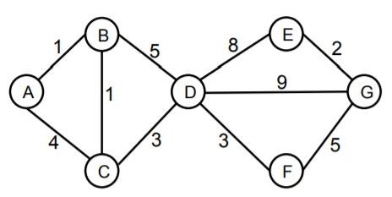

Find the way from A to G. Show the transformation steps of fringe (stack, queue).

1. BFS

BFS expands shallowest unexpanded node. Its implementation: frontier is a FIFO queue.

Fringe = {A}

Fringe = {B, C}

Fringe = {C, D}

Fringe = {D}

Fringe = {E, F, G}

Expanded cell = <A, B, C, D>

Path = {A, B, D, G}

1. DSF

DFS expands deepest unexpanded node. Its implementation: frontier is a LIFO Stack.

Fringe = {A}

Fringe = {B, C}

Fringe = {B, D}

Fringe = {B, E, F, G}

Expanded cell = <A, C, D>

Path = {A, C, D, G}

1. UCS

UCS expands the node 𝑛 with the lowest path cost. Its implementation: frontier is a priority queue ordered by cost.

Fringe = {(A;0)}

Fringe = {(B;1), (C;4)}

Fringe = {(C;2), (D;6)

Fringe = {(D;5)}

Fringe = {(F;8), (E;13), (G;14)}

Fringe = {(E;13), (G;13)}

Fringe = {(G;13)}

Fringe = ∅

Expanded cell = {(A;0), (B;1), (C;2), (D;5), (F;8), (E;13), (G;13)}

Path = {(A;0), (B;1), (C;2), (D;5), (F;8), (G;13)}