



Institute of Technology of Cambodia

Département de Génie Informatique et Communication

Department of Information and Communication Engineering

Professeur : HOK TIN

Subject : Internet Programming

Assigment : TP-08(Authentication frontend API)

STUDENT : THUE NARATT

Group : I4GIC©

ID : E20191186

YEAR : 2023-2024

Contents

EX1 : By using VueJS router, we can access by 3

EX2 : Create a nodejs APIs for authentication with ExpressJS. 5

EX3 : Integrate Login/Register app with APIs 6

URL : https://github.com/thuenaratt/TP08

# EX1 : By using VueJS router, we can access by

▪ Login: <http://localhost:3000/>

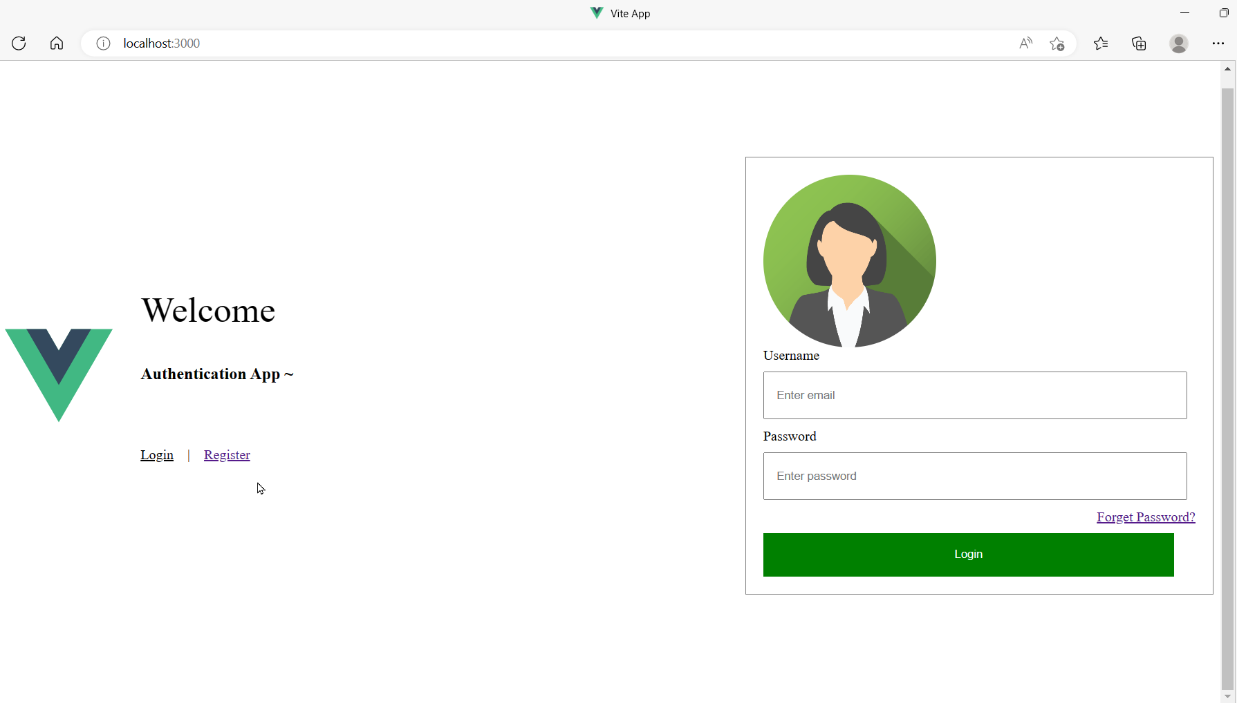

▪ Register: <http://localhost:3000/register>

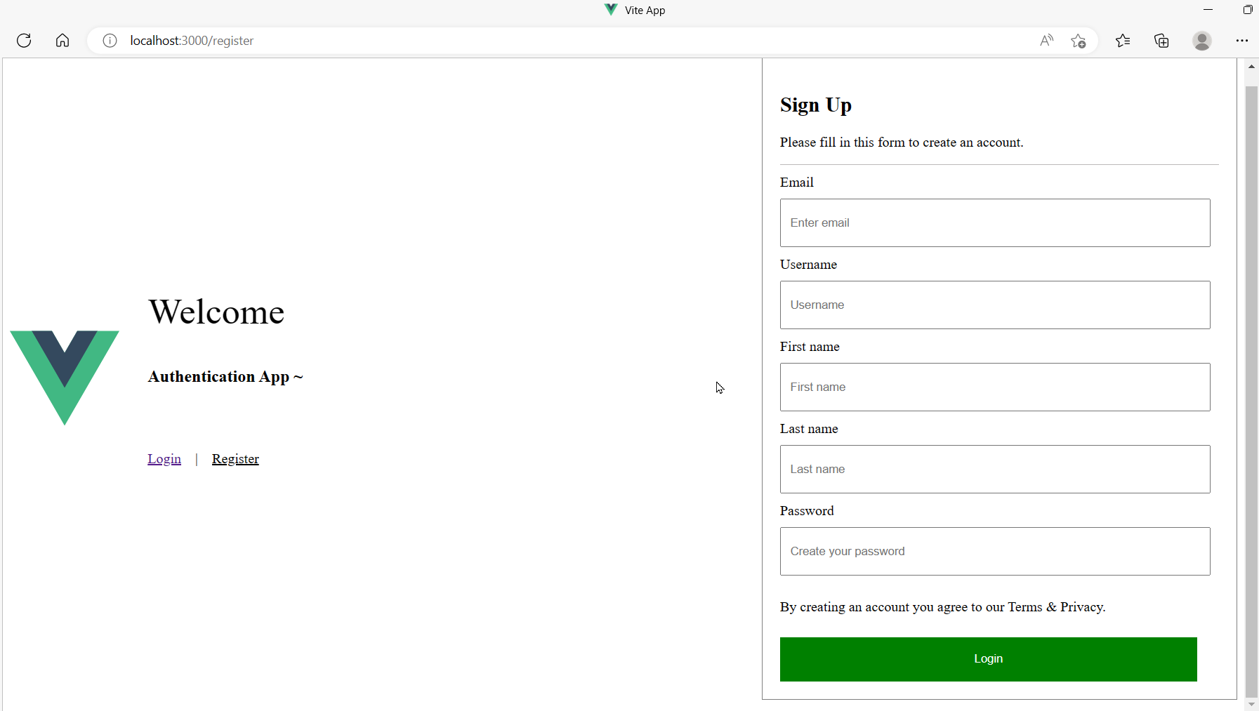

▪ Home: <http://localhost:3000/home>

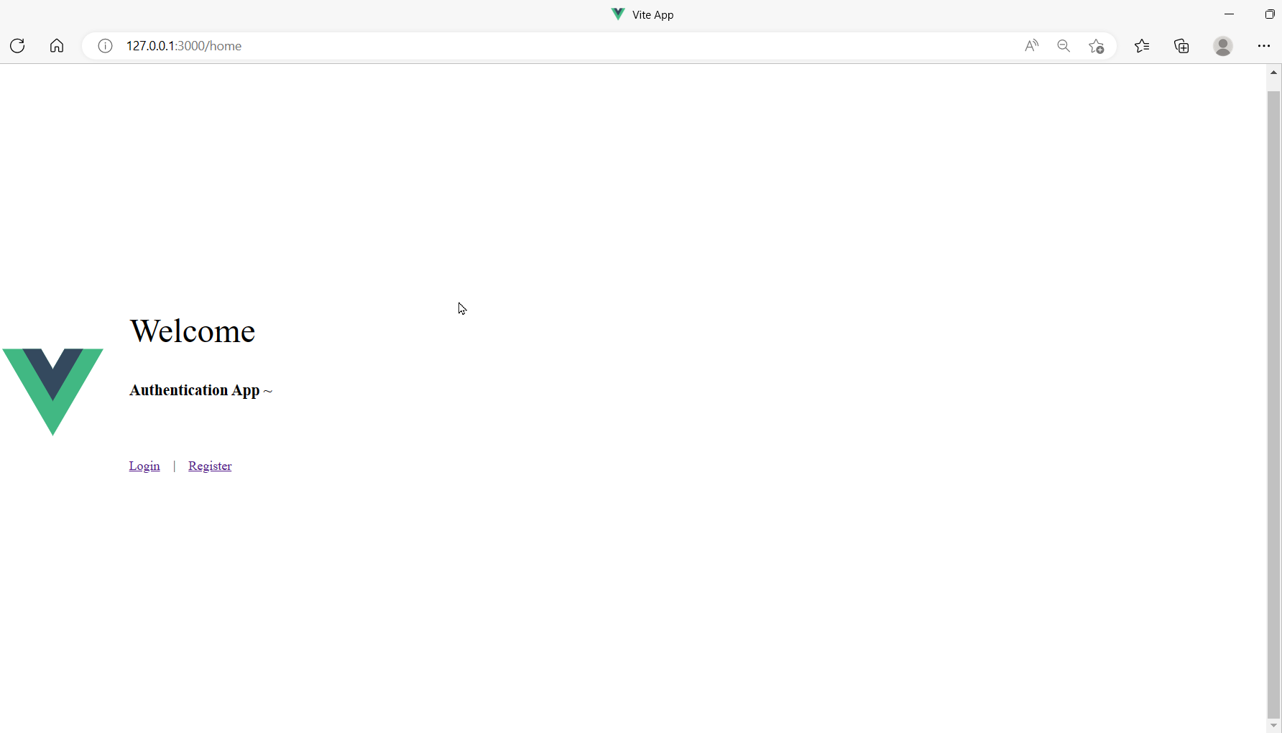

# EX2 : Create a nodejs APIs for authentication with ExpressJS.

Use Json file as a database to store user’s information.

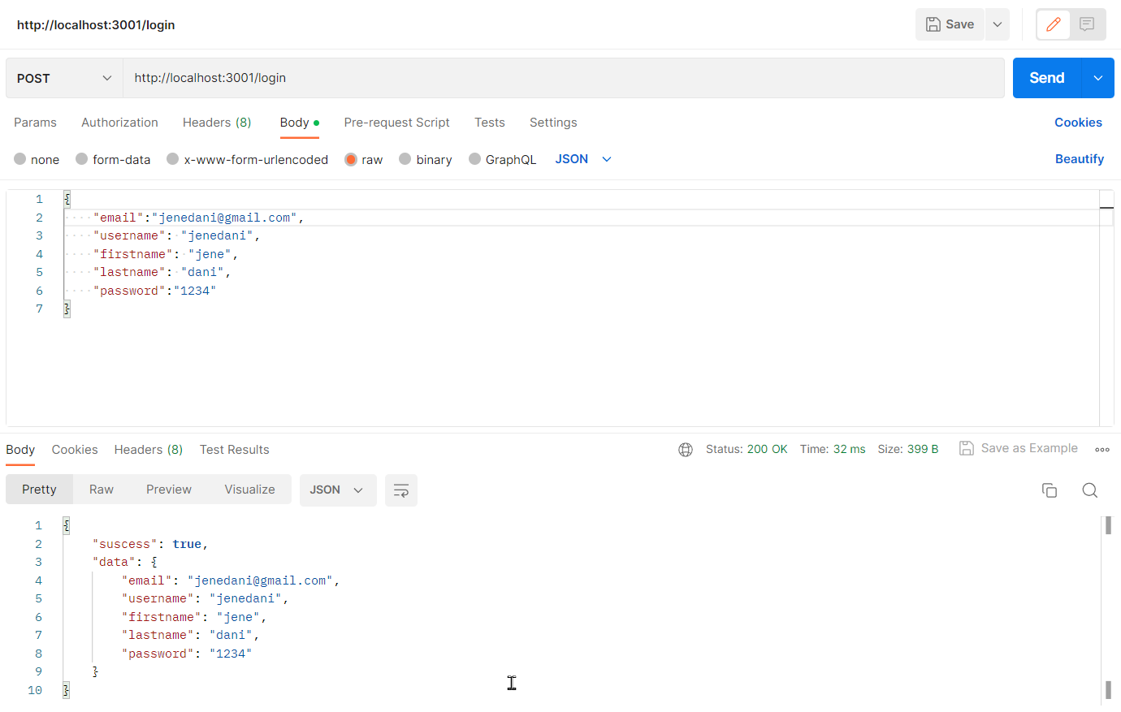

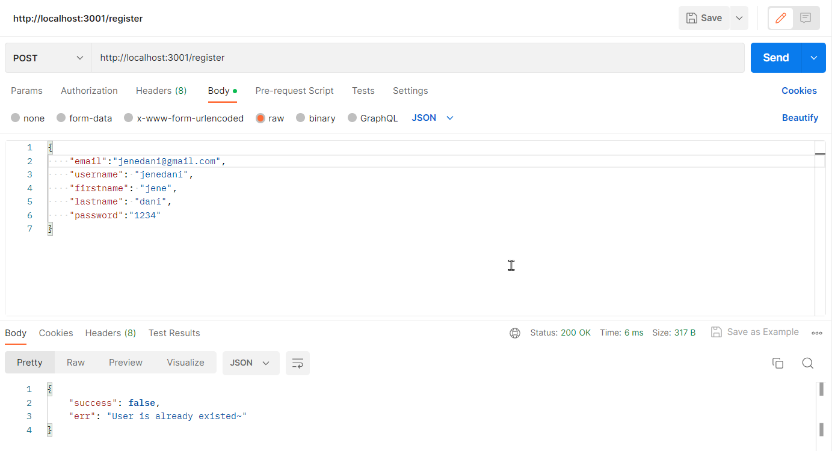

# EX3 : Integrate Login/Register app with APIs

# 

