



Institute of Technology of Cambodia

Département de Génie Informatique et Communication

Department of Information and Communication Engineering

Professeur : HOK TIN

Subject : Internet Programming

Assigment : TP09-Assigment Submission

(Nodejs)

STUDENT : THUE NARATT

Group : I4GIC©

ID : E20191186

YEAR : 2023-2024

Table of Contents

TP09.1: NodeJS (Mongo Database) 3

TP09.2: Authentication with database 4

TP09.3: NodeJS (Token, Cookie) 5

# TP09.1: NodeJS (Mongo Database)

Ex1: For the previous authentication APIs, replace your user.json storage by a Nosql database, mongoose

* Result of Exercise1 : Connect to Mongo DB

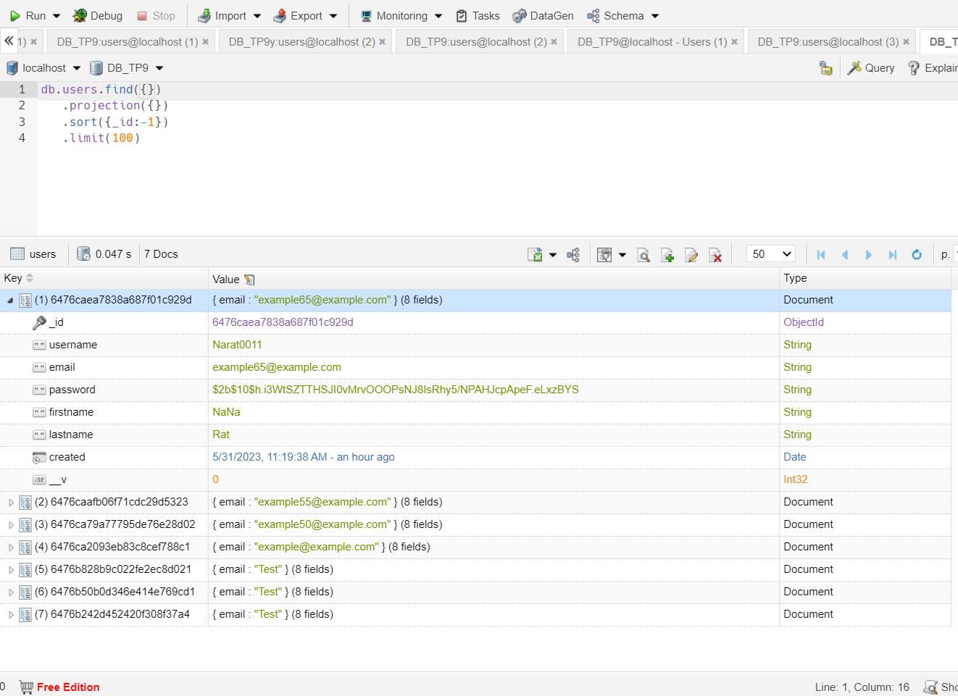

# TP09.2: Authentication with database

EX2: Implement the authentication with the password encrypted and request validation middleware.

* Encrypted password

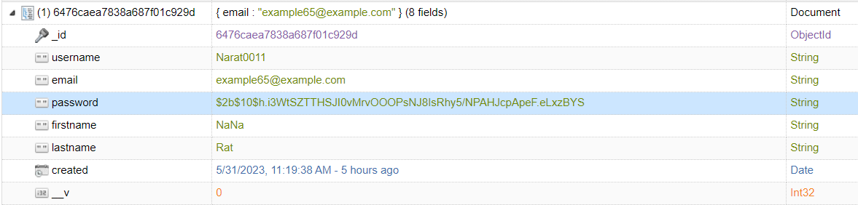

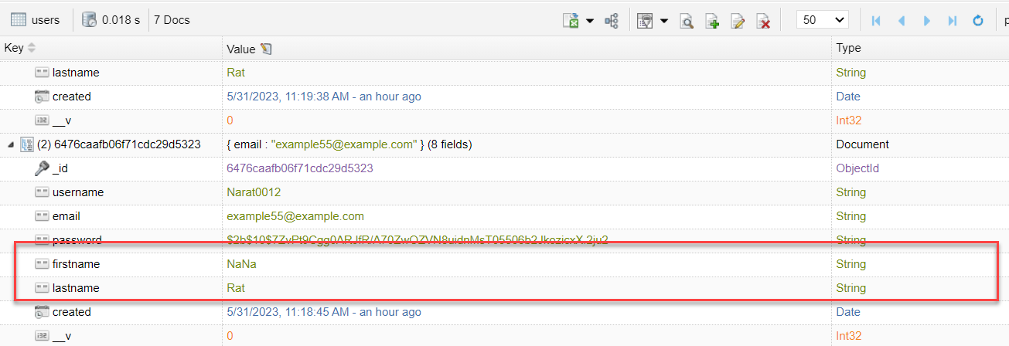

* Request valid Email

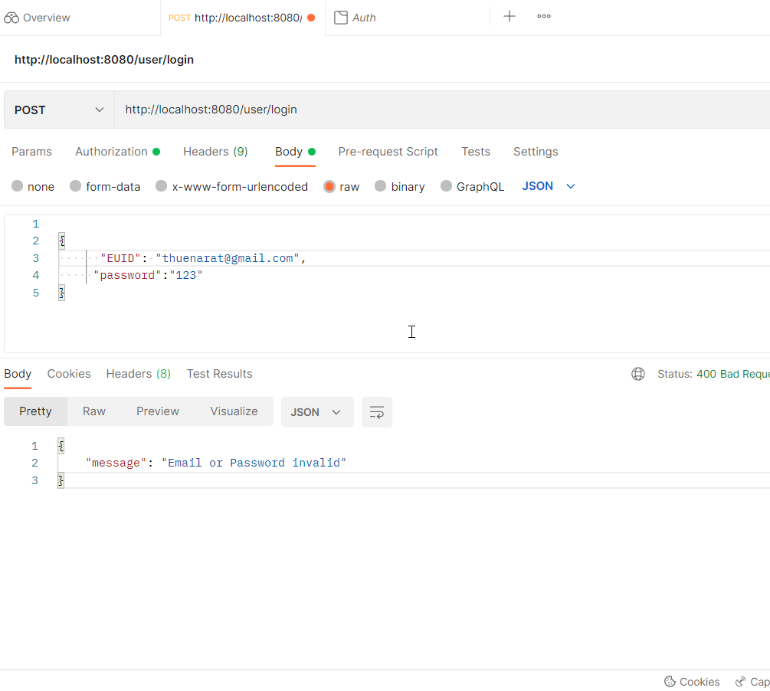

* valid Password

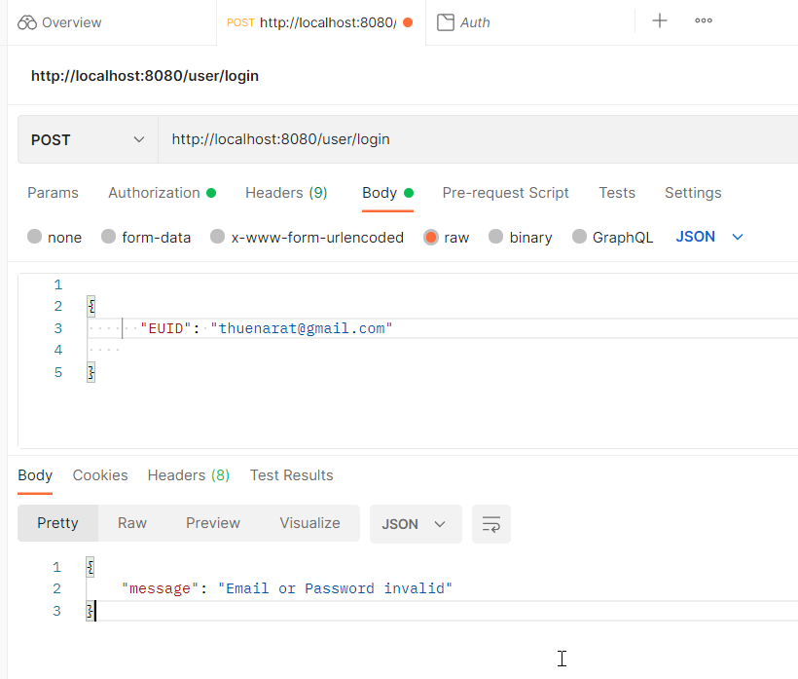

# 

# TP09.3: NodeJS (Token, Cookie)

Ex3: Create a token of an authenticated user and store it in the cookie for ensuring the authorized user. The token validation method must be a middleware function.

Result of Ex3:

* User Register Account

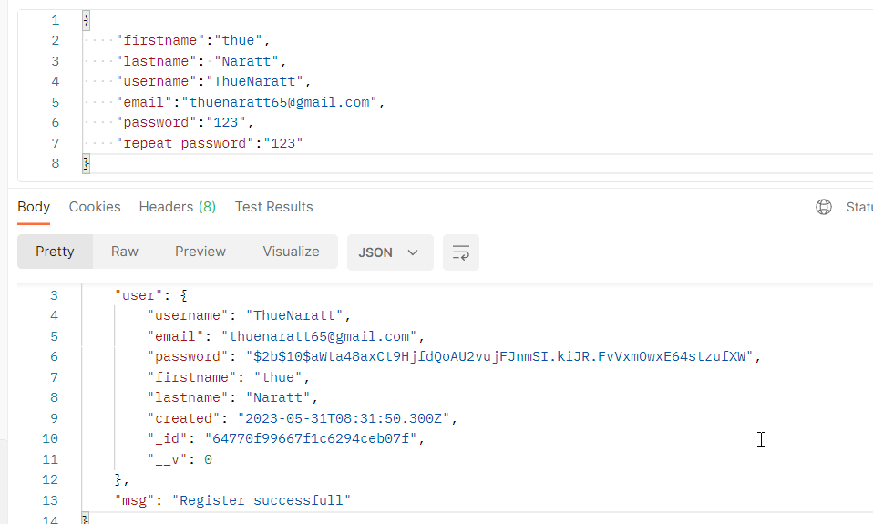

* if user already Register user account

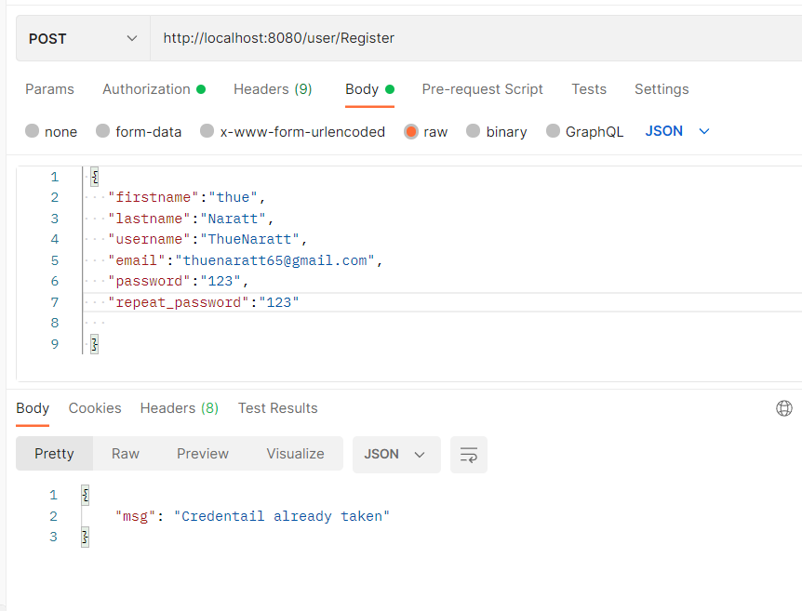

* login to user account just input _id:

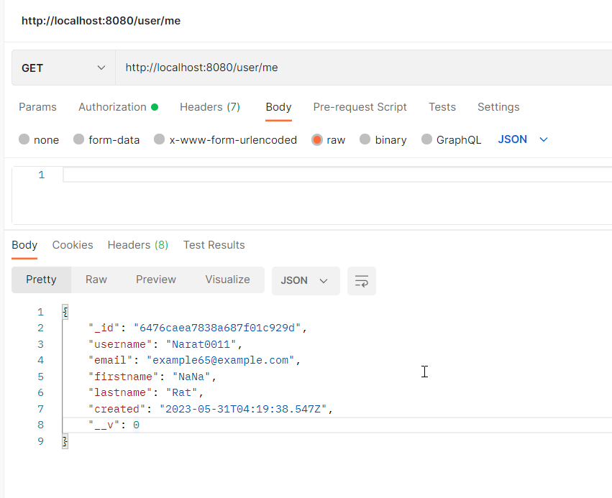

* /logout (Attempt to sign out failed)

