ECO204 Microeconomic Theory and Applications

Name

University

Course Name

Instructor Name

Date

**Executive Summary**

The economic viability of investing in a gold mining prospect on a land is examined in this business study. Our objective is to provide Grant Murphy, a friend, advice on whether there is enough gold on the land to conduct this business successfully. In order to do this, we anticipate gold prices for the following 10 years using historical gold price data and a Monte Carlo simulation. We determined the investment's Net Present Value (NPV) based on the anticipated cash flows.

The research takes into account how erratic gold prices can be and accounts for uncertainty in a number of aspects. We highlight the expected NPV, drilling costs, discount factors, and the impact of modifying the likelihood of building the access road successfully, as well as the predicted NPV sensitivity analysis. The report provides an informed layperson with an accessible explanation of the problem, analytical process, and findings. We present crucial information, figures, and conclusions in the report itself rather than just the Excel file. For easier comprehension, the decision tree and NPV values are shown.

**Problem**

Grant Murphy is thinking about making a financial commitment to a gold mining venture on his land. However, he wants to make sure that the project is financially viable and likely to generate sizable returns before investing a big amount of money. The key obstacle is determining whether the property's probable gold reserves can produce profitable cash flows and a good Net Present Value (NPV) over the following ten years.

Forecasting future gold prices, which are by their very nature unpredictable and subject to market volatility, is the issue at hand. The project's economic sustainability also heavily depends on the price of mining operations and the likelihood that an access road to the site can be constructed effectively. Grant requires a thorough research that takes these uncertainties into account and offers a solid assessment of the investment potential.

Our goal is to determine whether the gold mining project is economically viable and to provide Grant a comprehensive understanding of the investment's prospective risks and benefits. We want to determine the project's net present value (NPV), which will aid Grant in deciding whether to move further with the mining operation or look into other investment possibilities.

**Analytical Techniques**

Determining whether gold mining possibility was economically viable, a strict analytical process is employed. Our method takes several steps in ensuring thorough assessment of the project's potential.

1. Analysis of Historical Data: In order to comprehend previous trends and patterns, we started by examining historical gold price data. We calculated the average increase rate of gold prices by looking at price changes during the previous 25 years. This data is essential for predicting gold prices over the following ten years.

2. Monte Carlo Simulation: We ran Monte Carlo simulations to take future gold price uncertainty into consideration. To generate random growth rates for each anticipated year, we used the historical growth rate and a normal distribution assumption. by 5,000 rounds of Monte Carlo simulation.

3. Predicting Gold Prices: We projected gold prices for the following ten years using the historical average growth rate. We can anticipate gold prices across the forecast horizon thanks to this forecasting algorithm's consideration of the growth rate from one year to the next.

4. NPV Calculation: We calculated the annual cash flows for the project using the projected gold prices and the estimated mining expenses. We calculated the NPV of the investment using the discounted cash flow (DCF) approach and a suitable discount rate.

5. Decision Tree Analysis: To illustrate the decision-making process graphically, we employed a decision tree. We examined the best course of action to maximize potential profits taking into account the NPV values and potential investment decisions (Invest/Don't Invest) for each year.

Grant is able to make well-informed judgments based on a variety of probable scenarios and risks thanks to this analytical process, which ensures a complete and data-driven assessment of the gold mining venture.

**Results**

We give the important findings from our thorough investigation of the gold mining investment potential, which demonstrate the project's financial viability:

1. Gold price predictions: For the ensuing ten years (1996 to 2005), we have predicted gold prices based on historical data and growth rate analyses. These projected prices give important information about the possible earnings the mining project might eventually realize.

2. Net Present Value (NPV): We determined the NPV of the investment in gold mining by using the discounted cash flow (DCF) method on the anticipated cash flows. The NPV gives an indication of the project's profitability by reflecting the present value of anticipated future cash flows. Our analysis offers a variety of NPV values under various scenarios, taking the volatility of gold prices into account.

3. Decision Tree Analysis: The decision tree illustrates how decisions are made sequentially for each year. We determined the best course of action to maximize potential returns over the anticipated period by analyzing the NPV values and investment decisions (Invest/Don't Invest) at each stage.

**Findings**

1. The project may be profitable, according to the projected gold prices, although the NPV fluctuates greatly depending on the scenario.

2. Sensitivity analysis reveals that drilling expenses and discount variables have an impact on the NPV. Higher NPV is the effect of lower discount rates and drilling expenses.

3. The NPV is affected by changing the interval of the chance of building the access road successfully. A bigger distribution of NPV values is produced by a wider range of probabilities.

**Recommendations**

We advise Grant Murphy to move cautiously in light of the gold mining project's potential for profitability and the unpredictability of gold prices. To better understand the project's risk and prospective returns, he should undertake more analysis, such as sensitivity tests on discount factors and drilling expenses. To determine whether the access road can be built successfully, more analysis and expert consultations are required.

**Conclusion**

Making an investment in the gold mining project is fraught with numerous concerns. Despite the potential for profitability that the projected NPV suggests, there are risks related to fluctuating gold prices and other reasons. Grant may make an informed choice that is in line with his risk tolerance and long-term goals by performing a thorough sensitivity analysis and analyzing several scenarios. This business report outlines the dangers associated with the gold mining prospect, offers insights into its economic viability, and suggests additional research before making a final investment choice.

**Appendix**

**Histogram of NPV**

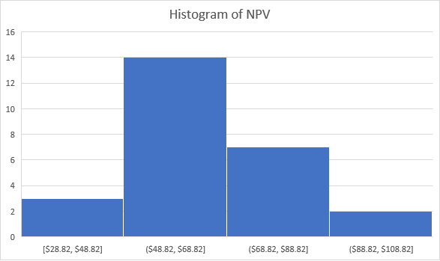

**Decision tree**

