**ASSIGNMENT #12 PUTTING IT ALL TOGETHER**

Instructions: Using the Sohana (constructs) dataset, develop a hypothesized model that includes the following:

* At least 3 IVs
* At least 2 DVs
* At least 1 mediator
* Optional: At least 1 moderator (your choice of multi-group or an interaction)
* At least 1 control

Please provide hypotheses, report and interpret all findings. Be sure to include model fit. Validate all claims including the significance of mediation, the significance and location of multi-group moderation etc.

# Introduction

At the request of Del Kundan, VP of Customer Service, this research study will focus upon the drivers of job satisfaction at Sohana Outfitters. The research will examine relationships between two job characteristics, specifically participation (part) and autonomy (aut) along with two job stressors, lack of control (lc) and role conflict (rc) on outcome constructs satisfaction with work and satisfaction with customers. The study should demonstrate both direct relationships between these factors and both satisfaction outcomes as well as relationships that are mediated by burnout tendencies construct: burnout from management. Kundan also wants to explore the hypothesis that there are differences between the customer service representatives and bill collector agents, so this study will also test for moderated mediation between these two groups. Controls include years in current job and the number of customer interactions per day.

# Theory

Recent empirical research on various topics of customer care highlights a number of areas of potential concern for Sohana Outfitters. Service workers, particularly those in call center environments, are highly susceptible to workplace burnout due to the conflicting demands between customers and managers (Harris & Lee, 2004). Customers calling in are often unhappy, irritable, or impatient, and place conflicting and unreasonable demands upon agents (Grandey, Dickter, & Sin, 2004). At the same time, high levels of monitoring and controls that are frequently regulated through modern call center technology correspond to higher levels of job stress and anxiety, including feelings of loss of control and a sense of role conflict, leading to burnout and employee churn (Harris & Lee, 2004).

Schaufeli and Bakker (2004) argue that the key antidote to service-job related burnout is engagement, meaning a job that provides meaning, is absorbing, and is professionally efficacious (2004). Sprigg & Jackson (2006) report that autonomy and extensive employee participation in designing how the workflow shall be planned; the associated decision making delegated to the employee; and finally, how job performance is measured are key attributes of self-efficacy, or what Schaufeli and Bakker would call attributes of employee engagement (2004).

Of additional concern is the role of perceived job stressors in the workplace, especially stressors that heighten job demands (2004). “Jones and Fletcher define demands as the degree to which the environment contains stimuli that peremptorily require attention and response. Demands are the things that have to be done.” (Schaufeli & Bakker, 2004). As these carry certain costs either physiological and/or psychological, demands become stressors when associated with high costs and negative affects such as anxiety or burnout (2004).

These are a number of potential factors for Kundan to consider, as agent retention is a significant area of concern. The recent resignations of two of his most experienced agents just in the past week have come at an unfortunate time, and Kundan does not have a clear insight on the possible drivers of agent dissatisfaction. If these causal relationships are not articulated and addressed quickly, Sohana indeed runs the risk of no longer leading the industry in service worker retention, which puts the performance goals of the firm at considerable risk as the company heads into the peak holiday season (Sohana, 2000).

## Hypotheses

Given that there are a number of factors that can potentially effect job satisfaction, specific job characteristics will be considered along with associated job stressors.

Higher levels of monitoring and controls introduced with the new ERP system are associated with lower levels of perceived autonomy (Sprigg & Jackson, 2006) as discussed in an earlier paper (Kendall, 2014). The associated work design changes introduced with ERP in particular have been shown to produce higher levels of job demand and lower levels of autonomy (2006), which several studies suggest is associated with lower work satisfaction (2006). Sprigg & Jackson note that machine-paced workflow instead of self-paced workflow demonstrated in the automation and mechanization of other industries like the postal service result in lower perceived levels of job autonomy (2006).

Lowered levels of autonomy are also associated with the job stressor lack of control (Jin & Guy, 2009; Schaufeli & Bakker, 2004; Sprigg & Jackson, 2006). Burnout in all three generally accepted constructs disengagement, exhaustion, and professional efficacy (Jin & Guy, 2009) is thought to increase when levels of autonomy go down (Jin & Guy, 2009; Schaufeli & Bakker, 2004; Sprigg & Jackson, 2006).

On a related topic that ties autonomy and satisfaction with customers is how customers have expressed frustration with the recent ERP rollout as well, and may be related to the departure of two high-value customer accounts leaving for another supplier (Sohana Outfitters Case Study, 2000). Under the best of situations, frustrated and unhappy customers are often verbally aggressive towards customer service workers. When agents have less perceived job autonomy, they have fewer tools at their discretion to respond to verbally aggressive or angry customers (Grandey et al., 2004). Several studies have found that agents with less perceived autonomy in these situations report lower feelings of satisfaction towards customers, and also experience an increase in feelings of job burnout, and higher levels of frustration associated with role conflict (Grandey et al., 2004).

Employee participation in defining job characteristics might be an issue at Sohana with the reduced levels of decision-making and autonomy stemming from the ERP implementation and new workflow design. The case study and associated data do not show the degree that employees participated in setting up the new ERP system or job design, but given the recent resignations of long-standing employees, it is possible that employees were not consulted enough or brought into the planning process. Participation in creating organizational changes of this magnitude are considered essential to successful adaptation, acceptance, and positive feelings of job satisfaction (Sprigg & Jackson, 2006). Low levels of participation during these types of change initiatives are correspondingly associated with burnout, particularly disengagement, along with employee turnover and lower levels of satisfaction (Jin & Guy, 2009).

Of notable absence in the literature is the role that job categories might play in moderating the relationships between autonomy, feedback, participation, burnout, and job satisfaction. When customer service workers are studied in the literature, their roles are aggregated as single job type (Grandey et al., 2004; Jin & Guy, 2009; Sprigg & Jackson, 2006). This study argues that it’s possible different job categories moderates these effects. Accordingly, we developed a moderated mediation model (Preacher, Rucker, & Hayes, 2007), which jointly examines burnout toward management as the mediating mechanism and job category as the moderator in order to more precisely define and understand these effects.

Based on analysis of job category work, we argue that that customer service representatives are more likely to experience lower levels of work satisfaction with increasing levels of burnout related to depersonalization and emotional exhaustion due to how work design changes lead to increasing number of calls per day. This in turn corresponds to lower levels of autonomy, lack of control, and role conflict as previously discussed. If we compare this to the experience to bill collectors, who have more control over the pace of calls made, complete fewer calls per day on average, and are typically compensated on the amount of money collected, bill collectors are likely to more satisfied with their work, but will be less satisfied with customers due to the high emotional labor associated with bill collecting (Harris & Lee, 2004; Jin & Guy, 2009).

To explore these relationships between job autonomy, employee participation, lack of control, role conflict, job satisfaction, and the moderated mediating role of burnout towards management, we propose the following hypotheses:

*H1. Job category will moderate the strength of the mediated relationship between participation (H1a), autonomy (H1b), lack of control H1c), and role conflict (H1d) with satisfaction towards work via burnout towards management, such that the relationship will be mediated less strongly for bill collectors than for customer service representatives, controlling for number of years on the job and number of customer interactions per day.*

*H2. Job category will moderate the strength of the mediated relationship between participation (H2a), autonomy (H2b), lack of control (H2c), and role conflict (H2d) with satisfaction towards customers via burnout towards management, such that the relationship will be mediated less strongly with customer service representatives than with bill collectors, controlling for number of years on the job and number of customer interactions per day.*

# Methods

## Sample

We used the *Sohana Constructs No Missing* dataset as provided, consisting of 305 completed surveys from Sohana customer service agents, classified as either customer service representatives (159 surveys) or bill collectors (146). The survey was given approximately six months ago, administered in English, and consisted of 106 usable items.

## Measures

We are using some of the a priori configured constructs from the completed survey data. From the survey measures used to test job characteristics, we are using scales developed for Participation (part) and Autonomy (aut). *Participation* was measured with 4 items measuring the amount of participation at work, and is a 5-point Likert scale where 1=strongly disagree, 5=strongly agree (e.g. I frequently participate in the decisions to adopt new policies). *Autonomy* was measured with 3 items measuring the amount of autonomy at work, and is a 5-point Likert scale where 1=strongly disagree, 5=strongly agree (e.g. I have enough freedom to do what I want on my job).

From the survey measures used to test job stressors, we are using scales using scales developed for Lack of Control (lc) and Role Conflict (rc). *Lack of Control* was measured with 4 items measuring the perception of lack of control at work, and is a 5-point scale using words: Never, Seldom, Sometimes, Usually, and Always (e.g. Having little say in decisions that affect my work). *Role Conflict* was measured with 3 items measuring the amount of perceived role conflict at work, and is a 5-point scale using words: Never, Seldom, Sometimes, Usually, and Always (e.g. Dealing with policies which change one day to the next).

To test *Burnout* tendencies, we are using scales developed for the company management (burnm) dimension of 6 items, which is a 6-point Likert scale (Singh, 2000; Singh, Goolsby, & Rhoads, 1994) that tests emotional exhaustion, reduced personal accomplishment and depersonalization (e.g. I feel burned out from trying to meet top management expectations).

For Individual characteristics, we are using *job category*, which is a demographic item that identifies whether the customer service agent is a customer service representative or a bill collector.

For *Job satisfaction*, we are using 3 work (satw) items and 3 customer (satc) items, Both of are 5-point Likert scales where 1=extremely dissatisfied, 5=extremely satisfied (e.g. With the opportunity for acquiring higher skills, I feel… and With the kind of customers I have to deal with, I feel..).

***Control variables***. We controlled for number of years in current job and number of interactions handled per day as both of these have been shown to influence burnout and job satisfaction (Grandey et al., 2004; Harris & Lee, 2004; Singh, 2000).

# Analysis

## Results

We tested the entire model twice, once for direct effects and once for mediation. As we found a significant effect for each path test, at least for one of the two groups, we did not trim the model, but retained all of the original hypotheses.

***Tests for Mediation.*** We tested for direct effects first, and evaluated using standardized estimates for Customer Service Representatives (CSR) and Bill Collectors (BC) agents. The path model is shown in Figure 1. Because of the relative complexity of the model tested and the variation of significance between direct (without mediation), mediated effects as well as moderated mediation between the two groups (CSR and BC), we’ve showing the path model used for the tests without any of the associated squared multiple correlations, covariances, or significant path coefficients values to keep the visual paths of our hypotheses as clear as possible.

FIGURE 1:   
Direct Effects Path Model for CSR and BC

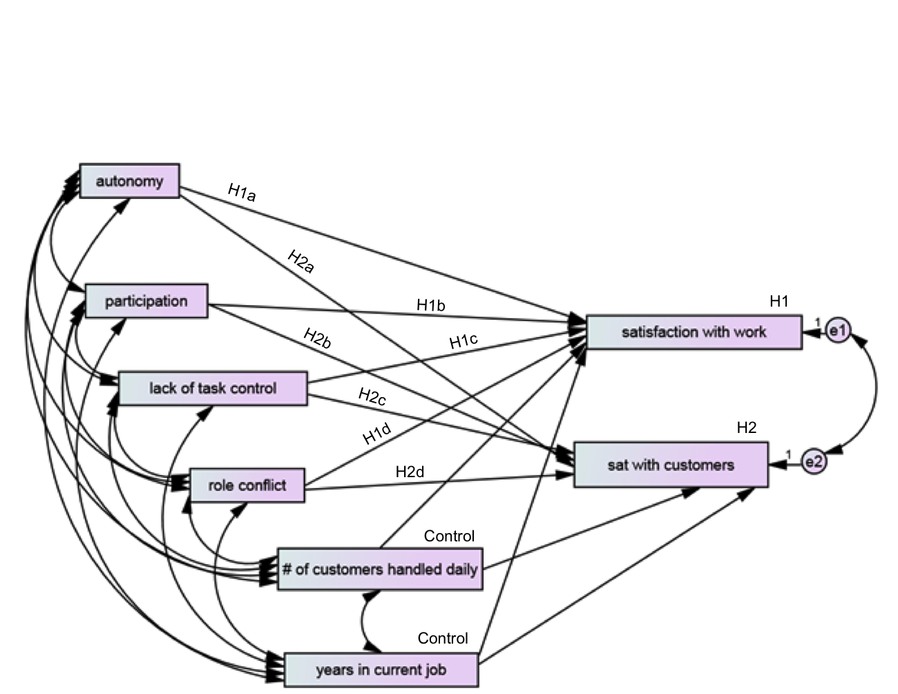

Next, we added the burnm mediator and re-tested, evaluating using standardized estimates again for CSR and BC. The path model is shown in Figure 2.

FIGURE 2:   
Mediated Path Model for CSR and BC

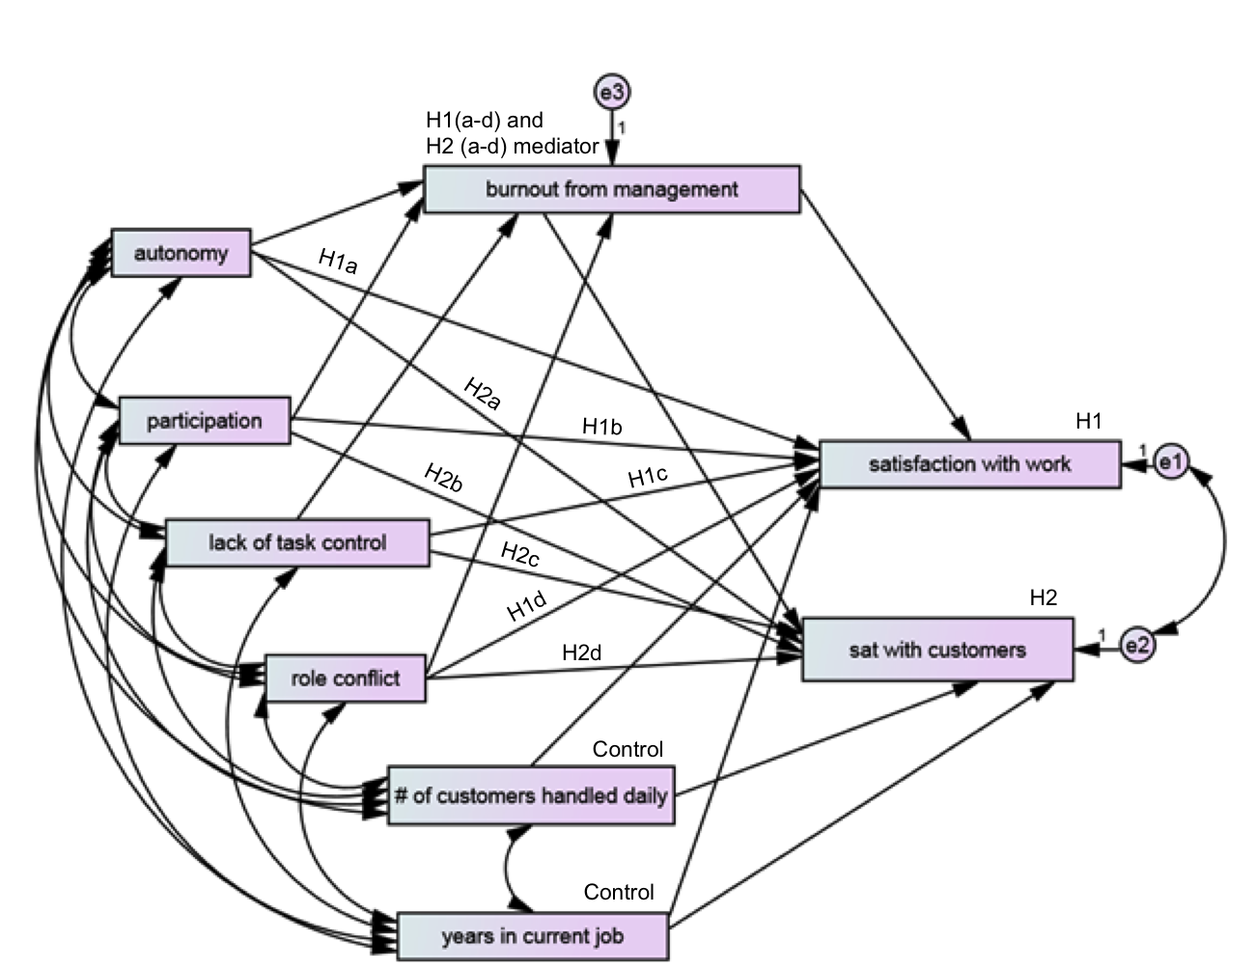

***Model fit statistics***. Table 1 shows various goodness of fit statistics for our final mediated model.

Table 1.   
Goodness of Fit Statistics

|  |  |  |  |  |  |  |  |  |  |  |  |  |
| --- | --- | --- | --- | --- | --- | --- | --- | --- | --- | --- | --- | --- |
| **Model #** | **Statistical Fit** | | | | **Relative Fit** | **Absolute Fit** | | | | | | |
|  | ***X*2** | **df** | **p** | **CMIN/df** | **CFI** | **GFI** | **AGFI** | **SRMR** | **RMSEA** | **Lo-90** | **Hi-90** | **Pclose** |
| **Mediated model for both groups** | 3.63 | 4 | .458  > .05 to reject independent model | .908  1-3 is good | 1.00  ≥0.95  (1 if *X*2<df) | 0.99  >0.95 | 0.94  >.80 | 0.008  <0.05 | 0.00  <0.05 (0 if *X*2<df) | 0.00 | 0.08 | 0.75  >0.05 for ns of null |

*X*2 above (CMIN) is the discrepancy between the unrestricted sample covariance matrix (S) and the restricted covariance matrix (∑). The ratio we are most interested in CMIN/df to be a range between 1.0 and 3.0, including good model fit. Our result of 0.908 shows an almost “too” good fit for this model. Next, we consider Comparative Fit Index (CFI), which is a comparison of the hypothesized model against the independent model. CFI = 1.00 because of *x*2<*df*. Nonetheless, this suggests that the hypothesized model represents a very good fit to the data. We also looked at the TLI index (the Tucker Lewis Index), which reported a very similar model as we would have expected.

Next, we turn to the absolute fit indices. goodness of fit index (GFI) of .99 is above the recommended threshold of > 0.95. The adjusted goodness of fix index (AGFI) of .94 is also above the threshold of > 0.80. The standardized root mean square residual (SRMR) of 0.008 is small, and below the recommended cut-off of 0.05, meaning that we have almost a perfect fit to the data. Root mean square of approximation (RMSEA) indicates that our value of 0.00 is because because of *x*2<*df*. Kenny (2014) argues RMSEA is not useful for low df models, however, the use of confidence intervals help where RMSEA is 0.000. We validate this further with LO 90 and HI 90, which show confidence intervals around the RMSEA values to reflect imprecision of the estimate. It is a narrow CI within Kenny’s recommendations of near zero for the lower CI and no more than .08 for the upper CI (Kenny, 2014). This tells us that our RMSEA, while 0, tells us that this is a very close-fitting model. Finally, we consider Pclose that tests the closeness of fit that the RMSEA value is good in the population. Our number at 0.75, allows us to reject the null hypothesis that the null model (the independence model) is a better fit than our default model, as it is well above the recommended cutoff value for significance at 0.05 (Kenny, 2014).

***Modification indices***. We chose to covary the error terms to improve model fit, because both outcome variables have statistical, not causal correlations. Under limited situations, it is permissible to covary the error terms in order to account for the systematic statistical correlations without implying a causal relationship (Gaskin, 2012). We expect and find that the residual error terms for both satisfaction with work and satisfaction with customer are similar, but as the variables themselves are not causally related, it does not make sense to draw a regression line from one to the other (2012).

# Findings

## Hypotheses Test Results

The outcomes of our two multi-part hypotheses are listed in Table 2 broken out by CSR respectively.

TABLE 2:   
Sohana Mediation Results for Group 0 – Customer Services Representatives (CSR)

|  |  |  |  |  |
| --- | --- | --- | --- | --- |
| Group 0 – Customer Service Representatives (CSR) | | | | |
| Hypothesis | **Direct Beta w/o Mediation[1]** | **Direct Beta w/ Mediation** | **Indirect Beta** | **Mediation Type** |
| H1a: *Mediation*  aut-burnm-satw | .11(ns) | .07(ns) | .05(ns) | Non |
| H1b: *Mediation*  part-burnm-satw | .11(ns) | .02(ns) | .08*** | Indirect &  Moderated |
| H1c: *Mediation*  lc-burnm-satw | -.37*** | -.21* | -.16*** | Indirect &  Direct |
| H1d: *Mediation*  rc-burnm-satw | -.26*** | -.17** | -.09** | Indirect & Direct |
| H2a: *Mediation*  aut-burnm-satc | .06(ns) | .03(ns) | .03(ns) | None |
| H2b: *Mediation*  part-burnm-satc | .12(ns) | .08(ns) | .05** | Indirect & Direct |
| H2c: *Mediation*  lc-burnm-satc | -.21* | -.12(ns) | -.09** | Indirect |
| H2d: *Mediation*  rc-burnm-satc | -.32*** | -.27** | -.05** | Indirect & Direct |
| Controls: yrsjob-satw | -.09(ns) | -.09(ns) | .00(na) | N/A |
| Controls: cusinter-satw | -.01(ns) | -.05(ns) | .00(na) | N/A |
| Controls: yrsjob-satc | -.05(ns) | -.05(ns) | .00(na) | N/A |
| Controls: cusinter-satc | -.03(ns) | -.01(ns) | .00(na) | N/A |

The tables show the results of both multi-part hypotheses, starting with the beta and significance for direct effects, then direct effects with mediation, and then indirect effects. Running bootstrapping tests for 2000 samples, at .95 bias-correct confidence level and then reporting the results of the two-tailed significance tests using standardized estimates allowed us to obtain significance for direct effects with mediation and associated indirect effects.

Following the guidelines of Hayes (2008), we examined each multi-part hypothesis for mediation, following these four conditions: (a) No mediation if indirect beta is not significant and if direct effect of independent variable on mediator is insignificant or if direct effect from mediation to outcome variable is insignificant; (b) Indirect effect if both direct effects are not significant but indirect effect is significant, which runs counter to Baron and Kenny (1986), but has been the basis for recent research on mediation and moderated mediation by Preacher et. al. (2007) and Hayes (2008, 2009) respectively; (c) Full mediation if the direct effects were significant prior to adding the mediator or if indirect is significant and direct with mediator is not significant; and (d) Partial mediation if direct with mediation and indirect are significant. The regression results for testing mediation are reported in Table 1 and Table 2 under last column Mediation Type.

Next, we conducted two tests for moderated mediation. In approach one, we compared which of the mediated path were different for the two groups. For all but H1c, all paths were moderated by job category.

In approach two, we compared the size, direction, and significance of the indirect effect. The differences between the two groups are not large, but in each case, we can see small differences in absolute numbers and changes in significance in every case. This also suggests that for all paths except for H1c, the mediator burnout towards management is moderated by job category.

Results at the bottom of Table 3 and Table 4 show that none of the control variables were significant as expected.

## Results

For group CSR, hypothesis H1a (aut->burnm->satw) show that autonomy is not significant as a direct effort (0.11ns), nor is significantly mediated (.07ns), nor has a significant indirect effect (.05ns). The results for BC are quite different, showing partial mediation for feedback that is significant as a direct effect (.24***), is significantly mediated (.07**), and has a significant indirect effect (.04*). This difference suggests that both the direct effect of autonomy on job satisfaction towards work and burnout partially mediates this effect only for bill collectors, a clear case of moderated mediation.

In the case of H2a (autonomy->burnm->satc) show no effect or significance for CSR for direct effect (.06ns), is not significantly mediated (.03ns) and has an insignificant indirect effect (.03ns). However, for BC agents, there is only a slight indirect effect that is weak, which means that we see a slightly moderated indirect effect only. It appears in this case that autonomy has no bearing on job satisfaction towards customers for CSR agents and only a slight indirect effect for BC agents, but enough to show a statistical moderation.

While Autonomy in either case plays an insignificant role effecting work satisfaction for CSR agents, a positive and partially mediated role comes into play for BC agents. Satisfaction towards customers has no bearing in either case. Given our earlier discussion on hypotheses around the differences between the two job categories, we may be seeing an effect where autonomy and professional efficacy aspects of burnout do come into play for BC agents, along with feelings of emotional exhaustion and depersonalization (Singh, 2000). Given the difficult emotional labor aspects of calling customers and establishing rapport for the purposes of collecting overdue accounts, we might expect delegated authority in how to approach the task and deal with the emotional labor from customers to be viewed as more important for this group of agents (Jin & Guy, 2009).

Hypotheses 1b hypothesis (part->burnm->satw) show that participation is not significant as a direct effect for CSR (.11ns), is not significantly mediated (.02ns), and has a significant indirect effect (.08***). The results for BC are quite different, showing no significant direct effect (.02ns), is not significantly mediated (.02ns), and has an insignificant indirect effect (.01ns). This difference suggests that there is only an indirect effect for customer service reps, another case of moderated mediation.

In the case of H2b (part->burnm->satc), we see that participation is not significant as a direct effect for CSR (.12ns), is not significantly mediated (.08ns), and has a significant indirect effect (.05**). The results for BC are different again, showing a significant direct effect (.20*), is not significantly mediated (.07ns), and has an insignificant indirect effect (.02ns). This difference suggests that feelings of participation is only an indirect effect on job satisfaction on both dimensions (work and customer) for CSR agents with on a small direct effect on job satisfaction towards customers for BC agents.

Given the significance of the workflow changes associated with the ERP rollout and our earlier arguments around the significance of participating in workflow changes of this magnitude with a disproportionate impact upon CSR agents and not BC agents, this only slightly confirms a key issue for Sohana for resolve. The management team might reconsider its policies around involving the rank-and-file staff in the planning stages of workflow change, and not just training after the fact. However, as we will see from the job stressor constructs, this may be more important that the effects observed for participation alone.

Hypotheses 1c (lc->burnm->satw) show that lack of control is significant as a direct effect for both groups CSR and BC (-.37***;-.46***), is significantly mediated for both groups (-.21*;-.21***), and has a significant indirect effect for both (-.16***;-.09**). There is no moderation for this path as both groups are partially mediated. In the case of H2c (lc->burnm->satc), we see that CSR shows that lack of control is significant as a direct effort for CSR (-.21*), is not significantly mediated (-.12ns), and has a significant indirect effect (-.09**), and is fully mediated. The results for BC are different, showing an insignificant direct effect (-.18ns), is insignificantly mediated (-.12ns), and has a significant indirect effect (-.15***). This difference suggests that lack of control effects both dimensions of job satisfaction toward work and customer for CSR agents, and is partially or fully mediated by burnout towards management, depending on the dimension of satisfaction. Conversely, lack of control is partially mediated for BC agents towards satisfaction towards work only, with only an indirect effect on job satisfaction towards customers. There is no moderated mediation for H1c while there is moderated mediation for H2c.

As discussed relative to both participation and autonomy, lack of control is a job stressor and is a key predictor of burnout and and job satisfaction, so given the significance of the workflow changes associated with the ERP rollout, the greater impact upon CSR agents versus BC agents, and our earlier arguments around the significance of designing in autonomy into the workflow, this confirms a key issue for Sohana for resolve.

Finally, hypotheses 1d (rc->burnm->satw) show that resource conflicts is significant as a direct effect for CSR (-.26***), is significantly mediated (-.17**), and has a significant indirect effect (-.09**) for a partial mediation. For BC agents, there is no significant direct effect (-.13ns), nor significant mediated effect (-.17ns), and a significant indirect effect (-.06**). In the case of H2d (rc->burnm->satc), resource conflict is significant as a direct effort for CSR (-.32***), is significantly mediated (-.27**), and has a significant indirect effect   
(-.05**), and is partially mediated. The results for BC are different, showing an insignificant direct effect (-.03ns), is insignificantly mediated (-.27ns), and has a significant indirect effect (-.10***). This difference suggests that resource conflict effects both dimensions of job satisfaction toward work and customer for CSR agents, and is partially or fully mediated by burnout towards management, depending on the dimension of satisfaction. Conversely, resource conflict has indirect effects only across both dimensions. The issue of resource conflict across both dimensions (job satisfaction towards work and job satisfaction towards customer) is a moderated mediation on both cases. As discussed relative to both participation and autonomy, resource conflict is another job stressor and is a key predictor of burnout and job satisfaction, so given the significance of the workflow changes associated with the ERP rollout, the greater impact upon CSR agents versus BC agents, and our earlier arguments around the significance of designing in autonomy into the workflow, this also confirms a key issue for Sohana for resolve.

The controls used in this study: number of customer transactions handled per day and number of years in current job had no significant effect upon the model, which underscores one key observation: the number of transactions and relative seniority are not significant factors driving job satisfaction.

# Discussion

Sprigg and Jackson (2006) argue successfully that the extremely detailed level of scripting along with high levels of performance monitoring introduced by modern call center environments introduces job stress and emotional exhaustion. This type of scripting, which is also associated with loss of autonomy and lack of control appears to be a significant factor in increasing levels of reported feelings of burnout and has a negative effect upon job satisfaction. However, it affects both groups differently. Participation was largely irrelevant in driving job satisfaction on both dimensions for either group as the effects were small.

Autonomy was not a significant driver of satisfaction on either dimension for CSR agents, but it was a significant positive driver of satisfaction towards work for BC agents. From this difference, the type of scripting and the set of workflow instructions appear to give BC agents more autonomy. At first, this is a positive finding. However, the lack of control finding, especially on the dimension of job satisfaction towards work is a significant negative correlation. CSR agents are clearly unhappy at the lack of control in the new workflow design and policies and procedures, while BC agents are reporting the negative impact as well. This underscores a key recommendation echoed from the literature that Sohana management should reconsider its policies around involving the rank-and-file staff in the planning stages of workflow change. Even at this stage of the rollout, it’s certainly not too late to examine what workflow policies are the significant source of concern, and Kundan should expect that CSR agents and BC agents will have different needs and views on the matter given the different job roles.

What is less clear, at least initially, is the role of resource conflict as the final stressor for consideration. Role conflict was largely irrelevant for BC agents, but a significant negative driver of job satisfaction on both dimensions (towards work and towards customers) for CSR agents. However, as the job scope for typical customer service agents is broader on average than the relatively narrow scope for bill collection, the questions themselves underscore possible ties to our previous observations. Sohana CSR agents responded negatively to being asked about the frequency of having to “deal with policies which change from one day to the next,” “Trying to meet conflicting demands of various departments,” and “dealing with or trying to satisfy too many different types of people” (Sohana, 2000). This finding was predicted by Grandey et al. (2004) as a consequent of the emotional labor associated by being unable to authentically respond to customer aggression, leading to feelings of emotional exhaustion, depersonalization, and lowered feelings of job satisfaction.

But why not for BC agents? Perhaps it is in the nature of the job as bill collectors know ahead of time that customers are going to be rude and not want to talk to them. BC agents usually have a lower level of empathy, are not required to “be nice,” and are rarely required to take the perspective that the customer is always right because to do so would be counterproductive for the purposes of bill collection (Grandey et al., 2004; Harris & Lee, 2004).

Customer service representatives on the other hand, have little resource since job terminations do occur at Sohana for perceived infractions of customer service policy, including the tone used with customers, and the insistence of “placing the customer first” (Sohana, 2000). What the data doesn’t show is the frequency of customer service policies and procedure changes and how agents are measured against those policies and procedures. This is an area that Sohana management should look at more carefully, as it may be as simple as whether CSR agents are feeling pulled into too many directions without a clear mandate on how to address charged and difficult service situations without being penalized by the new ERP system. The data only tells us that agents experience role conflict, or being pulled into different directions—we don’t know why, but this is another area where Kundan should extend his analysis and do additional data collection.

# Conclusion

Some small write up should go here.

**REFERENCES**

Baron, R. M. & Kenny, D. A. 1986. The moderator–mediator variable distinction in social psychological research: Conceptual, strategic, and statistical considerations. ***Journal of personality and social psychology***, 51(6): 1173.

Gaskin, J.; Structural Equation Modeling; <http://statwiki.kolobkreations.com;> 4/1, 2014.

Grandey, A. A., Dickter, D. N., & Sin, H. P. 2004. The customer is not always right: Customer aggression and emotion regulation of service employees. ***Journal of Organizational Behavior***, 25(3): 397-418.

Harris, E. G. & Lee, J. M. 2004. The Customer, Co-Worker, and Management Burnout. Distinction in Service Settings: Personality Influencers and Outcomes. ***Services Marketing Quarterly***, 25(4): 13-31.

Hayes, A. F. 2008. ***Introduction to mediation, moderation, and conditional process analysis: A regression-based approach***: Guilford Press.

Hayes, A. F. 2009. Beyond Baron and Kenny: Statistical mediation analysis in the new millennium. ***Communication Monographs***, 76(4): 408-420.

Jin, M. H. & Guy, M. E. 2009. How Emotional Labor Influences Worker Pride, Job Satisfaction, and Burnout. ***Public Performance & Management Review***, 33(1): 88-105.

Kenny, D. A.; Measuring Model Fit; <http://davidakenny.net/cm/fit.htm>, 2014.

Preacher, K. J., Rucker, D. D., & Hayes, A. F. 2007. Addressing moderated mediation hypotheses: Theory, methods, and prescriptions. ***Multivariate behavioral research***, 42(1): 185-227.

Schaufeli, W. B. & Bakker, A. B. 2004. Job demands, job resources, and their relationship with burnout and engagement: A multi‐sample study. ***Journal of organizational Behavior***, 25(3): 293-315.

Singh, J., Goolsby, J. R., & Rhoads, G. K. 1994. Behavioral and psychological consequences of boundary spanning burnout for customer service representatives. ***Journal of Marketing Research (JMR)***, 31(4).

Singh, J. 2000. Performance productivity and quality of frontline employees in service organizations. ***Journal of marketing***, 64(2): 15-34.

Sprigg, C. A. & Jackson, P. R. 2006. Call centers as lean service environments: job-related strain and the mediating role of work design. ***Journal of occupational health psychology***, 11(2): 197.

# Appendix A

Inclusion of information not shown in main body of paper

1. Standardized regression weights used.