Title
S1234567, Andy, 陳家豪
Abstract
Digital transformation is one of the key strategies for companies to survive in a competitive global market. Digital transformation is one of the key strategies for companies to survive in a competitive global market.

1. Introduction
Digital transformation is one of the key strategies for companies to survive in a competitive global market. Depending on how actively it adapts to this environmental change, the fate of the organization changes forever(HBR, 2025). But the digital transformation is more about strategies than technologies(Kane et al., 2015).
The 2030 Agenda for Sustainable Development, adopted by all United Nations Member States in 2015, provides a shared blueprint for peace and prosperity for people and the planet, now and into the future. At its heart are the 17 Sustainable Development Goals (SDGs), which are an urgent call for action by all developed and developing countries in a global partnership.
The 2030 Agenda for Sustainable Development, adopted by all United Nations Member States in 2015, provides a shared blueprint for peace and prosperity for people and the planet, now and into the future. At its heart are the 17 Sustainable Development Goals (SDGs), which are an urgent call for action by all developed and developing countries in a global partnership.

2. Data and Methods
They recognize that ending poverty and other deprivations must go hand-in-hand with strategies that improve health and education, reduce inequality, and spur economic growth – all while tackling climate change and working to preserve our oceans and forests.
Table 1 presents the raw data of incoming traffic to Tunghai University.
Table 1 Traffic statistics in Tunghai University
Time | Location | Count | Speed | Pedestrian
11,01,2025 6:00 | Dorm Area | 102 | 44.6 | 293
11,01,2025 6:15 | Business School Rd. | 82 | 34 | 191
11,01,2025 6:30 | Library Rd. | 86 | 38.3 | 276
11,01,2025 6:45 | Business School Rd. | 74 | 10.8 | 160
11,01,2025 7:00 | Business School Rd. | 74 | 48.8 | 21
11,01,2025 6:00 | Dorm Area | 102 | 44.6 | 293

3. Results
As Figure 1 shows, the most popular term in 2021 is ‘app.’ The 2030 Agenda for Sustainable Development, adopted by all United Nations Member States in 2015, provides a shared blueprint for peace and prosperity for people and the planet, now and into the future. At its heart are the 17 Sustainable Development Goals (SDGs), which are an urgent call for action by all developed and developing countries in a global partnership.
The 2030 Agenda for Sustainable Development, adopted by all United Nations Member States in 2015, provides a shared blueprint for peace and prosperity for people and the planet, now and into the future. At its heart are the 17 Sustainable Development Goals (SDGs), which are an urgent call for action by all developed and developing countries in a global partnership.
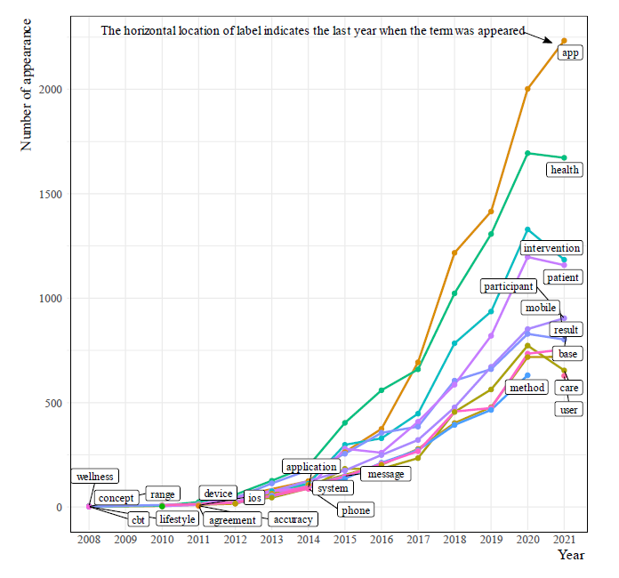
Figure 1 The most popular terms in the research

4. Conclusion
The 2030 Agenda for Sustainable Development, adopted by all United Nations Member States in 2015, provides a shared blueprint for peace and prosperity for people and the planet, now and into the future. At its heart are the 17 Sustainable Development Goals (SDGs), which are an urgent call for action by all developed and developing countries in a global partnership.
The 2030 Agenda for Sustainable Development, adopted by all United Nations Member States in 2015, provides a shared blueprint for peace and prosperity for people and the planet, now and into the future. At its heart are the 17 Sustainable Development Goals (SDGs), which are an urgent call for action by all developed and developing countries in a global partnership.
To manage the reference list, students are encouraged to use Zotero(https://www.zotero.org/) to insert in-text citations and reference list in the manuscript. After installing Zotero on the computer, follow the instructions explained in (Young, 2025a, 2025b)
#
# James
# File: James_Calculator.py
# Short description of the task
#

# 1. Input

# 2. Process

# 3. Output

References
HBR (Ed.). (2025). How 6 Companies Approached Digital Transformation. Harvard Business Review Digital Articles, 1–8. Business Source Elite.
Kane, G. C., Palmer, D., Phillips, A. N., Kiron, D., & Buckley, N. (2015). Strategy, not Technology, Drives Digital Transformation. MIT Sloan Management Review and Deloitte University Press. https://www2.deloitte.com/content/dam/Deloitte/fr/Documents/strategy/dup_strategy-not-technology-drives-digital-transformation.pdf
Young, S. (2025a). CMU LibGuides: Zotero: Getting Started. https://guides.library.cmu.edu/Zotero/home
Young, S. (2025b). CMU LibGuides: Zotero: Video Tutorials. https://guides.library.cmu.edu/Zotero/tutorials

